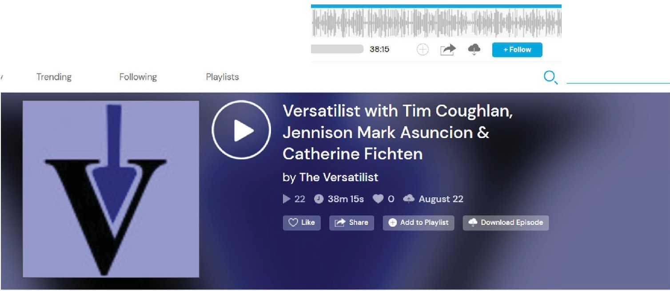
►
Versatilist with Tim Coughlan, Jennison Mark Asuncion & ...
The VerMtilist
◄
0:00
-•

EPISODE DESCRIPTION

In this episode, I speak with Tim Coughlan. Jennison Mark Asuncion

& Catherine Fichten about their work "Changing times: Emerging technologies for students with disabilities in higher education” For more about their work, check out the links below (including the transcript for the interview).

Is The Metaverse Likely To Be Accessible And Inclusive To People With Disabilities? https://www.forbes.com/sites/gusalexiou/2022/03/31/is-the­ metaverse-like!y-to-be-accessible-and-inclusive-of-peopte-with-disabilities/

https://b!ogs.microsoft.com/accessibility/ai4aedugrants2021/

ABOUT THIS PODCAST
Want more from this podcast?
Request New Episodes

SUPPORT THIS POOCAST

