Étudiants ayant des incapacités au cégep : Réussite et avenir
College Students with Disabilities: Their Future and Success

0000.doc 0000.doc





Final Report Presented to FQRSC
Rapport final présenté à FQRSC
Spring / Printemps 2006

Authors / Auteures
Catherine Fichten, Ph.D.¹²³
Shirley Jorgensen, M.B.A.²
Alice Havel, Ph.D. ²
Maria Barile, M.S.W.¹
With the Collaboration of / Avec la Collaboration de
Marie-Eve Landry, M.Ps.¹
Daniel Fiset, B.A.⁴
Jean-Charles Juhel, M.Ed.⁵
Sylvie Tétreault, Ph.D.⁶
Vittoria Ferraro, B.Sc. ¹³

Caroline Chwojka, B.A.¹⁷
Mai N. Nguyen, B.Sc.¹
Iris Alapin, M.A.¹
Rosie Arcuri¹⁷
Gabrielle Huard⁸
Rhonda Amsel, M.Sc.³

Adaptech Research Network / Réseau de Recherche Adaptech¹
Dawson College²
McGill University³
Cégep du Vieux Montréal⁴
Cégep de Ste-Foy⁵
Université Laval⁶
Concordia University⁷
Association québécoise des étudiants ayant des incapacités au postsecondaire (AQEIPS)⁸

Étudiants ayant des incapacités au cégep : Réussite et avenir
College Students with Disabilities: Their Future and Success

Adaptech Research Network / Réseau de Recherche Adaptech¹
Dawson College²
McGill University³
Cégep du Vieux Montréal⁴
Cégep de Ste-Foy⁵
Université Laval⁶
Concordia University⁷
Association québécoise des étudiants ayant des incapacités au postsecondaire (AQEIPS)⁸

Final Report Presented to FQRSC
Rapport final présenté à FQRSC
Printemps / Spring 2006

Authors / Auteures
Catherine Fichten, Ph.D.¹²³
Shirley Jorgensen, M.B.A.²
Alice Havel, Ph.D. ²
Maria Barile, M.S.W.¹

With the collaboration of / Avec la collaboration de
Marie-Eve Landry, M.Ps.¹
Daniel Fiset, B.A.⁴
Jean-Charles Juhel, M.Ed.⁵
Sylvie Tétreault, Ph.D.⁶
Vittoria Ferraro, B.Sc. ¹³
Caroline Chwojka, B.A.¹⁷
Mai N. Nguyen, B.Sc.¹
Iris Alapin, M.A.¹
Rosie Arcuri¹⁷
Gabrielle Huard⁸
Rhonda Amsel, M.Sc.³

La présente recherche a été subventionnée par le Fonds de recherche sur la société et la culture (FQRSC). Le contenu du présent rapport n'engage que la responsabilité des auteures.

Dépôt légal — Bibliothèque nationale du Québec, 2006
Dépôt légal — Bibliothèque nationale du Canada, 2006

ISBN 1-55016-974-2

Table of Contents

Table of Contents 3
Acknowledgements 4
Executive Summary 5
Abstract 5
Goals 6
Method 6
Results 6
Recommendations 10
CEGEP EXPERIENCE QUESTIONNAIRE 14
Contact Information 15
Sommaire 16
Résumé 16
Objectifs 17
Méthodologie 17
Résultats 18
Conclusions 21
Recommandations 22
QUESTIONNAIRE SUR VOTRE EXPÉRIENCE AU CÉGEP 26
Information pour nous rejoindre 27
Introduction 28
Background 28
Goals 32
Conceptual Framework: PPH Model (Processus de production du handicap) 33
The Present Investigation 34
Methodology 35
Overview 35
Participants 36
Measures 38
Procedure 39
Results 47
Sample Characteristics 47
Enrollment: Proportion Of Students / Graduates Registered To Receive Disability Related Services 52
Open-Ended Data About Facilitators, Obstacles, And Things To Change 54
Cegep Experience Questionnaire: Refining the CEQ - Psychometric Analyses 77
Cegep Experience Questionnaire (CEQ): Facilitators And Obstacles 82
What Happens After Graduation? 114
Results In Brief 120
Summary, Discussion, Conclusions, and Recommendations 130
Sample Characteristics And Representation Of Students And Graduates With Disabilities In The Cegeps 130
Using The Cegep Experience Questionnaire (CEQ) To Facilitate Student Success 132
What Factors Make Cegep Studies Easier? Harder? What Should Be Changed? 132
What Happens After Graduation? 136
Limitations Of This Investigation 136
Recommendations 138
References 142
Appendix - Cegep Experience Questionnaire: English and French Versions 149
English versions: CEGEP EXPERIENCE QUESTIONNAIRE 149
French versions: QUESTIONNAIRE SUR VOTRE EXPÉRIENCE AU CÉGEP 149

Acknowledgements

We would like to thank Dawson College and the funding agency, Fonds de recherche sur la société et la culture (FQRSC), for making this project possible.
Executive Summary - College Students with Disabilities: Their Future and Success

Final Report Presented to FQRSC
Spring, 2006

Catherine Fichten, Ph.D., Shirley Jorgensen, M.B.A., Alice Havel, Ph.D., Maria Barile, M.S.W.
With the Collaboration of
Marie-Eve Landry, M.Ps., Daniel Fiset, B.A., Jean-Charles Juhel, M.Ed., Sylvie Tétreault, Ph.D., Vittoria Ferraro, B.Sc., Caroline Chwojka, B.A., Mai N. Nguyen, B.Sc., Iris Alapin, M.A., Rosie Arcuri, Gabrielle Huard, Rhonda Amsel, M.Sc.

Adaptech Research Network - Dawson College, Montréal

Executive Summary

Abstract

In this investigation we examined views about obstacles and facilitators of academic success as perceived by Cegep graduates with and without disabilities as well as by Cegep based disability service providers and currently enrolled Cegep students with a variety of disabilities. Because both student and service provider perspectives are valid and reflect different aspects of the Cegep experience, information is needed about both views. The sampling also allowed us to determine similarities and differences between the experiences of nondisabled graduates and of graduates with disabilities who did, and those who did not, register to receive disability related services. It also enabled us to examine what happens to students after they graduate from Cegep (i.e., find out whether they were employed, continuing their studies, or doing something else) and to estimate what proportion of individuals with disabilities register to receive disability related services from their Cegep.

To accomplish this we studied (a) Cegep based disability service providers, (b) students with all types of disabilities who were enrolled at one of the 48 public Cegeps at the time of testing and who were registered to receive disability related services, and (c) three groups of recent graduates (nondisabled, with a disability and registered to receive services, with a disability and not registered to receive services). The graduates were sampled from three large Cegeps: Dawson College, Cégep du Vieux Montréal, and Cégep de Sainte-Foy. Disabilities studied included: learning disability/ADD, mobility impairment, hearing impairment, medically related condition, psychological disability, limitation in the use of hands/arms, low vision, blindness, neurological impairment, Deafness, speech/language impairment, and PDD (pervasive developmental disorder such as autism and Asperger’s).

The data collected allowed us to answer the following questions: In what programs are students with disabilities registered at the college? What are graduates doing approximately one year after graduation? What are seen as personal, Cegep based, and external community based facilitators and obstacles to academic success? What can students, Cegeps and community based organizations do to facilitate the success outcomes of students with disabilities?

Here we summarize the findings and make recommendations for research and practice. Additional details are available in the full report along with English and French versions of the measure we developed - the Cegep Experience Questionnaire (CEQ) - in alternate formats.

Goals

To remove barriers, support success for students with disabilities in our postsecondary institutions and inform policy developers it is imperative that accurate information reflecting realities of diverse aspects of the Cegep community be made available to concerned groups and individuals so that they can: (a) help recruit, retain, and graduate students with disabilities, (b) ensure that these students have appropriate opportunities for further education and employment after they graduate, and (c) determine factors which influence the academic outcomes of students with disabilities that are unique to them and that are not evident from studies of nondisabled students. The overall goal of the present research was to provide such information which, ultimately, will help students with disabilities graduate and successfully compete for positions at university and in the workplace.

To realize this goal in the present research we (1) conducted a systematic study of what Cegep based disability service providers and current students with various disabilities perceive as important facilitators and obstacles in pursuing Cegep studies and in succeeding in the system, and (2) explored post Cegep educational and vocational outcomes and views about facilitators and obstacles of recent Cegep graduates with and without disabilities from both pre-university and career/technical programs. Because we surveyed all graduates from the three Cegeps with the largest enrollments of students with disabilities (i.e., Dawson College, Cégep de Ste-Foy, Cégep du Vieux Montréal), we were able to compare the views of nondisabled graduates, graduates with disabilities who registered to receive disability related services from their Cegep, as well as graduates with disabilities who did not register to receive services.

Specific goals were as follows
- Examine what makes it easier (facilitators) and harder (obstacles) for students with disabilities to succeed in their Cegep studies
- Explore similarities and differences between nondisabled Cegep graduates and graduates with disabilities who were and who were not registered to receive disability related services from their Cegep
- Describe what happens to students with disabilities after graduation
- Provide a questionnaire that evaluates academic obstacles and facilitators to students for use in institutional evaluation
- Inform policy development and practice

Method

The study was carried out in three phases. Response rates were 83% (Phase 1), 32% (Phase 2), and 28% (Phase 3).

- Phase 1 - 57 disability service providers completed the measures (Demographic Questions, Open-Ended Easier-Harder-Change Questions, Cegep Experience Questionnaire) by telephone interview during the fall 2004 semester.
- Phase 2 - 300 current students registered to receive disability related services from their Cegep completed similar measures during the winter 2005 semester. At least four weeks later, 159 of them completed the measures a second time (test-retest).
- Phase 3 - 1486 recent graduates with and without disabilities from two French and one English Cegep completed the same measures as well as the Post Cegep Questionnaire. 182 of these graduates indicated that they had a disability. 1304 had no disability.

Results

Sample characteristics and representation of students and graduates with disabilities in the Cegeps. Although this varied greatly, campus based disability service providers typically had seven years experience in the job and devoted an average of one day per week to providing services to students with disabilities. Over half of the campus based disability service providers reported that they had experience providing services to students with learning disabilities and mobility and hearing impairments. However, less than half of them had experience providing services to students with medical and psychological disabilities.

As is the trend in all postsecondary education, Cegep students with disabilities and all three groups of graduates were more likely to be female than male. Consistent with the results of an earlier study where we found that Cegep students with disabilities take one semester longer to graduate, in the present investigation we found that Cegep graduates with disabilities are, on average, ½ year older than their nondisabled counterparts. The vast majority (over 90%) of both current students with disabilities and all three groups of graduates were enrolled in a regular diploma program: approximately ½ in a pre-university program and ½ in a career/technical program.
The nature of the impairments of those who register to receive disability related services from their Cegep has changed over the years. Among the most common impairments of current students and graduates were: learning disability/attention deficit disorder, mobility impairment, hearing impairment, medically related disability, and psychological disability. Also, approximately 25% of those who registered for disability related services had two or more impairments.
The impairments of many students with disabilities no longer fit the original tripartite Québec Ministère de l’Éducation, Loisir et Sport (MELS) division of visual impairment, hearing impairment, and "other." In fact, a learning disability, the most common impairment reported by current students registered to receive disability related services from their Cegep, is not funded according to the MELS’s traditional funding formula. Other common impairments of students include psychiatric and psychological disabilities, impairments which are not recognized or funded by the MELS, and about which disability service providers know relatively little.

We found that the proportion of Cegep students who are registered to receive disability related services has risen slightly since 1999. This change, however, is not dramatic and it may not be keeping up with corresponding increases in other provinces. Most troubling is that the percentage continues to be under 1% of the student body. Similarly, the percentage of students registered to receive disability related services for whom the Cegeps receive funding from the MELS has improved over the 1999 level, but only slightly. Currently, the Cegeps receive funding only for approximately ⅓ of the students who are actually registered to receive services. This has resulted in serious service provision and funding issues. Cegeps handle this problem in various ways. For example, some Cegeps have "waiting lists" for services.

Our study of graduates suggests that the actual proportion of Cegep students who self-identify as having a disability hovers around 10%, but that most students with disabilities do not register to receive disability related services. The majority of graduates with disabilities who had not registered for disability related services had medical, psychological, visual or learning disabilities.

Registered vs. unregistered students. As is the case in the rest of North American colleges and universites, our results suggest that the majority (approximately 90% in our sample) of students with self-reported disabilities in the Cegeps do not register to receive disability related services or accommodations. Therefore, estimating the rate of disability in the Cegeps using only those students who register significantly under-reports the actual rate. This also raises the question of whether there really are, proportionally, very few students with disabilities who require disability related services in the Cegep system or whether the students are enrolled, but, for a variety of reasons, do not register to receive disability related services.

Nevertheless, because most students with disabilities are not registered to receive disability related services, accommodations are often not made for them by faculty or staff. Therefore, there is increased need for universal instructional design, which involves educational strategies that are accessible to all students, including those with disabilities.

Funding issues. Extrapolation suggests that there are approximately 15,000 students with disabilities currently enrolled in the Cegeps (i.e., approximately 10% of all Cegep students), although only about 10% of them register to receive disability related services from their Cegep. In turn, Cegeps receive funding for only about ⅓ of students who are registered, suggesting that there are serious financial concerns around providing services for students with disabilities.

The "emerging clientele." Reports from the disability service providers and from the managers in charge of services for students with disabilities at the three “centre d’accueil” Cegeps show important trends in the types of impairments presented by students to whom they provide services. Many of these are impairments for which Cegeps receive little or no funding from the MELS. The trend over time shows that the "emerging clientele" of students with learning disabilities, psychiatric and medical conditions has been increasing dramatically, resulting in even more important funding concerns. The "emerging clientele" has also posed difficulties for disability service providers who feel inexperienced and inadequate in providing services to many of these students.
Although the "emerging clientele" has translated into only very modest funding increases, the MELS has already instituted a variety of changes in the Cegeps to ensure that students with learning disabilities receive increased attention.

Using the Cegep Experience Questionnaire (CEQ) to facilitate student success. We developed the content of the 32 item closed-ended Cegep Experience Questionnaire and established that it has acceptable reliability and validity. Regular print, large print and digital (Word) versions are provided in the Appendix of the full report in French and English. Although there are no "norms," average scores for students with disabilities in general as well as for students with specific impairments are provided in the full report.

What factors make Cegep studies easier? Harder? What should be changed? In general, all samples of participants indicated more conditions that made academic studies easier than harder. This was especially notable in the case of Cegep based factors, which were generally seen as both important and quite facilitating. Students' personal situations and community and government based services were less so. In general, the more impairments a student reported having, the more obstacles he or she encountered.
Disability service providers identified numerous issues related to their functions which they considered important to student success. These include: good collaboration between professors and disability service providers; affordable diagnostic services external to the Cegep, such as evaluations of learning disabilities; students’ ability to express their needs; the attitudes of the administration toward services provided to students with disabilities; identification of students' individual needs by the disability service provider; students’ awareness of the impact of their disability; the budget allocated for disability services at the Cegep; willingness of students to use suitable accommodations; students' choice of career; and professors’ level of knowledge about disability services and accommodations.

For the most part, individuals with and without disabilities reported similar facilitators as well as obstacles. Individuals with disabilities who did not register for disability related services, however, had significantly and substantially less facilitating scores overall, as well as on several Cegep environment related items, than nondisabled individuals or individuals with disabilities who did register.

Good teachers, tutors and learning centers (which assist with studying, writing, and exam taking skills and provide tutoring), and the availability of computers both on and off-campus were generally seen as important facilitators by current students and all three groups of graduates. Friends, good schedules, easy and interesting courses and programs, a good financial situation, good motivation and good study skills were also identified as facilitators. On the other hand, poor teachers, difficult courses, poor schedules, having to hold a job, transportation problems, a poor financial situation, lack of access to computers, having to take too many courses, poor study skills, demanding and boring programs, poor motivation, and insufficient time were generally seen as obstacles.

Consistent with the finding that the availability and accessibility of computers, both at the Cegep and off-campus, were seen as important facilitators, other investigations have also found that computers were rated as important facilitators by students with disabilities. In addition, a recent investigation shows that computer use on the job is associated with higher salaries for employees both with and without disabilities. Nevertheless, a comprehensive recent review, which showed that eLearning initiatives are important in Canadian postsecondary education, also noted that very little is known about eLearning needs and concerns of students with disabilities. Clearly, more research is needed.

Although level of personal motivation was rated as a very important facilitator by most students, it was seen as especially facilitating by students with learning disabilities. This is consistent with other research which showed that personal motivation was identified among the most important facilitators, along with family and friends, by students with learning disabilities.

Nondisabled graduates and graduates with disabilities who were and who were not registered to receive disability related services. The results also show that, overall, graduates with disabilities had significantly lower scores on personal situation items as well as on the overall Index of Difficulty (IDF) than nondisabled graduates. Issues of concern to those with disabilities include: poor health and the impact of their disability/impairment.

Improvements suggested by current students with disabilities as well as by graduates with and without disabilities were very similar and were generally aimed at aspects of the Cegep environment. Of greatest importance to all groups were better schedules, improving the college system, improving programs and courses in general, having better teachers, more available computer technologies, support and help as well as improvements to the physical environment of the college. Changes suggested by disability service providers generally focused on improving the accessibility of classrooms and facilities as well as aspects of their services. Promoting collaboration and communication between staff, teachers and students, increased funding for their services, and better availability of tutoring were also frequent suggestions among disability service providers.

The data also suggest that it may be important for students with disabilities to register with their disability service provider. For example, graduates with disabilities who registered experienced certain aspects of their Cegep environment, such as the availability of computers and course materials, as more facilitating. They also had overall Index of Difficulty (IDF) scores that were more facilitating than graduates with disabilities who did not register. In fact, graduates with disabilities who did not register for services generally had the worst scores, especially on Cegep environment related items. The IDF score for graduates who had registered for disability related services was similar to that for graduates with no disabilities. However, when disability related items were excluded, the registered graduates had IDF scores that were, on average, more facilitating than those of graduates without disabilities. This was not true for unregistered graduates.

Consistent with reports by others, individuals with disabilities who were registered to receive disability related services from their Cegep overwhelmingly indicated that disability related accommodations were among the most important facilitators, along with sensitization and information dissemination about disabilities to teachers. In the present investigation specific accommodations seen as helpful were: having a note taker or interpreter in class, extended time for exams and assignments, accessible facilities, as well as MELS and college policies which permit students with disabilities to take a reduced number of courses and still be considered "full time students."

Not only has extended time been shown to be especially important to students with learning disabilities in other investigations, but it has also been shown to improve their scores. This has been found to be the case for both algebra and reading comprehension tasks where students with learning disabilities, who initially scored significantly lower than nondisabled peers under regular timing conditions, improved their scores and did not differ from nondisabled peers when both groups experienced extended time conditions.

Comparing students with disabilities and campus based disability service providers. In most cases students and service providers agreed on which factors were important as obstacles and facilitators. Exceptions show that although students identified a variety of "personal situation" variables as facilitators, such as friends, their schedule, computers off-campus, physical adaptations at home, and their finances, disability service providers did not do so. Also, students noted the following important obstacles that were not mentioned by service providers: too many and difficult courses, bad schedules, the impact of their impairment, a problematic financial situation, and having to hold a job while studying.

Campus based disability service providers, on the other hand, indicated that a knowledgeable service provider, pre-registration of students with disabilities for courses before other students register, the attitude and willingness of professors to adjust their courses to students' needs, and good counselling and academic advising were important facilitators - factors generally not noted by students with disabilities. On the other hand, although students did not identify these concerns, service providers were dissatisfied with various aspects of the disability related services and accommodations that they provide, with the lack of information and sensitization about disabilities in the Cegep, with having inadequate knowledge about disabilities and accommodations themselves, and with students' poor self-advocacy skills. Indeed, self-advocacy skills have long been seen as important for academic success by disability service providers and the importance of the evolving role of faculty in the successful outcomes of students with disabilities has been stressed in several recent publications.

What happens after graduation? Our findings show little difference in the percentage of graduates with and without disabilities who continued their studies after Cegep or in the percentages of those who were working full time or part time. Similarly, there was no significant difference between the employment rates of graduates with and without disabilities.

The employment rates of graduates in career/technical programs was very high - over 95% for both graduates with and without disabilities. Statistics Canada findings for people with and without disabilities in 2001 generally also showed little difference in the employment rates of adults with and without disabilities. There is an important caveat, however, because the overall statistics for Canada also show a huge difference between the proportions of people with and without disabilities who are not in the labor force. This was not found for Cegep graduates, as the proportions of graduates with and without disabilities who were studying or not available to the labor force for other reasons were very similar.

Also, there was no significant difference between graduates with and without disabilities concerning whether their employment was related to their field of study. This was also found to be true of university graduates in a large U.S. study. Indeed, the only important difference we found between graduates with and without disabilities was that graduates with disabilities in career/technical programs were less likely than their nondisabled counterparts to obtain employment in a field "closely" related to their field of study.

Conclusions

Overall, when it comes to individuals with disabilities in the Cegeps, the findings of this investigation show more positives than negatives. The proportion of Cegep students with disabilities has increased during the past five years. Participants reported substantially more facilitators than obstacles to student success, especially facilitators related to the Cegep environment. And, graduates with and without disabilities continued their studies and successfully joined the labor force in equal proportions.

There are, however, three major reasons for concern. First, the growth during the past five years in the number of students with disabilities who registered to receive disability related services from their Cegep has been limited and remains under 1% of the student body, compared to the approximately 6% we found for the rest of Canada five years ago. Second, the findings show that approximately nine out of 10 Cegep graduates who had a disability did not register for disability related services. Furthermore, these unregistered graduates with disabilities experienced more obstacles and, in particular, more Cegep related obstacles, than nondisabled graduates or graduates with disabilities who had registered for services. Third, the findings highlight serious funding problems for Cegep based disability related services that need urgent attention.

Recommendations

Research recommendations.

Evaluate obstacles and facilitators to students with different impairments before and after changes are made to Cegep policies and practices at the college.
- The Cegep Experience Questionnaire (CEQ) can be used to evaluate obstacles and facilitators for current students with and without disabilities as well as in institutional research surveys of students and graduates

Routinely include questions related to students' disability status and the nature of their disabilities in research.
- Include disability related questions on all Cegep based surveys and make sure these are available in alternate formats
- Include disability related questions on SRAM (Service régional d'admission du Montréal métropolitain) and SRAQ (Service régional d'admission au collégial de Québec) surveys

Conduct research on the accessibility of eLearning and computer technologies.
- Given that the availability of computers and information technologies was seen as either an important obstacle or an important facilitator, research on the accessibility of eLearning and computer technologies needs to be carried out at the Cegeps

Evaluate the impact of funding of Cegeps' disability related services.
- The academic outcomes of students for whom the Cegeps receive funding should be compared to those of students who are registered but for whom funding is not available (i.e., those with “recognized” vs. “not recognized” disabilities). High school leaving grade can be used as a covariate or as a basis for equating the two groups of students

Gather more information about students with disabilities who do not register to receive disability related services
- Those with disabilities who did not register for disability related services at their Cegep experienced more obstacles to academic success than either individuals with disabilities who had registered for services or nondisabled individuals.
- To ensure appropriate services to unregistered students with disabilities, more information is needed about them: Why do they not register? What are their needs and concerns? How can their educational needs best be met when they are not registered? Would they be better off academically if they were to register?
- There is a need to compare the academic outcomes of students with disabilities who are registered to receive disability related services and those who are not. Here, too, high school leaving grade can be used as a covariate or as a basis for equating the two groups of students

Evaluate the effectiveness of each type of Cegep based disability accommodation for students with different disabilities.
- Disability related accommodations were among the most important facilitators for individuals with disabilities

Conduct prospective and retrospective studies to investigate what happens to Cegep graduates.
- What happens to Cegep graduates with disabilities?
- Since such a large proportion of Cegep graduates continue their studies, how do graduates with disabilities fare at university compared to their nondisabled peers?
- How do the careers of technical program graduates, including their salaries, progress in the long term?

Practice recommendations. These are intended primarily for MELS and college personnel, including campus based disability service providers, faculty, managers of disability related resources, personnel responsible for student services, financial aid, information and computer technologies, professional development, etc.

There is a need for evidence based practice in providing disability related funding, services and accommodations in the Cegeps.
- Inform campus based disability service providers about relevant research findings to promote evidence based practice
- Use the newly developed Cegep Experience Questionnaire (CEQ) in program evaluation and in evaluations of how students with disabilities are faring at the Cegep
- Disability service providers can regularly administer the (CEQ) to their clientele to provide a snapshot of students' current situations. This can help improve services by incorporating the students' views, tracking changes over time, evaluating the impact of any improvements, and providing evidence to facilitate decision making by Cegep and MELS based administrators

There are fewer students with disabilities who are registered to receive disability related services in Québec's colleges compared to other provinces. Also, relatively few Cegep students with disabilities are registered to receive disability related services from their Cegep. In addition, appropriate accommodations and information dissemination about disabilities to the college community were seen as especially facilitating. This suggests that there is a need for greater visibility of disability related services and accommodations in a variety of contexts.
- Increase the visibility of disability related services at the college to incoming students by sending pamphlets to all students upon admission to the Cegep
- Develop a college guide for students with disabilities which provides information about the types of accommodations, resources and facilities available, and information about successful outcomes of students with disabilities, and make this available to all students, not only those with disabilities
- Develop a promotional video and pamphlet to discuss the services available to students with disabilities in the Cegeps. Include services that could benefit students with learning, psychological/psychiatric, and medical disabilities
- Publicize the success of students with disabilities and the availability of disability related services in various settings (e.g., within the Cegep, in high schools, in rehabilitation centers, to community groups, to the Ordre des conseillers et conseillères d’orientation et des psychoéducateurs et psychoéducatrices du Québec, to Emploi Québec, to adapted employment centres such as the SEMOs)
- Include information on disability related accommodations available at the Cegeps at open house and high school visits
- High school professionals and teachers need to motivate high school students with disabilities to attend Cegep
- Include disability related information in SRAM (Service régional d’admission du Montréal métropolitain) and SRAQ (Service régional d'admission au collégial de Québec) publications such as the "Guide aux études" and the "Guide général d'admission"
- Given the high priority accorded by both students with disabilities and disability service providers to sensitizing and informing others about disabilities, design and distribute promotional materials to sensitize and inform college personnel, especially faculty, about disabilities and appropriate accommodations
- Promotional materials could be designed and distributed to all college personnel, with a special emphasis on faculty
- Promote the benefits of registering for disability related services in Cegep newsletters, web sites, and other publications
- Suggest to faculty that they include a statement such as, "If you have a disability you may want to get in touch with the Cegep's campus based disability service provider so that he or she can provide appropriate accommodations to support your success" on all course outlines
- De-stigmatize registration for disability related services by including these among other services offered in the Cegeps (e.g., exam invigilation service, not intended exclusively for students with disabilities)

Students stated that their financial situations and their need to work at a paid job during the term posed obstacles.
- College personnel and MELS policy makers need to pay more attention to students' financial situations. There is an urgent need for better financial assistance to students with disabilities to reduce the need to work during the academic term
- Lobby for more government support to students with disabilities
- Get involved in committees to make improvements to government financial aid and compensation programs for students (e.g., social assistance, funding related to students' Cegep studies)
- Publicize the availability of scholarships to students with disabilities (cf. AQEIPS (Association québécoise des étudiants ayant des incapacités au postsecondaire), NEADS (National Educational Association of Disabled Students))

Students with disabilities indicated that friends constitute an important facilitator.
- Help develop a system of peer mentoring for students with disabilities

Employment is an important post-Cegep outcome.
- Provide support and training to students and graduates with disabilities to help them find summer and permanent jobs and internships
- Encourage prospective employers and adapted employment agencies (e.g., IAM CARES, SEMOs) to recruit on campus

Computer and information technologies, universal instructional design, and knowledgeable faculty were seen as important facilitators.
- Enhance access to computer technologies with needed adaptations for both Cegep and off-campus use
- Promote universal instructional design and the accessibility of eLearning to Cegep based organizations such as APOP (Association des applications pédagogiques de l'ordinateur au postsecondaire), AQPC (Association québécoise de pédagogie collégiale), profWeb (2006), Clic (Bulletin collégial des technologies de l’information et des communications)
- Provide more information about universal instructional design at professional development activities for faculty, disability service providers, and eLearning practitioners and specialists at the Cegep (e.g., PERFORMA, education degree programs)
- Enhance professors’ knowledge by developing faculty teams which can promote accessibility to their peers
- Include consideration of the accessibility of eLearning in Cegep information and communication technology initiatives and activities
- Sensitize rehabilitation centers and officials from various ministries about the importance of computers for off-campus use
- Lobby for better funding for Cegep based adaptive and accessible computer tehcnologies

Campus based disability service providers believe that they are not sufficiently knowledgeable and that providing services to students with disabilities is not an important Cegep priority.
- Improve the status, recognition and relevance of disability service providers in the colleges
- Ensure more job stability of campus based disability service providers
- Provide additional opportunities for professional development for campus based disability service providers to become more knowledgeable about adaptive computer technologies and about how to better meet the needs of the increasing numbers of "emerging clientele" students with disabilities (e.g., students with medical and psychological impairments), whether these students are registered with the service or not

Improving services and accommodations for students with disabilities was seen as an important issue by both students and service providers.
- Given that personal situation factors posed significant obstacles to students with disabilities, campus based disability service providers need to pay more attention to ameliorating problematic situations in this realm.
- Provide services to students with all types of impairments
- Provide supplementary transportation services to supplement adapted transport
- Ensure better availability of tutoring
- Improve the accessibility of college buildings and facilities
- Because a good schedule was seen as an important facilitator, offer pre-registration to students with disabilities to permit them to obtain schedules that better fit with their impairments
- Because having too many courses was seen as an obstacle by many, inform students with disabilities that they are permitted to register for fewer courses and still be considered full-time students and encourage career/technical program coordinators to allow students to complete their studies in more semesters than specified in the program description
- Provide better links between inexperienced campus based disability service providers and the Eastern and Western Quebec "centre d'accueil" Cegeps

Improved funding for disability related services at Cegeps was seen as an important priority.
- The MELS needs to reconsider its funding formula for services to students with disabilities. Changes need to acknowledge the “unrecognized” disabilities of the "emerging clientele," such as learning disabilities, certain medical conditions and psychiatric disabilities

CEGEP EXPERIENCE QUESTIONNAIRE
Using the following scale, indicate in what way each of the items below has affected your Cegep studies by making them:
1 | 2 | 3 | 4 | 5 | 6 |  | [ N/A ]
Much  Harder | Moderately Harder | Slightly  Harder | Slightly  Easier | Moderately Easier | Much  Easier |  | Not  Applicable
Put a number beside all items. If an item is not applicable to you, respond with N/A (not applicable).

Personal Situation
- ______Financial situation
- ______Paid employment
- ______Family situation
- ______Friends
- ______Level of personal motivation
- ______Study habits
- ______Previous education experiences
- ______Health
- ______Impact of my disability

Cegep Environment
- ______Level of difficulty of courses
- ______Course load
- ______Course schedule
- ______Attitudes of professors
- ______Attitudes of non-teaching staff (e.g., registration staff, financial aid staff)
- ______Attitudes of students
- ______Availability of computers on campus
- ______Training on computer technologies on campus
- ______Availability of course materials
- ______Opportunity to participate in Cegep extracurricular activities (e.g., clubs, sports, social activities)
- ______Willingness of professors to adapt courses to my needs
- ______Accessibility of building facilities (e.g., doorways, classrooms, labs)
- ______Accessibility of Cegep physical education courses
- ______Availability of disability related services at the Cegep

Government and Community Supports and Services
- ______Availability of financial aid
- ______Availability of tutoring outside the Cegep
- ______Public transportation
- ______Availability of computers off-campus
- ______Training on computer technologies off-campus
- ______Disability-related support services off-campus
- ______Availability of adapted transport for student with disabilities
- ______Coordination between disability-related support services (e.g., attendant care, adapted transport) and school
- ______Availability of adaptations / career/technical aids at home (e.g., ramp, TDD)

Contact Information

For additional information and the full report, consult the Adaptech Research Network web site (http://www.adaptech.org) or contact one of the principal investigators.

Catherine S. Fichten, Ph.D.
cfichten@dawsoncollege.qc.ca

Shirley Jorgensen, M.B.A.
sjorgensen@dawsoncollege.qc.ca

Alice Havel, Ph.D.
ahavel@dawsoncollege.qc.ca

Maria Barile, M.S.W.
mbarile@dawsoncollege.qc.ca

Adaptech Research Network
Dawson College
3040 Sherbrooke St. West
Montréal, Québec
Canada H3Z 1A4

Tel: (514) 931-8731
Fax: (514) 931-3567
www.adaptech.org

Sommaire - Étudiants ayant des incapacités au cégep : Réussite et avenir
Rapport final présenté à FQRSC
Printemps 2006

Catherine Fichten, Ph.D., Shirley Jorgensen, M.B.A., Alice Havel, Ph.D., Maria Barile, M.S.W.
Avec la Collaboration de :
Marie-Eve Landry, M.Ps., Daniel Fiset, B.A., Jean-Charles Juhel, M.Ed., Sylvie Tétreault, Ph.D., Vittoria Ferraro, B.Sc., Caroline Chwojka, B.A., Mai N. Nguyen, B.Sc., Iris Alapin, M.A., Rosie Arcuri, Gabrielle Huard, Rhonda Amsel, M.Sc.

Réseau de Recherche Adaptech – Collège Dawson, Montréal

Sommaire

Résumé

Dans la présente étude nous avons examiné les perceptions sur les obstacles et les facilitateurs au succès scolaire tels que perçus par les diplômés de niveau collégial avec ou sans incapacité, des répondants locaux (conseillers pour les étudiants ayant des incapacités) oeuvrant dans les cégeps, et les étudiants ayant divers types d’incapacités. Dans la mesure où les perspectives des étudiants et des répondants sont valides et qu’elles reflètent différents aspects de l’expérience collégiale, il est important d’obtenir des informations de ces deux sources. L’échantillonnage a également permis d’identifier les similarités et les différences des expériences des diplômés sans incapacité et de ceux ayant des incapacités qui étaient ou n’étaient pas inscrits pour recevoir des services spécialisés. Enfin, cette étude a aussi permis de connaître ce qui arrive aux étudiants une fois qu’ils ont complété leurs études collégiales (ex. : se renseigner sur leur projets futurs, que ce soit un emploi, la poursuite de leurs études ou d’autres projets) et de connaître quelle proportion d’étudiants ayant des incapacités s’inscrivent pour recevoir des services spécialisés à leur cégep.

En vue de répondre à ces objectifs, nous avons interrogé (a) des répondants oeuvrant dans les cégeps; (b) des étudiants ayant différents types d’incapacités qui étaient inscrits dans l’un des 48 cégeps publics au moment de l’étude et qui recevaient des services spécialisés reliés à leurs incapacités; (c) trois groupes de diplômés récents (sans incapacité, avec incapacités qui étaient inscrits pour recevoir des services spécialisés et avec incapacités, mais sans être inscrits à ces services). Les diplômés provenaient de trois cégeps ayant une large population étudiante, soit : le Collège Dawson, le Cégep du Vieux Montréal et le Cégep de Sainte-Foy. Les types d’incapacités étudiées comprenaient : les troubles d’apprentissage/déficits de l’attention, les déficiences motrices, les déficiences auditives, les problèmes médicaux, les troubles psychologiques, les limitations fonctionnelles aux mains/bras, la basse vision, la cécité, les troubles neurologiques, la Surdité, les troubles du langage ou de la communication et les troubles envahissants du développement (TED), tels que l’autisme ou le syndrome d’Asperger.

Les données obtenues ont permis de répondre aux questions suivantes : Dans quels programmes les étudiants ayant des incapacités sont-ils inscrits au Cégep? Que font-ils un an après avoir été diplômés? Que perçoivent-ils comme étant des facilitateurs ou des obstacles au plan personnel, au plan du Cégep et au plan de la communauté en lien avec leur succès scolaire? Qu’est-ce que les étudiants, les cégeps et les organismes communautaires peuvent faire pour faciliter le succès scolaire des étudiants ayant des incapacités?

Nous résumons dans cette partie du rapport, les résultats de la présente étude et indiquons des recommandations à des fins de recherche et d’intervention. Des détails additionnels sont disponibles dans le rapport final, incluant les versions anglaise et française de l’instrument de mesure développé par notre groupe de recherche, le Questionnaire sur votre expériences au cégep (QEC) disponible en formats adaptés.

Objectifs

Afin de diminuer les obstacles, soutenir le succès scolaire des étudiants ayant des incapacités dans nos institutions post-secondaires et sensibiliser les administrateurs, il est impératif que les informations qui reflètent bien les diverses réalités de la communauté collégiale soient transmises aux groupes et aux individus concernés afin qu’ils puissent : (a) aider à recruter, retenir et augmenter le taux de diplômation des étudiants ayant des incapacités; (b) assurer que ces étudiants aient des opportunités d’emploi et de poursuivre leur éducation une fois diplômés; et (c) déterminer les facteurs spécifiques qui influencent leur succès scolaire qui ne sont pas identifiés dans les études portant sur les étudiants sans incapacité. L’objectif principal de la présente recherche est de fournir ces informations qui, ultérieurement, aideront les étudiants ayant des incapacités à réussir leurs études collégiales et devenir concurrentiels pour les places dans les universités ainsi que sur le marché du travail.

Pour réaliser cet objectif, nous avons (1) mené une étude systématique sur la perception des répondants locaux (conseillers pour les étudiants ayant des incapacités) et des étudiants en cours de formation ayant divers types d’incapacités, des facilitateurs et des obstacles à la poursuite et à la réussite de leurs études collégiales et leur succès dans le système scolaire; 2) exploré les perceptions post-cégep des facilitateurs et des obstacles de récents diplômés avec et sans incapacité des programmes d’études pré-universitaires et techniques/professionnels. Puisque notre population de diplômés provient des trois cégeps comptant le plus grand nombre d’étudiants ayant des incapacités (c’est-à-dire le Collège Dawson, le Cégep du Vieux Montréal et le Cégep de Sainte-Foy, nommés les « centres d’accueil »), nous avons été en mesure de comparer les réponses des diplômés n’ayant pas d’incapacité, des diplômés ayant des incapacités inscrits pour recevoir des services spécialisés, ainsi que celles des diplômés ayant des incapacités non-inscrits pour obtenir de tels services.

Les objectifs spécifiques étaient les suivants
- Examiner ce qui rend plus facile (les facilitateurs) ou à l’inverse, plus difficile (les obstacles) la réussite scolaire des étudiants ayant des incapacités au cégep
- Explorer les similarités et les différences entre les diplômés sans incapacité et ceux ayant des incapacités qui sont inscrits ou non aux services spécialisés de leur cégep
- Décrire ce qui arrive aux étudiants après l’obtention de leur diplôme
- Fournir un questionnaire qui permet d’évaluer les obstacles et les facilitateurs académiques des étudiants pour des fins d’évaluation institutionnelle
- Informer les administrateurs pour le développement de politiques et de pratiques appropriées

Méthodologie

Cette étude a été menée en trois phases. Les taux de réponses à chaque phase sont de 83% (Phase 1), 32% (Phase 2) et 28%
(Phase 3).

- Phase 1 - 57 répondants ont complété les instruments de mesure (les questions démographiques, les questions
qualitatives sur les éléments qui rendent les études « plus faciles », « plus difficiles » et les changements suggérés, et le Questionnaire sur votre expérience au cégep) lors d’un entretien téléphonique au cours de la session d’automne 2004
- Phase 2 - 300 étudiants inscrits aux services spécialisés de leur cégep à la session d’hiver 2005 ont complété des
questionnaires similaires. Parmi ceux-ci, 159 ont complété les instruments à deux reprises à 4 semaines d’intervalle afin de déterminer la fidélité du questionnaire (test-retest)
- Phase 3 - 1486 diplômés récents, avec et sans incapacité, provenant de deux cégeps francophones et d’un cégep
anglophone, ont complété les mêmes questionnaires ainsi qu’une section supplémentaire, le Questionnaire Post-Collégial. Parmi ces diplômés, 182 ont indiqué qu’ils avaient une incapacité et 1304 ont indiqué n’en présenter aucune.

Résultats

Caractéristiques de l’échantillon et représentation des étudiants et des diplômés ayant des incapacités dans les cégeps. Dans le même sens que la tendance générale au niveau de l’éducation post-secondaire, les étudiants actuels ayant des incapacités et les trois groupes de diplômés étaient plus susceptibles d’être des femmes que des hommes. Les diplômés ayant des incapacités étaient en moyenne plus âgés de 6 mois que leurs collègues sans incapacité, ce qui abonde dans le même sens que les résultats d’une étude antérieure qui indiquait que les étudiants ayant des incapacités prenaient environ une session de plus que leurs pairs sans incapacité pour terminer leurs études collégiales. La majorité des étudiants ayant des incapacités et des trois groupes de diplômés (au total, plus de 90%), étaient inscrits dans des programmes réguliers visant l’obtention d’un diplôme d’études collégiales (DEC) : environ 50% provenaient d’un programme d’études pré-universitaires et 50% d’un programme technique/professionnel.

Bien qu’une grande variation existe d’un cégep à l’autre, les répondants ont mentionné avoir en moyenne sept années d’expérience dans leur emploi et consacré en moyenne une journée (20%) par semaine pour les services aux étudiants ayant des incapacités. Plus de la moitié de ces professionnels ont indiqué avoir de l’expérience dans l’octroi de services auprès d’étudiants ayant des troubles d’apprentissage, des déficiences motrices et des déficiences auditives alors que moins de la moitié d’entre eux avaient de l’expérience dans la distribution de services spécialisés aux étudiants présentant des troubles d’ordre médical et/ou psychologique.

La nature des incapacités des étudiants inscrits pour recevoir des services spécialisés dans leur Cégep a changé au courant des dernières années. Les incapacités les plus souvent rapportées par les étudiants et diplômés étaient : des troubles d’apprentissage/d’attention, des déficiences motrices, des déficiences auditives, des problèmes médicaux et des troubles psychologiques. De plus, il est à noter que près de 25% de ceux qui sont inscrits aux services spécialisés présentaient plus d’une incapacité.

Les déficiences d’une grande partie des étudiants ayant des incapacités ne correspondent plus à la division tripartite originale du Ministère de l’Éducation, Loisir et Sport (MELS) du Québec, qui se divise par déficiences visuelles, par déficiences auditives et par une catégorie générale « autres ». En effet, le type d’incapacités le plus rapporté parmi les étudiants inscrits pour recevoir des services spécialisés au sein de leur cégep sont les troubles d’apprentissage et ces derniers ne sont pas une catégorie reconnue et financée par le modèle traditionnel du MELS. D’autres incapacités fréquemment rapportées par les étudiants incluent les troubles psychologiques et psychiatriques, qui ne sont également pas reconnus ou financés par le MELS et pour lesquels les répondants estiment avoir peu de connaissances.

Nous avons trouvé que la proportion d’étudiants inscrits aux services spécialisés de leur établissement scolaire avait légèrement augmenté depuis 1999. Toutefois, cette augmentation paraît minime et ne semble pas suivre l’augmentation correspondante dans les autres provinces. Le fait le plus bouleversant est que la proportion continue à représenter moins de 1% de tout l’effectif étudiant. De la même façon, le pourcentage d’étudiants inscrits pour recevoir des services spécialisés et pour lesquels les cégeps reçoivent du financement du MELS a augmenté par rapport à celui observé en 1999, mais de façon peu considérable. En effet, à l’heure actuelle, les cégeps ne reçoivent des fonds que pour soutenir le tiers des étudiants présentement inscrits pour recevoir des services spécialisés. Cette situation a contribué à de sérieux problèmes financiers et des difficultés en termes de distribution des services. Pour pallier ces difficultés, les cégeps gèrent la situation par divers moyens. À titre d’exemple, certains cégeps ont une liste d’attente.

Notre étude sur les diplômés suggère que la proportion actuelle d’étudiants rapportant des incapacités se situe autour de 10%. Parmi eux, la majorité ne s’inscrit pas pour recevoir des services spécialisés. Notons par ailleurs que la majorité de ces derniers présentent des incapacités d’ordre médical, psychologique ou encore des incapacités visuelles et des troubles d’apprentissage.

Étudiants inscrits versus non-inscrits aux services spécialisés. Comme c’est le cas dans les autres collèges et universités en Amérique du Nord, nos résultats suggèrent que la majorité des étudiants rapportant des incapacités dans les cégeps (à peu près 90% dans nos échantillons) ne s’inscrivent pas pour obtenir des services spécialisés ou pour recevoir des adaptations particulières. Par conséquent, l’évaluation du nombre d’étudiants ayant des incapacités à partir des inscriptions aux services spécialisés représente une sous-estimation de la proportion réelle. Ceci soulève également la question à savoir s’il y a en effet une proportion très petite d’étudiants ayant des incapacités dans le système collégial ou encore s’ils sont inscrits dans les cégeps, mais pour des diverses raisons, ne s’inscrivent pas aux services spécialisés.

Néanmoins, puisque la majorité des étudiants ayant des incapacités ne sont pas inscrits pour recevoir de services spécialisés, des adaptations sont rarement fournies par le personnel ou le corps enseignant. Le besoin d’appliquer le modèle de l’accessibilité universelle en pédagogie, qui implique des stratégies éducationnelles accessibles à tous les étudiants, incluant ceux ayant des incapacités, apparaît donc important.

Problèmes de financement. Des estimations suggèrent qu’il y a approximativement 15 000 étudiants ayant des incapacités actuellement inscrits dans les cégeps (c’est-à-dire à peu près 10% des cégépiens) bien que seulement 10% sont inscrits aux services spécialisés. Pour leur part, les cégeps ne reçoivent du financement que pour un tiers des étudiants inscrits à ces services. Ces données indiquent donc des problèmes sérieux de financement concernant la distribution de services spécialisés pour les étudiants ayant des incapacités.

« La clientèle émergente ». Les rapports des répondants et des gestionnaires des services spécialisés des trois cégeps « centres d’accueil » montrent des tendances quant aux types d’incapacités présentées par les étudiants qu’ils desservent. Les cégeps reçoivent peu ou pas de financement du MELS pour plusieurs d’entre elles. La tendance à long terme montre que la « clientèle émergente » d’étudiants présentant des troubles d’apprentissage et des problèmes médicaux et psychologiques augmente substantiellement, ce qui soulève de nouvelles préoccupations financières. De même, cette clientèle amène des difficultés pour les répondants qui se sentent peu expérimentés et peu aptes à leur donner les services adéquats.

Bien que le MELS ait déjà mis en vigueur un ensemble de changements dans les cégeps pour assurer que les étudiants présentant des troubles d’apprentissage reçoivent davantage d’attention, des augmentations budgétaires très modestes ont été enregistrées pour faire face à cette « clientèle émergente ».

Utilisation du Questionnaire sur votre expérience au cégep (QEC) pour faciliter la réussite des étudiants. Nous avons développé 32 items pour le Questionnaire sur votre expérience au cégep et établi des coefficients de validité et de fidélité acceptables. Le questionnaire est disponible en anglais et en français, en format régulier, en gros caractères et en version digitale (format Word) dans l’Appendice du rapport intégral. Malgré le fait qu’il n’y a pas de « normes », les moyennes obtenues pour chaque item sont présentées dans le rapport final en fonction des étudiants ayant des incapacités en général et en fonction des incapacités spécifiques.

Quels facteurs facilitent les études au cégep? Lesquels présentent des obstacles? Que faudrait-il changer? De manière générale, tous les participants ont mentionné davantage de facteurs qui ont facilité leurs études que de facteurs qui les ont rendu plus difficiles. Cette tendance était surtout observable lorsqu’il s’agissait de facteurs reliés à l’environnement du cégep et qui étaient généralement perçus comme importants et facilitants à la fois. Les situations personnelles des étudiants et les services de la communauté et du gouvernement étaient perçus comme moins importants et facilitants. De plus, les étudiants qui rapportaient plusieurs incapacités rencontraient plus d’obstacles.

Les répondants (conseillers pour les étudiants ayant des incapacités) ont identifié plusieurs facteurs reliés à leur fonction qu’ils considéraient comme étant importants pour la réussite des étudiants. Ceux-ci incluent : une bonne collaboration entre les professeurs et les répondants; des services de diagnostique à l’extérieur du cégep tels que des évaluations de troubles d’apprentissage; la capacité des étudiants à formuler leurs besoins; des attitudes favorables de l’administration du cégep face aux services spécialisés; l’identification des besoins des étudiants par les répondants, la reconnaissance de la part des étudiants de l’impact de leurs incapacités; le budget alloué aux services spécialisés de leur cégep; l’ouverture des étudiants à utiliser les services; les choix de carrière des étudiants et le niveau de connaissances des professeurs concernant les services spécialisés et les types d’adaptations nécessaires.

La majorité des participants avec et sans incapacité ont rapporté des facilitateurs et des obstacles similaires. Toutefois , les diplômés ayant des incapacités qui n’étaient pas inscrits pour recevoir de services spécialisés ont obtenu des scores significativement moins élevés à l’échelle globale ainsi qu’aux items reliés à l’environnement du cégep que les diplômés sans incapacité et les diplômés qui étaient inscrits aux services spécialisés. D’une part, de bons professeurs, les tuteurs, les centres d’apprentissage (aide pour l’étude, l’écriture, la prise d’examens et le tutorat) et la disponibilité des ordinateurs sur le campus et à l’extérieur étaient considérés comme des facilitateurs importants par les étudiants et les trois groupes de diplômés. Les amis, les horaires de cours, la facilité et l’attrait des cours et des programmes, une bonne situation financière, une grande motivation et des habiletés pour les études sont aussi considérés comme des facilitateurs. D’autre part, de « mauvais enseignants », des cours et des horaires difficiles, l’obligation d’avoir un emploi, des problèmes de transport public, une mauvaise situation financière, un manque d’accès aux ordinateurs du cégep, une trop grande charge de cours, le manque d’habiletés pour les études, la difficulté et le manque d’intérêt pour les programmes, une faible motivation et le manque de temps étaient généralement perçus comme des obstacles.

Les résultats sur la disponibilité et l’accessibilité des ordinateurs au cégep et hors-campus, qui sont perçus comme des facilitateurs, correspondent aux résultats d’autres études appuyant l’idée que les ordinateurs facilitaient grandement les études des étudiants ayant des incapacités. De plus, une recherche récente rapporte que l’utilisation de l’ordinateur au travail est associée à un salaire plus élevé pour les employés avec et sans incapacité. Cependant, une autre étude récente indique que malgré l’utilisation importante du cyber-apprentissage au niveau de l’éducation post-secondaire au Canada, peu d’informations sont disponibles sur les besoins et les préoccupations des étudiants ayant des incapacités par rapport au cyber-apprentissage. Il est clair que plus d’études sont nécessaires.

Même si le niveau de motivation personnelle était perçu comme un facilitateur important pour la plupart des étudiants, il était spécialement facilitant pour les étudiants ayant des troubles d’apprentissage. Cette conclusion appuie d’autres recherches qui ont démontré que la motivation personnelle était identifiée comme un des plus importants facilitateurs, suivis de la famille et des amis, pour les étudiants ayant des troubles d’apprentissage.

Les diplômés sans incapacité et les diplômés avec incapacités inscrits et non-inscrits aux services spécialisés. Les résultats indiquent qu’en général, les diplômés ayant des incapacités ont obtenu des scores significativement inférieurs à ceux des diplômés sans incapacité, particulièrement pour les items reliés à la situation personnelle et pour l’index de difficulté global (IDF). Pour les individus ayant des incapacités, les préoccupations particulières incluent : leur mauvais état de santé et l’impact de leur incapacité.

Les changements suggérés par les étudiants ayant des incapacités de même que les diplômés avec ou sans incapacité étaient très semblables et visaient généralement l’environnement du cégep. Les facteurs les plus importants pour tous les groupes étaient l’amélioration des horaires de cours, du fonctionnement de leur cégep, des programmes et cours en général, de meilleurs professeurs, une plus grande disponibilité d’ordinateurs et de technologies de l’information, de soutien et d’aide ainsi que des améliorations à l’environnement physique du cégep. Les changements suggérés par les répondants visaient surtout l’amélioration de l’accessibilité aux locaux et aux installations de même que certains aspects des services qu’ils offrent. Promouvoir la collaboration et la communication entre les membres du personnel, les professeurs et les étudiants, accroître le financement de leurs services et plus de disponibilité de service de tutorat comptent parmi les changements les plus rapportés par les répondants.

Les données suggèrent aussi qu’il peut être important pour les étudiants ayant des incapacités de s’inscrire aux services spécialisés. Par exemple, les diplômés ayant des incapacités inscrits aux services spécialisés ont perçu que certains aspects de l’environnement du cégep, tels que la disponibilité des ordinateurs et du matériel de cours, étaient plus facilitants. Ils ont aussi des scores plus élevés pour l’index de difficulté global (IDF) que ceux non-inscrits. En fait, les diplômés ayant des incapacités non-inscrits détenaient les scores les plus bas, spécialement pour les items reliés à l’environnement du cégep. Les scores de l’index de difficulté global (IDF) pour les diplômés ayant des incapacités et qui sont inscrits étaient similaires aux scores des diplômés sans incapacité. Par contre, en excluant les items du questionnaire reliés aux incapacités, les diplômés inscrits avaient des scores à l’IDF, en moyenne, supérieurs à ceux des diplômés sans incapacité. Ceci ne s’appliquait pas aux diplômés non-inscrits.

En concordance avec d’autres études, les individus ayant des incapacités qui étaient inscrits aux services spécialisés de leur cégep ont mentionné de façon marquée que les adaptations comptaient parmi les plus importants facilitateurs, avec la sensibilisation et la diffusion de l’information au corps enseignant sur les incapacités. Dans la présente étude, les adaptations spécifiques perçues comme utiles étaient : avoir un preneur de note ou un interprète en classe, du temps supplémentaire pour les examens et travaux, des installations accessibles ainsi que les politiques du MELS et des cégeps qui permettent aux étudiants ayant des incapacités de réduire leur charge de cours tout en étant considérés comme des « étudiants à temps plein ».

D’autres études ont indiqué que le temps supplémentaire était important chez les étudiants ayant des troubles d’apprentissage et augmentait aussi leurs résultats scolaires. Ceci a été démontré dans le cas de tâches de compréhension de textes et d’algèbre, dans lesquelles les étudiants ayant des troubles d’apprentissage, qui avaient initialement obtenu des résultats plus faibles que leurs pairs sans incapacité sous des conditions de temps régulier, ont amélioré leurs résultats. De plus, ils ne se distinguaient pas de leurs pairs sans incapacité quand les deux groupes bénéficiaient d’une période de temps prolongée.

Comparaison entre les étudiants ayant des incapacités et les répondants. Dans la plupart des cas, les étudiants et les répondants s’entendaient sur les obstacles et les facilitateurs les plus importants. Les exceptions démontrent que même si les étudiants ont identifié différents facteurs sous la catégorie « situation personnelle » comme étant des facilitateurs (tels que les amis, leur horaire, l’accessibilité des ordinateurs hors-campus, les adaptations physiques à la maison et leur situation financière), les répondants ne partageaient pas leurs perceptions. De plus, les étudiants ont identifié des obstacles qui ne sont pas mentionnés par les répondants : une trop grande charge de cours, des cours trop difficiles, des mauvais horaires, l’impact de leur incapacité, une situation financière problématique et l’obligation de travailler pendant les études.

De leur côté, les répondants ont indiqué qu’un répondant bien informé, le service de pré-inscription aux cours pour les étudiants ayant des incapacités avant les autres étudiants, l’attitude et l’ouverture des professeurs à adapter leurs cours selon les besoins des étudiants, un bon service de counseling et d’aide pédagogique étaient d’importants facilitateurs, de même qu’une bonne revendication personnelle de l’étudiant – facteurs généralement non mentionnés par les étudiants ayant des incapacités. D’un autre côté, même si les étudiants n’ont pas identifié ces préoccupations, les répondants étaient insatisfaits à l’égard de divers aspects reliés aux services spécialisés et aux adaptations qu’ils offrent, le manque d’information et de sensibilisation à l’égard des incapacités au cégep, leur manque de connaissances sur les incapacités et les adaptations et la faible revendication personnelle des étudiants. En effet, la revendication personnelle (le fait de demander de l’aide et/ou d’affirmer ses besoins) a longtemps été perçue comme étant un facteur primordial pour le succès scolaire par les répondants. De plus, l’importance accrue du rôle du corps enseignant pour le succès scolaire des étudiants ayant des incapacités a aussi été soulevée dans plusieurs publications récentes.

Que se passe-t-il après l’obtention du diplôme? Nos conclusions font ressortir très peu de différences entre les pourcentages des diplômés avec ou sans incapacité qui ont continué leurs études post-collégiales ou dans les pourcentages de ceux qui travaillaient à temps plein ou à temps partiel. Il n’y avait pas de différence significative entre les taux d’emploi chez les diplômés avec ou sans incapacité.

Le taux d’emploi chez les diplômés dans les programmes techniques était très élevé - plus de 95% pour les diplômés avec ou sans incapacité. Les résultats de Statistiques Canada pour les individus ayant ou non des incapacités en 2001 n’indiquent qu’une légère différence dans les taux d’emploi chez les adultes avec ou sans incapacité. Par contre, il est important de noter que les statistiques générales pour le Canada notent une différence importante entre la proportion des individus avec et sans incapacité qui ne sont pas sur le marché du travail. Ceci ne s’appliquait pas aux diplômés du cégep puisque les proportions des diplômés avec et sans incapacité qui étudiaient ou qui n’étaient pas disponibles sur le marché du travail pour diverses raisons étaient très similaires.

De plus, il n’y avait pas de différence significative entre les diplômés avec ou sans incapacité en fonction du fait que leur emploi était relié ou non à leur domaine d’étude. Ces données sont consistantes à celles des diplômés universitaires mentionnées dans une importante étude américaine. En effet, la seule différence que nous avons trouvée entre les diplômés avec ou sans incapacité était le fait que les diplômés avec incapacités et qui étaient inscrits dans des programmes techniques étaient moins susceptibles que leurs collègues sans incapacité d’obtenir un emploi relié « étroitement » à leur domaine d’étude.

Conclusions

De manière générale, en analysant la situation des étudiants ayant des incapacités dans les cégeps, les résultats de cette étude indiquent plus d’éléments positifs que négatifs. La proportion des étudiants avec des incapacités a augmenté au cours des cinq dernières années. Les participants ont reporté substantiellement plus de facilitateurs que d’obstacles au plan de la réussite scolaire, particulièrement des facilitateurs associés à l’environnement du cégep. Par ailleurs, les diplômés avec ou sans incapacité ont poursuivi leurs études et sont entrés sur le marché du travail avec succès dans des proportions équivalentes.

Par contre, trois préoccupations principales doivent être notées. Premièrement, la croissance durant les cinq dernières années du nombre d’étudiants ayant des incapacités qui s’inscrivent aux services spécialisés dans leur cégep est limitée et demeure en dessous de 1% du corps étudiant comparativement à 6% dans le reste du Canada, donnée que nous avons trouvée il y a cinq ans. Deuxièmement, les résultats rapportent qu’approximativement 9 diplômés ayant des incapacités sur 10 ne s’inscrivent pas aux services spécialisés. En outre, ces diplômés non-inscrits ont vécu plus d’obstacles, en particulier reliés à l’environnement du cégep, que les diplômés sans incapacité ou les diplômés ayant des incapacités inscrits. Troisièmement, les résultats soulignent de sérieux problèmes de financement pour les services spécialisés, ce qui demande une attention particulière.

Recommandations

Recommandations pour fins de recherche.
Évaluer les obstacles et les facilitateurs des étudiants ayant diverses incapacités avant et après l’application des changements aux politiques et pratiques du cégep.
- Le Questionnaire sur votre expérience au cégep (QEC) peut être utilisé pour évaluer les obstacles et les facilitateurs chez les étudiants avec ou sans incapacité et peut aussi être inclus dans les sondages de recherche institutionnelle ciblant les étudiants et diplômés

Inclure systémiquement les questions relatives au statut et à la nature des incapacités des étudiants dans les études.
- Inclure les questions relatives aux incapacités dans tous les sondages des cégeps et s’assurer qu’ils soient disponibles en divers formats
- Inclure les questions relatives aux incapacités dans les sondages du SRAM (Service régional d’admission du Montréal métropolitain) et du SRAQ (Service régional d’admission au collégial de Québec)

Effectuer une étude sur l’accessibilité du cyber-apprentissage et sur les technologies de l’information.
- Dépendamment des circonstances, les ordinateurs et les technologies de l’information étaient perçus comme étant soit des obstacles importants, soit des facilitateurs importants. Il est donc indispensable d’effectuer des recherches sur l’accessibilité du cyber-apprentissage et sur les besoins des technologies de l’information dans les cégeps

Évaluer l’impact du financement des services spécialisés du cégep.
- Les résultats scolaires provenant des étudiants qui reçoivent du financement devraient être comparés à ceux des étudiants inscrits mais pour qui le financement n’est pas disponible (ex. : ceux ayant des incapacités « reconnues » versus « non-reconnues »). La moyenne générale obtenue au secondaire peut être utilisée comme une covariante ou un repère dans l’appariement des deux groupes d’étudiants

Rechercher plus d’informations sur les étudiants ayant des incapacités qui ne s’inscrivent pas aux services spécialisés de leur cégep.
- Les individus ayant des incapacités non-inscrits aux services spécialisés ont rencontré plus d’obstacles que les individus ayant des incapacités inscrits aux services et les individus sans incapacité.
- Pour assurer l’accès aux services appropriés aux étudiants avec des incapacités non-inscrits, il est essentiel d’obtenir plus d’informations sur ce groupe : Pourquoi ne se sont-ils pas inscrits? Quels sont leurs besoins et préoccupations? Comment leurs besoins scolaires peuvent-ils être comblés sans être inscrits aux services spécialisés? Auraient-ils eu de meilleurs résultats académiques s’ils s’étaient inscrits?
- Il s’avère essentiel de comparer les résultats scolaires des étudiants ayant des incapacités inscrits avec ceux des étudiants non-inscrits. Encore ici, la moyenne générale obtenue au secondaire peut être la covariante ou un repère dans l’appariement des deux groupes d’étudiants

Évaluer l’efficacité de chaque type de services offerts au cégep pour les différentes incapacités.
- Les adaptations reliées aux incapacités se trouvaient parmi les facilitateurs les plus importants pour les individus ayant des incapacités

Effectuer des études prospectives et rétrospectives afin d’analyser le cheminement des diplômés.
- Qu’arrive-il aux diplômés ayant des incapacités?
- Étant donné qu’une grande proportion des diplômés poursuit leurs études après le cégep, quel est le cheminement universitaire des diplômés ayant des incapacités comparativement à ceux sans incapacité?
- Quel est le cheminement de carrière à long terme des personnes diplômées des programmes techniques/professionnels, ainsi que leurs salaires?

Recommandations pour la pratique. Ces recommandations visent essentiellement le personnel du MELS et des cégeps, incluant les répondants (conseillers pour les étudiants ayant des incapacités) oeuvrant dans les cégeps, le corps enseignant, les gestionnaires des services reliés aux incapacités, le personnel responsable des services étudiants, l’aide financière, les technologies informatiques et de l’information, le développement professionnel, etc.

Il existe un besoin pour la pratique basée sur les données probantes dans l’approvisionnement du financement des services et adaptations reliés aux incapacités.
- Informer les répondants travaillant sur le campus des résultats de recherches pertinentes afin de promouvoir la pratique basée sur des données probantes
- Utiliser le QEC pour l’évaluation de programmes et de l’évaluation du cheminement scolaire des étudiants ayant des incapacités
- Les répondants peuvent administrer régulièrement le QEC à leur clientèle afin d’obtenir des informations sur la réalité des étudiants. Ce questionnaire peut permettre d’améliorer les services en incorporant les idées des étudiants, en tenant compte des changements dans le temps, en évaluant l’impact des améliorations et en offrant de la documentation afin de faciliter les prises de décision par les administrateurs des cégeps et du MELS

Il y a moins d’étudiants ayant des incapacités inscrits dans les cégeps au Québec comparativement aux autres provinces et relativement moins d’étudiants sont inscrits aux services spécialisés de leur cégep. De plus, les adaptations appropriées et la diffusion d’information concernant les incapacités dans la communauté collégiale étaient perçues comme étant particulièrement facilitantes. Ce dernier point suggère qu’il existe un besoin pour une plus grande visibilité des services et des adaptations reliés aux incapacités dans des contextes variés.
- Une meilleure visibilité des services spécialisés dans les cégeps pour les nouveaux arrivants, en acheminant, par exemple, des dépliants à tous les étudiants lorsqu’ils sont admis au cégep
- Élaborer un guide collégial qui fournit l’information concernant la disponibilité de diverses adaptations, de ressources et d’installations, en incluant aussi de l’information concernant le niveau de réussite des étudiants ayant utilisé ces services, et rendre ce guide accessible à tous les étudiants, non seulement à ceux ayant des incapacités
- Créer une vidéo et un dépliant promotionnels offrant de l’information sur les services disponibles pour les étudiants ayant des incapacités à travers les cégeps. Inclure les services qui pourraient aider les étudiants ayant des troubles d’apprentissage, des troubles psychologiques/psychiatriques et des problèmes médicaux.
- Publiciser les réussites des étudiants ayant des incapacités ainsi que les services spécialisés dans divers contextes (ex. : à l’intérieur du cégep, dans les écoles secondaires, dans les centres de réadaptation, aux groupes communautaires, à l’Ordre des Conseillers et Conseilleurs d’orientation et à l’Ordre des Psychoéducateurs et Psychoéducatrices du Québec, à Emploi-Québec, aux centres d’emploi adaptés tel que le SEMO, etc.
- Inclure l’information sur la disponibilité des adaptations reliées aux incapacités à travers les cégeps pendant les journées Portes ouvertes et à la visite dans les écoles secondaires
- Les professionnels et les professeurs des écoles secondaires doivent motiver les étudiants ayant des incapacités à poursuivre leurs études au cégep
- Inclure l’information reliée aux incapacités dans les publications tels que le « Guide aux études » et le « Guide général d’admission » du SRAM (Service régional d’admission du Montréal métropolitain) et du SRAQ (Service régional d’admission au collégial de Québec)
- Mettre en œuvre et diffuser des outils promotionnels qui sensibiliseront et informeront le personnel du cégep, avec une emphase particulière pour le corps enseignant, sur les incapacités en général et les adaptations appropriées
- Promouvoir les avantages de s’inscrire aux services spécialisés via le bulletin du cégep, les sites web et autres publications
- Suggérer aux membres du corps enseignant d’inclure dans tous leurs plans de cours, des déclarations telles que : « Si vous avez des incapacités, vous pouvez contacter les services spécialisés du cégep afin que le répondant puisse vous offrir les adaptations nécessaires pour faciliter vos études »
- Dé-stigmatiser l’inscription aux services spécialisés en les incluant parmi les autres services offerts dans les cégeps (ex. : la supervision durant les examens, qui n’est pas désignée exclusivement pour les étudiants ayant des incapacités)

Les étudiants rapportent que leur situation financière et la nécessité d’avoir un travail rémunéré durant leurs études leur posaient des obstacles.
- Le personnel des cégeps et les gestionnaires du MELS doivent accorder plus d’attention à la situation financière des étudiants. Il existe un besoin urgent pour une meilleure assistance financière désignée aux étudiants ayant des incapacités afin de pouvoir réduire leurs heures de travail durant les sessions scolaires
- Faire pression pour plus de soutien gouvernemental envers les étudiants ayant des incapacités
- Participer aux comités afin d’améliorer l’aide financière gouvernementale et aux programmes de compensation pour les étudiants (ex. : assistance sociale, financement relié aux études collégiales des étudiants)
- Publiciser la disponibilité de bourses aux étudiants avec des incapacités (ex. : AQEIPS (Association québécoise des étudiants ayant des incapacités au post-secondaire), NEADS (Association nationale des étudiant(e)s handicapé(e)s au niveau postsecondaire))

Les amis représentent un facilitateur important pour les étudiants ayant des incapacités.
- Aider à développer un programme de mentor par les pairs pour les étudiants ayant des incapacités

L’emploi est un aboutissement post-collégial important.
- Fournir le soutien et la formation nécessaire aux étudiants et diplômés afin de les aider à obtenir un emploi d’été, un emploi permanent ou des stages
- Encourager les employeurs potentiels et les agences d’emploi (ex. : AIM CROIT, SEMO) à recruter sur les campus

Les ordinateurs et les technologies de l’information, l’accessibilité universelle en pédagogie et un corps enseignant instruit étaient perçus comme étant des facilitateurs importants.
- Optimiser l’accès aux technologies de l’information avec des adaptations supplémentaires pour leur utilisation dans les cégeps et hors-campus
- Promouvoir l’accessibilité universelle en pédagogie et l’accessibilité du cyber-apprentissage aux organismes collégiaux tels que l’APOP (Association des applications pédagogiques de l’ordinateur au postsecondaire), AQPC (Association québécoise de pédagogie collégiale), profWeb (2006) et Clic (Bulletin collégial des technologies de l’information et des communications)
- Fournir plus d’information à propos de l’accessibilité universelle en pédagogie durant les séminaires professionnels pour les membres du corps enseignant, les répondants, les praticiens et les spécialistes du cyber-apprentissage dans les cégeps (ex. : PERFORMA)
- Approfondir les connaissances des professeurs en développant des équipes parmi les membres du corps enseignant pour discuter des problématiques reliées à l’accessibilité du cyber-apprentissage
- Considérer l’accessibilité du cyber-apprentissage dans les activités et les initiatives de technologies de l’information et de la communication au cégep
- Sensibiliser les centres de réadaptation et les fonctionnaires provenant de divers ministères par rapport à l’importance de l’accès des ordinateurs hors-campus
- Faire pression pour un meilleur financement pour les technologies de l’information adaptées dans les cégeps

Les répondants oeuvrant dans les cégeps croient qu’ils n’ont pas suffisamment de connaissances et que fournir des services aux étudiants ayant des incapacités n’est pas une priorité pour leur établissement.
- Améliorer le statut et la reconnaissance des répondants dans les cégeps
- Assurer une meilleure stabilité d’emploi aux répondants et reconnaître la pertinence de leur travail
- Offrir plus d’opportunités pour un développement professionnel afin que les répondants travaillant sur le campus puissent être mieux informés par rapport aux technologies de l’information adaptées et par rapport à la rencontre des besoins d’un nombre croissant de cette « clientèle émergente » (ex. : les étudiants ayant des problèmes médicaux ou des problèmes psychologiques), peu importe si les étudiants sont inscrits ou non à leurs services

L’amélioration des services et des adaptations pour les étudiants avec des incapacités était perçue comme étant une problématique importante autant pour les étudiants que pour les répondants.
- Les facteurs reliés à la situation personnelle amenant des obstacles significatifs pour les étudiants ayant des incapacités, les répondants doivent porter plus d’attention vers l’amélioration de cet aspect
- Fournir des services aux étudiants ayant tous les types d’incapacités
- Fournir des services de transport supplémentaires en plus du transport adapté
- Assurer une plus grande disponibilité du tutorat
- Améliorer l’accessibilité des immeubles et des installations du cégep
- Offrir un service de pré-inscription aux étudiants ayant des incapacités afin de leur permettre d’obtenir des horaires qui conviennent mieux à leurs besoins
- Informer les étudiants ayant des incapacités qu’ils ont la permission d’avoir un horaire moins chargé tout en étant considérés comme des étudiants à temps plein et encourager les coordinateurs des programmes techniques/professionnels de permettre aux étudiants de compléter leurs études en davantage de sessions que le nombre prescrit dans la description du programme
- Créer des liens plus étroits entre les répondants inexpérimentés et les cégeps « centres d’accueils » de l’est et l’ouest du Québec

Un financement amélioré pour les services reliés aux incapacités dans les cégeps était perçu comme une priorité importante.
- MELS doit reconsidérer sa formule de financement pour les services aux étudiants ayant des incapacités. Il est primordial de reconnaître les incapacités « non-reconnues » de la « clientèle émergente », tels que les troubles d’apprentissage, certains problèmes médicaux et troubles psychiatriques

QUESTIONNAIRE SUR VOTRE EXPÉRIENCE AU CÉGEP
À l’aide de l’échelle suivante, indiquez comment chaque item a influencé vos études au Cégep en les rendant :
1 | 2 | 3 | 4 | 5 | 6 |  | [ N/A ]
Plus difficile | Modérément plus difficile | Légèrement plus difficile | Légèrement plus facile | Modérément plus facile | Plus facile |  | Non  Applicable
Inscrivez le chiffre correspondant pour chaque item. Si un élément ne s’applique pas à votre situation, répondez par N/A (non applicable).

Situation personnelle
- ______Situation financière
- ______Travail rémunéré
- ______Situation familiale
- ______Ami(es)
- ______Degré de motivation personnelle
- ______Gestion du travail scolaire (méthode, organisation)
- ______Expériences scolaires antérieures
- ______État de santé
- ______Impact de mon incapacité

Environnement du Cégep
- ______Degré de difficulté des cours
- ______Charge reliée au nombre de cours
- ______Horaire des cours
- ______Attitude des professeurs
- ______Attitude du personnel non enseignant (ex. : personnel du registrariat /de l’aide financière)
- ______Attitude des étudiants
- ______Disponibilité des ordinateurs dans le Cégep
- ______Formation sur les technologies informatiques au Cégep
- ______Disponibilité du matériel de cours
- ______Opportunité de participer aux activités parascolaires au Cégep (ex. : clubs, sports, activités sociales)
- ______Ouverture des professeurs à adapter les cours en fonction de mes besoins
- ______Accessibilité des installations physiques (ex. : portes, salles de cours, laboratoires)
- ______Accessibilité aux cours d’éducation physique au Cégep
- ______Disponibilité des services au Cégep pour les étudiants ayant des incapacités

Soutien et services de la communauté et du gouvernement
- ______Disponibilité d’une aide financière
- ______Disponibilité de tutorat à l’extérieur du Cégep
- ______Service de transport public
- ______Disponibilité des ordinateurs à l’extérieur du Cégep
- ______Formation sur les technologies informatiques à l’extérieur du Cégep
- ______Services adaptés pour les étudiant(es) ayant des incapacités à l’extérieur du Cégep
- ______Disponibilité d’un moyen de transport adapté pour les étudiant(es) ayant des incapacités
- ______Coordination des horaires des services spécialisés pour les étudiant(es) ayant des incapacités
(ex. : préposé(e) aux soins, transport adapté) et du Cégep
- ______Disponibilité des adaptations / aides techniques à mon domicile (ex. : rampe d’accès, ATS)

Information pour nous rejoindre

Pour de plus amples informations et pour obtenir le texte intégral du rapport, veuillez consulter le site Web du Réseau de Recherche Adaptech (http://www.adaptech.org ) ou contacter l’une des chercheures principales.

Catherine S. Fichten, Ph.D.
cfichten@dawsoncollege.qc.ca

Shirley Jorgensen, M.B.A.
sjorgensen@dawsoncollege.qc.ca

Alice Havel, Ph.D.
ahavel@dawsoncollege.qc.ca

Maria Barile, M.S.W.
mbarile@dawsoncollege.qc.ca

Réseau de Recherche Adaptech
Collège Dawson
3040, rue Sherbrooke Ouest
Montréal (Québec)
H3Z 1A4 Canada

Tél.: (514) 931-8731
Téléc.: (514) 931-3567
www.adaptech.org

Introduction

What happens to students with disabilities after Cegep? Do they continue their education? Get a job? Or become unemployed? What do students see as helping or hindering their progress? What could Cegeps do to increase retention and graduation rates of these students? The marked growth in the number of students with disabilities at Cegeps since the early 1980s makes it critical to evaluate how students are faring in the system.

As Québec moves toward a knowledge-based technology-driven economy, physical ability and sensory acuity will no longer be pre-requisites for employment or involvement in community life. Therefore, people with disabilities will have an unprecedented opportunity to participate fully in the workforce and all aspects of society. To realize this potential they, like others, must succeed in postsecondary education. In Québec the first step is to attend and graduate from Cegep. Therefore, removing obstacles and providing conditions that support success for learners with disabilities within these institutions are vital.

To provide an educational environment in the Cegeps that helps ensure that students with disabilities are given every opportunity to succeed requires that services be evaluated for their effectiveness. This allows disability related accommodations to be modified in response to these research findings. The academic outcomes of all students with disabilities, including those not registered for disability related services, needs to be examined and compared to their non-disabled peers so that environmental interventions can be initiated to improve the success of both groups of students. Among the educational objectives announced by the Conseil supérieur de l'éducation (2000) is the goal of 40% of the Québec population under age 30 attending a university within the next decade, with 30% graduating. For youth with disabilities, similar targets also need to be adopted and monitored. However, for these targets to have a realistic chance of being met, it is necessary for disability service units in the colleges to provide the necessary accommodations and to evaluate the effectiveness of these services.

Background

Our data on a large number of Dawson College students over a 12 year period show that students with disabilities who registered to receive disability related services do as well as their nondisabled peers in terms of grades, proportion of courses passed, and graduation rates, although they take an average of one semester longer to graduate (Jorgensen, Fichten, Havel, Lamb, James, & Barile, 2003; 2005). This suggests that investment in ensuring that students have the needed accommodations are money and effort well spent.

As the numbers of students with disabilities in postsecondary education continue to rise (Bouchard & Veillette, 2005; CADSPPE, 1999; Fournier & Tremblay, 2003, Tremblay, Gagné, & Le May, 2004; Tremblay & Le May, 2005; Wagner, Newman, Cameto, & Levine, 2005), demands on disability service providers and disability related services will escalate (Asuncion, Fichten, Barile, Fossey, & Robillard, 2004; Fichten, Asuncion, Barile, Fossey, Robillard, Judd, Wolforth, Senécal, Généreux, Guimont, Lamb, & Juhel, 2004). It is important that decision makers associated with budget allocations are provided with evidence based research that shows the impact of investment in disability support services. Better system-wide collection of data on facilitators and obstacles to the success of students with disabilities is required to achieve this.

History. The public Cegeps provided postsecondary education to approximately 142,635 full time students in 2005 (Ministère de l'Éducation, du Loisir et du Sport, 2005). Postsecondary education is the key to training a labour force and, as M. Rochon noted as long as five years ago (Ministère de la Recherche, de la Science et de la Technologie, 2000), Québec is working hard to meet the challenges of the new knowledge-based economy. Indeed, the 2001 Canadian Census showed that of the increase in the labor force between 1991 and 2001, almost half of the growth "occurred in highly skilled occupations that normally require university qualifications" (Statistics Canada, 2003). In its recently released report, Knowledge Matters, the Government of Canada (2002) estimates that, “more than 70 percent of all new jobs created in Canada will require some form of postsecondary education.” "Postsecondary education has been targeted as one of the key vehicles for providing a labour force ready to meet the challenges of the new workplace. Human Resources Development Canada estimates that nearly half of the jobs created in the next decade will require a minimum of 17 years of education" (Butlin, 1999, p. 9). Similar sentiments have also been voiced for the Québec context (e.g., Cartier, 2000). It is important, therefore, that all students are given the opportunity to undertake the levels of postsecondary education that are necessary to ensure full participation in the workforce of the future.

As we become increasingly reliant on the new knowledge-based economy, individuals with disabilities can have an unprecedented opportunity to fully participate in the social and economic life of their communities. The 10% of Québec residents over the age of 15 who have some level of disabilities (Statistics Canada, 2002) will have promising new possibilities in an environment where valuable commodities are no longer physical goods and services but information and knowledge (e.g., Loewen & Tomassetti, 2002; Wolfe & Gertler, 2001). However, this will only become a reality when they have the same opportunities for postsecondary education as others in Québec.

It is only in the past 25 years that North American institutions of higher education have begun to recognize the need to deliver disability related services to people with disabilities (Fichten, Bourdon, Creti, & Martos, 1987; Hill, 1992). This is also true of Québec’s Cegeps (cf. Bouchard & Veillette, 2005; Leblanc, 1990, 1999; King, Mimouni, & Courtemanche, 2006; Mimouni, 2006). During this time, the number of students with disabilities in postsecondary education has increased substantially in Québec, the US and the rest of Canada (e.g., Fournier & Tremblay, 2003; Hill, 1996; Harris Interactive 2000; 2004; Tremblay, Gagné, & Le May, 2004; Tousignant, 1995; Wagner, Newman, Cameto, & Levine, 2005). The increase has also been felt in the Cegeps (e.g., AQEHPS, 1999; Bouchard, et al., 2005; Fichten, Asuncion, Barile, Robillard, Fossey, & Lamb, 2003; Fichten, Landry, Jorgensen, Juhel, Tétreault, Barile, Havel, Fiset, Huard, & Amsel, 2006; Généreux, 2001; Senécal, 1998). In general, students with disabilities are more likely to enroll in colleges than universities; this is true of Québec, the rest of Canada, England and the United States (e.g., Fichten et al., 2003; Horn & Berktold, 1999; Richardson, 2001; Richardson & Roy, 2002). Québec’s unique Cegep system, with its mixture of pre-university and career/technical programs, makes it especially important to evaluate what happens to Cegep graduates with disabilities.

A number of documents express a high level of commitment in Québec to the inclusion of people with disabilities in Québec society. In 1992 the Ministère de la Santé et des Services sociaux (MSSS, 1992) established goals for the year 2002. Among these was the intention to, "diminuer les situations qui entraînaient un handicap." The first priority concerned school and vocational inclusion (MSSS, 1992, p. 128). More recently, Francois Legault, when he was Minister of State for Education and Youth, wrote in his introduction to a major policy document (Ministère de l'éducation du Québec, 1999) that, "Young people with difficulties ask that we not only show concern for them but also help them achieve success. This is an obligation from which no one can be exempted."

The Strategic Plan of the Ministère de l'Éducation, du Loisir et du Sport (2005) reiterates its commitment to support students with special educational needs and to fostering their success and inclusion. In achieving this policy initiative to help young people achieve success the Cegeps have an important role to play. Although the government’s strategic plan focuses on the integration of students with special needs at the secondary level, full inclusion of young people with special needs does not occur until they have equal access to higher education and are integrated into the workforce. Postsecondary education needs to ensure that people with disabilities are able to compete on a level playing field in the job market and for places at university once they graduate from Cegep. It is only then that individuals with disabilities will be able to fulfill personal goals, attain economic independence, reduce their reliance on public funds and participate fully in the social and economic life of their communities. It is important, therefore, that Cegeps have in place effective services to ensure that students with disabilities are able to overcome educational disadvantages associated with their disability, and that they are able to evaluate whether these services are achieving the intended goals.

In Canada, a substantially smaller proportion of individuals with disabilities (35%) than those without disabilities (49%) have some postsecondary education (Statistics Canada, 1992). Data from the comprehensive PALS 2001 Statistics Canada survey show that for Canadian youth aged 15 to 24, 7% of individuals with disabilities and 10% of nondisabled individuals have completed college. The figures for university graduation are 3% and 7%, respectively (Human Resources Development Canada, 2003). When it comes to working age Canadians, in 2001 a substantially smaller proportion of Canadians with disabilities (38%) than those without disabilities (48%) had some postsecondary education (Statistics Canada, 2003). This report also shows that although the percentages of Canadians with and without disabilities who obtained junior/community college qualifications were similar (i.e., 16% vs. 17%), only 11% of working age Canadians with disabilities graduated from university compared to 20% of those without disabilities.

Postsecondary graduates with and without disabilities have better employment outcomes than their counterparts with no postsecondary education (e.g., Canadian Council on Social Development, 2002; 2004; undated; Horn & Berktold, 1999; Government of Canada, 1996; Nichols, 1998; Stodden & Dowrick, 2000). The rates of employment for people who have a university degree are higher than that of students who did not complete university, who, in turn, generally fare better than those who never went to college (Canadian Council on Social Development, 2002; undated; Fawcett, 1996; Government of Canada, 1996; Harris Interactive Inc., 2000 Nichols, 1998). For example, U.S. data show that in a large sample of university graduates, of those who obtained a bachelor's degree in 1992-1993, 67% of graduates with disabilities and 73% of nondisabled graduates were working a year later (Horn & Berktold, 1999). It has been shown that although employment of postsecondary graduates with disabilities is somewhat lower than that of their nondisabled peers both in the U.S. (e.g., Horn & Berktold, 1999) and Canada (Fawcett, 1996), once employed, salaries are similar and rates of employment are still substantially higher than rates for those who did not complete postsecondary studies (Canadian Council on Social Development, 2002; Horn & Berktold, 1999). Data on postsecondary students and graduates with disabilities indicate that most want to work (Hubka & Killean, 1996).

Proportion of students with disabilities in North American postsecondary institutions. Data on the number of students with disabilities on campus are affected by the definition of disability used, what question is asked, of whom it is asked, and how percentages are calculated. Much research is based on self-reports by probability samples or freshman surveys, although a substantial number are based on responses of campus based professionals who provide disability related services.

At most North American colleges and universities, including Cegeps, there is at least one designated person whose responsibility it is to provide disability related services and accommodations to students with disabilities. Examples of the kind of services offered include exam accommodations, advocacy, peer tutoring, production of academic material in alternative formats and assistance with specialized computer technologies (e.g., Juhel, 2000). Students have the option to register for services and, in most cases, need to provide documented proof of the disability and the need for specialized services.

There are many students with disabilities who do not register for services. Students do not register because they feel they do not need services or because they do not wish to be "stigmatized" as a student who has a disability (Fichten, Bourdon, Creti, & Martos, 1987; Greenbaum, Graham, & Scales, 1995). Other possible reasons include "denial" and, in the case of nonvisible disabilities, the possible threat of being found out (cf. Livneh, 2001). Consequently, the rate of disability in the college population is higher than reflected in the figures provided by the disability service providers for their postsecondary institutions. Estimates from a number of self-report surveys conducted in the 1990s put the proportion of North American postsecondary students with some disability at somewhere between 5% to 11%, with colleges having a larger proportion of students with disabilities than universities. For example, the 1995-96 National Postsecondary Aid Study (cited by Horn & Berktold, 1999) indicates that approximately 6% of 21,000 American university undergraduates surveyed indicated that they had a disability. The 1994 freshman survey conducted by the Cooperative Institutional Research Program studied 237,777 students attending 461 American universities and 2 year colleges (Henderson, 1995). The 1998 freshman survey examined responses at 469 American junior/community colleges and universities. In both freshman surveys, approximately 9% of students reported at least one disability (Henderson, 1995, 1999). More recently, the freshman survey has looked only at university students. Here the data show that 6% of freshmen reported having a disability (Henderson, 2001). The most recent American study, which surveyed 120,000 students randomly selected from enrollment lists at about 1,600 postsecondary institutions, shows that, overall, 12.2% of public 2 year junior college students reported having a disability; the corresponding figure for public 4 year universities with and without a doctoral program were 9.4% and 11% (D'Amico, 2006; Munsey, 2006).
In the late 1990s in Canada, according to the Canadian Association of Disability Service Providers in Post-Secondary Education (CADSPPE) 7% percent of persons with disabilities reportedly participated in postsecondary education in Canada (CADSPPE, 1999). Two surveys of enrolled students conducted at Dawson College in 2002 and 2005 indicate that the percentage of students who reported a disability represented between 6.5% and 9.0% of the college’s student population, consistent with the figures reported in the literature (Jorgensen, 2006). When it comes to postsecondary graduates, a decade old Canadian survey based on self-reports showed that 6% of junior/community college graduates and 4% of university graduates in 1995 indicated that they had a disability (Taillon & Paju, 1999).

In a study of Canadian disability service providers, however, we showed that in 1999, overall, only 2½% of students were registered to receive disability related services from their colleges or universities and that this varied from ½% to 6% across the country (Fichten, et al., 2003). Junior/community colleges had a higher percentage of students with disabilities registered to receive disability related services (3¾%) than universities (1⅔%). The results also showed that Québec had a smaller proportion of both college (⅔% vs. 6%) and university (½% vs. 2½%) students with disabilities than the rest of Canada. A targeted study involving 46 professionals who provided disability related services in 1999 in Quebec’s Cegeps (Fichten, Barile, Robillard, Fossey, Asuncion, Généreux, Judd, & Guimont, 2000) revealed that lack of recognition of learning disabilities for postsecondary funding by the Quebec government is an important contributor to the low Québec percentages, although this, alone cannot explain the huge discrepancies between Québec and the rest of Canada (Fichten, et al., 2003).
Disability related services and accommodations and institutional research. Data from the United States (e.g., Horn & Berktold, 1999; Miller, 2001) and from selected Canadian postsecondary institutions (Outcomes Group, 1998) including Cegeps (Jorgensen, et al., 2005) show that postsecondary students with disabilities who receive accommodation services persist in their studies and graduate at similar rates to their nondisabled peers. The low number of postsecondary students, as well as of workers, with disabilities in Québec compared to the rest of Canada (i.e., in the 2001 PALS survey, of working age adults aged 15-64, only 33% of Québeckers with disabilities were employed compared to 42% for the totality of Canada (Statistics Canada, 2003) makes it especially important to know about factors that facilitate or impede their academic and vocational accomplishments. Only in this way can we improve pedagogical and student services and alter policies related to students with disabilities to enhance their ability to succeed.

A concerted search of databases such as ERIC and PsycINFO, and the resources of specialized libraries such as that of the Centre de documentation of the OPHQ and the Centre de documentation collégiale (CDC) revealed surprisingly little recent research and no appropriate tools or instruments which investigate students' beliefs about what factors made their studies easier or harder.

To enhance opportunities for Cegep students with disabilities and to enable them to succeed it is vital that reliable and valid information on facilitators and obstacles to student success are available. This means following up with current students as well as with those who have graduated or have failed to complete their studies. These data then need to be accessible to those who are involved in the planning of curriculum and policy development as well as to those overseeing the delivery of disability related services. For example, when it comes to making computer equipment available to students with disabilities on campus, the Cegeps' centralized adaptive equipment loan bank system (SAIDE at Cégep du Vieux Montréal and les Services adaptés of the Cégep de Ste-Foy) is not only innovative but also, as shown by our findings, a huge success (Fichten, Barile, Robillard, Fossey, Asuncion, Généreux, Judd, & Guimont, 2000). Clearly this is one aspect of services for students with disabilities that is a facilitator and needs to be retained.

When it comes to students with disabilities, neither Cegeps nor most other postsecondary institutions in Québec and the rest of North America have a well-established program of evaluation. Although some studies have been carried out, these generally use "home-made" instruments (e.g., Roessler & Kirk, 1998 for the University of Arkansas, Wolfe & Stokley, 1998, for Auburn University) that (1) have not been subjected to psychometric evaluation and consist of measures and items for which reliability and validity are unknown, (2) were designed to answer specific questions related to a specific institution's services for students with disabilities, and (3) fail to compare responses of students with disabilities to those of nondisabled students. In addition, a very recent survey was conducted by NEADS to evaluate the alternate formats needs of students with print impairments (Kilmurray & Faba, with the collaboration of Alphonse & Smith, 2005). However, although recent and comprehensive, this survey deals only with alternate formats and has a low participation rate from Cegep students. There is one measure prepared for a wide-based audience of Canadian students with disabilities (Killean & Hubka, 1999). This, however, is 11 dense pages long, making easy administration and high response rates unlikely. In addition, there are wide-ranging measures of student outcomes designed for American students with disabilities (e.g., Horn & Berktold, 1999) and there exists a Québec-based survey of students with disabilities who failed to complete high school (Charest, 1997). Perhaps most relevant is a measure prepared by André Leblanc (1999) for his thesis, which was co-supervised by one of us (Fichten), on the history of students with disabilities at Champlain College. Although Leblanc's research bears directly on Cegep related issues, he did not examine students' perceptions of individual and environmental obstacles and facilitators.

To the best of our knowledge, only one study has investigated employment outcomes of Cegep students with disabilities (HERMES-Information stratégique, 1999). Although the sample was small, it highlights issues and concerns of interest to Cegep students with different types of disabilities and discusses environmental obstacles and facilitators to acquiring a job.

Cegeps generally carry out follow-up studies of their students in the career/technical programs (e.g., Direction générale de l’enseignement collégial, 1993). These are used, in part, to report students' vocational outcomes to a centralized Ministère de l'Éducation, du Loisir et du Sport (MELS) grouping such as the Service régional d’admission du Montréal métropolitain (SRAM). How Cegeps do this is highly individualized. In general, there are several problems with using this approach to gather information about students with disabilities, including: the lack of a means for respondents to identify their disability status, the lack of information about facilitators and obstacles impacting students with disabilities in achieving successful post Cegep academic and vocational outcomes, and the lack of adaptations of formats to make surveys suitable for those who need an accessible version (e.g., students with print impairments).

Goals

To remove barriers, support success for students with disabilities in our postsecondary institutions and further inform policy development it is imperative that accurate information reflecting realities of diverse aspects of the Cegep community be made available to concerned groups and individuals so that they can: (a) help recruit, retain, and graduate students with disabilities, (b) ensure that these students have appropriate opportunities for further education and employment after they graduate, and (c) determine factors which influence the academic outcomes of students with disabilities that are unique to them and that are not evident from studies of nondisabled students. The overall goal of the present research was to provide such information which, ultimately, will help students with disabilities graduate and successfully compete for positions at university and in the workplace.

To realize this goal in the present research we (1) conducted a systematic study of what Cegep based disability service providers and current students with various disabilities perceive as important facilitators and obstacles in pursuing Cegep studies and in succeeding in the system, and (2) explored post Cegep educational and vocational outcomes and views about facilitators and obstacles of recent Cegep graduates with and without disabilities from both pre-university and career/technical programs. Because we surveyed all graduates from the three Cegeps with the largest enrollments of students with disabilities (i.e., Dawson College, Cégep de Ste-Foy, Cégep du Vieux Montréal), we were able to compare the views of nondisabled graduates, graduates with disabilities who registered to receive disability related services from their Cegep as well as graduates with disabilities who did not register to receive services. To the best of our knowledge, nothing is known about this latter group, which makes up a very large segment of postsecondary students with disabilities (Fichten, Asuncion, Barile, Robillard, Fossey, & Lamb, 2003).

Specific goals are as follows.
- Examine what makes it easier (facilitators) and harder (obstacles) for students with disabilities to succeed in their Cegep studies
- Explore similarities and differences between nondisabled Cegep graduates and graduates with disabilities who were and who were not registered to receive disability related services from their Cegep
- Describe what happens to students with disabilities after graduation
- Provide a questionnaire for use in institutional evaluation
- Inform policy development and practice

Objectives. The objectives are to realize these goals by
- Providing descriptive data about individual, Cegep related, and external community based facilitators, obstacles, and things to change from the perspectives of:
    - Current students registered to receive disability related services
    - Cegep based disability service providers
    - Three groups of recent Cegep graduates
    - Nondisabled graduates
    - Graduates with disabilities registered to receive disability related services
    - Graduates with disabilities who were not registered
- Comparing views of current students with disabilities and Cegep based disability service providers
- Examining facilitators and obstacles for students with different types of impairments
- Comparing responses of graduates with disabilities registered and not registered to receive disability related services from their Cegep
- Comparing the post Cegep outcomes of the three groups of recent Cegep graduates
- Refining the Cegep Experience Questionnaire

Table 1 below provides an outline of the three phases of the research.

Table 1

Phases | Samples | Start | End
Phase 1 | Service providers at public Cegeps  - Phone survey | Oct. 2004 | Dec. 2004
Phase 2 | Current students registered for disability related services in the Winter 2005 semester at their Cegep  - Cegep Experience Questionnaire - distributed by répondants  - Completed twice: test and retest | Jan. 2005 | July 2005
Phase 3 | Graduates (Dawson, CVM, Saint-Foy) with and without disabilities  - Cegep Experience Questionnaire & Post Cegep Questionnaire - mailed | Jan. 2005 | July 2005

Conceptual Framework: PPH Model (Processus de production du handicap)

As noted earlier, over 10 years ago the Ministère de la Santé et des Services sociaux (MSSS, 1992) established goals for Québec society. Among these was the intention to, "diminuer les situations qui entraînaient un handicap." The first priority concerned school and vocational inclusion (MSSS, 1992, p. 128). One of our objectives was to explore this issue by examining the findings from the perspective of the conceptual framework dominant in Québec: Fougeyrollas et al.'s PPH model (Processus de production du handicap: Fougeyrollas & Beauregard, 2001; Fougeyrollas, Lippel, St-Onge, Gervais, Boucher, Bernard, & Lavoie, 1999; RIPPH, undated).

The PPH is a Québec based model which proposes that a “situation de handicap” (i.e., reduced ability to perform daily activities) is the result of the interaction between individual factors (i.e., impairments and disabilities - the biological factors) on the one hand, and the environment (which consists of obstacles and facilitators), on the other. According to the model, the goal is to reduce or eliminate the barriers that hinder participation. This can only happen if a person is able to perform daily activities required for specific tasks. It is important that both individual and environmental aspects be taken into consideration, « Les éléments forts du modèle conceptuel permettent ainsi de distinguer entre ce qui appartient à la personne (facteurs personnels) et ce qui appartient à l'environnement (facteurs environnementaux) faisant, de ce fait, du handicap un résultat situationnel et non plus une caractéristique personnelle » (RIPPH, undated).

A third concept that interacts with personal and environmental factors is life habits ("habitudes de vie"). A life habit is described as “a daily activity or social role valued by the person or his or her sociocultural context according to his or her characteristics” (Fougeyrollas & Beauregard, 2001, p. 183). In the case of education, "life habits" involve attending college, studying, writing, and reading (cf. Lemieux-Brassard, 1996). For the purposes of the present study, life habits, such as paid employment, previous education experiences, and family situation, have been included under the construct of personal factors as we view these concepts to be closely related. In our view, the social participation involved in life habits plays a role in shaping the individual: experiences lead to the acquisition of knowledge and the formation of identity.

In the context of the PPH model, "impairment" (déficience) refers to the degree to which a person is affected physiologically. "Disability" (incapacité) refers to a degree of reduction of ability. Of particular interest to this investigation are the notions of "situation de handicap" (a reduction in ability to perform daily activities) and "situation de participation sociale" (full participation). These are due to the interaction between personal factors and environmental obstacles (i.e., create obstacles to access) and environmental facilitators (i.e., make execution of a task easier) (cf. Lemieux-Brassard, 2002). For example, certain pedagogical practices, such as talking while students are viewing a film in a darkened classroom, can create an environmental obstacle for students with hearing impairments. On the other hand, when giving a lecture, having an interpreter in class or an FM system would be facilitating.

To better understand factors that facilitate success among students with disabilities in this investigation we examined the nature of disability related individual and environmental factors (facilitators as well as obstacles) that help students succeed in their Cegep studies. We applied the PPH model to the construction of our measure, and we examined the nature and impact of disability related obstacles and facilitators in influencing how students with disabilities fare in Cegep.
In the present investigation the main measure, the Cegep Experience Questionnaire (CEQ), evaluates personal (e.g., health, financial situation) factors, Cegep specific environmental factors (e.g., accessibility of classrooms, attitudes of professors), and community based environmental factors (e.g., availability of adapted transportation, availability of computer technologies off-campus) that students see as facilitating or hindering their progress.

Key PPH model concepts in the context of the present research.

- Personal situation (e.g., health, financial situation)
- Cegep environment (e.g., availability of needed disability related services, attitudes of professors)
- Community and government based environmental factors (e.g., availability of needed external support services such as home-care or mobility training, availability of needed adapted transportation)
- Obstacles are factors that make Cegep studies more difficult
- Facilitators are factors that make Cegep studies easier

The Present Investigation

In this investigation we examined views about obstacles and facilitators of academic success as perceived by Cegep graduates with and without disabilities as well as by Cegep based disability service providers and currently enrolled Cegep students with a variety of disabilities. Because both student and service provider perspectives are valid and reflect different aspects of the Cegep experience, information is needed about both views. The sampling also allowed us to determine similarities and differences between the experiences of nondisabled graduates and of graduates with disabilities who did, and those who did not, register to receive disability related services. It also enabled us to examine what happens to students after they graduate from Cegep (i.e., find out whether they were employed, continuing their studies, or doing something else) and to estimate what proportion of individuals with disabilities register to receive disability related services from their Cegep.

To accomplish this we studied (a) Cegep based disability service providers, (b) students with all types of disabilities who were enrolled at one of the 48 public Cegeps at the time of testing and who were registered to receive disability related services, and (c) three groups of recent graduates (nondisabled, with a disability and registered to receive services, with a disability and not registered to receive services). The graduates were sampled from three large Cegeps: Dawson College, Cégep du Vieux Montréal, and Cégep de Sainte-Foy. Disabilities studied included: learning disability/ADD, mobility impairment, hearing impairment, medically related condition, psychological disability, limitation in the use of hands/arms, low vision, blindness, neurological impairment, Deafness, speech/language impairment, and PDD (pervasive developmental disorder such as autism and Asperger’s).

We also obtained data to answer the following questions: What programs are students with disabilities registered in at the college? What are graduates doing approximately one year after graduation? What are seen as personal, Cegep based, and external community based facilitators and barriers to academic success? What can students, Cegeps and community based organizations do to facilitate the success outcomes of students with disabilities?

Methodology

Overview

The study was carried out in 3 phases.
- Phase 1 - 57 disability service providers completed the measures by telephone interview during the fall 2004 semester. They completed the following measures:
  - Demographic Questions
  - Open-Ended Easier-Harder-Change Questions
  - Cegep Experience Questionnaire

- Phase 2 - 300 current students registered to receive disability related services from their Cegep completed similar measures during the winter 2005 semester. 159 of them completed the measures a second time, a minimum of 4 weeks later (test-retest). They completed the following measures:
  - Demographic Questions
  - Open-Ended Easier-Harder-Change Questions
  - Cegep Experience Questionnaire

- Phase 3 - 1486 recent graduates with and without disabilities from 2 French and 1 English Cegep completed the measures. 182 of these graduates indicated that they had a disability. 1304 had no disability. They completed the following measures:
  - Demographic Questions
  - Open-Ended Easier-Harder-Change Questions
  - Cegep Experience Questionnaire
  - Post Cegep Questionnaire

Table 2 below provides a summary of the 5 samples and the measures they completed.

Table 2

Overview Of The 5 Samples And The Measures They Completed

 | Cegep Based |  | Current Students Registered |  | Graduates:  From the 3 participating Cegeps: Dawson College, Cégep du Vieux Montréal and Cégep de Sainte-Foy
Measures | Disability Service Providers |  | to Receive Disability Related Services |  | Nondisabled | With A Disability
 | Disability Service Providers |  | to Receive Disability Related Services |  | Nondisabled | Registered to receive disability related services | Not registered to receive disability related services
Introductory Letter - Informed Consent Form | X |  | X |  | X | X | X
Demographic Questions | X |  | X |  | X | X | X
Open-Ended Easier-Harder-Change Questions | X |  | X |  | X | X | X
Cegep Experience Questionnaire | X |  | X |  | X | X | X
Post Cegep Questionnaire: | n/a |  | n/a |  | X | X | X

Participants

There were five samples of volunteer participants: (1) Cegep based disability service providers, (2) students with all types of disabilities who were enrolled at the time of testing at one of the public Cegeps and who were registered to receive disability related services (current students), and three groups of recent graduates: (3) graduates who are nondisabled, (4) graduates with a disability who were registered to receive disability related services from their Cegep, and (5) graduates with disabilities who were not registered to receive disability related services. These were recent graduates of three large Cegeps: Dawson College, Cégep du Vieux Montréal, and Cégep de Sainte-Foy. The three participating Cegeps are among the five largest Cegeps, with enrolments in excess of 6000 full time students. All three have been designated, and funded by the Ministère de l'Éducation, du Loisir et du Sport (MELS), as specialized "centres d'accueil" (Ministère de l’éducation du Québec, 1998). These host the largest numbers of students with disabilities. Detailed sample characteristics are available in the Results section.

Cegep based disability service providers. Fifty-seven Cegep based disability service providers, 24 men and 33 women, participated. Respondents were selected from the 48 public anglophone and francophone Cegeps listed on the web page of the Fédération des cégeps (2006). They represent 42 of the 46 eligible Cegeps (2 Cegeps had no students with disabilities, 4 Cegeps could not be reached, and some Cegeps had more than one service provider). The distance education unit of the Cégep de Rosemont (Centre collégial de formation à distance) was excluded because many of the questions of interest are not applicable to a college with no physical “campus.” 10 service providers were situated in English Cegeps and 47 in French Cegeps. They represent 83% of potential participants whom we approached.

Current Cegep students with disabilities. Three hundred current students with various disabilities, 113 males and 187 females, participated: 188 from French Cegeps and 112 from English Cegeps. They represent 32 of the 43 Cegeps where campus based disability service providers handed out questionnaires. Their mean age was 21 (range = 17-50, median = 20). All were registered with their Cegep to receive disability related services and all were enrolled in continuing education or in the regular day division, either in a 2 year pre-university program or in a 3 year career/technical program. 159 of these students were retested and completed the questionnaire twice. It can be seen from Table 3 below that the 300 students represent a 32% response rate.

Table 3

Current Student Return Rates

CEQ TEST |  |  |  | CEQ RETEST
 | Sent | Received | % | Sent | Received | %
Total | 928 | 300 | 32% | 255 | 159 | 62%
French | 507 | 188 | 37% | 157 | 102 | 65%
English | 421 | 112 | 27% | 98 | 57 | 58%
Male |  | 113 |  |  | 48
Female |  | 187 |  |  | 111

Graduates. Of the 5251 recent graduates (i.e., received a diploma in the context of their studies either in a 2 year pre-university program or in a 3 year career program within the previous 5-12 months) of 3 large Cegeps (2 French, 1 English) who were sent questionnaires, a total of 1486 returned usable responses for a total return rate of 28%. 1032 graduates were males, 451 were females, and 3 failed to indicate their sex. The average age of the graduates was 22.5 years. Details are available in Table 4.

Table 4

Graduate Participants: Return Rates Per Cegep

Cegep | Number of  Questionnaires Sent | Number of Questionnaires Received | Return Rate (%)
Total | 5251 | 1486 | 28%
Dawson College | 2120 | 492 | 23%
Cégep de Ste-Foy | 1844 | 620 | 34%
Cégep du Vieux Montréal | 1287 | 374 | 29%

It can be seen in Table 5x that of the 182 graduates responding, 12%, indicated that they had a disability. The percentages from the three participating Cegeps were similar and ranged from 11% to 14%. Of the 182 participants with disabilities, only 24 (13%) were registered to receive disability related services from their Cegep.

Table 5

Graduate Participants With No Disabilities And Graduates With Disabilities Who Were, And Who Were Not Registered To Receive Disability Related Services

Cegep | Number Of Questionnaires Received | Graduates With  Disabilities | Graduates With Disabilities:  Registered To Receive Services | Graduates With Disabilities: Not  Registered To Receive Services
Dawson College | 492 | 61 (12%) | 11 | 50
Cégep de Sainte-Foy | 620 | 68 (11%) | 6 | 62
Cégep du Vieux Montréal | 374 | 53 (14%) | 7 | 46
Total | 1486 | 182 (12%) | 24 | 158

Graduates with disabilities (M = 23.0, SD = 4.3) were slightly, but significantly older than graduates without disabilities (M = 22.4, SD = 3.4), t(1476) = 2.13, p = .033. The sex breakdown was 69.5% female and 30.4% male. A chi-square test, χ² (1, N = 1483) = 0.76, p = 0.384, showed no significant difference between the proportions of male and female graduates with disabilities (Males = 27.6%; Females = 72.4%) compared to those without disabilities (Males = 30.8%; Females = 69.2%).

Measures

All participants completed a two page questionnaire. The first page included a brief set of objective demographic questions, three open-ended questions asking respondents to indicate, in an open-ended manner, 3 factors that make Cegep studies easier, 3 factors that make Cegep studies harder, and 3 things that could be changed to make Cegep studies easier. For Cegep graduates, page 1 also inquired about current activities including employment and continuing studies. Page 2 was devoted to the College Experience Questionnaire (CEQ). English and French versions of the CEQ are enclosed in the Appendix.

Demographic Questions. Each sample was administered pertinent demographic questions related to: sex, age, Cegep program, nature of the student's disabilities/impairments, years working providing services to students with disabilities, and number of students registered to receive disability related services at the Cegep. Most of the questions on this measure have been used in our previous studies (Fichten, Barile, & Asuncion, 1999; Fichten, Jorgensen, Havel, Barile, 2005).

Enrollment statistics. To enable us to compare the proportion of students with disabilities who are registered to receive disability related services from the Cegep to our data from 1999 (Barile, Fichten, Robillard, Fossey, Généreux, & Guimont, 2000) we asked service providers to answer the following question, "Since the beginning of the 2004-2005 academic year, approximately how many students identified themselves to receive disability related services at your Cegep?" We also obtained "official figures" for 2004 fall provided by the 3 "centres d'accueil:" by the Service d'Aide à l'Intégration Des Élèves (SAIDE) at Cégep du Vieux Montréal (Fiset, 2004), by les Services adaptés du Cégep de Sainte-Foy (Juhel, 2004), and by Alice Havel of Dawson College (personal communication, 2005). These official figures represent the number of students for whom an individualized education plan (IIP) had been submitted to the MELS and approved, and for whom the Cegep is funded to deliver disability related services. To obtain total college enrollment statistics we consulted the web site of the MELS, which provides full time enrollment data for 2004 (Ministère de l'Éducation, du Loisir et du Sport, 2005). To find out about the disabilities of students at the Cegeps we also asked campus based disability service providers to indicate whether they have ever provided services for students in the following disability categories: learning disability / ADD, mobility impairment, hearing impairment, medically related condition, psychological disability, limitation in the use of hands / arms, low vision, blindness, neurological impairment, Deafness, speech / language impairment, and PDD (pervasive developmental disorder such as autism and Asperger’s).

Open-Ended Easier-Harder-Change Questions. Three open-ended items were included. These asked respondents to identify the 3 most important factors that make Cegep studies easier, the 3 most important factors that make Cegep studies harder, and 3 things that could be changed to make Cegep studies easier. The easier-harder questions have been used in our previous research (Nguyen, Fichten, Barile, & Lévesque, in press; Fichten, Jorgensen, Havel, Barile, 2005).

Post Cegep Questionnaire. A series of 4 questions inquired about whether the graduate was currently studying (full or part time), working (full or part time), and, if working, to what extent the work was related to their Cegep education. These questions were adapted from the SRAM survey questions (cf. SRAM, 2003).

Cegep Experience Questionnaire (CEQ). This 1 page 32 item questionnaire, which is included in the Appendix, is based on the PPH model (Processus de production du handicap: Fougeyrollas et al., 1999). It was originally developed and validated on English and French speaking students with physical disabilities in the context of our PAREA research (Fichten, Jorgensen, Havel, & Barile, 2005). Although the validation included alternate formats, students who had only learning disabilities or psychiatric impairments were excluded. Therefore, the measure was modified for the present investigation and a 10 item section dealing with Service Provision was added for disability service providers. Service Provision items are based on the findings of a nominal group with disability service providers.

Students and graduate respondents used a 6-point Likert-type response scale (1 = much harder, 6 = much easier, as well as not applicable) and indicated the extent to which each item made their Cegep studies easier or harder. The measure can be scored on an item-by-item basis and also has an overall Index of Difficulty (IDF) and 3 Subscale scores: Students' Personal Situation, Cegep Environment, and Government and Community Supports and Services. To compile Subscale scores, data from participants who answered a minimum of 50% of items on the Subscale in question were used. IDF scores were calculated only for those participants who completed at least 50% of all items. Two sets of Subscale and IDF scores were calculated for graduates with disabilities: those which included and those which excluded disability specific items.

The response scale used for students and graduates was not appropriate for campus based disability service providers. Therefore, we changed the response scale for disability service providers to a 5-point Likert-type scale of importance (1 = not important, 5 = extremely important, as well as not applicable).

Procedure

Ethics. On an Information and Consent Form current students with disabilities and graduates from the two French Cegeps were informed about the nature and requirements of the research (Dawson College graduates were sent the usual institutional research information). Individuals were informed that participation is voluntary and that confidentiality will be maintained. Students and graduates were assured that neither their campus based disability service provider nor any of the disability service provider team members would be able to associate their responses with their names. All participants were told about the purpose of the project, risks and benefits envisaged, the task requirements, the right to withdraw at any time without penalty and measures taken to ensure confidentiality. They were informed that they may discuss any questions or concerns about this study with the principal investigator, Catherine Fichten (514-931-8731 #1546). The protocol and the Information and Consent Form were approved by Dawson's Institutional Ethics Committee.

Modifications to measures. The first activity was to adapt the questions to the needs of: current students with learning disabilities/attention deficit disorders and those with psychiatric impairments, Cegep based disability service providers, and graduates with all types of disabilities as well as those without disabilities. Because we already obtained focus group data from students with all types of disabilities in the context of previous research (Fichten, Jorgensen, Havel, & Barile, 2005), we had the requisite information to make needed modifications to the measure to allow students with a variety of disabilities to complete it. The modified student and graduate versions of the measures were made available in French and English in the following formats: regular and large print, Word, and Web-based versions. The modified items and the new Web-based versions were extensively pre-tested with both current students and graduates with disabilities as well as with nondisabled graduates. The Demographic Questions were also slightly modified for students and graduates.

A series of questions were added for campus based disability service providers to obtain relevant demographic information on these participants as well as on their Cegep. These questions were adapted from measures previously used successfully in our research (Fichten, Asuncion, Barile, Fossey, Robillard, Judd, Wolforth, Senécal, Généreux, Guimont, Lamb, & Juhel, 2004). In addition, a series of 10 questions related to Service Provision were added for disability service providers. These were based on two data sources: open-ended written responses of 57 Cegep based disability service providers about facilitators and obstacles to the success of students with disabilities and the results of a nominal group activity carried out with 15 disability service providers. These activities are described below.

In addition, because the response scale used for students and graduates was not appropriate for the campus based disability service provider questions, we changed the response scale for disability service providers to a 5-point Likert-type scale of importance (1 = not important, 5 = extremely important, as well as not applicable). The new items and the new response scale were administered to 3 disability service providers in a pilot study. No further psychometric testing was done on the modifications for this sample.

Open-ended written responses and nominal group of Cegep based disability service providers. To establish content for the additional items for the CEQ for campus based disability service providers, in May 2004 during the "Journée des répondants" activities held at Cégep de Sainte-Foy and Cégep du Vieux Montréal we asked disability service providers to provide written, anonymous answers to the following 4 questions: Please tell us how each of the following factors plays a role in making the postsecondary studies of students with disabilities easier and harder: (1) the personal situation of the student (such as financial situation; paid employment; family; friends; level of personal motivation; study habits; previous education experiences; health; impact of the disability), (2) the environment internal to your Cegep (such as difficulty of courses; course load; attitudes and knowledge of professors; attitudes and knowledge of non-teaching staff (e.g., registration, financial aid staff); attitudes of fellow students; computers on campus; availability of course materials; accessibility of the Cegep; accessibility of Cegep extracurricular activities; willingness of professors to adapt courses student’s needs; accessibility of classrooms; accessibility of labs; accessibility of Cegep physical education courses; availability of disability related services at the Cegep), (3) the external environment (such as availability of financial aid; private tutoring; public transport; availability of computers off-campus; computer technologies training off-campus; disability related support services off-campus; availability of adapted transportation for people with disabilities; scheduling conflicts between disability related support services (e.g., attendant, adapted transport) and school; availability of physical adaptations at home (e.g., ramp, lift, mobility aids), and (4) any other categories or items that we have missed. 21 individuals provided responses which we grouped into factors that made Cegep studies easier or harder for students with disabilities.

We also held a nominal group session with 15 disability service providers in the context of a Journée des Répondants at Cégep de Sainte-Foy. Here, 15 disability service providers indicated 55 factors that they felt made Cegep studies easier or harder for students with disabilities. They then, as a group, classified each as "essential, important, unimportant" for student success. Items with an "essential" rating were adapted and included as Service Provision items on the CEQ.

Phase 1: Disability service providers. We tried to telephone disability service providers at the 48 public Cegeps. When we managed to reach someone we described the study to them and asked them to participate. For a 2 week period we repeatedly telephoned service providers, hoping to reach them directly. If we did not succeed in doing so, we left up to 3 messages indicating the purpose of the call and inviting the campus based disability service provider to call us back. In this way we were able to obtain the participation of 57 individuals. Two Cegeps indicated that they had no students with disabilities. We were not able to obtain the participation of any service provider from 4 Cegeps. Several Cegeps had more than 1 individual who provided services to students with disabilities (e.g., different campuses geographically distant, services are provided by different individuals for students with learning and with other disabilities). We interviewed all disability service providers who were willing to participate. Thus the 57 campus based disability service provider participants represent 42 Cegeps which enrolled at least 1 student with a disability in the fall 2004 semester. 69 individuals were contacted, so the 57 participants represent a response rate of 83%.

A time was scheduled for the interview for all disability service providers who agreed to participate. The structured interview included the following measures: Demographic Questions, Open-Ended Easier-Harder-Change Questions, Cegep Experience Questionnaire. Questions were faxed or e-mailed to participants prior to the scheduled appointment to assist in the process. This included the Introductory Letter - Informed Consent Form. To encourage honest responses, even if these did not reflect well on their Cegep, participants were assured that the information that they provided would never be linked either to themselves or to their Cegep. During the phone call the interviewer read each question and gave the respondent ample time to answer. Clarification was provided if participants were unsure of the meaning of particular questions.

Phase 2: Current students registered to receive disability related services from their Cegeps. Participants were students with disabilities who were enrolled in a Cegep in the winter 2005 semester and who were registered to receive disability related services from their Cegep at the time of testing. All students received a 4 page packet (Introductory Letter - Informed Consent Form, Demographic Questions, Open-Ended Easier-Harder-Change Questions, Cegep Experience Questionnaire) and a stamped, self addressed envelope as well as a "tear-off coupon" form to complete. This coupon asked about their coordinates and asked whether we may contact the student again for future studies. The Introductory Letter - Informed Consent Form advised students that when we received their completed questionnaire and coupon we would send them $5 as a token of our appreciation for helping us with this research and that one participant would receive an additional $25. Students were informed that they could complete the questionnaire on paper, by email, or online in French or English and that they could request a different format (e.g., large print).

We recruited students with the assistance of campus based disability service providers at the public Cegeps. We phoned disability service providers and asked for their help in distributing packages. We then asked how many packages, in regular and in large print, they wished to have and either gave these to the disability service providers directly or couriered this to them just before the Christmas break in the fall 2004 semester. We suggested to disability service providers that they could make the questionnaires available in their offices so that when students came to consult in the new semester they could pick up the packages. An alternative was that they could mail them to students (we offered to reimburse postage costs). 43 campus based disability service providers indicated that they had distributed questionnaires.

Disability service providers were contacted by a research team member several times during the spring 2005 semester to find out how things were going, to remind disability service providers to keep distributing questionnaires and, finally, to obtain a total number of the questionnaire packages distributed.

Four weeks after receipt of their questionnaires we mailed all participants who indicated their name the $5 honorarium. Of the 300 usable questionnaires received, 255 current students indicated that we may contact them again. Four weeks after receipt of their questionnaires we mailed these 255 students a new questionnaire packet, this time informing them that the honorarium would be $10 and that by completing the questionnaire a second time they would qualify for a second chance at the $25. 159 of these students completed the retest for a response rate of 62%. The mean test-retest duration was 6 weeks (range = 4 to 17 weeks, median = 6 weeks).

Phase 3: Three groups of graduates. In January 2005, between 5 and 10 months after graduation, all 5251 graduates (i.e., from both career/technical and pre-university programs) at the three participating Cegeps (i.e., Vieux Montréal, Cégep de Sainte-Foy, Dawson College) were mailed a cover letter and the Demographic Questions, Open-Ended Easier-Harder-Change Questions, Cegep Experience Questionnaire, and Post Cegep Questionnaire and a stamped, self addressed envelope. Graduates' student numbers appeared on the questionnaire. Graduates were informed that they may request a different format or language and that they could answer using any format they wish. They were given 2 weeks to return the questionnaires. Three weeks after the first mailing the questionnaires were once more sent to graduates who had not replied. For graduates at Dawson College the questionnaire was included as part of a larger institutional research package for graduates. For the other two Cegeps only the measures described above were mailed.

182 (12%) of the 1486 graduates who responded self-identified as having a disability. The student numbers of these graduates were checked against the colleges' records to determine how many of them had been registered with their Cegep to receive disability related services.

Open-Ended Easier-Harder-Change Questions

A coding manual consisting of 65 categories of Facilitators and Obstacles to the academic success of current students with and without disabilities was used. This is a modification of a 60 item manual that was developed in our previous investigation (Fichten, Jorgensen, Havel, & Barile, 2005; Nguyen, Fichten, Barile, & Lévesque, in press). This was modified by the addition of 5 items to take into account responses of graduates and of disability service providers. A 40 item coding manual was developed to evaluate recommendations for changes. Tables 6 and 9 provide listings. Three coders, trained to a minimum of 80% item-by-item inter-rater agreement (which required approximately 30 hours of training) who were blind to student and graduate participants' group, classified responses to each question into the Facilitator and Obstacle codes. 5 coders, also blind to students' and graduates' disability status, coded recommendations made in response to the item which asked how things could be improved into 40 Change content codes. Responses of campus based disability service providers were obtained though interview, making the format different. 2 trained coders jointly coded these responses.

Inter-rater agreement (%) is calculated as follows: 2 x Number of Agreements / (Number of codes recorded by Coder 1 + Number of codes recorded by Coder 2). Inter-rater agreements for obstacles and facilitators were assessed on 33 checks of reliability (15 on Facilitators and 18 on Obstacles on responses of 360 participants). 3 of the checks of reliability fell below the target minimum of 70%; in all instances the protocols coded since the last reliability calibration were redone. 13 reliability checks were made on the Change codes of 1340 participants. Average inter-rater reliability for Obstacles / Facilitators codes was 87% (range: 74% - 96%; Cohen's kappa score for facilitators was .86 for one pair of coders and .81 for the second pair; it was .86 and .83 for the two pairs of coders for obstacles). The corresponding value for Change codes was 82% (range: 72% - 95%; Cohen's kappa was .82). As an additional means of ensuring the integrity of coding, after all protocols were completed two of the coders went back and re-checked all codes.

Table 6

Obstacles/Facilitators Coding Manual
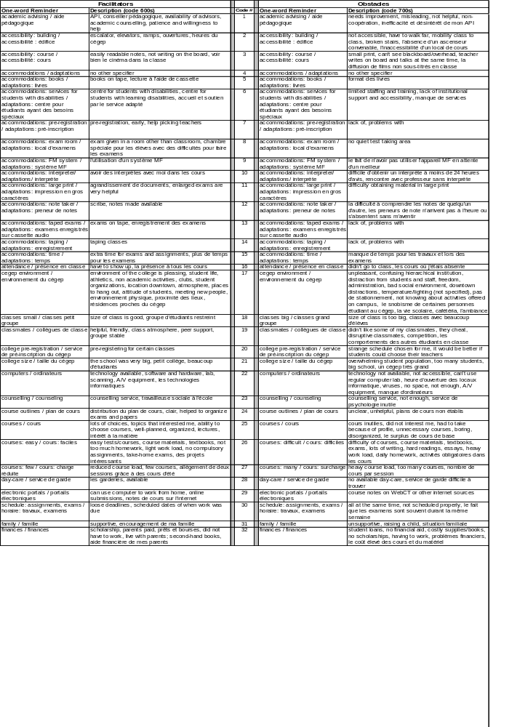

Table 6 continued

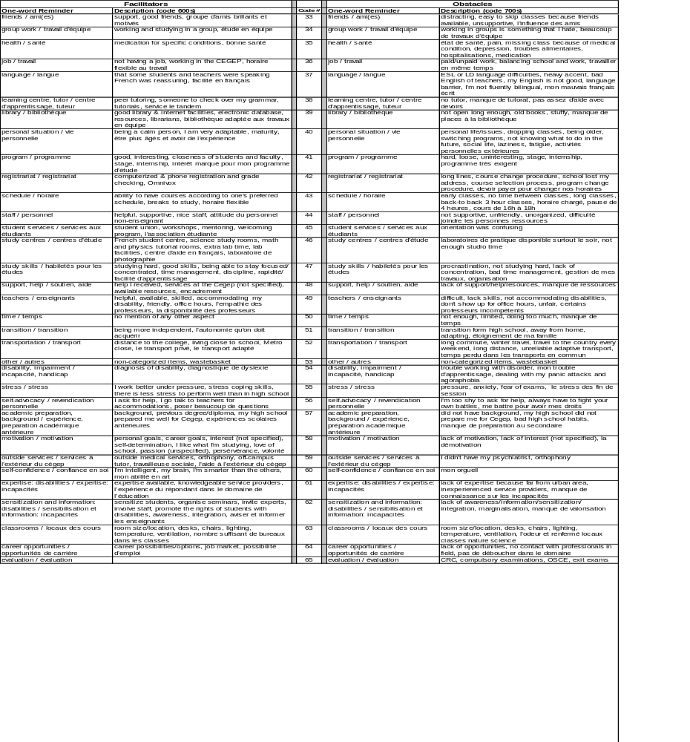

Table 7 shows the coding guidelines that were followed.

Table 7

Coding Guidelines

- Base your coding on the actual response without drawing inferences regarding what the participant "really meant." If they didn't explicitly say it, we can't code it.
- If a response fits into more than one category, use the most specific category without going beyond the actual response. For example, for the response, "The staff in the Center for Students with Disabilities was very helpful," categories 48, 44, and 6 all fit. However, category 6 is the most specific and should be used in this case.
- Use the most up-to-date version of the coding manual, as it will reflect decisions made during reliability meetings.
- Be as consistent as possible with your coding, even if this means double checking your coding or the manual before deciding on a code. The extra time and attention to detail is worth it!
- When coding facilitators and obstacles, don't automatically code a factor as an accommodation unless it is evident that this is a disability related accommodation. For example, if the student simply lists "pre-registration" as a facilitator, use code 20 unless there is evidence that the student was taking advantage of a pre-registration for students with disabilities specifically at his/her college (i.e., they mention other accommodations they receive).
- If the response mentions a cause and its effect, code the cause. For example, for "Lack of time stressed me out," code 50 instead of 55 because the lack of time is the cause of the stress.
- Use code 65 for assessment/evaluation methods outside the course (i.e., at the college, provincial or national level). Fairness/unfairness of marking should be coded as 49, because marking is done by the teacher. Ease/difficulty of exams/assignments should be coded as 26, because they are related to course difficulty.
- When more specific examples are given in parentheses, code the first example given in parentheses instead of the more general factor preceding the parentheses.
- Reliability checks should be done on 20 subjects out of every 100. If the inter-rater agreement does not reach at least 70%, all 100 responses must be recoded by both coders and any disagreement must be discussed until an agreement is reached.

Guidelines for the coding of recommendations for changes are presented in Table 8. The coding manual is included in Table 9.

Table 8

Guidelines For The Coding Of Recommendations For Changes

- In general, the same guidelines that applied to the coding of facilitators and obstacles apply to the coding of the changes as well.
- If the direction of the change is ambiguous or unclear from the response (e.g., "teachers"), then don't code it.
- If a response starts off by stating that no changes are needed, but then goes on to suggest one or more changes, ignore the first statement (i.e. don't code 39) and code only the recommendations.
- If the response reads "I didn't have any problems," "I have no idea/I don't know," or "It doesn't apply to me," don’t code it. Only if it reads, "I don't think anything has to be changed" should 39 be coded.
- If a response refers back to a previous response (i.e., obstacles), do not go back to read the response. Simply, do not code such responses, as doing so would involve inferring what solutions could be suggested to the previously stated obstacles.

Table 9

Recommendations For Changes Coding Manual
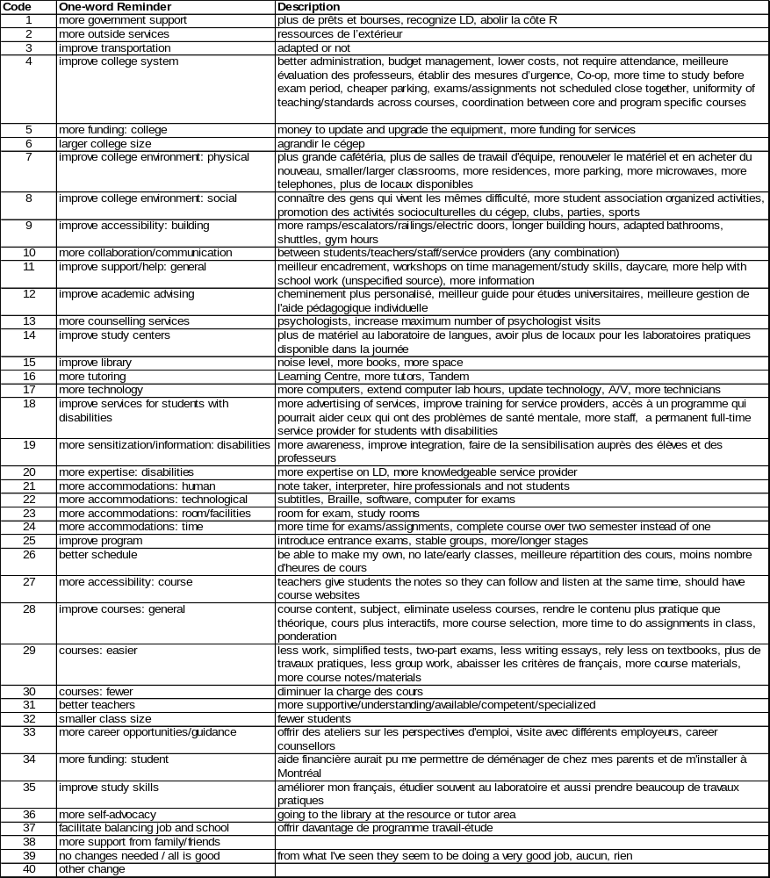

Disability service providers. All 57 participants answered the following 3 questions

- At your Cegep, what are the 3 most important factors that make Cegep studies easier for students with disabilities?
- At your Cegep, what are the 3 most important factors that make Cegep studies harder for students with disabilities?
- At your Cegep, what could be changed to make Cegep studies easier for students with disabilities?

Current students registered to receive disability related services from their Cegep. 297 of the 300 participants in this category answered the open-ended questions. It should be noted, however, that the Change question was phrased slightly differently on the English and French questionnaires, with the French questionnaires asking about "making Cegep studies easier for you" and the English questionnaires asking about "making Cegep studies easier for students with disabilities." Because of the difference in wording, we analyzed the Change questions separately for participants who responded on the English and on the French questionnaires.

- What are the 3 most important factors that have made your Cegep studies easier?
- What are the 3 most important factors that have made your Cegep studies harder?
- At your Cegep, what could be changed to make Cegep studies easier for you? (French questionnaire)
At your Cegep, what could be changed to make Cegep studies easier for students with disabilities? (English questionnaire)

Graduates. 1417 of the 1486 participants in this category answered the open-ended questions. It should be noted, however, that as in the case of current students, the Change question was phrased slightly differently on the English and French questionnaires, with the French questionnaires asking about "making Cegep studies easier for you" and the English questionnaires asking about "making Cegep studies easier for students with disabilities." Because of the difference in wording, we did not analyze the Change question for nondisabled graduates who completed the English questionnaire and we analyzed the Change questions separately for participants with disabilities who responded on the English and on the French questionnaires.

- What are the 3 most important factors that have made your Cegep studies easier?
- What are the 3 most important factors that have made your Cegep studies harder?
- At your Cegep, what could be changed to make Cegep studies easier for you? (French questionnaire)
At your Cegep, what could be changed to make Cegep studies easier for students with disabilities? (English questionnaire)

Results

Sample Characteristics

Campus based disability service providers. 24 campus based disability service providers were men and 33 were women. Disability service providers had worked a mean of 7 years providing services to students with disabilities (median = 5 years, range = 0.2-20 years). This activity constituted an average of 20% of their workload (median = 11%, range = 1%-100%). Results in Table 10 show that more than ¾ of the disability service providers had provided services to students with learning disabilities / ADD, a mobility impairment and a hearing impairment. Relatively few, however, less than ½, had provided services to students with psychological / psychiatric disabilities, medically related conditions, or a speech / communication impairment.

Table 10
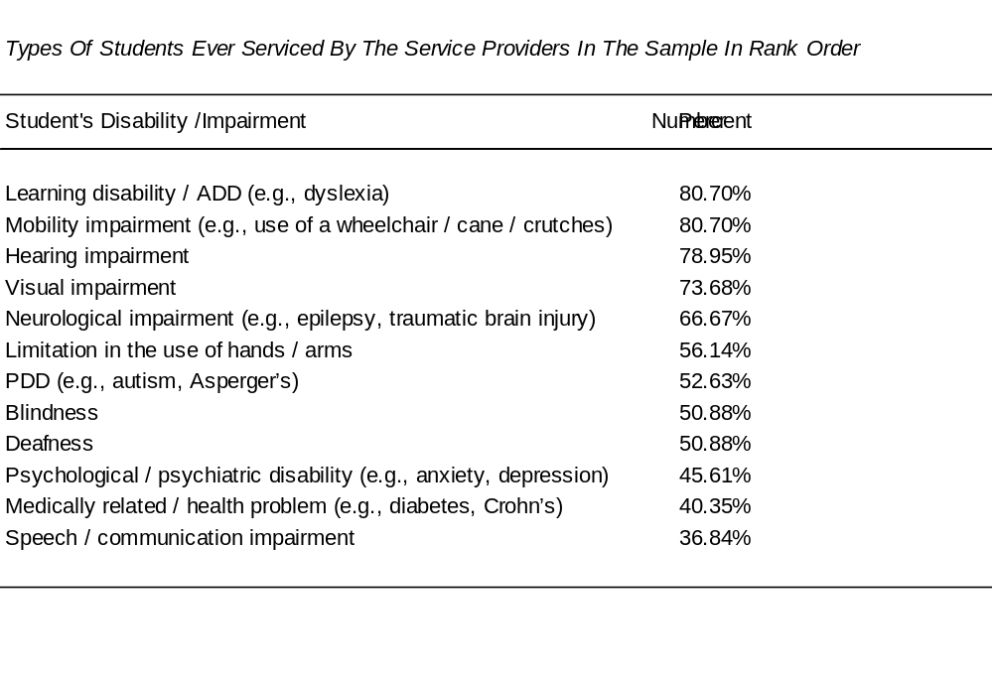

Current students with disabilities. The mean age of students was 21 (standard deviation = 5, minimum = 17, maximum = 50, median = 20). It can be seen in Table 11 that that by far the largest number of students, over 90%, were enrolled in a diploma program with approximately ½ of them enrolled in a pre-university program and the other half in a career/technical program. Approximately 6% were enrolled in an attestation program (AEC) or in another course of studies.

Table 11

College Programs of the Current Student Sample

Program | Number | %
Pre-university | 140 | 46.67%
Career / Technical | 141 | 47.00%
AEC | 5 | 1.67%
Other (e.g., continuing education) | 14 | 4.67%
Total | 300 | 100%

Students had a variety of impairments. It can be seen in Table 12 that the most common impairment/disability was a learning disability/attention deficit disorder, followed by mobility impairment, hearing impairment, medically related disability, and psychological disability.

Table 12

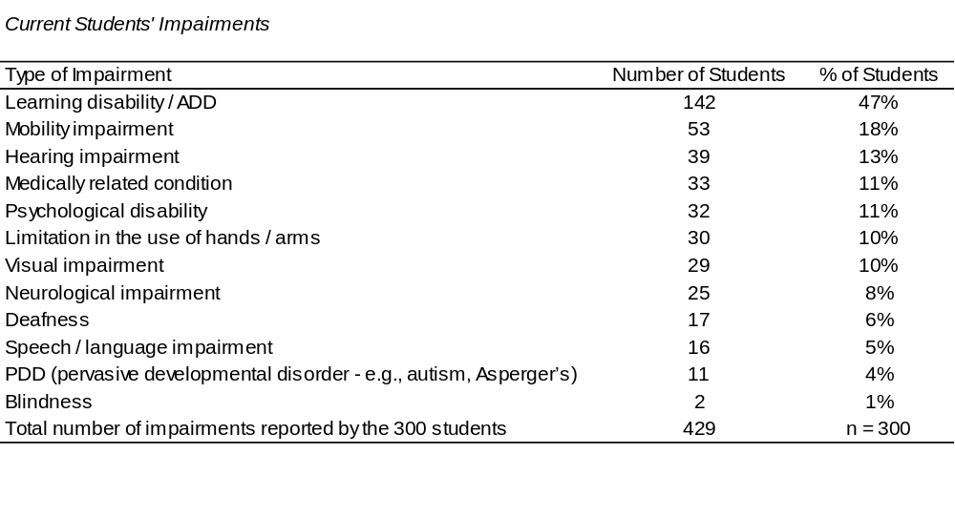

It is noteworthy that over 30% of students with disabilities had more than one impairment, with 9% having 3 or more impairments (see Table 13).

Table 13
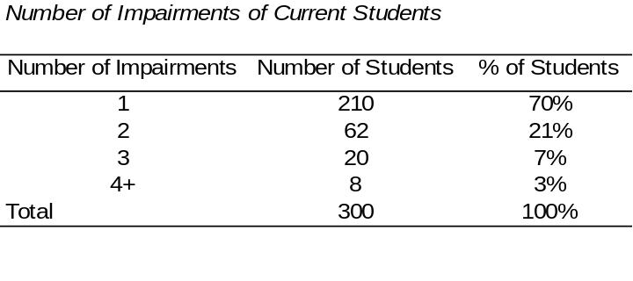

Graduates. Of the 1486 graduates responding to the survey, 182 (12.2%) reported a disability. Of the graduates with a disability 24 (13.2%) had registered with their Cegep disability service provider and 158 (86.8%) were unregistered. The remaining 1304 graduates reported no disability.

It can be seen in Table 14 that approximately half of the graduates with and without disabilities were enrolled in a pre-university program and half in a career/technical program. Overall, 57.0% of the graduates were enrolled in pre-university programs, 42.4% in career/technical programs and the remainder in some other form of study. There was no significant difference between the proportion of graduates in pre-university and career/technical programs when graduates with and without disabilities were compared, χ2 (1, N = 1473) = 2.85, p = 0.091.

Table 14

Program Breakdown Of Graduates With And Without Disabilities

Program | With A Disability | No Disability | Total
Pre-University  Career/Technical  Other  *Total | 91  (50.6%)  86  (47.8%)  3  (1.7%)  180 | 753  (57.8%)  543  (41.7%)  6  (0.5%)  1302 | 844  (57.0%)  629  (42.4%)  9  (0.6%)  1482
*4 graduates did not reply to the diploma type question.

We also examined the sector of enrollment of graduates with disabilities who had, and those who had not registered for disability related services from their Cegep. Figure 1 shows that similar proportions of all three groups of graduates were enrolled in pre-university and in career/technical programs.

Figure 1

Graduates' Programs
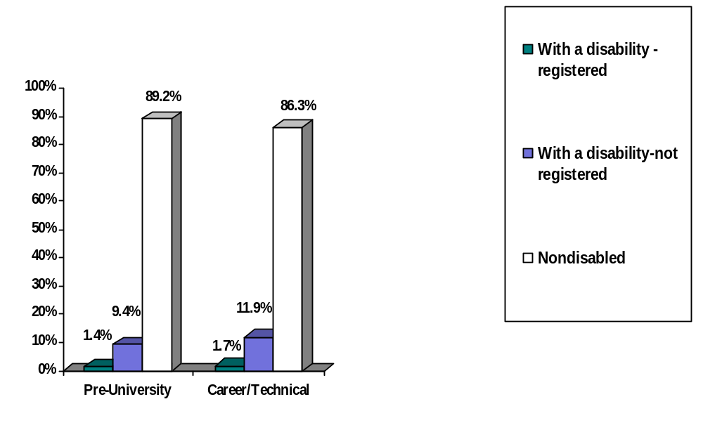

Graduates had a variety of impairments. One hundred and eighty-two graduates reported a total of 212 disabilities. The distribution of disability types for graduates who registered with their Cegep to receive disability related services and those who did not is shown in Table 15 below.

Table 15

Types of Disabilities Reported by Registered and Unregistered Graduates

Disabilities / Impairments | Registered |  | Unregistered |  | Total
Disabilities / Impairments | Number Of Graduates(N=24) | Percent In Disability Category | Number Of Graduates  (N=158) | Percent In Disability Category | Number Of Graduates  (N=182) | Percent In Disability Category
Blind | 0 | 0.0% | 0 | 0.0% | 0 | 0.0%
Visual Impairment | 0 | 0.0% | 57 | 31.3% | 57 | 26.9%
Deaf | 2 | 6.7% | 0 | 0.0% | 2 | 0.9%
Hearing Impairment | 2 | 6.7% | 6 | 3.3% | 8 | 3.8%
Speech/Communication impairment | 1 | 3.3% | 1 | 0.5% | 2 | 0.9%
Learning Disability | 10 | 33.3% | 15 | 8.2% | 25 | 11.8%
Mobility Impairment | 5 | 16.7% | 2 | 1.1% | 7 | 3.3%
Limitation use of hands | 3 | 10.0% | 0 | 0.0% | 3 | 1.4%
Medically Related | 4 | 13.3% | 46 | 25.3% | 50 | 23.6%
Psychological | 3 | 10.0% | 46 | 25.3% | 49 | 23.1%
Neurological | 0 | 0.0% | 2 | 1.1% | 2 | 0.9%
PDD | 0 | 0.0% | 2 | 1.1% | 2 | 0.9%
Other | 0 | 0.0% | 5 | 2.7% | 5 | 2.4%
Number of disabilities reported | 30 | 100% | 182 | 100% | 212 | 100%

To find out whether there was a significant difference in the distribution of disabilities between registered and unregistered graduates we conducted a chi-square test. Graduates' disabilities were grouped into seven disability categories to ensure that there were sufficient numbers in each category to perform a valid test. Table 16 shows the categories of disability used in the analysis.

Table 16

Grouping Graduates With Disabilities Into 7 Combined Disability Categories

 | Combined Disability Categories | Registered |  | Unregistered |  | Total
1  2  3  4  5  6  7 | Learning disability/ADD  Medical impairment  Psychological impairment  Visual impairment and blindness  Hearing impairment and Deafness  Multiple disabilities  Other (includes pervasive developmental disabilities, mobility impairment, limitation in use of hands or arms, neurological impairment, speech/communication impairment)  Total with disabilities | 8  33.3%  2  8.3%  2  8.3%  0  0.0%  4  16.7%  5  20.8%  3  12.5%  24  100% |  | 10  6.3%  31  19.6%  39  24.7%  47  29.7%  5  3.2%  19  12.0%  7  4.4%  158  100% |  | 18  9.9%  33  18.1%  41  22.5%  47  25.8%  9  4.9%  24  13.2%  10  5.5%  182  100%

A chi-square test showed that there was a significant difference in the distribution of disabilities between registered and unregistered graduates, χ2 (6, N = 182) = 37.81, p < 0.001. From Table 16 it can be seen that none of the registered graduates reported a visual impairment and that registered graduates were more likely to have a learning disability, a hearing impairment and multiple disabilities while unregistered graduates were more likely to have a visual, psychological or medical disability. The distribution of the numbers of disabilities reported by both groups is shown in Table 17 below.

Table 17

Numbers of Disabilities Reported by Registered and Unregistered Graduates With Disabilities

 | Registered |  | Not Registered |  | Total
Number of Disabilities | Number | % | Number | % | Number | %
One | 19 | 79.2% | 139 | 88.0% | 158 | 86.8%
Two | 4 | 16.7% | 16 | 10.1% | 20 | 11.0%
Three | 1 | 4.2% | 1 | 0.6% | 2 | 1.1%
Four  Total  Graduates with more than one disability | 0  24  5 | 0.0%  100%  20.8% | 2  158  19 | 1.3%  100%  12.0% | 2  182  24 | 1.1%  100.0%  13.2%

Enrollment: Proportion Of Students / Graduates Registered To Receive Disability Related Services

We obtained statistics about the number of students with disabilities registered to receive disability related services from the Cegep from 44 of the public Cegeps. This includes the 2 Cegeps that indicated that they currently had no students with disabilities. The question disability service providers were asked was, "Since the beginning of the 2004-2005 academic year, approximately how many students identified themselves to receive disability related services at your Cegep?" We also obtained "official figures" for the fall of 2004 provided by the 3 "centres d'accueil:" by the Service d'Aide à l'Intégration Des Élèves (SAIDE) at Cégep du Vieux Montréal (Fiset, 2004), by les Services adaptés du Cégep de Sainte-Foy (Juhel, 2004), and by Alice Havel of Dawson College (personal communication, 2005). These official figures represent the number of students for whom an individualized education plan (IIP) had been submitted and approved by the MELS and, thus, for whom disability related services were funded. To obtain total college enrollment statistics we consulted the web site of the MELS, which provides full time enrollment data for 2004 (Ministère de l'Éducation, du Loisir et du Sport, 2005a).

The data indicate that there were great discrepancies among Cegeps in the percentage of students with disabilities (range 0% to 3.34%). Summary data on student enrollments at participants' institutions and percentages of students with disabilities registered to receive disability related services, based on the 2 data sources (i.e., full time enrollments available for 2004 on the web site of the Ministère de l'Éducation, du Loisir et du Sport (2005a) and the Cegep based disability service providers) are available in Table 18. Overall, the findings show that the average total full time enrolment at the 44 participating Cegeps for 2004 was approximately 2906 (standard deviation = 1842, range = 559 to 7237). Information concerning the number of students with disabilities registered to receive disability related services according to the disability service providers show that the mean was 24 students per Cegep (median = 12, standard deviation = 19, range = 0 to 238). The mean percentage of students with disabilities registered to receive disability related services in a Cegep was 0.84% (i.e., approximately ¾ of 1%).

Table 18

Enrollment Data For 2004

44/48 Cegeps Were Reached | Total Enrollment  At The 44 Cegeps | Number Of Students Registered For Disability Related Services  (Fall 2004) | Number With Individualized Education Plans (PII)
Total N | 127 870 | 1069  % of 127 870 = (0.84%) | 391  % of 127 870 = (0.31%)  % of 1 069 = (37%)

It can be seen in Table 18 that of the 1069 students with disabilities registered to receive disability related services from their Cegep, only 391 had individualized education plans approved by the MELS (i.e., the Cegeps were funded for only 391 students - only 37% of those registered to receive services). The average number of students with disabilities for whom funding was provided by the MELS was 9 per Cegep (median = 5 per Cegep). Thus funding was provided by the MELS for only about a third of students who registered for services.

Changes from 1999 to 2004. To examine changes in the proportion of students with disabilities registered to receive services from their Cegep we compared the current data with data obtained in 1999, when we also asked disability service providers about the number of students registered to receive services (Fichten, Barile, Robillard, Fossey, Asuncion, Généreux, Judd, & Guimont, 2000). Numbers were available for 1999 and 2004 from the same 31 colleges: 27 French and 4 English Cegeps. Results of the comparison, presented in Table 19, show that there was some increase in the proportion of students with disabilities registered for disability related services (change from 0.75% to 0.94%). There was also a change in the proportion of students registered for disability related services from their Cegep for whom the MELS provided funding (from 32% to 36%). However, neither the comparison on the proportion of the student body that is registered to receive services, t(30) = .357, p=.724, or on the proportion of students registered to receive disability related services for whom the Cegep is funded by the MELS, t(28) = .966, p = .342, were significant. The proportion of the full time student body funded for disability related services by the MELS increased from 0.24% of the total full time student population to 0.34%; this is a significant change from 1999 to 2004, t(29) = 3.21, p = .003. This was a result of an increase in the number of students with disabilities who have an Individualized Educating Plan (IIP) coupled with a decline in overall Cegep enrollments.

Table 19

Number Of Cegep Students Registered For Disability Related Services At Their Cegep
Year | Total Enrollment  at the Same  31 Cegeps | Number of Students  Registered for Services | Number with  Individualized Education Plans (PII)
1999 | 105 153 | 787  % of 105 153 = (0.75%) | 252  % of 105 153 = (0.24%)  % of 787 = (32%)
2004 | 100 369 | 940  % of 100 369 = (0.94%) | 343  % of 100 369 = (0.34%)  % of 940 = (36%)

Open-Ended Data About Facilitators, Obstacles, And Things To Change

Current students with disabilities. It should be noted that students with different impairments may require either similar accommodations (e.g., extended time for exams) or disability specific accommodations (e.g., a sign language interpreter). Therefore, the percentage of responses that deal with accommodations in Figure 2 should be interpreted in this light. To provide perspective, we also calculated the number of participants who noted any type of disability related accommodation in response to both the facilitator and obstacle questions.

Facilitators. Results detailed in Figure 2 show that most students with disabilities indicated that disability related accommodations were among the most frequently noted facilitators. Indeed, 171 of the 297 current students who answered the open ended questions (i.e., 58%) noted at least 1 disability related accommodation as a facilitator.

Figure 2

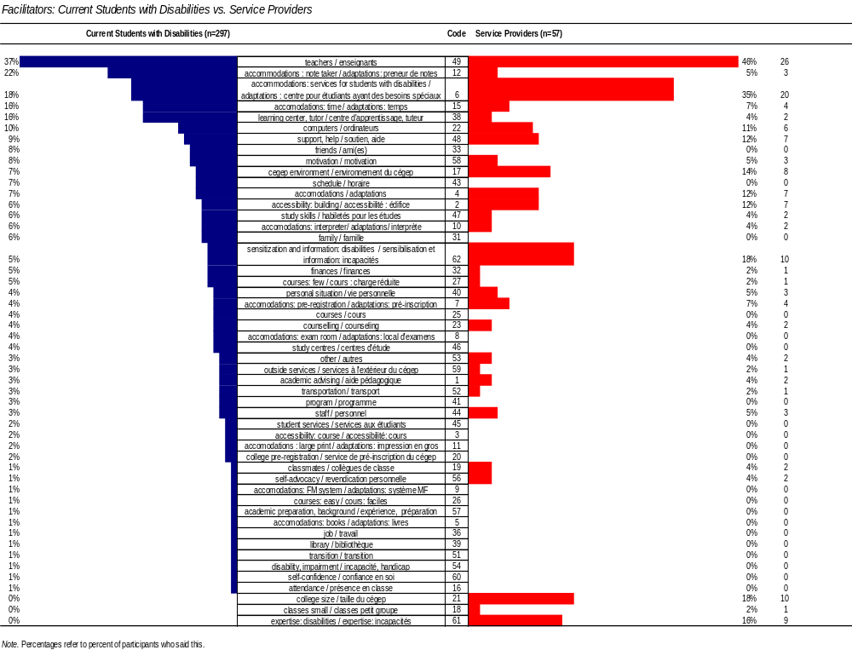

We decided that "important facilitators" were those that were noted by at least 5% of the participants who completed open-ended questions (i.e., at least 15 of the 297 participants). Important facilitators for students include: services for students with disabilities in general and specific disability related accommodations such as having a note taker or interpreter in class, extended time for exams and assignments, an accessible building, as well as Ministère de l'Éducation, du Loisir et du Sport and college policies which permit students with disabilities to take a reduced number of courses and still be considered "full time students." Sensitization and information about disabilities was also seen as a facilitator.
Approximately half of the important facilitators are not specifically disability related but are issues of concern to all students. These include: good teachers (this ranks in first place), the Cegep environment, tutors and learning centers (which assist with studying, writing, and exam taking skills and provide tutoring), the availability of computers and of support and help. Other factors that students indicated made their studies easier are the facilitating role of: friends and family, having a good schedule, students' financial situation, motivation and good study skills. These facilitators are best seen in Table 20 below, where items common to all students are boxed.

Table 20

Important Facilitators For Current Students with Disabilities In Rank Order

teachers: good 37%
accommodations: note taker 22%
accommodations: services for students with disabilities 18%
accommodations: time 16%
learning center, tutor 16%
computers 10%
support, help 9%
friends 8%
motivation 8%
schedule: good 7%
Cegep environment 7%
accommodations: in general 7%
study skills: good 6%
accessibility: building 6%
family 6%
accommodations: interpreter 6%
finances 5%
sensitization and information: disabilities 5%
courses: few 5%

Note. Common items to all students are boxed. Important facilitators are those that were noted by at least 15 of the 297 participants who completed open-ended questions (i.e., at least 5%).

Obstacles. The obstacles noted by current students with disabilities are detailed in Figure 3. Important obstacles are those that were noted by at least 15 of the 297 participants (i.e., at least 5%). This includes only one item that is disability specific: poor health. Indeed, when we collapsed all of the disability related items, results indicate that only 10 of the 297 participants (i.e., 3%) noted at least 1 disability related accommodation as an obstacle.

Figure 3
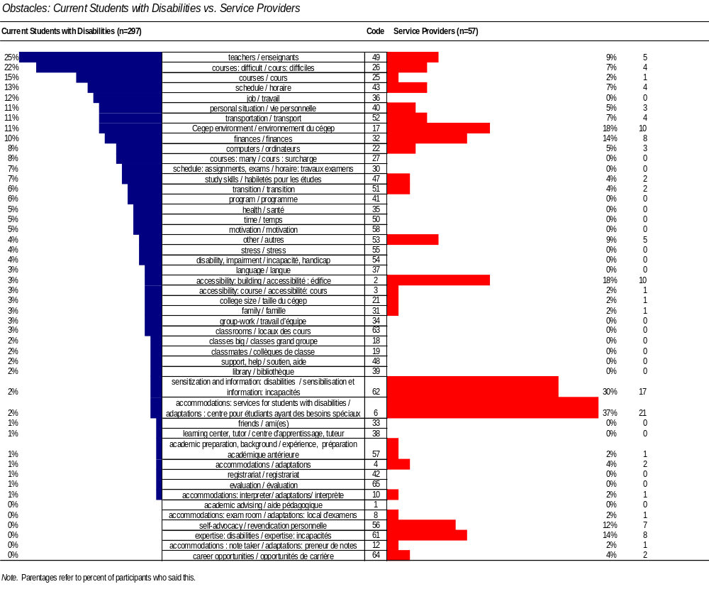

Other "important obstacles," shown in Table 21, include: bad teachers, hard courses, poor schedules, having to hold a job, students' personal situations in general, the Cegep environment, transportation issues, students' finances, lack of availability of computers, too many courses, poor study skills, bad exam and assignment schedules, transition related issues, demanding and boring programs, poor motivation, and insufficient time.

Table 21

Important Obstacles For Current Students With Disabilities In Rank Order of Popularity

teachers: bad 25%
courses: hard 22%
courses in general 15%
schedule: bad 13%
job 12%
personal situation bad 11%
Cegep environment 11%
transportation 11%
finances 10%
computers 8%
courses: too many 8%
study skills: poor 7%
schedule: assignments, exams (bad) 7%
transition 6%
program 6%
motivation 5%
health: poor 5%
time: insufficient 5%

Note. Common items to all students are boxed. Important obstacles are those that were noted by at least 15 of the 297 participants who completed open-ended questions (i.e., at least 5%).

Disability service providers. Scores of campus based disability service providers are also presented in Figures 2 and 3.

Facilitators. Results detailed in Figure 2 show that most campus based disability service providers also indicated that disability related accommodations were among the most important facilitators. This is particularly evident when we collapsed the data across all disability related accommodations: the findings show that 31 of the 57 campus based disability service providers (i.e., 54%) noted at least 1 disability related accommodation as a facilitator.

Important facilitators are those that were noted by at least 3 of the 57 participants (i.e., at least 5%). These include: services for students with disabilities in general and specific disability related accommodations such as having a note taker or interpreter in class, extended time for exams and assignments, good building accessibility, and the possibility of early pre-registration for students with disabilities. Sensitization / providing information about disabilities was also seen as an important facilitator. In addition, the campus based disability service provider's expertise and students' self-advocacy skills were also seen as important.

Approximately half of the important facilitators are not specifically disability related. These include: good teachers (this ranks in first place) the Cegep's small size and its overall environment, the availability of computers, counsellors, academic advising, support and help, helpful college staff, and the availability of tutors and learning centers (which assist with studying, writing, and exam taking skills and provide tutoring). Other factors that campus based disability service providers indicated made students' college studies easier are the facilitating role of: the student's classmates as well as students' motivation, study skills, and overall personal situation. These relationships are best seen in Table 22 below, where items common to all students are boxed.

Table 22

Important Facilitators For Campus Based Disability Service Providers In Rank Order of Popularity

teachers 46%
accommodations: services for students with disabilities 35%
sensitization and information: disabilities 18%
college size 18%
expertise: disabilities 16%
Cegep environment 14%
support, help 12%
accommodations: general 12%
accessibility: building 12%
computers 11%
accommodations: time 7%
accommodations: pre-registration 7%
accommodations : note taker 5%
motivation 5%
personal situation 5%
staff 5%
Note. Common items to both groups are boxed. Important facilitators are those that were noted by at least 3 of the 57 participants (i.e., at least 5%).

Obstacles. The obstacles noted by campus based disability service providers are detailed in Figure 3. Services for students with disabilities on campus ranked at the top of the list. In fact, the lack of available accommodations and/or poor accommodations were seen as impediments to student success. This is particularly evident when we collapsed the data across all disability related accommodations: the findings show that 24 of the 57 campus based disability service providers (i.e., 42%) noted at least 1 disability related accommodation as an obstacle.

Important obstacles are those that were noted by at least 3 of the 57 participants (i.e., at least 5%). Approximately ⅓ of these items are disability specific: the absence of appropriate services for students with disabilities, lack of sensitization and information dissemination on campus about disabilities, inaccessible buildings, lack of expertise of the part of the service provider about disabilities, and poor self-advocacy skills of students. Other important obstacles, shown in Table 23, include: bad teachers, hard courses, poor schedules, students' personal situations in general, the Cegep environment, transportation issues, the students' finances, and lack of availability of computers.

Table 23

Important Obstacles For Campus Based Disability Service Providers In Rank Order From Most to Least Important

accommodations: services for students with disabilities 37%
sensitization and information: disabilities 30%
Cegep environment 18%
accessibility: building 18%
finances 14%
expertise: disabilities 14%
self-advocacy 12%
teachers 9%
courses: difficult 7%
schedule 7%
transportation 7%
personal situation 5%
computers 5%

Note. Common items to both groups are boxed. Important facilitators are those that were noted by at least 3 of the 57 participants (i.e., at least 5%).

Comparing the views of students with disabilities and disability service providers. Table 24 provides a listing of facilitators and obstacles noted by at least 5% of students with disabilities and 5% of campus based disability service provider participants.

Facilitators. It can be seen in Table 24 that most important facilitators noted by students with disabilities were also noted by campus based disability service providers. Exceptions are as follows. Students noted that important facilitators for them were: friends, their schedule, their family, finances, and the possibility of taking fewer courses than is typical. Campus based disability service providers, on the other hand, indicated that a small college, the service provider being knowledgeable about disabilities, pre-registration for courses before other students register, helpful staff and classmates, and the availability of good counselling and academic advising for students were important facilitators, as were the student's personal situation and self-advocacy skills.

Obstacles. Table 24 also shows that most obstacles noted by campus based disability service providers were also noted by students with disabilities. A notable exception relates to disability related accommodations, which 42% of disability service providers saw as an obstacle, while Figure 3 shows that only 2% of students with disabilities did so. Other exceptions are as follows. Service providers noted that important obstacles included poor or few accommodations and services for students with disabilities, lack of information and sensitization about disabilities, disability service providers not having adequate knowledge about disabilities and accommodations, the building’s accessibility and students' poor self-advocacy skills. Students noted the following important obstacles that were not mentioned by service providers: too many courses and problems with their courses and programs of study in general, insufficient time, bad exam and assignment schedules, transition issues, having to hold a job, and poor motivation, study skills, and health.

Table 24

Commonalities Between Students With Disabilities And Campus Based Disability Service Providers In Rank Order Of Popularity

Facilitators: Students With Disabilities Facilitators: Disability Service Providers
teachers 46%
accommodations:
services for students with disabilities 35%
sensitization and information: disabilities 18%
college size 18%
expertise: disabilities 16%
Cegep environment 14%
support, help 12%
accommodations: in general 12%
accessibility: building 12%
computers 11%
accommodations: time 7%
accommodations: pre-registration 7%
accommodations: note taker 5%
motivation 5%
personal situation 5%
staff 5%

teachers 37%
accommodations : note taker 22%
accommodations:
services for students with disabilities 18%
accommodations: time 16%
learning center, tutor 16%
computers 10%
support, help 9%
friends 8%
motivation 8%
schedule 7%
Cegep environment 7%
accommodations: in general 7%
study skills 6%
accessibility: building 6%
family 6%
accommodations: interpreter 6%
finances 5%
sensitization and information: disabilities 5%
courses: few 5%

Obstacles: Students With Disabilities Obstacles: Disability Service Providers

accommodations: services for students with disabilities 37%
sensitization and information: disabilities 30%
Cegep environment 18%
accessibility: building 18%
finances 14%
expertise: disabilities 14%
self-advocacy 12%
teachers 9%
courses: difficult 7%
schedule 7%
transportation 7%
personal situation 5%
computers 5%

teachers 25%
courses: difficult 22%
courses 15%
schedule 13%
job 12%
personal situation 11%
Cegep environment 11%
transportation 11%
finances 10%
computers 8%
courses: too many 8%
study skills 7%
schedule: assignments, exams 7%
transition 6%
program 6%
motivation 5%
health 5%
time 5%

Note. Items noted by both groups are boxed. Important facilitators and obstacles are those that were noted by at least 5% of participants.

Students' Personal Situation, Cegep Environment, and Government and Community Supports and Services based Facilitators and Obstacles. We also examined the relative frequencies of current students' and campus based disability service providers' responses that fell into each of these categories and evaluated the hypothesis that campus based disability service providers would provide more "personal" (i.e., Student's Personal Situation) comments about both facilitators and obstacles while students would make relatively more "environmental" comments (i.e., Cegep Environment, Government and Government and Community Supports and Services). The codes in the three grouping can be seen in Table 25.

Table 25
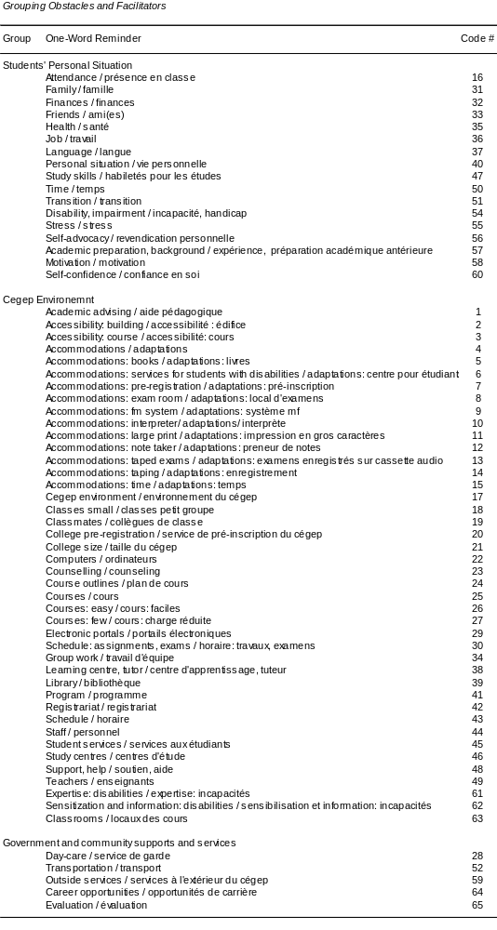

To test this hypothesis we used chi-square to examine the relative frequencies of Student's Personal Situation and Cegep Environment codes by students with disabilities and by campus based disability service providers, separately for Facilitators and Obstacles. We did the same for Student's Personal Situation and Government and Community Supports and Services frequencies. None of the chi-square tests was significant. It can be seen in Tables 26 and 27 that, not surprisingly, both students and service providers noted substantially more (approximately ¾) Cegep Environment than Student's Personal Situation Facilitators and Obstacles. Both groups also noted more (approximately ¾) Student's Personal Situation than Government and Community Supports and Services facilitators and obstacles.

Table 26
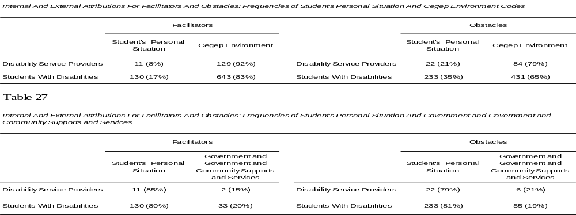_______________________________________________________________________________________

We also compared the relative frequencies of Facilitators and Obstacles in each of the Student's Personal Situation, Cegep Environment, and Government and Community Supports and Services categories of students with disabilities and service providers. None of the chi-square tests was significant. The frequencies in Table 28 show that both students and service providers indicated substantially more (approximately ⅔) Cegep Environment based Facilitators than Obstacles and that they indicated more (approximately ⅔) Student's Personal Situation and Government and Community Supports and Services Obstacles than Facilitators.

Table 28
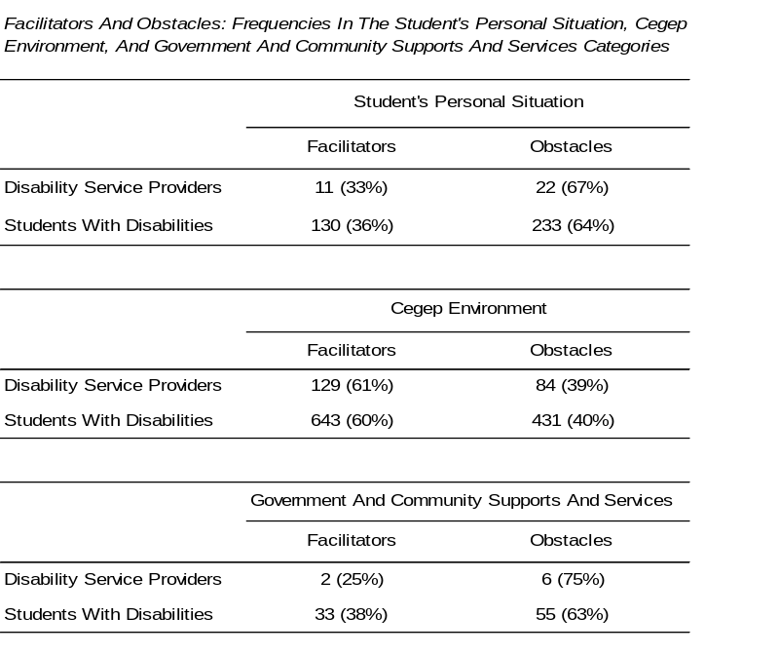

Commonalities between obstacles and facilitators. Some topics figured prominently as both an obstacle as well as a facilitator. These can best be seen in Figure 4.

Current students with disabilities. For example, it can be seen in Figure 4 and in Table 29 that teachers, the availability of computers, the Cegep environment, students' schedules, and the course load could be either facilitators or obstacles, depending on the circumstances. The same is true of students' motivation, study skills, and finances.

Figure 4

Commonalities Between Facilitators and Obstacles: Current Students with Disabilities
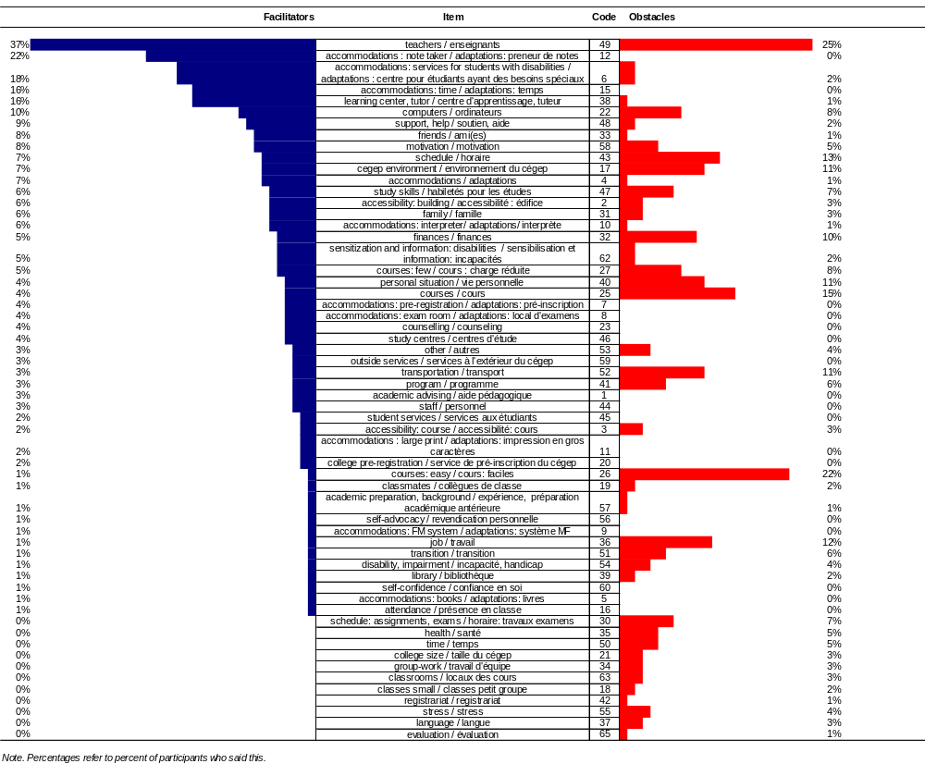

Table 29

Commonalities Between Important Obstacles and Facilitators: Current Students With Disabilities

Facilitators: Students With Disabilities Obstacles: Students With Disabilities
teachers 25%
courses: hard 22%
courses: general 15%
schedule 13%
job 12%
personal situation 11%
Cegep environment 11%
transportation 11%
finances 10%
computers 8%
courses: few-many 8%
study skills 7%
schedule: assignments, exams 7%
transition 6%
program 6%
motivation 5%
health 5%
time inadequate 5%

teachers 37%
accommodations : note taker 22%
accommodations:
services for students with disabilities 18%
accommodations: time 16%
learning center, tutor 16%
computers 10%
support, help 9%
friends 8%
motivation 8%
schedule 7%
Cegep environment 7%
accommodations: general 7%
study skills 6%
accessibility: building 6%
family 6%
accommodations: interpreter 6%
finances 5%
sensitization and information: disabilities 5%
courses: few-many 5%

Note. Boxed items are common to facilitators and obstacles. Important facilitators and obstacles are those that were noted by at least 5% of participants.

Campus based disability service providers. The same was true for service providers. For example, it can be seen in Figure 5 and Table 30 that availability and quality of disability related services, the accessibility of the building, the overall Cegep environment, how knowledgeable the campus based disability service provider is about disability and accommodations, and sensitization and information about disabilities were common to facilitators and obstacles. The same was true of teachers, the availability of computers, and students' personal situations.

Figure 5

Commonalities Between Facilitators and Obstacles: Campus Based Disability Service Providers

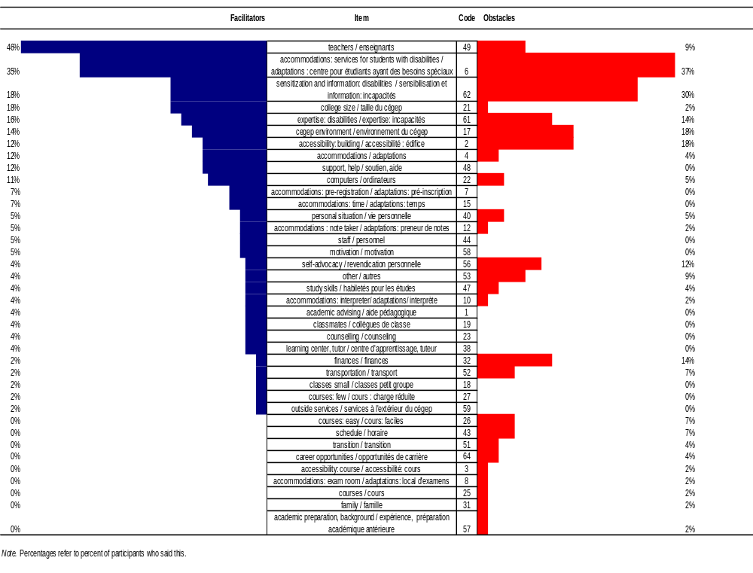

Table 30

Commonalities Between Important Obstacles And Facilitators: Campus Based Disability Service Providers

Facilitators: Disability Service Providers Obstacles: Disability Service Providers
accommodations: services for students with disabilities 37%
sensitization and information: disabilities 30%
Cegep environment 18%
accessibility: building 18%
expertise: disabilities 14%
finances 14%
self-advocacy 12%
teachers 9%
transportation 7%
courses: easy-hard 7%
schedule 7%
computers 5%
personal situation 5%

teachers | 46%
accommodations: services for students with disabilities | 35%
sensitization and information: disabilities | 18%
college size | 18%
expertise: disabilities | 16%
Cegep environment | 14%
accessibility: building | 12%
accommodations: general | 12%
support, help | 12%
computers | 11%
accommodation: pre-registration | 7%
accommodation: time | 7%
personal situation | 5%
accommodation: note taker | 5%
staff | 5%
motivation | 5%

Note. Boxed items are common to facilitators and obstacles. Important facilitators and obstacles are those that were noted by at least 5% of participants.

Graduates with and without disabilities. It should be noted that graduates with different impairments may have required either similar accommodations (e.g., extended time for exams) or disability specific accommodations (e.g., a sign language interpreter). Therefore, the percentage of responses that deal with accommodations should be interpreted in this light.

Facilitators. It can be seen in Figure 6 that graduates with and without disabilities noted virtually all of the same important facilitators (i.e., noted by at least 5% of participants). There are only three exceptions: graduates with disabilities indicated that their classmates and the services for students with disabilities were important facilitators while nondisabled graduates noted that their academic preparation was an important facilitator.

Figure 6
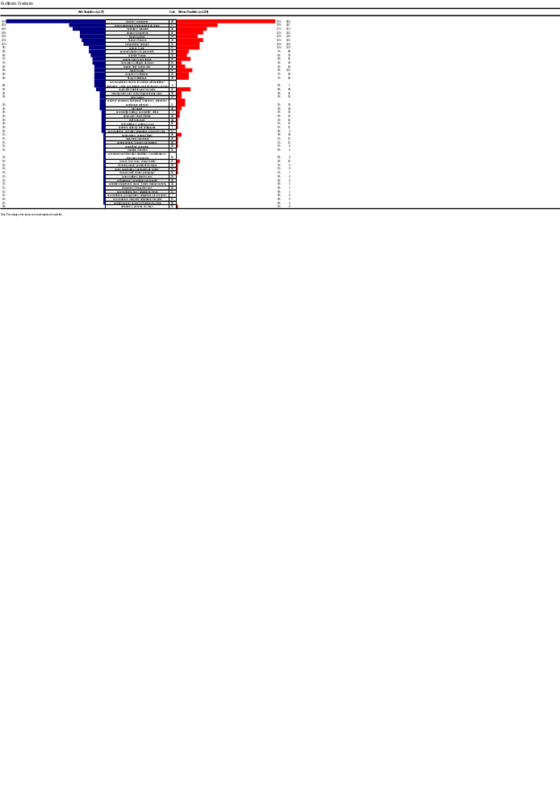

Obstacles. Similarly, it can be seen in Figure 7 that most important obstacles are also shared (i.e., noted by at least 5% of participants). Exceptions are that graduates with disabilities noted that their family posed an important obstacle along with poor motivation and the impact of their disability/impairment. Slightly more nondisabled graduates, on the other hand, noted that inadequate availability of computers and their academic schedules posed problems.

Figure 7
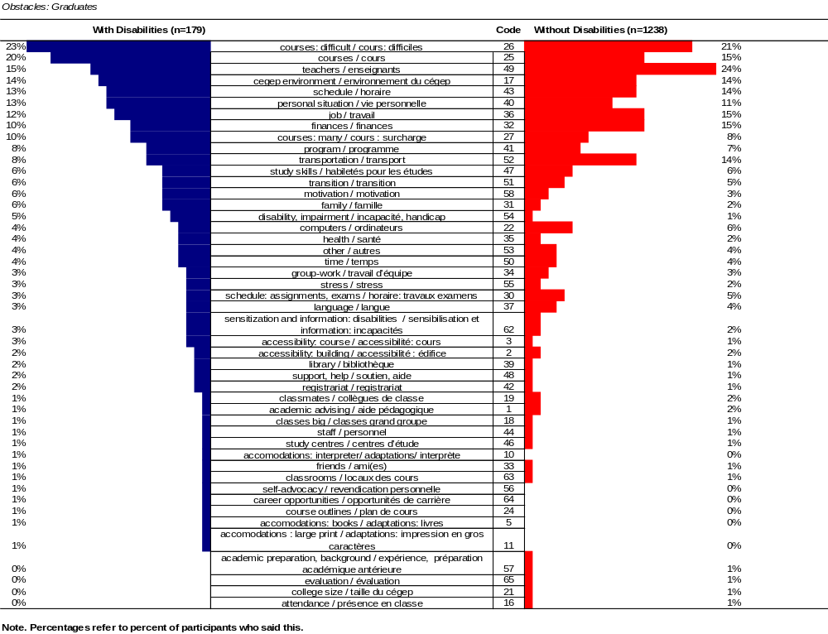

Graduates with disabilities who are, and who are not registered to receive disability related services. It can be seen in Figures 8 and 9 that there were many dissimilarities between these two groups.

Facilitators. Figure 8 shows that 43% of the 23 graduates registered to receive disability related services noted that this service was a facilitator, making this the second most popular option of this group. It is not surprising that students not registered for disability related services did not mention this.

Figure 8

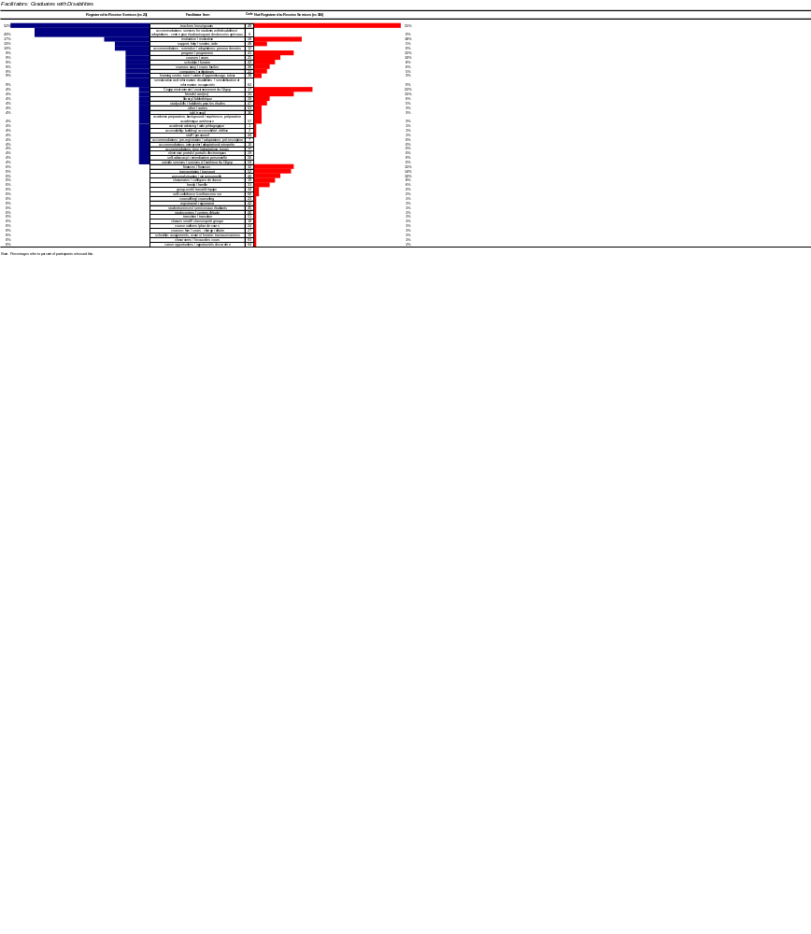

It can be seen in Table 31 that while there were many similarities between the two groups, there were also important differences. In particular, registered graduates noted that disability related accommodations were important for them while those not registered noted other types of facilitators, such as the Cegep environment, their classmates, friends, family, finances, study skills, and personal situation in general as well as good transportation and library facilities.

Table 31

Commonalities Between Important Facilitators: Graduates Registered And Not Registered For Disability Related Services

Graduates Registered For Disability Related Services Graduates Not Registered For Disability Related Services

teachers 55%
Cegep environment 22%
motivation 18%
friends 15%
program 15%
finances 15%
transportation 14%
personal situation 10%
courses 10%
schedule 8%
classmates 8%
courses: easy 6%
family 6%
library 6%
support, help 5%
computers 5%
study skills 5%

teachers 52%
accommodations:
services for students with disabilities 43%
motivation 17%
support, help 13%
accommodations : note taker 13%
program 9%
courses: general 9%
schedule 9%
courses: easy 9%
computers 9%
learning center, tutor 9%
sensitization and information: disabilities 9%

Note. Boxed items are common to both groups. Important facilitators and obstacles are those that were noted by at least 5% of participants.

Obstacles. Figure 9 presents the obstacles noted by graduates with disabilities who were, and who were not registered to receive disability related services. Here it can be seen that registered graduates were much more likely to indicate that their disability and health were obstacles and that non-registered graduates were more likely to see transportation as problematic. It is noteworthy that none of the registered graduates indicated that a disability related accommodation posed an obstacle.

Figure 9

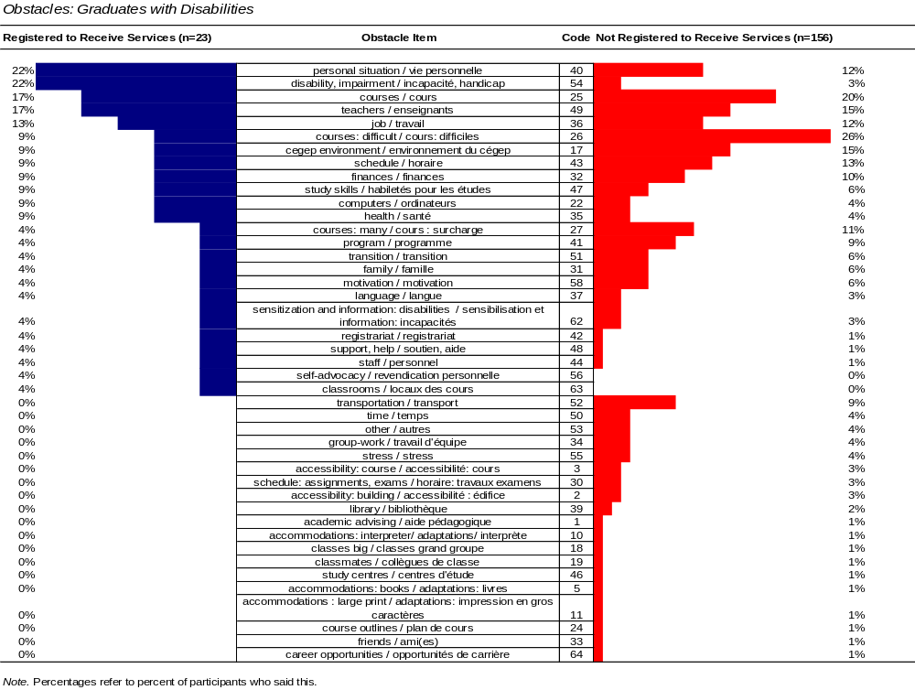

It can be seen in Table 32 that registered graduates with disabilities were likely to see their disability/impairment, their health, and poor access to computers as important obstacles while graduates with disabilities who did not register did not note these as obstacles. They did, however, note that their course load and program of studies posed obstacles along with transition issues, transportation problems, their family situations and a low level of motivation.

Table 32

Commonalities Between Important Obstacles: Graduates Registered And Not Registered For Disability Related Services

Graduates Registered For Disability Related Services Graduates Not Registered For Disability Related Services

courses: difficult 26%
courses: general 20%
teachers 15%
Cegep environment 15%
schedule 13%
job 12%
personal situation 12%
courses: many 11%
finances 10%
program 9%
transportation 9%
transition 6%
study skills 6%
family 6%
motivation 6%

personal situation 22%
disability, impairment 22%
courses: general 17%
teachers 17%
job 13%
courses: difficult 9%
Cegep environment 9%
schedule 9%
finances 9%
study skills 9%
computers 9%
health 9%

Note. Boxed items are common to both groups. Important facilitators and obstacles are those that were noted by at least 5% of participants.

Recommendations for changes. The questions asked on French and English versions of the questionnaire were slightly different. Before combining the results we examined the responses of participants who were asked different questions.

Current students with disabilities and campus based disability service providers. Responses of students with disabilities who were asked the two different questions are presented in Figure 10. Visual examination revealed that changes suggested by current students responding to the two slightly different questions were similar enough to combine. Therefore, the comparison of the recommendations made by all current students with disabilities and by campus based disability service providers is presented in Figure 11.

Figure 10
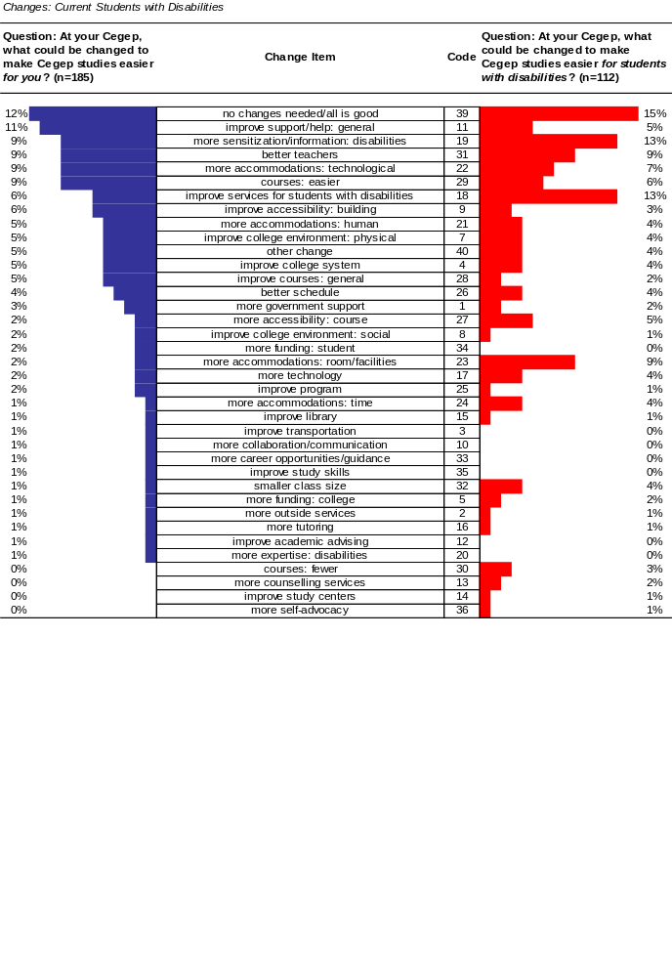

Note. Percentages refer to the percent of participants who said this.

Figure 11

Recommendations Made By All Current Students With Disabilities And By Campus Based Disability Service Providers
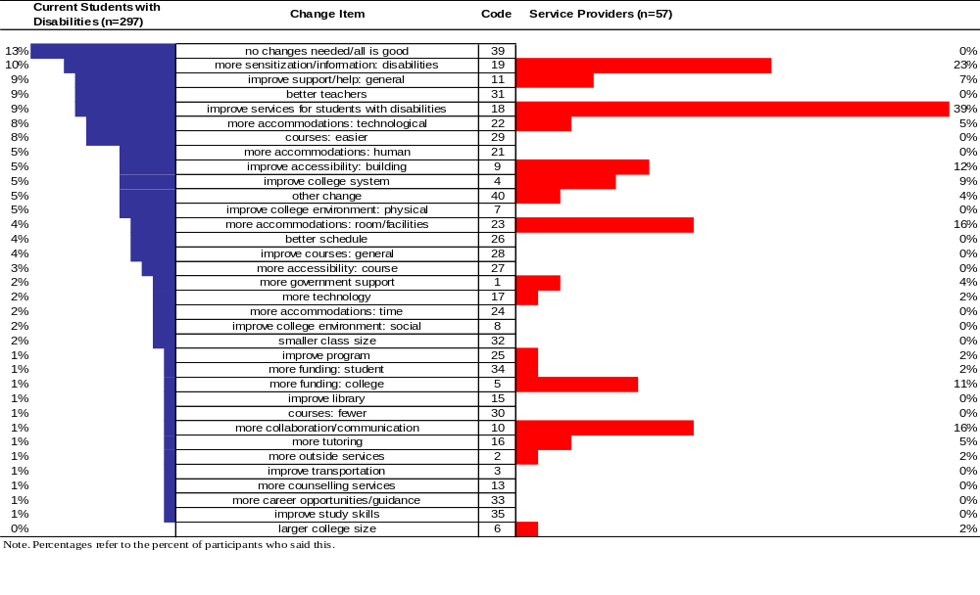

It can be seen in Figure 11 that, 13% of students with disabilities felt that things were reasonably good and that no changes were needed whereas this response not given by any of the service providers. Of high priority to both students with disabilities and disability service providers was the need for sensitizing and informing others about disabilities. Other changes that were suggested frequently by both groups were improving general support and help, improving services for students with disabilities, including providing better access to computer technologies, improving building accessibility and the college system as a whole. Disability service providers were far more likely to suggest changes involving their services and accessibility of classrooms and facilities than were students with disabilities. Promoting collaboration and communication between staff, teachers and students, increased funding for their services, and better availability of tutoring were also frequent suggestions among disability service providers. Students, but not campus based disability service providers, also wanted easier courses, better teachers, more human assistance, and improvement of the Cegep's facilities in general.

Graduates. Because we wanted to compare the responses of graduates with and without disabilities from the same institutions we used data from only those graduates who answered the identical question: "At your Cegep, what could be changed to make Cegep studies easier for you?" Figure 12 presents the results.

Figure 12

Recommendations Made By Graduates With And Without Disabilities
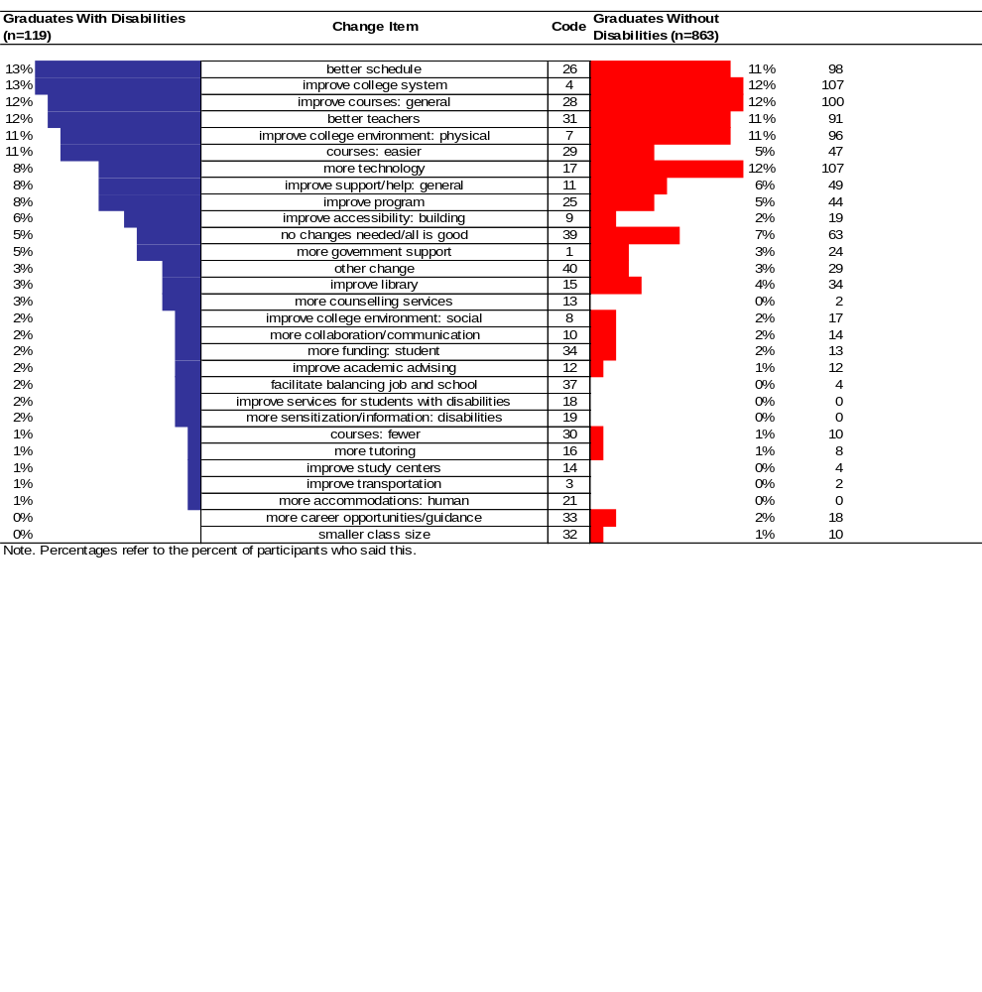

Changes suggested by graduates with and without disabilities were very similar and were generally aimed at the Cegep in general. Of greatest importance to both groups were better schedules, improving the college system, improving programs and courses in general, having better teachers, more available computer technologies, support and help as well as improvements to the physical environment of the college. A slightly larger proportion of graduates with disabilities suggested the need for easier courses, better building accessibility and more government support.

Cegep Experience Questionnaire: Refining the CEQ - Psychometric Analyses

Two kinds of reliability were evaluated on data from current students with disabilities: temporal stability and internal consistency. Temporal stability was evaluated by correlating test-retest scores (item-by-item, 3 Subscales, Index of Difficulty). Internal consistency of each of the 3 Subscales was evaluated using Cronbach's alpha for current students with disabilities and for graduates with and without disabilities.

Students made ratings on the 32 items of the Cegep Experience Questionnaire using a 6-point Likert-type scale (1 = much harder, 6 = much easier). We grouped the 32 items based on face validity into three PPH model based conceptual subscales and an overall Index of Difficutly (IDF):

- Students' Personal Situation (9 items including 1 that is applicable to students/graduates with disabilities only)
- Cegep Environment (13 items including 1 that is applicable to students/graduates with disabilities only)
- Government and Community Supports and Services (9 items including 4 that are applicable to students/graduates with disabilities only)
- Index of Difficulty (IDF) (25 items are common to students with and without disabilities, 6 are applicable only to students/graduates with disabilities).

To be consistent with the goals of providing an instrument that can be used on an item-by-item basis as well as having subscales, we used the single items, the 3 Subscales, and the total Index of Difficulty (IDF) in the analyses.

Two versions of the Index of Difficulty (IDF) and of the Subscale scores were calculated: one set includes only those items which are applicable to both students and graduates with and without disabilities. These are best used when comparing scores of students or graduates with and without disabilities. A second set was calculated that includes items that are disability specific as well. This set of scores is best used in analyses dealing only with students or graduates with disabilities.

Although most of the validation of this instrument was carried out in a previous investigation (Fichten, Jorgensen, Havel, & Barile, 2005) we also carried an additional test of validity by correlating Subscale and Index of Difficulty scores.

Temporal stability: test-retest reliability. To determine temporal stability of items we performed Pearson product-moment correlations on the test-retest questionnaire scores of current students with disabilities.

Item-by-item evaluation. Data from current students were used to examine the test-retest results for each of the 32 items. Results presented in Table 33 show that all correlation coefficients are of moderate to large size and highly significant. Moreover, of the 32 paired t-tests which compared Time 1 and Time 2 (i.e., test-retest) scores, only one was significant before a Bonferroni adjustment to the alpha level was made. After the Bonferroni adjustment, none remained significant.
Table 33
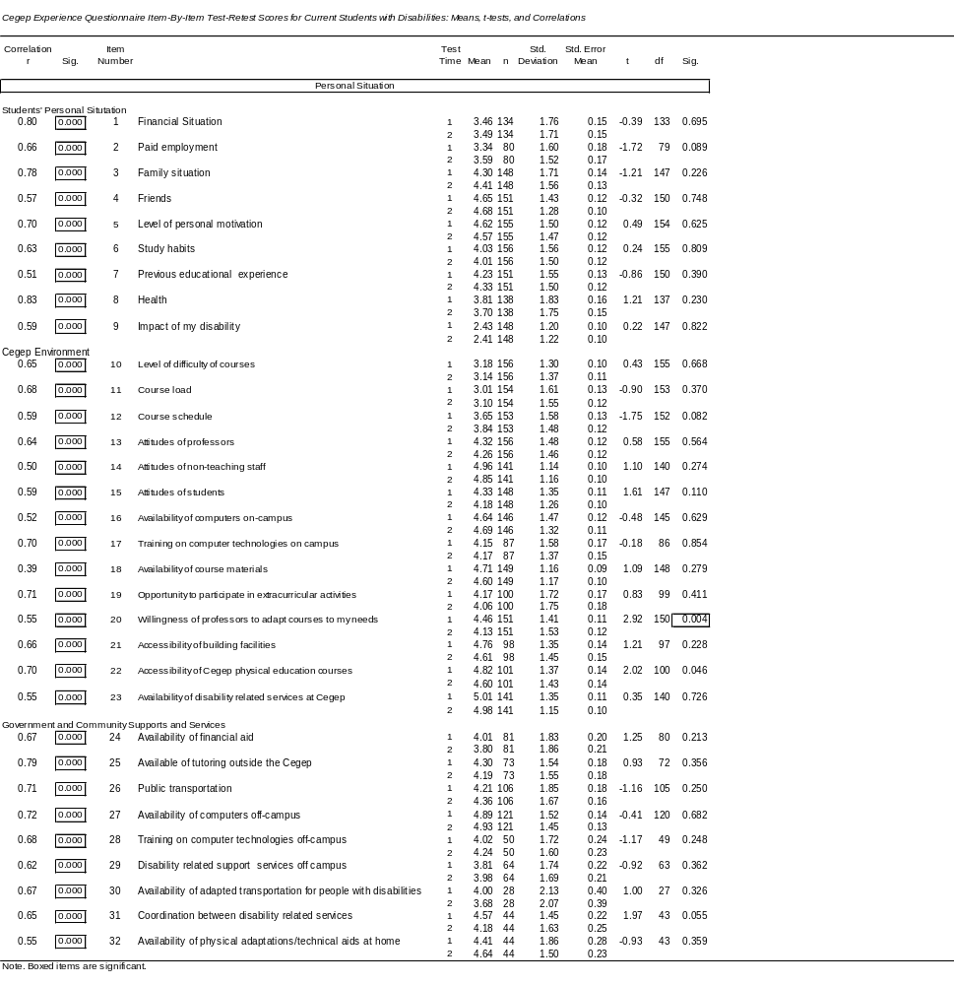
Subscale scores. The three Subscales that are comprised of Cegep Experience Questionnaire items are: Students' Personal Situation, Cegep Environment, and Government and Community Supports and Services. Items included in the Subscales are indicated in Table 34 below (boxed items are part of the subscales for students/graduates with disabilities only). Similarly, although items from all three Subscales are included in the Index of Difficulty (IDF), boxed items are part of the Index of Difficulty for students and graduates with disabilities only.

Table 34
Items Comprising the Subscales and Index of Difficulty (IDF)

Students' Personal Situation
1 | Financial situation
2 | Paid employment
3 | Family situation
4 | Friends
5 | Level of personal motivation
6 | Study habits
7 | Previous educational experience
8 | Health
9 | Impact of my disability
Cegep Environment
10 | Level of difficulty of courses
11 | Course load
12 | Course schedule
13 | Attitudes of professors
14 | Attitudes of non-teaching staff
15 | Attitudes of students
16 | Availability of computers on campus
17 | Training on computer technologies on campus
18 | Availability of course materials
19 | Opportunity to participate in extracurricular activities
20 | Willingness of professors to adapt courses to my needs
21 | Accessibility of building facilities
22 | Accessibility of Cegep physical education courses
23 | Availability of disability related services at the Cegep
Government and Community Supports and Services
24 | Availability of financial aid
25 | Availability of tutoring outside the Cegep
26 | Public transportation
27 | Availability of computers off-campus
28 | Training on computer technologies off-campus
29 | Disability related support services off-campus
30 | Availability of adapted transportation for people with disabilities
31 | Coordination between disability related services
32 | Availability of physical adaptations/technical aids at home

Note. Boxed items are part of the Subscales for students/graduates with disabilities only.

Results presented in Table 35 show a significant difference between the two testing times for the Cegep Environment Subscale only. After a Bonferroni adjustment to the alpha level, this item was no longer significant. All test-retest Pearson product-moment coefficients are moderate to large and highly significant, indicating acceptable temporal stability for the Subscales and Index of Difficulty both for scores including and excluding disability related items.
Table 35
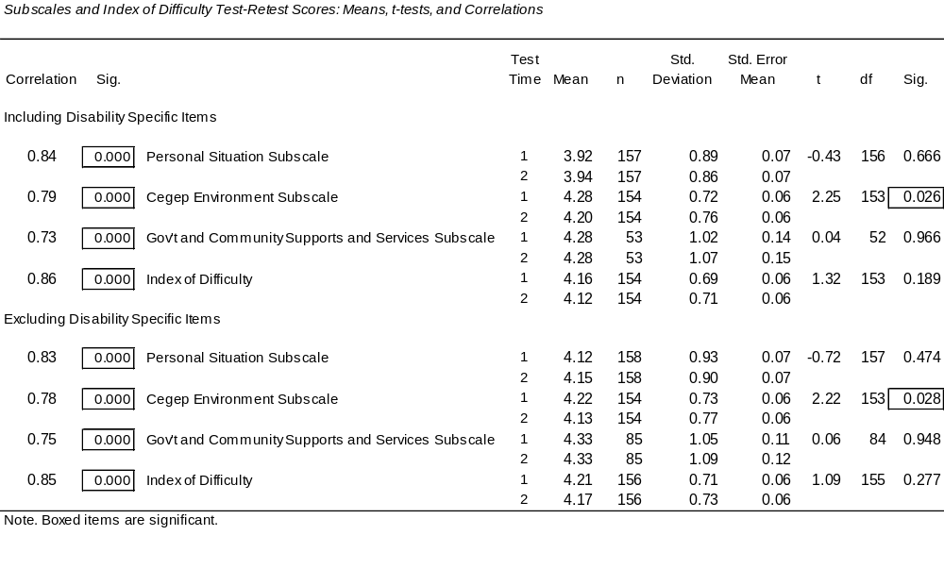

Internal consistency reliability: Cegep Experience Questionnaire Subscale and Index of Difficulty scores. We evaluated internal consistency both for current students with disabilities as well as for graduates with and without disabilities. Cronbach’s alpha coefficients reported in Table 36 indicate that the internal consistency of the 3 Subscales are acceptable and that most alpha values exceed .700, with the lowest being .584. Subscale scores and Index of Difficulty scores were calculated both including and excluding the disability specific items.
Table 36
Internal Consistency of Subscales: Cronbach's Alpha
Subscales | Current Students With Disabilities |  | Graduates  No Disabilities | Graduates With Disabilities
Subscales | n | Alpha | n Alpha | n | Alpha
Only items common to those with and without disabilities included: 26 items
Students' Personal Situation | 126 | .716 | 666 .637 | 96 | .598
Cegep Environment | 94 | .757 | 432 .762 | 51 | .830
Government and Community Supports and Services | 45 | .756 | 108 .659 | 15 | .584
Disability specific items included: 32 items
Students' Personal Situation | 119 | .737 |  | 47 | .719
Cegep Subscale | 92 | .774 |  | 21 | .895
Government and Community Supports and Services | 20 | .891 |  | ---- | ----
Relationships Among Cegep Experience Questionnaire Subscales: Validity

Pearson product–moment correlation coefficients for current students with disabilities presented in Table 37 indicate modest significant correlations among Subscales and with Index of Difficulty scores when the scores on the Subscale in question are excluded. The correlations are very high and significant between Subscales and Index of Difficulty scores when the Subscale in question is included. This is true when disability specific items are as well as when they are not part of the analyses.

Table 37
Correlations Among Subscale and Index of Difficulty Scores for Current Students with Disabilities

 |  |  |  |  |  |  |  | Personal Subscale |  |  | Cegep Subscale |  |  | Community Subscale |  |  |  |  | Index of Difficulty
Excluding Disability Specific Items
Students' Personal Situation |  |  |  |  | Pearson r
 |  |  |  |  | Significance
 |  |  |  |  | N
Cegep Environment |  |  |  |  | Pearson r |  |  |  | 0.431
 |  |  |  |  | Significance |  |  |  | 0.000
 |  |  |  |  | N |  |  |  | 289
Government and Community Supports and Services |  |  |  |  | Pearson r |  |  |  | 0.341 |  |  | 0.529
 |  |  |  |  | Significance |  |  |  | 0.000 |  |  | 0.000
 |  |  |  |  | N |  |  |  | 247 |  |  | 245
Index of Difficulty (relevant Subscale included) |  |  |  |  | Pearson r |  |  |  | 0.776 |  |  | 0.872 |  |  |  | 0.694
 |  |  |  |  | Significance |  |  |  | 0.000 |  |  | 0.000 |  |  |  | 0.000
 |  |  |  |  | N |  |  |  | 293 |  |  | 291 |  |  |  | 248
Index of Difficulty (relevant Subscale excluded) |  |  |  |  | Pearson r |  |  |  | 0.453 |  |  | 0.533 |  |  |  | 0.518
 |  |  |  |  | Significance |  |  |  | 0.000 |  |  | 0.000 |  |  |  | 0.000
 |  |  |  |  | N |  |  |  | 249 |  |  | 285 |  |  |  | 248
Including Disability Specific Items
Students' Personal Situation |  |  |  |  | Pearson r
 |  |  |  |  | Significance
 |  |  |  |  | N
Cegep Environment |  |  |  |  | Pearson r |  |  |  | 0.444
 |  |  |  |  | Significance |  |  |  | 0.000
 |  |  |  |  | N |  |  |  | 286
Government and Community Supports and Services |  |  |  |  | Pearson r |  |  |  | 0.379 |  |  | 0.573
 |  |  |  |  | Significance |  |  |  | 0.000 |  |  | 0.000
 |  |  |  |  | N |  |  |  | 132 |  |  | 131
Index of Difficulty (relevant Subscale included) |  |  |  |  | Pearson r |  |  |  | 0.764 |  |  | 0.871 |  |  |  |  | 0.795
 |  |  |  |  | Significance |  |  |  | 0.000 |  |  | 0.000 |  |  |  |  | 0.000
 |  |  |  |  | N |  |  |  | 287 |  |  | 290 |  |  |  |  | 132
Index of Difficulty (relevant Subscale excluded) |  |  |  |  | Pearson r |  |  |  | 0.458 |  |  | 0.610 |  |  |  | 0.537
 |  |  |  |  | Significance |  |  |  | 0.000 |  |  | 0.000 |  |  |  | 0.000
 |  |  |  |  | N |  |  |  | 264 |  |  | 272 |  |  |  | 132

Cegep Experience Questionnaire (CEQ): Facilitators And Obstacles

A series of analyses were conducted to evaluate Students' Personal Situation, Cegep Environment, and Government and Community Supports and Services Subscale based obstacles and facilitators for current students with disabilities, Cegep based disability service providers, and the 3 groups of graduates. It should be noted that the response scale for students and graduates was a 6-point scale of difficulty, with 1 = much harder and 6 = much easier. For campus based disability service providers the response scale was a 5-point scale of importance, with 1 = not important and 5 = extremely important.

Current students with disabilities. Table 38 shows the mean scores and sample sizes (n) for all CEQ questionnaire items.

Table 38
CEGEP EXPERIENCE QUESTIONNAIRE
Using the following scale, indicate in what way each of the items below has affected your Cegep studies by making them:
1 | 2 | 3 | 4 | 5 | 6 |  | [ N/A ]
Much  Harder | Moderately Harder | Slightly  Harder | Slightly  Easier | Moderately Easier | Much  Easier |  | Not  Applicable
Put a number beside all items. If an item is not applicable to you, respond with N/A (not applicable).
Students' Personal Situation
- __3.46 (n=243)__Financial situation
- __3.24 (n=160)__Paid employment
- __4.33 (n=276)__Family situation
- __4.65 (n=275)__Friends
- __4.55 (n=293)__Level of personal motivation
- __3.86 (n=296)__Study habits
- __4.26 (n=288)__Previous education experiences
- __3.89 (n=258)__Health
- __2.55 (n=274)__Impact of my disability

Cegep Environment
- __3.16 (n=295)__Level of difficulty of courses
- __3.04 (n=296)__Course load
- __3.79 (n=291)__Course schedule
- __4.46 (n=295)__Attitudes of professors
- __4.94 (n=273)__Attitudes of non-teaching staff (e.g., registration staff, financial aid staff)
- __4.47 (n=287)__Attitudes of students
- __4.59 (n=272)__Availability of computers on campus
- __4.30 (n=184)__Training on computer technologies on campus
- __4.66 (n=279)__Availability of course materials
- __4.03 (n=208)__Opportunity to participate in Cegep extracurricular activities (e.g., clubs, sports, social activities)
- __4.42 (n=285)__Willingness of professors to adapt courses to my needs
- __4.75 (n=208)__Accessibility of building facilities (e.g., doorways, classrooms, labs)
- __4.68 (n=203)__Accessibility of Cegep physical education courses
- __4.98 (n=281)__Availability of disability related services at the Cegep
Government and Community Supports and Services
- __3.98 (n=168)__Availability of financial aid
- __3.95 (n=157)__Availability of tutoring outside the Cegep
- __4.04 (n=207)__Public transportation
- __4.89 (n=233)__Availability of computers off-campus
- __4.05 (n=114)__Training on computer technologies off-campus
- __3.78 (n=157)__Disability-related support services off-campus
- __3.48 (n=65)___Availability of adapted transport for student with disabilities
- __4.14 (n=95)___Coordination between disability-related support services (e.g., attendant care, adapted transport) and school
- __4.43 (n=94)___Availability of adaptations / technical aids at home (e.g., ramp, TDD)

Table 39 shows the mean scores, in rank order of difficulty, ranging from making studies easier to harder, of current students with disabilities. Results indicate that the availability of disability related services and accommodations was seen as the most important facilitator by students and the impact of their disability was seen as the most important obstacle.

The mean difficulty rating of items was 4.12 (median = 4.20) on a 6-point scale, with lower scores indicating greater difficulty (range: 2.55 to 4.98). Results indicate that on Subscales (including disability specific items), Students' Personal Situation posed the most difficulty and Cegep Environment the least, with Government and Community Supports and Services being in between.

Table 39
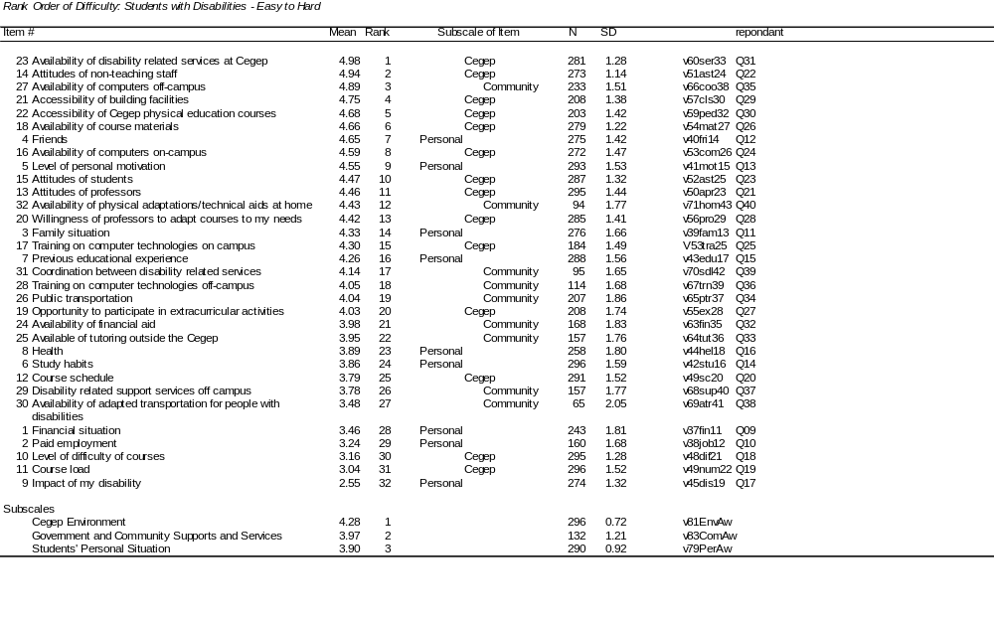

Results of a 1-way multivariate analysis of variance (MANOVA) examining mean scores on the 3 Subscales shows a significant-test result, F(2, 260) = 8.50, p=.000. Post hoc tests show that the Cegep Environment score was significantly higher than scores on both Personal and Community Subscales and that Students' Personal Situation Subscale did not differ significantly from the Government and Community Supports and Services Subscale score.

It can be seen in Table 40 below, which shows facilitator CEQ items (i.e., score > 3.5 on a 6-point scale) arranged in rank order of difficulty (easier items have higher ranks than more difficult items) within groupings, that most factors were seen as facilitating students' studies. It should be noted that although the means indicate that these are, overall, facilitating, these factors constituted obstacles to some students.

Table 40

Facilitating Factors For Students With Disabilities In Rank Order By Subscale

Students' Personal Situation
1 Friends
2 Student’s motivation
3 Family situation
4 Previous education experiences
5 Health
6 Study habits

Cegep Environment
1 Availability of disability related services
2 Attitudes of non-teaching staff
3 Accessibility of building facilities
4 Accessibility of physical education courses
5 Availability of course material
6 Availability of computers
7 Attitudes of students
8 Attitudes of profs
9 Willingness of profs to adapt courses
10 Training on computer technologies
11 Opportunity to participate in extracurricular activities
12 Course schedule

Government and Community Supports and Services
1 Availability of computers off-campus
2 Availability of adaptations at home
3 Training on computers off-campus
4 Coordination between support services
5 Public transportation
6 Availability of financial aid
7 Availability of tutoring outside the Cegep
8 Disability related support services off-campus

Although most items were seen as facilitating student success, the 6 factors shown in Table 23x were seen as obstacles (scores in the obstacles range <3.5 on a 6-point scale). It should be noted, however, that although the means indicate that these are, overall, obstacles, these factors constituted facilitators to some students.

Table 41

Obstacles For Students With Disabilities In Rank Order of Difficulty (Most to Least Difficult)

Students' Personal Situation
- Impact of my disability
- Paid employment
- Financial situation

Cegep Environment
- Course load
- Course difficulty

Government and Community Supports and Services
- Adapted transport
Relationship between facilitators and obstacles and the number of students' impairments. We expected that the more impairments students have (i.e., 1 or 2 or 3 or 4, etc.) , the more obstacles they would encounter. Correlations between the number of students' impairments and Cegep Experience Questionnaire Index of Difficulty, Subscale and item-by-item scores for current students with disabilities are presented in Table 42. Results show that for 9 of the 10 instances where there was a significant correlation, the more disabilities students had, the more likely they were to experience the item as an obstacle.

Table 42
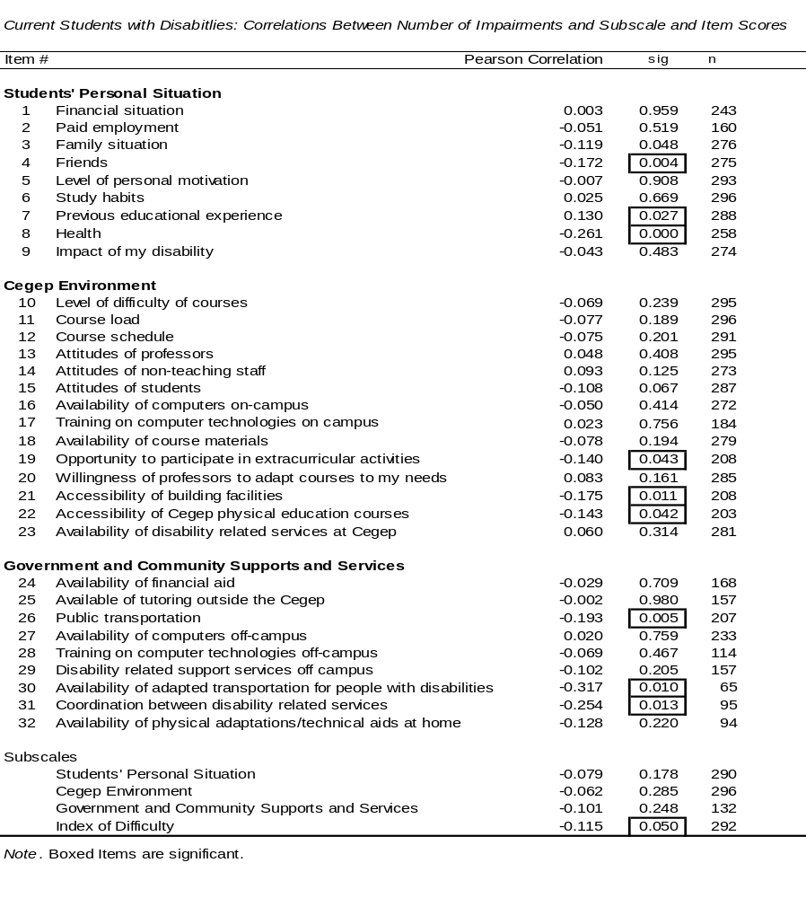

Similarities and differences between current students with different disabilities. In Table 43 means on CEQ items and Subscales are presented for students in each disability group. It should be noted that a large proportion of students have multiple disabilities, and that the scores in Table 43 include all students who mentioned the disability in question. Scores of students who have only the disability in question can be seen in Tables 44, 46, and 16.
Table 43

Subscales, Index of Difficulty and Cegep Experience Questionnaire Scores of Current Students with Different Disabilities
Item # |  |  |  |  | Blind |  |  |  |  |  | Visual impairment |  |  |  |  |  | Deaf |  |  | Hearing impairment |  |  |  |  |  | Speech / communication impairment |  |  |  |  |  |  |  | Learning disability / ADD
 |  |  |  |  | N | Mean |  |  |  |  | N | Mean |  |  |  |  | N | Mean |  | N |  |  | Mean |  |  | N |  | Mean |  |  |  |  |  | N |  | Mean
Subscales
 | Students' Personal Situation |  |  |  | 2 | 3.44 |  |  |  |  | 28 | 4.04 |  |  |  |  | 16 | 4.17 |  | 38 |  |  | 4.20 |  |  | 14 |  | 4.17 |  |  |  |  |  | 137 |  | 3.79
 | Cegep Environment |  |  |  | 1 | 4.08 |  |  |  |  | 29 | 4.16 |  |  |  |  | 17 | 4.32 |  | 38 |  |  | 4.57 |  |  | 16 |  | 4.19 |  |  |  |  |  | 141 |  | 4.17
 | Government and Community Supports and Services |  |  |  | 2 | 3.50 |  |  |  |  | 19 | 3.68 |  |  |  |  | 10 | 4.19 |  | 14 |  |  | 4.41 |  |  | 7 |  | 3.72 |  |  |  |  |  | 58 |  | 3.97
Index of Difficulty |  |  |  |  | 2 | 3.76 |  |  |  |  | 28 | 4.06 |  |  |  |  | 17 | 4.29 |  | 38 |  |  | 4.45 |  |  | 15 |  | 4.08 |  |  |  |  |  | 139 |  | 4.06
Students' Personal Situation
1 | Financial situation |  |  |  | 2 | 4.00 |  |  |  |  | 26 | 3.38 |  |  |  |  | 16 | 3.06 |  | 30 |  |  | 3.77 |  |  | 11 |  | 3.91 |  |  |  |  |  | 114 |  | 3.49
2 | Paid employment |  |  |  | 0 |  |  |  |  |  | 17 | 2.82 |  |  |  |  | 11 | 3.55 |  | 20 |  |  | 3.85 |  |  | 6 |  | 3.00 |  |  |  |  |  | 82 |  | 3.20
3 | Family situation |  |  |  | 2 | 2.50 |  |  |  |  | 28 | 4.39 |  |  |  |  | 15 | 4.80 |  | 34 |  |  | 4.41 |  |  | 15 |  | 4.80 |  |  |  |  |  | 129 |  | 4.16
4 | Friends |  |  |  | 2 | 3.50 |  |  |  |  | 26 | 5.08 |  |  |  |  | 16 | 4.94 |  | 34 |  |  | 4.79 |  |  | 12 |  | 4.08 |  |  |  |  |  | 132 |  | 4.69
5 | Level of personal motivation |  |  |  | 2 | 4.50 |  |  |  |  | 28 | 4.86 |  |  |  |  | 16 | 4.38 |  | 38 |  |  | 4.74 |  |  | 15 |  | 5.00 |  |  |  |  |  | 141 |  | 4.38
6 | Study habits |  |  |  | 2 | 4.00 |  |  |  |  | 29 | 4.17 |  |  |  |  | 16 | 4.50 |  | 38 |  |  | 4.05 |  |  | 16 |  | 4.06 |  |  |  |  |  | 140 |  | 3.62
7 | Previous education experiences |  |  |  | 2 | 5.00 |  |  |  |  | 26 | 4.46 |  |  |  |  | 17 | 4.35 |  | 36 |  |  | 4.22 |  |  | 15 |  | 5.40 |  |  |  |  |  | 138 |  | 3.89
8 | Health |  |  |  | 2 | 3.00 |  |  |  |  | 24 | 3.83 |  |  |  |  | 15 | 4.53 |  | 36 |  |  | 4.64 |  |  | 13 |  | 3.46 |  |  |  |  |  | 118 |  | 4.26
9 | Impact of my disability |  |  |  | 2 | 1.00 |  |  |  |  | 25 | 2.40 |  |  |  |  | 16 | 3.50 |  | 36 |  |  | 3.19 |  |  | 12 |  | 2.83 |  |  |  |  |  | 130 |  | 2.35
Cegep Environment
10 | Level of difficulty of courses |  |  |  | 2 | 2.00 |  |  |  |  | 29 | 3.24 |  |  |  |  | 17 | 3.29 |  | 38 |  |  | 3.32 |  |  | 14 |  | 3.00 |  |  |  |  |  | 142 |  | 2.82
11 | Course load |  |  |  | 1 | 3.00 |  |  |  |  | 28 | 3.25 |  |  |  |  | 17 | 3.53 |  | 39 |  |  | 3.21 |  |  | 16 |  | 3.00 |  |  |  |  |  | 142 |  | 2.72
12 | Course schedule |  |  |  | 1 | 4.00 |  |  |  |  | 29 | 3.86 |  |  |  |  | 17 | 4.12 |  | 38 |  |  | 3.92 |  |  | 16 |  | 3.69 |  |  |  |  |  | 138 |  | 3.68
13 | Attitudes of professors |  |  |  | 2 | 4.50 |  |  |  |  | 29 | 4.48 |  |  |  |  | 17 | 4.76 |  | 38 |  |  | 4.66 |  |  | 16 |  | 4.88 |  |  |  |  |  | 139 |  | 4.17
14 | Attitudes of non-teaching staff |  |  |  | 1 | 4.00 |  |  |  |  | 26 | 4.73 |  |  |  |  | 17 | 4.53 |  | 31 |  |  | 5.13 |  |  | 15 |  | 5.07 |  |  |  |  |  | 129 |  | 4.82
15 | Attitudes of students |  |  |  | 2 | 5.50 |  |  |  |  | 26 | 4.54 |  |  |  |  | 17 | 4.41 |  | 38 |  |  | 4.79 |  |  | 16 |  | 4.31 |  |  |  |  |  | 136 |  | 4.49
16 | Availability of computers on campus |  |  |  | 1 | 6.00 |  |  |  |  | 27 | 3.85 |  |  |  |  | 16 | 4.75 |  | 35 |  |  | 5.09 |  |  | 13 |  | 4.00 |  |  |  |  |  | 132 |  | 4.62
17 | Training on computer technologies on campus |  |  |  | 0 |  |  |  |  |  | 15 | 3.87 |  |  |  |  | 13 | 4.54 |  | 21 |  |  | 4.90 |  |  | 9 |  | 3.78 |  |  |  |  |  | 92 |  | 4.11
18 | Availability of course materials |  |  |  | 1 | 1.00 |  |  |  |  | 28 | 4.04 |  |  |  |  | 16 | 4.63 |  | 33 |  |  | 5.06 |  |  | 14 |  | 4.50 |  |  |  |  |  | 132 |  | 4.61
19 | Opportunity to participate in Cegep extracurricular activities |  |  |  | 1 | 5.00 |  |  |  |  | 20 | 4.15 |  |  |  |  | 13 | 3.23 |  | 25 |  |  | 4.68 |  |  | 10 |  | 3.40 |  |  |  |  |  | 102 |  | 4.16
20 | Willingness of professors to adapt courses to my needs |  |  |  | 2 | 4.00 |  |  |  |  | 28 | 4.43 |  |  |  |  | 17 | 4.35 |  | 35 |  |  | 4.86 |  |  | 16 |  | 4.63 |  |  |  |  |  | 137 |  | 4.28
21 | Accessibility of building facilities |  |  |  | 1 | 5.00 |  |  |  |  | 22 | 4.55 |  |  |  |  | 11 | 4.82 |  | 27 |  |  | 5.48 |  |  | 13 |  | 4.23 |  |  |  |  |  | 88 |  | 4.91
22 | Accessibility of Cegep physical education courses |  |  |  | 1 | 5.00 |  |  |  |  | 21 | 4.24 |  |  |  |  | 13 | 4.54 |  | 29 |  |  | 5.07 |  |  | 10 |  | 4.10 |  |  |  |  |  | 89 |  | 4.88
23 | Availability of disability related services at the Cegep |  |  |  | 2 | 5.50 |  |  |  |  | 28 | 5.07 |  |  |  |  | 17 | 4.76 |  | 36 |  |  | 4.72 |  |  | 14 |  | 5.21 |  |  |  |  |  | 132 |  | 4.91
Government and Community Supports and Services
24 | Availability of financial aid |  |  |  | 0 |  |  |  |  |  | 21 | 3.71 |  |  |  |  | 16 | 3.81 |  | 23 |  |  | 4.13 |  |  | 10 |  | 4.40 |  |  |  |  |  | 69 |  | 3.87
25 | Availability of tutoring outside the Cegep |  |  |  | 0 |  |  |  |  |  | 14 | 3.43 |  |  |  |  | 12 | 4.50 |  | 23 |  |  | 4.00 |  |  | 8 |  | 4.13 |  |  |  |  |  | 88 |  | 3.77
26 | Public transportation |  |  |  | 2 | 3.50 |  |  |  |  | 20 | 3.50 |  |  |  |  | 11 | 4.73 |  | 26 |  |  | 5.15 |  |  | 12 |  | 3.33 |  |  |  |  |  | 95 |  | 4.21
27 | Availability of computers off-campus |  |  |  | 1 | 6.00 |  |  |  |  | 23 | 4.70 |  |  |  |  | 11 | 4.91 |  | 31 |  |  | 5.00 |  |  | 14 |  | 5.14 |  |  |  |  |  | 116 |  | 4.98
28 | Training on computer technologies off-campus |  |  |  | 2 | 4.50 |  |  |  |  | 16 | 3.50 |  |  |  |  | 7 | 4.00 |  | 11 |  |  | 3.82 |  |  | 5 |  | 3.80 |  |  |  |  |  | 63 |  | 4.02
29 | Disability related support services off-campus |  |  |  | 1 | 2.00 |  |  |  |  | 20 | 3.90 |  |  |  |  | 9 | 3.56 |  | 21 |  |  | 4.52 |  |  | 9 |  | 2.89 |  |  |  |  |  | 66 |  | 3.41
30 | Availability of adapted transport for students with disabilities |  |  |  | 2 | 1.50 |  |  |  |  | 9 | 2.33 |  |  |  |  | 5 | 4.40 |  | 5 |  |  | 5.40 |  |  | 3 |  | 1.00 |  |  |  |  |  | 15 |  | 4.40
31 | Coordination between disability related support services and school |  |  |  | 1 | 2.00 |  |  |  |  | 12 | 3.83 |  |  |  |  | 6 | 4.33 |  | 6 |  |  | 5.33 |  |  | 3 |  | 2.67 |  |  |  |  |  | 33 |  | 4.39
32 | Availability of adaptations / technical aids at home |  |  |  | 1 | 6.00 |  |  |  |  | 15 | 4.07 |  |  |  |  | 14 | 4.29 |  | 13 |  |  | 4.46 |  |  | 4 |  | 3.25 |  |  |  |  |  | 24 |  | 4.42
Item # |  |  | Mobility impairment |  |  |  |  | Limitation in the use of hands / arms |  |  |  |  |  | Medically related / Health problem |  |  |  |  |  |  |  | Psychological / Psychiatric disability |  |  |  |  |  |  | Neurological impairment |  |  |  | PDD
 |  |  | N | Mean |  |  |  | N |  | Mean |  |  |  | N |  | Mean |  |  |  |  |  | N |  | Mean |  |  |  |  | N | Mean |  |  | N |  | Mean
Subscales
 |  | Students' Personal Situation | 53 | 3.92 |  |  |  | 28 |  | 4.23 |  |  |  | 32 |  | 3.41 |  |  |  |  |  | 32 |  | 3.44 |  |  |  |  | 23 | 3.82 |  |  | 1 |  | 2.22
 |  | Cegep Environment | 51 | 4.34 |  |  |  | 30 |  | 4.42 |  |  |  | 33 |  | 4.16 |  |  |  |  |  | 32 |  | 4.05 |  |  |  |  | 25 | 4.32 |  |  | 1 |  | 3.57
 |  | Government and Community Supports and Services | 36 | 3.69 |  |  |  | 22 |  | 3.81 |  |  |  | 15 |  | 3.81 |  |  |  |  |  | 18 |  | 3.98 |  |  |  |  | 8 | 3.73 |  |  | 1 |  | 3.50
Index of Difficulty |  |  | 52 | 4.10 |  |  |  | 29 |  | 4.25 |  |  |  | 33 |  | 3.88 |  |  |  |  |  | 32 |  | 3.85 |  |  |  |  | 24 | 4.12 |  |  | 1 |  | 3.16
Students' Personal Situation
1 |  | Financial situation | 46 | 3.13 |  |  |  | 25 |  | 3.96 |  |  |  | 29 |  | 3.14 |  |  |  |  |  | 26 |  | 3.35 |  |  |  |  | 19 | 3.26 |  |  | 7 |  | 4.86
2 |  | Paid employment | 17 | 2.88 |  |  |  | 10 |  | 3.70 |  |  |  | 16 |  | 2.81 |  |  |  |  |  | 13 |  | 3.62 |  |  |  |  | 10 | 2.40 |  |  | 1 |  | 4.00
3 |  | Family situation | 52 | 4.37 |  |  |  | 27 |  | 4.85 |  |  |  | 31 |  | 3.52 |  |  |  |  |  | 31 |  | 3.32 |  |  |  |  | 22 | 4.55 |  |  | 10 |  | 4.50
4 |  | Friends | 47 | 4.64 |  |  |  | 25 |  | 4.56 |  |  |  | 31 |  | 4.16 |  |  |  |  |  | 31 |  | 4.00 |  |  |  |  | 21 | 4.05 |  |  | 9 |  | 3.56
5 |  | Level of personal motivation | 52 | 4.79 |  |  |  | 29 |  | 5.00 |  |  |  | 33 |  | 4.24 |  |  |  |  |  | 31 |  | 4.03 |  |  |  |  | 25 | 4.72 |  |  | 11 |  | 4.45
6 |  | Study habits | 53 | 3.87 |  |  |  | 30 |  | 4.17 |  |  |  | 33 |  | 3.97 |  |  |  |  |  | 32 |  | 3.97 |  |  |  |  | 25 | 3.88 |  |  | 11 |  | 3.64
7 |  | Previous education experiences | 51 | 4.88 |  |  |  | 29 |  | 5.31 |  |  |  | 33 |  | 4.42 |  |  |  |  |  | 32 |  | 4.25 |  |  |  |  | 25 | 4.56 |  |  | 11 |  | 4.36
8 |  | Health | 47 | 2.98 |  |  |  | 27 |  | 3.30 |  |  |  | 33 |  | 2.03 |  |  |  |  |  | 30 |  | 2.53 |  |  |  |  | 23 | 3.35 |  |  | 10 |  | 4.30
9 |  | Impact of my disability | 48 | 2.60 |  |  |  | 27 |  | 2.85 |  |  |  | 31 |  | 2.10 |  |  |  |  |  | 32 |  | 1.88 |  |  |  |  | 20 | 2.60 |  |  | 10 |  | 2.90
Cegep Environment
10 |  | Level of difficulty of courses | 50 | 3.72 |  |  |  | 28 |  | 3.57 |  |  |  | 33 |  | 2.94 |  |  |  |  |  | 32 |  | 3.19 |  |  |  |  | 24 | 2.46 |  |  | 11 |  | 3.45
11 |  | Course load | 50 | 3.08 |  |  |  | 30 |  | 3.30 |  |  |  | 33 |  | 2.70 |  |  |  |  |  | 32 |  | 3.03 |  |  |  |  | 25 | 2.56 |  |  | 11 |  | 4.00
12 |  | Course schedule | 48 | 3.58 |  |  |  | 28 |  | 3.64 |  |  |  | 33 |  | 3.45 |  |  |  |  |  | 32 |  | 3.97 |  |  |  |  | 25 | 3.76 |  |  | 11 |  | 3.73
13 |  | Attitudes of professors | 52 | 5.04 |  |  |  | 30 |  | 5.10 |  |  |  | 33 |  | 4.27 |  |  |  |  |  | 32 |  | 4.06 |  |  |  |  | 25 | 4.44 |  |  | 11 |  | 5.00
14 |  | Attitudes of non-teaching staff | 51 | 5.29 |  |  |  | 29 |  | 5.41 |  |  |  | 31 |  | 4.94 |  |  |  |  |  | 32 |  | 5.06 |  |  |  |  | 23 | 5.30 |  |  | 11 |  | 5.00
15 |  | Attitudes of students | 53 | 4.43 |  |  |  | 30 |  | 4.53 |  |  |  | 33 |  | 3.91 |  |  |  |  |  | 31 |  | 3.61 |  |  |  |  | 23 | 4.57 |  |  | 10 |  | 4.10
16 |  | Availability of computers on campus | 45 | 4.53 |  |  |  | 26 |  | 4.69 |  |  |  | 31 |  | 4.48 |  |  |  |  |  | 31 |  | 4.29 |  |  |  |  | 22 | 4.50 |  |  | 10 |  | 4.80
17 |  | Training on computer technologies on campus | 31 | 4.71 |  |  |  | 20 |  | 4.95 |  |  |  | 18 |  | 4.72 |  |  |  |  |  | 19 |  | 3.63 |  |  |  |  | 15 | 4.40 |  |  | 10 |  | 4.10
18 |  | Availability of course materials | 48 | 4.77 |  |  |  | 28 |  | 4.64 |  |  |  | 32 |  | 4.59 |  |  |  |  |  | 31 |  | 4.16 |  |  |  |  | 21 | 5.00 |  |  | 11 |  | 4.73
19 |  | Opportunity to participate in Cegep extracurricular activities | 35 | 3.09 |  |  |  | 19 |  | 2.63 |  |  |  | 19 |  | 3.95 |  |  |  |  |  | 20 |  | 4.25 |  |  |  |  | 17 | 3.94 |  |  | 4 |  | 5.50
20 |  | Willingness of professors to adapt courses to my needs | 49 | 4.69 |  |  |  | 30 |  | 4.83 |  |  |  | 33 |  | 4.61 |  |  |  |  |  | 31 |  | 3.94 |  |  |  |  | 24 | 4.88 |  |  | 10 |  | 4.60
21 |  | Accessibility of building facilities | 50 | 3.90 |  |  |  | 29 |  | 4.00 |  |  |  | 29 |  | 4.69 |  |  |  |  |  | 20 |  | 4.30 |  |  |  |  | 20 | 4.95 |  |  | 8 |  | 5.00
22 |  | Accessibility of Cegep physical education courses | 32 | 4.03 |  |  |  | 17 |  | 4.65 |  |  |  | 27 |  | 4.48 |  |  |  |  |  | 22 |  | 4.18 |  |  |  |  | 17 | 4.71 |  |  | 8 |  | 4.50
23 |  | Availability of disability related services at the Cegep | 51 | 5.37 |  |  |  | 29 |  | 5.28 |  |  |  | 32 |  | 5.00 |  |  |  |  |  | 29 |  | 4.69 |  |  |  |  | 23 | 5.43 |  |  | 10 |  | 5.20
Government and Community Supports and Services
24 |  | Availability of financial aid | 37 | 4.14 |  |  |  | 18 |  | 4.06 |  |  |  | 21 |  | 3.71 |  |  |  |  |  | 18 |  | 3.56 |  |  |  |  | 10 | 4.70 |  |  | 4 |  | 4.25
25 |  | Availability of tutoring outside the Cegep | 17 | 3.82 |  |  |  | 11 |  | 4.36 |  |  |  | 17 |  | 3.76 |  |  |  |  |  | 18 |  | 4.06 |  |  |  |  | 9 | 4.33 |  |  | 8 |  | 5.00
26 |  | Public transportation | 36 | 2.78 |  |  |  | 20 |  | 2.80 |  |  |  | 25 |  | 3.28 |  |  |  |  |  | 27 |  | 3.63 |  |  |  |  | 20 | 3.85 |  |  | 8 |  | 5.00
27 |  | Availability of computers off-campus | 39 | 4.77 |  |  |  | 23 |  | 5.13 |  |  |  | 25 |  | 4.72 |  |  |  |  |  | 31 |  | 4.58 |  |  |  |  | 20 | 5.25 |  |  | 9 |  | 4.89
28 |  | Training on computer technologies off-campus | 18 | 4.56 |  |  |  | 10 |  | 4.90 |  |  |  | 8 |  | 4.00 |  |  |  |  |  | 11 |  | 3.45 |  |  |  |  | 9 | 3.56 |  |  | 3 |  | 3.67
29 |  | Disability related support services off-campus | 32 | 3.47 |  |  |  | 19 |  | 3.58 |  |  |  | 18 |  | 3.72 |  |  |  |  |  | 22 |  | 3.91 |  |  |  |  | 10 | 3.70 |  |  | 8 |  | 4.50
30 |  | Availability of adapted transport for students with disabilities | 32 | 2.72 |  |  |  | 17 |  | 2.24 |  |  |  | 9 |  | 3.78 |  |  |  |  |  | 5 |  | 3.20 |  |  |  |  | 8 | 3.25 |  |  | 0
31 |  | Coordination between disability related support services and school | 34 | 3.47 |  |  |  | 18 |  | 3.44 |  |  |  | 11 |  | 3.82 |  |  |  |  |  | 14 |  | 3.86 |  |  |  |  | 11 | 4.27 |  |  | 4 |  | 4.25
32 |  | Availability of adaptations / technical aids at home | 34 | 4.32 |  |  |  | 22 |  | 4.64 |  |  |  | 12 |  | 4.00 |  |  |  |  |  | 7 |  | 4.86 |  |  |  |  | 10 | 4.00 |  |  | 1 |  | 1.00

Comparisons of CEQ means by disability type. To determine whether there were differences in CEQ scores related to graduates' impairments, disability categories were combined. Here we ensured that current students with multiple disabilities were grouped into one category and were not represented in each disability category. This resulted in 8 impairment categories. The number of students who fell in each of the categories is shown in Table 44. Scores of students who have only the disability in question can be seen in Tables 45.

Table 44

Grouping Current Students With Disabilities Into 8 Combined Disability Categories
Combined Disability Categories |  |  | Frequency |  | Percent
1 | Visual impairment and blindness only |  |  | 16 |  | 5.33 |  | %
2 | Hearing impairment and Deafness only |  |  | 39 |  | 13.00 |  | %
3 | Learning disability/ADD only |  |  | 103 |  | 34.33 |  | %
4 | Mobility and hand/arm impairment only |  |  | 19 |  | 6.33 |  | %
5 | Medical / neurological impairment only |  |  | 14 |  | 4.67 |  | %
6 | Psychological impairment / PDD only |  |  | 16 |  | 5.33 |  | %
7 | Multiple disabilities |  |  | 90 |  | 30.00 |  | %
8 | Other (unclassified and speech/communication impairment) |  |  | 3 |  | 1.00 |  | %
 | Total with disabilities |  |  | 300 |  | 100.00 |  | %

Table 45

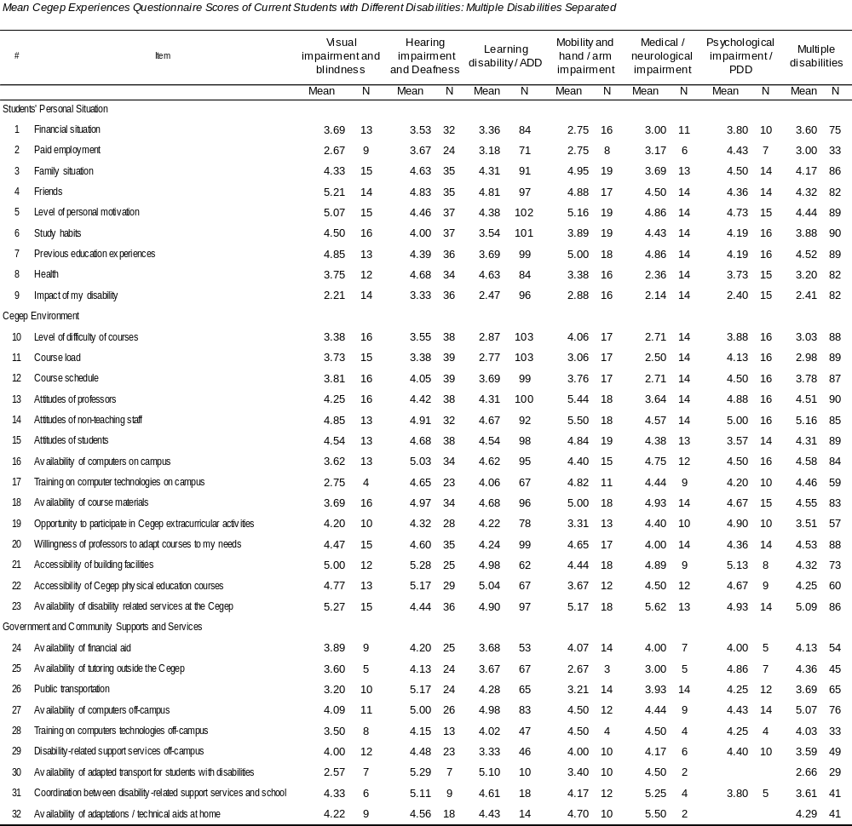

To examine similarities and differences among students with different disabilities we conducted a one-way MANOVA (multivariate analysis of variance) comparison on Students' Personal Situation and Cegep Environment Subscale scores (7 Disability Categories X 2 Subscales). The Subscale means included all disability related items. The Community and Government Supports and Services Subscale was not included as there were not enough responses on this subscale for meaningful analysis. The results revealed no significant difference among the 7 levels of the variable (category 8 (Other) was not included).

A series of 2 MANOVAs on items in the Students' Personal Situation and in the Cegep Environment Subscale showed significant differences among groups, Wilks’ Λ = 0.46, F(54,530) = 1.63, p=.004, Wilks’ Λ = 0.24, F(84,408) = 1.42, p=.014, respectively.

One-way analysis of variance comparisons (ANOVAs) (7 Disability Categories) on Students' Personal Situation Subscale items showed significant findings. Best seen in Table 46, these showed significant results on 3 of the 9 items that comprise the Students' Personal Experiences Subscale: (1) students with learning disabilities/ADD felt that their previous educational experiences (Item 7) was considerably less facilitating than did students with other impairments, (2) that good health (Item 8) was a facilitator for students with hearing impairments and with learning disabilities/ADD while this was an obstacle for students with medical/neurological impairments, multiple disabilities, and mobility and hand impairments, and (3) that while the scores of students in all disability groups was in the obstacle range for the item dealing with the impact of their disability (Item 9), students with medical/neurological impairments felt that this was more of an obstacle than did students with hearing impairments.

The ANOVAs on 6 of the 14 items on the Cegep Environment Subscale were significant. These are also presented in Table 46 and show that (1) students with medical/neurological impairments found that the level of difficulty of their courses (Item 10) posed the greatest obstacle, (2) and that their course schedules (Item 12) posed important difficulties for them, although course schedules were seen as especially facilitating by students with psychological impairments or PDD, (3) that the attitude of professors (Item 13) and (4) of non teaching staff (Item 14) were most problematic for students with medical/neurological impairments and most facilitating for students with mobility and arm/hand impairments, (5) that the availability of course materials (Item 18) was most facilitating for students with mobility and arm/hand impairments and least facilitating for students with visual impairments, and (6) that the accessibility of Cegep physical education courses (Item 22) was least facilitating for students with mobility or arm/hand impairments.

On Government and Community Supports and Services items 2 of the 9 items were significant: (1) both public transportation (Item 26) and (2) the availability of adapted transport for students with disabilities (Item 30). They were both especially problematic for students with multiple disabilities and mobility and hand/arm impairments, although public transportation was least facilitating for students with visual impairments and adapted transportation also caused problems for students with medical / neurological impairments.

Table 46
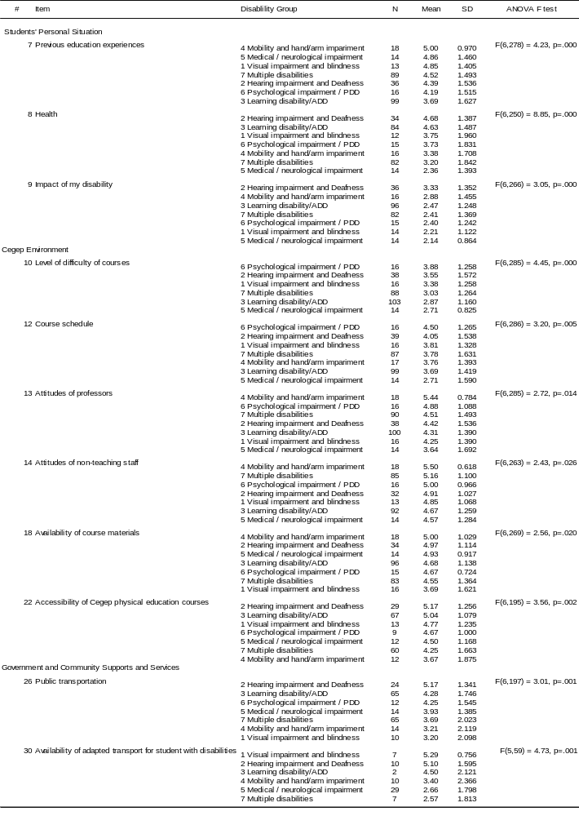

Cegep based disability service providers. Table 47 shows mean scores of disability service providers' importance ratings on CEQ items, where 1 = not important and 5 = extremely important. The composition of a 4th Subscale - Service Provision - which was present only on the campus based disability service provider version of the CEQ, can be seen in Table 47.

Table 47

Disability Service Providers' Importance Ratings on CEQ Items
Using the following scale, from your experience, indicate the level of importance of each item for the academic performance of Cegep students with disabilities. Think of students with disabilities in general. If you feel an item is not applicable, respond with N/A (not applicable).
1 | 2 | 3 | 4 | 5 | [ N/A ]
Not  Important | Slightly Important | Moderately Important | Very Important | Extremely Important | Not Applicable

Students’ Personal Situation
- __3.21__Financial situation
- __2.42__Paid employment
- __3.98__Family situation
- __3.93__Friends
- __4.73__Level of personal motivation
- __4.30__Study habits
- __3.79__Previous education experiences
- __4.26__Health
- __3.70__Impact of their disability
Cegep Environment
- __3.49__Level of difficulty of courses
- __4.07__Course load
- __3.53__Course schedule
- __4.46__Attitudes of professors
- __3.86__Attitudes of non-teaching staff (e.g., registration staff, financial aid staff)
- __4.00__Attitudes of fellow students
- __3.36__Availability of computers on campus
- __2.96__Training on computer technologies on campus
- __3.82__Availability of course materials
- __2.91__Opportunity to participate in Cegep extracurricular activities (e.g., clubs, sports, social activities)
- __4.29__Willingness of professors to adapt courses to students’ needs
- __4.22__Accessibility of building facilities (e.g., doorways, classrooms, labs)
- __3.28__Accessibility of Cegep physical education courses
- __4.32__Availability of disability related services at the Cegep
Government and Community Supports and Services
- __4.00__Availability of financial aid
- __3.32__Availability of tutoring outside of the Cegep
- __3.79__Public transportation
- __3.19__Availability of computers off-campus
- __2.94__Training on adapted computer technologies off-campus
- __3.60__Disability related support services off-campus
- __4.19__Availability of adapted transport for students with disabilities
- __3.94__Coordination between disability related support services (e.g., attendant care, adapted transport) and school
- __3.91__Availability of adaptations / technical aids at home (e.g., ramp, TDD)
Service Provision
- __4.27__Budget allocated for disability services at the Cegep
- __4.43__Availability of affordable diagnostic services (e.g., LD assessment) external to Cegep)
- __4.21__Willingness of students to use suitable accommodations
- __4.28__Students’ awareness of the impact of their disability
- __4.37__Students’ ability to express their needs
- __4.04__Students' choice of career
- __4.28__Identification of students' individual needs by the disability service provider
- __3.96__On-going support by the disability service provider
- __4.00__Professors’ level of knowledge about disability services / accommodations
- __4.48__Collaboration between professors and disability service providers
- __4.30__Attitudes of the administration toward services provided to students with disabilities
Table 48 shows importance ratings in rank order for each subscale. The mean of importance scores was 3.87. Results on Subscales (including disability specific items) indicate that Service Provision was seen as most important, followed by Students' Personal Situation, Cegep Environment, and Government and Community Supports and Services. Results on a 1-way ANOVA examining mean scores on the 4 Subscales shows a significant test result, F(3, 165) = 146.27, p=.000. Post hoc tests show that the Service Provision score was significantly higher than scores on all other Subscales and that the Students' Personal Situation Subscale was more important than the Government and Community Supports and Services Subscale. Cegep scores did not differ significantly from Personal or Government and Community Supports and Services scores.

Table 48
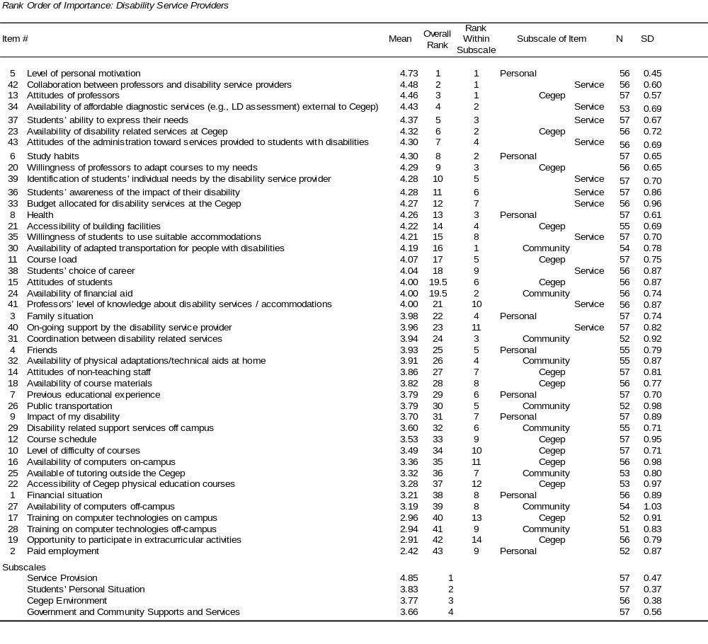

Table 49 shows "very important" CEQ items (i.e., score ≥ 4 on a 5-point scale) arranged in rank order of importance within groupings. These indicate that 3 of the 9 Students’ Personal Situation items, 6 of the 14 Cegep Environment items, 2 of the 9 Government and Community Supports and Services items, and 10 of the 11 Service Provision items were seen as very important.

Table 49

"Very Important" CEQ Items For Campus Based Disability Service Providers: Rank Ordering Within Groupings

Rank # Item

Students’ Personal Situation
1 15 | Level of personal motivation
2 6 | Study habits
3 8 | Health

Cegep Environment
1 13 | Attitudes of professors
2 23 | Availability of disability related services at the Cegep
3 20 | Willingness of professors to adapt courses to my needs
4 21 | Accessibility of building facilities
5 11 | Course load
6 15 | Attitudes of students

Government and Community Supports and Services
1 30 | Availability of adapted transportation for people with disabilities
2 24 | Availability of financial aid

Service Provision
1 42 | Collaboration between professors and disability service providers
2 34 | Availability of affordable diagnostic services (e.g., LD assessment) external to Cegep
3 37 | Students’ ability to express their needs
4 43 | Attitudes of the administration toward services provided to students with disabilities
5 39 | Identification of students' individual needs by the disability service provider
6 36 | Students’ awareness of the impact of their disability
7 33 | Budget allocated for disability services at the Cegep
8 35 | Willingness of students to use suitable accommodations
9 38 | Students' choice of career
10 41 | Professors’ level of knowledge about disability services / accommodations

Comparison Of Disability Service Providers' And Current Students' Ratings

We examined items seen by disability service providers as most important, mid-range in importance, and least important and examined students' facilitator and obstacle scores. Results indicate that the correlation between importance ranks and obstacle-facilitator ranks is not significant, r(30)=.215, p=.238, indicating a discrepancy between what was most important to service providers and what was experienced as most difficult by current students with disabilities. Table 50 shows the scores.

Table 50
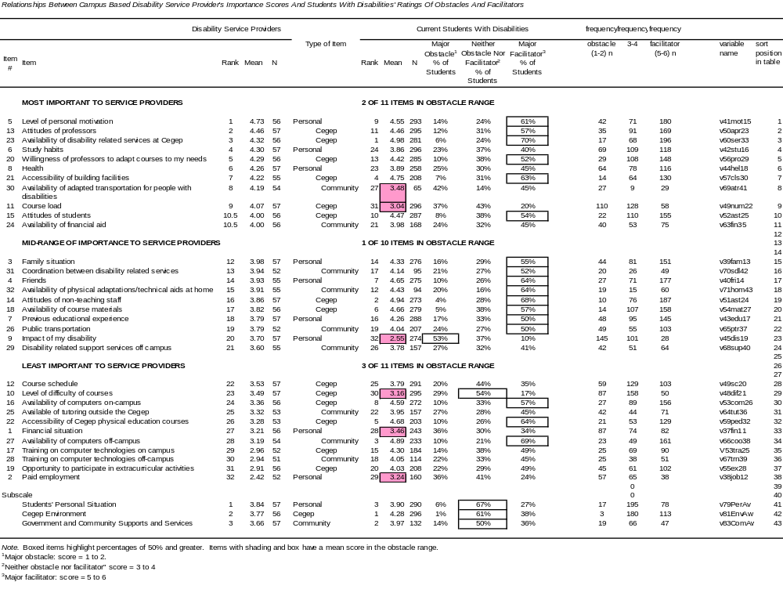

Results in Table 50 also show that the number 1 ranked facilitator, considered a facilitator by 70% of students, was the availability of disability related services at the Cegep, an item among those seen as the most important by service providers. The corresponding greatest obstacle, endorsed by 53% of students, was the impact of their disability; this item, however, was only seen as being of intermediate importance by service providers. Table 50 also shows that among items rated among the most important by disability service providers, 2 items had scores in the obstacle range: availability of adapted transportation for people with disabilities and course load. Three items that were seen as among the least important by disability service providers were seen as major obstacles by students with disabilities: their financial situation, paid employment, and the level of difficulty of their courses.

Figures 13 and 14 illustrate some of these relationships for items rated as very important by disability service providers (i.e., rating = 4 to 5) and for items rated as major facilitators (score = 5 to 6) and major obstacles (score = 1 to 2) by current students with disabilities.

Figure 13

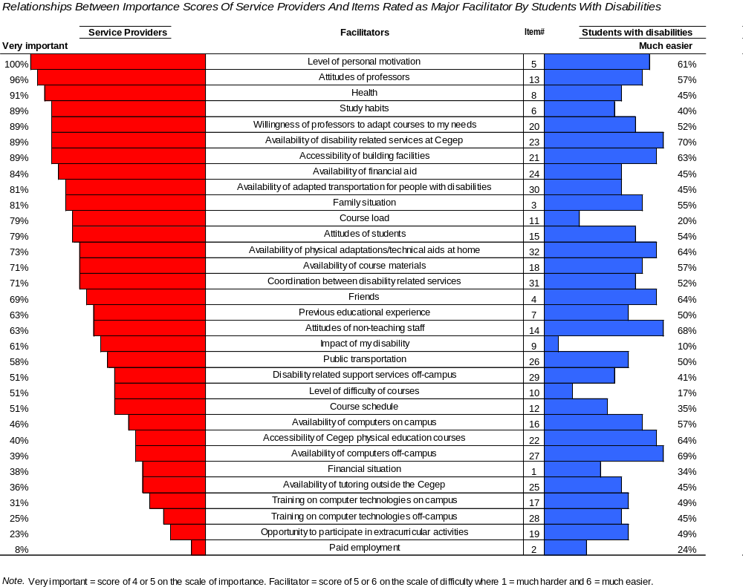

It can be seen in Figure 13 that three of the items rated very important by at least ½ of the campus based disability service providers were seen as key facilitators by fewer than 20% of students with disabilities: course load, the impact of the student's disability, and the level of difficulty of courses. Similarly, 3 items that at least ½ of the students with disabilities indicated made their Cegep studies easier were seen as very important by fewer than 50% of campus based disability service providers: the availability of computers both on and off-campus and the accessibility of Cegep physical education courses.

In Figure 14 it can be seen that 3 of the items rated very important by at least ½ of the campus based disability service providers were seen as key obstacles by at least ⅓ of students with disabilities: the availability of adapted transport for people with disabilities, a heavy course load, and the impact of students' disabilities. Data in the open-ended portion of this investigation shows that the problem with paid employment is that students feel they are spending too much time working at a job, but that this is necessary to enable them to stay in school.

Figure 14
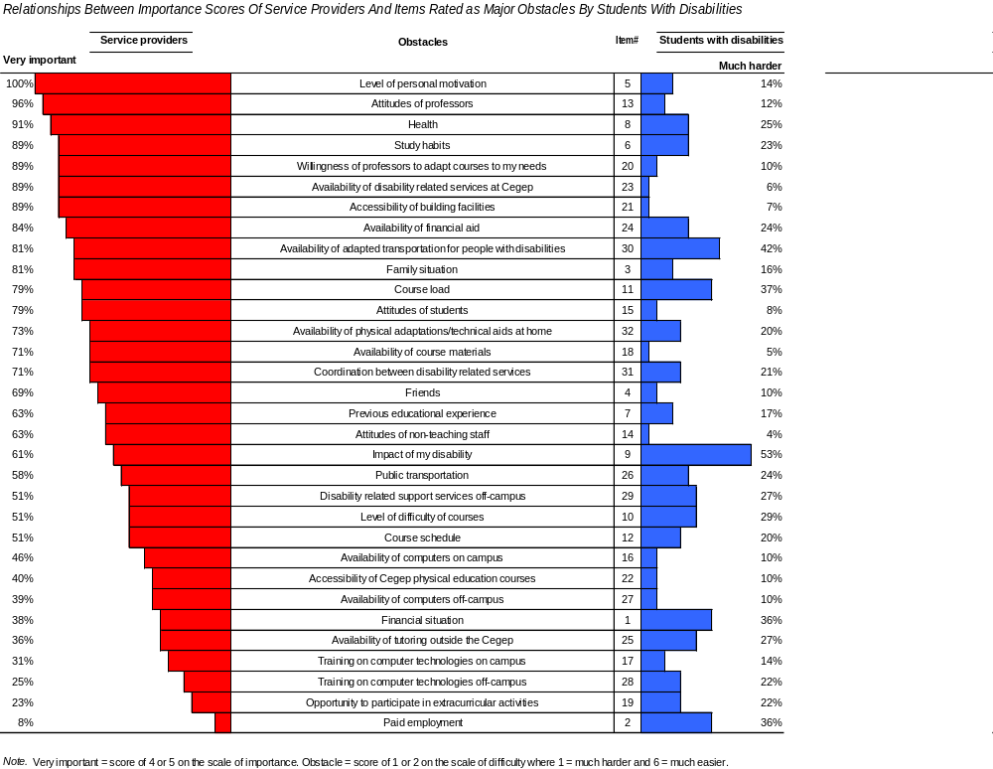

We also tried to carry out a direct comparison of service providers' and current students' importance ratings by converting the easier-harder ratings of students into importance scores. We did this by collapsing the easier-harder scores in the following way. We made the assumptions that if an item was a major facilitator or a major obstacle (i.e., had a score of 1 (much harder) or 6 (much easier)) that the item was very important. We transformed both of these scores by giving them a new "computed importance" score of 3. Items with easy-difficult scores of 3 or 4 (i.e., slightly harder or easier) were given a score of 1. Items in between (i.e., those with a rating of 5 or 2 - moderately easier or harder) we gave a score of 2. Table 51 shows the means for students with disabilities and disability service providers. It can be seen in this Table, and in the nonsignificant correlation coefficient, r(30)= .136, p=.458, that there is little in common between the two sets of scores.

Table 51
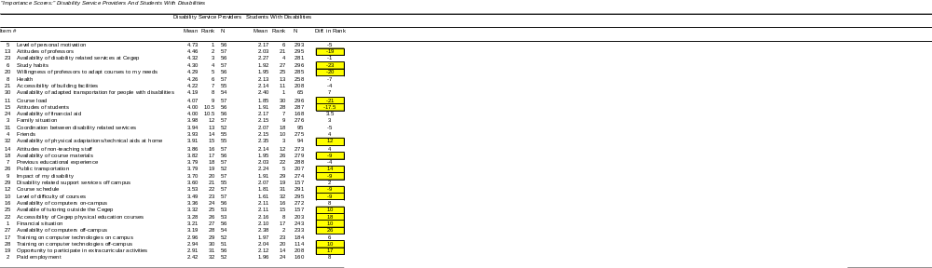

Note. Higher scores indicate greater importance. Maximum score for campus based disability service providers is 5. Maximum score for students with disabilities is 3. Items that differed by 9 or more rank positions are boxed and highlighted.

Nevertheless, it can be seen in Table 52 that on the top 11 items of importance (as rated by the campus based disability service providers) students and service providers agreed upon most (i.e., of the 11 items that were most important to disability services, 5 were also in the top 11 of student rankings). Differences show that campus based disability service providers felt that the attitude and willingness of professors to adjust their courses to students' needs were important as well as students' study habits, health, and course load as well as the attitudes of other students. Students felt that the availability of computers off-campus and of physical adaptations at home were important along with public transportation, the accessibility of Cegep physical education courses, and their friends and family situation.

Table 52

Commonalities Between The Top Eleven "Importance" Scores: Campus Based Disability Service Providers And Students With Disabilities

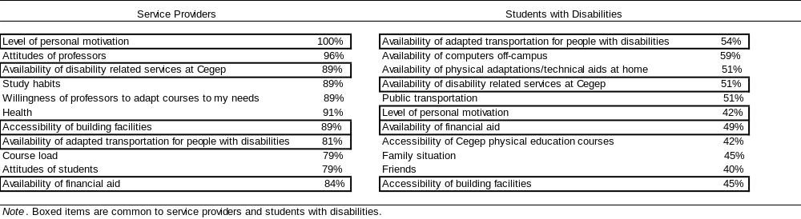

Graduates. Three groups of graduates completed the CEQ and the Post Cegep Questionnaire which inquired about graduates' current situation (i.e., questions related to whether they were continuing their studies, were holding a job, etc.): graduates without disabilities, graduates with disabilities who were registered to receive disability related services, and graduates with disabilities who did not register to receive disability related services.

CEQ: Graduates' Personal Situation. A one-way multivariate analysis of variance (MANOVA) was conducted to determine the effect of the presence or absence of a disability on the variables on the Graduates' Personal Situation items that were common to both graduates with and without disabilities. There was a significant difference between graduates with and without a disability on the dependent measures, Wilks’ Λ = 0.86, F (8, 753) = 14.76, p < .001. Follow-up independent t-tests were conducted. These showed that there were significant differences on Item 8 (Health) and Item 3 (Family). Mean scores of graduates with disabilities showed that their health scores were significantly lower (M = 3.69, SD = 1.82) than those of graduates without disabilities (M = 5.06, SD = 1.23), t (181) = 9.20, p < .001. Family also proved to be less of a facilitator for graduates with disabilities (M = 3.99, SD = 1.60) than without disabilities (M = 4.66, SD = 1.46), t (1304) = 5.43, p < .001. The means, standard deviations and independent t-test results for all items on the Personal Situation subscale are shown in Table 53.

A series of two independent t-tests on the Students' Personal Subscale means showed that there was a significant difference between graduates with and without disabilities both when the disability specific item was included in the mean for graduates with disabilities as well as when this was excluded. Means and t-test results are available in Table 53. These show that the overall personal situation of graduates with disabilities was less facilitating than that of graduates without disabilities.

We also examined the Graduates' Personal Situation variables of graduates in pre-university and career/technical programs separately. A one-way MANOVA was conducted to determine the effect of the presence or absence of a disability on the 7 variables on the Personal Situation subscale that were common to both graduates with and without disabilities in pre-university programs. The test showed a significant difference, Wilks’ Λ = 0.87, F (8, 405) = 6.5, p < .001. A series of follow up independent t-tests were conducted and the outcomes are shown in Table 54. As in the previous analysis, the means of Item 3 (Family) and Item 8 (Health) were significantly different, with graduates with disabilities experiencing these aspects of their Cegep experience as less facilitating. However, an additional item (Item 14: Friends) also showed a statistically significant difference in means, with graduates with disabilities in pre-university programs (M = 4.50, SD = 1.37) experiencing this aspect as less facilitating than graduates without disabilities (4.81, SD = 1.28). This item, however, was not significant after a Bonferroni correction was applied to the alpha level. The difference in Personal Situation Subscale means was also significant for graduates in pre-university programs. Means, standard deviations and t-test results can be found in Table 54.

A MANOVA was also conducted for career/technical programs. The test showed a significant difference on the Personal Situation variables, Wilks’ Λ = 0.82, F (8, 332) = 9.3, p < .001) between graduates with and without a disability. A series of follow-up independent t-tests showed that the pattern for career/technical programs was consistent with the earlier analysis (i.e., the Health and Family items showed a statistically significant difference, as did the Students' Personal Situation Subscale mean). Results of the independent t-tests are shown in Table 55 for career/technical programs.

CEQ Cegep Environment. A one-way multivariate analysis of variance (MANOVA) was conducted on the items common to both graduates with and without disabilities to determine whether there was difference between the two groups on the Cegep Environment items (13 variables). The MANOVA was not significant, Wilks’ Λ = 0.99, F (13,469) = 0.45, p = .952. Because of the importance of the items on this subscale we nevertheless carried out independent t-tests on the individual items. Results showed a significant difference on Item 22 (Accessibility of Cegep physical education courses). Graduates with disabilities (M = 4.43, SD = 1.48) had lower mean scores on this item than graduates without disabilities (M = 4.68, SD = 1.16) (see Table 53), although the difference was no longer significant after a Bonferroni adjustment to the alpha level .

An independent t-test on the overall Cegep Environment Subscale means showed no significant difference between graduates with (M = 4.02, SD = 0.80) and without (M = 4.10, SD = 0.67) disabilities, t(211) = 1.55, p=.178) (see Table 53).

We again examined the Cegep Environment variables of graduates in pre-university and career/technical programs separately. Means are available in Tables 54 and 55. A one-way MANOVA was conducted on the items common to both graduates with and without disabilities to determine whether there was a difference between the two groups on the Cegep Environment items (13 variables) for graduates in pre-university programs (see Table 54). The comparison was not statistically significant, Wilks’ Λ = 0.97, F (13, 264) = 0.55, p = .892. The difference in the Cegep Subscale means (0.03) was also not statistically significant. Nevertheless, we conducted independent t-tests on individual items to examine trends in the pre-university data. These show that scores on Item 22 (Accessibility of Cegep physical education courses) of graduates with and without disabilities in pre-university programs differed, as was the case in the analysis on the whole sample of graduates. However, in addition, scores on Item 12 (Course schedule) and Item 18 (Availability of course materials) were also different. Although the score on Item 12 was below 4.0 for both groups, graduates with disabilities (M = 3.96, SD = 1.32) rated this item higher than did graduates without disabilities (3.62, SD =1.34). Graduates with disabilities (M = 4.74, SD = 1.13) also rated Item 18 (Availability of course materials) higher than graduates without disabilities (M = 4.44, SD = 1.10). Given the nonsignificant MANOVA, it was not surprising that after a Bonferroni adjustment to the alpha level none of these items were significantly different.

The MANOVA on Cegep Environment scores of career/technical program graduates also was not significant, Wilks’ Λ = 0.93, F (13, 184) = 1.10, p = .366. When independent t-tests were done, the only item showing a difference in means was Item 20 (Willingness of professors to adapt courses to the student's needs). In this case, graduates with disabilities (M = 3.82, SD = 1.39) rated the item lower than graduates without disabilities (M = 4.29, SD = 1.35). Again, the difference was not significant after a Bonferroni correction was applied. Table 55 shows the means, standard deviations and t-test outcomes for career/technical programs.

CEQ: Government and Community Supports and Services. A one-way MANOVA was conducted on the 5 items common to both graduates with and without disabilities to determine whether there was a difference between the two groups. Results show that the comparison was not significant, Wilks’ Λ = 0.95, F (5, 117) = 1.31, p = .348. The means and standard deviations for each item on the subscale for both groups are shown in Table 53.

When Government and Community Supports Subscale averages were compared, again, there was no significant differences between graduates with (M = 4.22, SD = 1.20) and without disabilities (M = 4.19, SD = 1.17). Details of the means, standard deviations and independent t-test values can be found in Table 53.

The small number of responses on items on CEQ Government and Community Supports and Services items did not allow for a meaningful MANOVA comparison. However, consistent with the earlier analysis, when independent t-tests were performed for each of the 5 items there was no statistically significant difference between graduates with and without disabilities. This was true for both the pre-university and the career/technical graduates (see Tables 54 and 55).

CEQ: Index of Difficulty (IDF). It can be seen in Table 53 that when IDF scores of graduates with and without disabilities were compared there was a significant difference on the Index of Difficulty (IDF) for all graduates combined, as well as for those graduating from career/technical and from pre-university programs. Graduates with disabilities had scores that were lower than graduates without disabilities. The difference for pre-university graduates was only significant when the disability specific items were included in the comparison (see Tables 53, 54, 55).
Table 53

CEQ: Comparing Graduates With And Without Disabilities On Item And Subscale Scores In All Programs And Sectors
# | Item | With Disabilities |  |  | Without Disabilities |  |  | t | df | Sig | Difference
# | Item | N | Mean | SD | N | Mean | SD |  |  |  |  | P<.05
1 | Financial situation | 161 | 3.60 | 1.68 | 1125 | 3.86 | 1.64 | -1.85 | 1284 | 0.064 | -0.26
2 | Paid employment | 131 | 3.27 | 1.53 | 953 | 3.44 | 1.44 | -1.24 | 1082 | 0.215 | -0.17
3 | Family | 162 | 3.99 | 1.60 | 1144 | 4.66 | 1.45 | -5.43 | 1304 | 0.000 | -0.67 | *
4 | Friends | 169 | 4.71 | 1.40 | 1214 | 4.87 | 1.23 | -1.37 | 206 | 0.171 | -0.16
5 | Level of personal motivation | 180 | 4.75 | 1.41 | 1283 | 4.74 | 1.36 | 0.05 | 1461 | 0.959 | 0.01
6 | Study habits | 176 | 4.23 | 1.43 | 1284 | 4.37 | 1.38 | -1.26 | 1458 | 0.209 | -0.14
7 | Previous educational experience | 167 | 4.55 | 1.33 | 1211 | 4.61 | 1.24 | -0.60 | 1376 | 0.550 | -0.06
8 | Health | 160 | 3.69 | 1.82 | 1090 | 5.06 | 1.23 | -9.20 | 181 | 0.000 | -1.37 | *
9 | Impact of disability | 78 | 2.69 | 1.43
 | Personal Situation Subscale (Exclude 9) | 177 | 4.13 | 0.85 | 1248 | 4.48 | 0.76 | 5.05 | 1423 | 0.000 | -0.34 | *
 | Personal Situation Subscale (Include 9) | 177 | 4.06 | 0.84 | 1248 | 4.48 | 0.76 | 6.70 | 4423 | 0.000 | -0.42 | *
10 | Level of difficulty of courses | 174 | 3.60 | 1.25 | 1268 | 3.68 | 1.25 | -0.77 | 1440 | 0.439 | -0.08
11 | Course load | 176 | 3.06 | 1.46 | 1274 | 3.11 | 1.31 | -0.41 | 1448 | 0.685 | -0.04
12 | Course schedule | 176 | 3.61 | 1.41 | 1275 | 3.52 | 1.33 | 0.85 | 1449 | 0.395 | 0.09
13 | Attitudes of professors | 178 | 4.35 | 1.36 | 1278 | 4.30 | 1.35 | 0.49 | 1454 | 0.627 | 0.05
14 | Attitudes of non-teaching staff | 147 | 4.09 | 1.43 | 1087 | 4.10 | 1.30 | -0.13 | 1232 | 0.899 | -0.01
15 | Attitudes of fellow students | 170 | 4.15 | 1.40 | 1257 | 4.31 | 1.22 | -1.46 | 205 | 0.145 | -0.17
16 | Availability of computers on campus | 164 | 3.91 | 1.74 | 1213 | 4.16 | 1.58 | -1.37 | 201 | 0.085 | -0.25
17 | IT training Cegep | 109 | 3.87 | 1.53 | 836 | 4.05 | 1.34 | -1.14 | 130 | 0.255 | -0.18
18 | Availability of course materials | 162 | 4.46 | 1.31 | 1212 | 4.44 | 1.15 | 0.22 | 195 | 0.824 | 0.02
19 | Accessibility of extracurricular activities | 106 | 4.19 | 1.64 | 819 | 4.43 | 1.27 | -1.47 | 122 | 0.143 | -0.24
20 | Willingness of professors to adapt courses to my needs | 160 | 3.97 | 1.38 | 1139 | 4.07 | 1.35 | -0.89 | 1297 | 0.372 | -0.10
21 | Accessibility of classrooms/labs etc | 157 | 4.63 | 1.27 | 1067 | 4.81 | 1.07 | -1.64 | 190 | 0.102 | -0.18
22 | Accessibility of Cegep physical education courses | 136 | 4.43 | 1.38 | 1047 | 4.68 | 1.16 | -2.03 | 161 | 0.044 | -0.25 | *
23 | Availability of disability related services | 56 | 4.43 | 1.46
 | Cegep Environment Subscale (Exclude 23) | 176 | 4.02 | 0.80 | 1258 | 4.10 | 0.66 | 1.55 | 211 | 0.178 | -0.08
 | Cegep Environment Subscale (Include 23) | 176 | 4.03 | 0.80 | 1258 | 4.10 | 0.67 | 1.18 | 210 | 0.238 | -0.08
24 | Availability of financial aid | 73 | 3.56 | 1.79 | 471 | 3.93 | 1.76 | -1.65 | 542 | 0.099 | -0.37
25 | Private tutoring | 43 | 4.00 | 1.65 | 276 | 3.96 | 1.48 | 0.18 | 317 | 0.860 | 0.04
26 | Public transport | 153 | 4.47 | 1.68 | 1059 | 4.60 | 1.55 | -0.99 | 1210 | 0.323 | -0.13
27 | Availability of computers off-campus | 112 | 4.51 | 1.62 | 822 | 4.59 | 1.62 | -0.48 | 932 | 0.630 | -0.08
28 | Computer technologies training off-campus | 37 | 3.35 | 1.83 | 356 | 3.81 | 1.54 | -1.69 | 391 | 0.091 | -0.46
29 | Disability related support services off-campus | 22 | 3.59 | 1.68
30 | Availability of adapted transportation for people with disabilities | 16 | 3.63 | 1.96
31 | Scheduling conflicts between disability related services | 13 | 3.54 | 2.03
32 | Availability of physical adaptations at home | 12 | 4.17 | 1.85
 | Gov't and Community Supports & Services Subscale (Exclude 29-32) | 85 | 4.22 | 1.20 | 415 | 4.19 | 1.16 | 0.22 | 498 | 0.823 | 0.03
 | Gov't and Community Supports & Services Subscale (Include 29-32) 42) | 85 | 4.21 | 1.22 | 415 | 4.19 | 1.17 | 0.12 | 498 | 0.907 | 0.02
 | Index of difficulty (Excluding disability specific Items) | 178 | 4.08 | 0.69 | 1280 | 4.26 | 0.59 | 3.73 | 1456 | 0.000 | -0.18 | *
 | Index of difficulty (Including disability specific Items) | 178 | 4.05 | 0.69 | 1280 | 4.26 | 0.59 | 4.31 | 1456 | 0.000 | -0.21 | *

Table 54

CEQ: Comparing Graduates With And Without Disabilities On Item And Subscale Scores In Pre-University Programs

# | Item | With Disabilities |  |  | Without Disabilities |  |  | t | df | Sig. (2-tailed) | Mean Difference | Sig p <=.05
# | Item | N | Mean | SD | N | Mean | SD
1 | Financial situation | 78 | 3.94 | 1.60 | 618 | 4.17 | 1.56 | -1.22 | 694 | 0.225 | -0.23
2 | Paid employment | 68 | 3.40 | 1.52 | 525 | 3.56 | 1.40 | -0.88 | 591 | 0.382 | -0.16
3 | Family situation | 80 | 3.99 | 1.61 | 667 | 4.67 | 1.42 | -4.04 | 745 | 0.000 | -0.69 | *
4 | Friends | 86 | 4.50 | 1.37 | 708 | 4.81 | 1.28 | -2.10 | 792 | 0.036 | -0.31 | *
5 | Level of personal motivation | 90 | 4.59 | 1.49 | 740 | 4.59 | 1.43 | -0.01 | 828 | 0.992 | 0.00
6 | Study habits | 88 | 4.07 | 1.40 | 741 | 4.30 | 1.44 | -1.41 | 827 | 0.160 | -0.23
7 | Previous educational experience | 88 | 4.64 | 1.30 | 707 | 4.58 | 1.26 | 0.38 | 793 | 0.707 | 0.05
8 | Health | 78 | 3.74 | 1.90 | 616 | 5.05 | 1.26 | -5.90 | 86 | 0.000 | -1.30 | *
9 | Impact of my disability | 40 | 2.73 | 1.60
 | Personal Situation Subscale (Exclude 9) | 89 | 4.15 | 0.79 | 719 | 4.49 | 0.79 | -3.83 | 806 | 0.000 | -0.34 | *
 | Personal Situation Subscale (Include 9) | 89 | 4.07 | 0.79 | 719 | 4.49 | 0.79 | -4.71 | 806 | 0.000 | -0.42 | *
10 | Level of difficulty of courses | 88 | 3.80 | 1.24 | 735 | 3.71 | 1.26 | 0.63 | 821 | 0.531 | 0.09
11 | Course load | 88 | 3.51 | 1.34 | 734 | 3.30 | 1.27 | 1.44 | 820 | 0.151 | 0.21
12 | Course schedule | 89 | 3.96 | 1.32 | 737 | 3.62 | 1.34 | 2.22 | 824 | 0.027 | 0.33 | *
13 | Attitudes of professors | 90 | 4.29 | 1.31 | 737 | 4.14 | 1.36 | 0.97 | 825 | 0.333 | 0.15
14 | Attitudes of non-teaching staff | 75 | 3.89 | 1.48 | 643 | 4.08 | 1.32 | -1.15 | 716 | 0.249 | -0.19
15 | Attitudes of students | 88 | 4.01 | 1.52 | 722 | 4.18 | 1.26 | -1.15 | 808 | 0.251 | -0.17
16 | Availability of computers on campus | 81 | 4.22 | 1.64 | 708 | 4.30 | 1.51 | -0.43 | 787 | 0.667 | -0.08
17 | Training on computer technologies on campus | 51 | 4.06 | 1.41 | 449 | 3.98 | 1.32 | 0.40 | 498 | 0.687 | 0.08
18 | Availability of course materials | 81 | 4.74 | 1.13 | 688 | 4.44 | 1.10 | 2.31 | 767 | 0.021 | 0.30 | *
19 | Opportunity to participate in extracurricular activities | 56 | 4.41 | 1.36 | 490 | 4.58 | 1.22 | -0.99 | 544 | 0.321 | -0.17
20 | Willingness of professors to adapt courses to my needs | 77 | 4.10 | 1.32 | 637 | 3.90 | 1.33 | 1.28 | 712 | 0.201 | 0.21
21 | Accessibility of building facilities | 79 | 4.63 | 1.22 | 603 | 4.83 | 1.06 | -1.34 | 94 | 0.183 | -0.19
22 | Accessibility of Cegep physical education courses | 80 | 4.31 | 1.42 | 644 | 4.72 | 1.15 | -2.45 | 94 | 0.016 | -0.40 | *
23 | Availability of disability related services at the Cegep | 28 | 4.32 | 1.52
 | Cegep Environment Subscale (Exclude 23) | 88 | 4.15 | 0.68 | 731 | 4.11 | 0.67 | 0.425 | 817 | 0.671 | 0.03
 | Cegep Environment Subscale (Include 23) | 88 | 4.15 | 0.69 | 731 | 4.11 | 0.67 | 0.478 | 817 | 0.633 | 0.04
24 | Availability of financial aid | 29 | 3.34 | 1.74 | 202 | 4.00 | 1.71 | -1.94 | 229 | 0.054 | -0.66
25 | Availability of tutoring outside the Cegep | 23 | 4.26 | 1.54 | 147 | 3.97 | 1.44 | 0.88 | 168 | 0.379 | 0.29
26 | Public transportation | 81 | 4.43 | 1.75 | 628 | 4.59 | 1.60 | -0.82 | 707 | 0.415 | -0.16
27 | Availability of computers off-campus | 56 | 4.95 | 1.38 | 488 | 4.73 | 1.59 | 1.11 | 73 | 0.272 | 0.22
28 | Training on computer technologies off-campus | 19 | 3.16 | 1.86 | 207 | 3.80 | 1.54 | -1.71 | 224 | 0.089 | -0.64
29 | Disability related support services off-campus | 11 | 3.91 | 1.87
30 | Availability of adapted transportation for people with disabilities | 8 | 3.88 | 1.96
31 | Coordination between disability related services | 9 | 3.89 | 2.03
32 | Availability of physical adaptations/technical aids at home | 8 | 4.75 | 1.28
 | Gov't and Community Supports & Services Subscale (Exclude 29-32) | 42 | 4.38 | 1.11 | 215 | 4.17 | 1.15 | 1.05 | 255 | 0.293 | 0.20
 | Gov't and Community Supports & Services Subscale (Include 29-32) | 42 | 4.38 | 1.15 | 215 | 4.17 | 1.15 | 1.08 | 255 | 0.281 | 0.21
 | Index of difficulty (Excluding disability specific Items) | 90 | 4.16 | 0.62 | 741 | 4.28 | 0.59 | -1.81 | 829 | 0.070 | -0.12
 | Index of difficulty (Including disability specific Items) | 90 | 4.13 | 0.63 | 741 | 4.28 | 0.59 | -2.25 | 829 | 0.025 | -0.15 | *

Table 55
CEQ: Comparing Graduates With And Without Disabilities On Item And Subscale Scores In Career/Technical Programs

# | Item | With Disabilities |  |  | Without Disabilities |  |  | t | df | Sig. | Mean Difference | Sig p<=.05
# | Item | N | Mean | SD | N | Mean | SD
1 | Financial situation | 78 | 3.32 | 1.69 | 501 | 3.49 | 1.65 | -0.81 | 577 | 0.416 | -0.16
2 | Paid employment | 58 | 3.26 | 1.54 | 422 | 3.32 | 1.48 | -0.27 | 478 | 0.787 | -0.06
3 | Family situation | 78 | 4.04 | 1.57 | 469 | 4.65 | 1.50 | -3.32 | 545 | 0.001 | -0.61 | *
4 | Friends | 79 | 4.87 | 1.42 | 499 | 4.96 | 1.13 | -0.62 | 94 | 0.534 | -0.09
5 | Level of personal motivation | 85 | 4.93 | 1.26 | 535 | 4.96 | 1.23 | -0.19 | 618 | 0.848 | -0.03
6 | Study habits | 83 | 4.45 | 1.41 | 535 | 4.45 | 1.30 | -0.05 | 616 | 0.957 | -0.01
7 | Previous educational experience | 75 | 4.48 | 1.37 | 497 | 4.65 | 1.22 | -1.13 | 570 | 0.257 | -0.17
8 | Health | 77 | 3.71 | 1.75 | 467 | 5.09 | 1.20 | -6.64 | 88 | 0.000 | -1.37 | *
9 | Impact of my disability | 34 | 2.71 | 1.17
 | Personal Situation Subscale (Exclude 9) | 83 | 4.16 | 0.85 | 521 | 4.46 | 0.72 | -3.40 | 602 | 0.001 | -0.30 | *
 | Personal Situation Subscale (Include 9) | 83 | 4.10 | 0.84 | 521 | 4.46 | 0.72 | -4.16 | 602 | 0.000 | -0.36 | *
10 | Level of difficulty of courses | 82 | 3.39 | 1.23 | 525 | 3.62 | 1.23 | -1.58 | 605 | 0.114 | -0.23
11 | Course load | 84 | 2.63 | 1.45 | 532 | 2.84 | 1.32 | -1.35 | 614 | 0.176 | -0.21
12 | Course schedule | 82 | 3.30 | 1.41 | 530 | 3.39 | 1.31 | -0.52 | 610 | 0.603 | -0.08
13 | Attitudes of professors | 83 | 4.40 | 1.41 | 533 | 4.52 | 1.32 | -0.75 | 614 | 0.453 | -0.12
14 | Attitudes of non-teaching staff | 67 | 4.28 | 1.35 | 436 | 4.14 | 1.27 | 0.88 | 501 | 0.379 | 0.15
15 | Attitudes of students | 78 | 4.29 | 1.28 | 527 | 4.50 | 1.13 | -1.49 | 603 | 0.137 | -0.21
16 | Availability of computers on campus | 78 | 3.62 | 1.80 | 497 | 3.95 | 1.64 | -1.63 | 573 | 0.104 | -0.33
17 | Training on computer technologies on campus | 55 | 3.75 | 1.66 | 381 | 4.13 | 1.35 | -1.64 | 65 | 0.106 | -0.38
18 | Availability of course materials | 78 | 4.18 | 1.41 | 516 | 4.43 | 1.20 | -1.51 | 95 | 0.134 | -0.25
19 | Opportunity to participate in extracurricular activities | 46 | 4.09 | 1.79 | 322 | 4.21 | 1.31 | -0.47 | 52 | 0.643 | -0.13
20 | Willingness of professors to adapt courses to my needs | 78 | 3.82 | 1.39 | 494 | 4.29 | 1.35 | -2.85 | 570 | 0.005 | -0.47 | *
21 | Accessibility of building facilities | 75 | 4.61 | 1.34 | 457 | 4.78 | 1.09 | -1.16 | 530 | 0.245 | -0.16
22 | Accessibility of Cegep physical education courses | 53 | 4.55 | 1.31 | 396 | 4.60 | 1.18 | -0.28 | 447 | 0.781 | -0.05
23 | Availability of disability related services at the Cegep | 24 | 4.54 | 1.41
 | Cegep Environment Subscale (Exclude 23) | 83 | 3.90 | 0.85 | 519 | 4.09 | 0.67 | -1.93 | 99 | 0.057 | -0.19
 | Cegep Environment Subscale (Include 23) | 83 | 3.91 | 0.85 | 519 | 4.09 | 0.67 | -1.76 | 99 | 0.082 | -0.17
24 | Availability of financial aid | 39 | 3.77 | 1.81 | 264 | 3.84 | 1.79 | -0.25 | 301 | 0.806 | -0.08
25 | Availability of tutoring outside the Cegep | 18 | 3.72 | 1.64 | 127 | 3.92 | 1.52 | -0.51 | 143 | 0.607 | -0.20
26 | Public transportation | 68 | 4.62 | 1.53 | 424 | 4.63 | 1.48 | -0.05 | 490 | 0.960 | -0.01
27 | Availability of computers off-campus | 52 | 4.17 | 1.70 | 327 | 4.36 | 1.65 | -0.77 | 377 | 0.440 | -0.19
28 | Training on computer technologies off-campus | 16 | 3.56 | 1.86 | 146 | 3.79 | 1.53 | -0.48 | 17 | 0.636 | -0.23
29 | Disability related support services off-campus | 9 | 3.44 | 1.42
30 | Availability of adapted transportation for people with disabilities | 6 | 2.50 | 1.52
31 | Coordination between disability related services | 3 | 2.33 | 2.31
32 | Availability of physical adaptations/technical aids at home | 4 | 3.00 | 2.45
 | Gov't and Community Supports & Services Subscale (Exclude 29-32) | 39 | 4.19 | 1.16 | 196 | 4.19 | 1.19 | 0.02 | 55 | 0.981 | 0.00
 | Gov't and Community Supports & Services Subscale (Include 29-32) | 39 | 4.15 | 1.17 | 196 | 4.19 | 1.19 | -0.16 | 55 | 0.872 | -0.03
 | Index of difficulty (Excluding disability specific Items) | 83 | 4.03 | 0.69 | 531 | 4.24 | 0.59 | -2.86 | 612 | 0.004 | -0.21 | *
 | Index of difficulty (Including disability specific Items) | 83 | 4.00 | 0.68 | 531 | 4.24 | 0.59 | -3.26 | 612 | 0.001 | -0.23 | *

Comparison of CEQ scores of graduates with disabilities who registered and those who did not register for disability related services. The sample consisted of 24 graduates who registered for disability related services provided by their college and a further 158 graduates who self-identified on the questionnaire as having a disability, but did not register for services. Due to the small number of graduates in the registered category it was not possible to conduct meaningful MANOVA comparisons. Instead, independent t-tests were performed for each Subscale and item score on the CEQ. The means, standard deviations and test results for items with significant findings are shown in summary form in Table 56. Details for all items and test results can be found in Table 57.

Table 56

Summary Comparison Of Graduates With Disabilities Who Registered For Services And Who Did Not Register

 |  |  | Unregistered |  |  |  | Registered |  |  | Sig  p <.05
# | Item | Mean | N | >3.5 | <3.5 | Mean | N | >3.5 | <3.5 | Sig  p <.05
 | *Personal Situation Subscale | 4.07 | 153 | 77.1% | 17.6% | 4.51 | 24 | 83.8% | 12.5% | *
 | Cegep Environment Subscale | 3.94 | 152 | 76.3% | 21.7% | 4.56 | 24 | 95.8% | 4.2% | *
 | Gov't & Community Supports & Services Subscale | 4.16 | 69 | 66.7% | 26.1% | 4.39 | 16 | 75.0% | 18.8%
 | Index of Difficulty | 3.99 | 154 | 80.5% | 18.2% | 4.43 | 24 | 100% | 0.0% | *
5 | Level of personal motivation | 4.66 | 156 | 80.1% | 19.9% | 5.33 | 24 | 95.8% | 4.2% | *
12 | Course schedule | 3.50 | 152 | 52.0% | 48.0% | 4.33 | 24 | 70.8% | 29.2% | *
14 | Attitudes of non-teaching staff | 4.11 | 125 | 68.8% | 31.2% | 4.36 | 22 | 86.4% | 13.6% | *
16 | Availability of computers on campus | 3.73 | 142 | 56.3% | 43.7% | 5.05 | 22 | 90.9% | 9.1% | *
18 | Availability of course materials | 4.38 | 141 | 78.7% | 21.3% | 5.05 | 21 | 90.5% | 9.5% | *
23 | Availability of disability related services at the Cegep | 3.97 | 34 | 78.7% | 21.3% | 5.14 | 23 | 99.5% | 4.5% | *
*Excludes disability specific Item 9.
Note. Except for the Personal Situation Subscale, comparisons include disability related item.

Table 56 shows the means as well as the percentage of graduates whose scores fell below 3.5 on the 6 point scale (a score that is toward the difficult end of the scale) and the percentage that fell above 3.5 (a score that is toward the facilitator end of the scale). This was done for the subscale means and for items that showed a statistically significant difference on the independent t-tests. The comparisons show that the differences between the registered and unregistered graduates with disabilities are largely related to Cegep Environment items. Significant differences were found for the following items: Course schedule (Item 11); Attitudes of non-teaching staff (Item 14); Availability of computers on campus (Item 16); Availability of course materials (Item 18); Availability of disability related services at the Cegep (Item 23). On the Cegep Environment Subscale 76.3% of the scores of unregistered graduates averaged above 3.50 compared to 95.8% of the scores of registered graduates. The five Cegep Environment items that differed showed that graduates who registered had a higher proportion of scores above 3.5 than unregistered graduates. Item 5 on the Personal Situation questions (Level of personal motivation) also showed a statistically significant difference between graduates who were and who were not registered. This suggests that graduates with disabilities who registered with their disability service providers tended to report higher levels of personal motivation and experienced the Cegep Environment as more facilitating compared to graduates who did not register.

An analysis was also undertaken to determine whether there was a significant difference between registered and unregistered graduates on the 3 Subscales. In this case the sample sizes permitted us to carry out a one-way MANOVA comparison. Subscale means were compared including the disability related items. The test showed a significant difference between the registered and unregistered graduates, Wilks’ Λ = 0.85, F (3, 78) = 4.72, p = .004.

Since the overall MANOVA was significant, follow-up independent t-tests were undertaken. Table 57 shows that there was a significant difference on the Cegep Environment Subscale (registered: M = 4.56, SD = 0.81; unregistered: M = 3.94, SD = 0 .81). The overall difference in the subscale mean was 0.62, with registered graduates finding the Cegep Environment more facilitating than unregistered graduates, t(174) = 3.63, p < .001).

Table 57

CEQ Item Means Of Registered And Unregistered Graduates With Disabilities

 |  | Unregistered |  |  | Registered |  |  |  |  | Test Results
 |  | N | Mean | Std. Deviation | N | Mean | Std. Deviation | t | df | Sig. (2-tailed) | Mean Difference | Sig p<=.05
1 | Financial situation | 142 | 3.56 | 1.66 | 19 | 3.89 | 1.85 | 0.81 | 159 | 0.422 | 0.33
2 | Paid employment | 116 | 3.24 | 1.51 | 15 | 3.53 | 1.73 | 0.69 | 129 | 0.489 | 0.29
3 | Family situation | 140 | 3.91 | 1.62 | 22 | 4.45 | 1.47 | 1.47 | 160 | 0.142 | 0.54
4 | Friends | 146 | 4.66 | 1.43 | 23 | 5.00 | 1.21 | 1.07 | 167 | 0.286 | 0.34
5 | Level of personal motivation | 156 | 4.66 | 1.46 | 24 | 5.33 | 0.82 | 2.21 | 178 | 0.029 | 0.67 | *
6 | Study habits | 152 | 4.18 | 1.45 | 24 | 4.54 | 1.32 | 1.16 | 174 | 0.248 | 0.36
7 | Previous educational experience | 146 | 4.53 | 1.36 | 21 | 4.67 | 1.15 | 0.43 | 165 | 0.671 | 0.13
8 | Health | 139 | 3.60 | 1.82 | 21 | 4.29 | 1.76 | 1.61 | 158 | 0.110 | 0.68
9 | Impact of my disability | 59 | 2.71 | 1.30 | 19 | 2.63 | 1.80 | -0.21 | 76 | 0.833 | -0.08
 | Personal Situation Subscale (Exclude 9) | 153 | 4.07 | 0.84 | 24 | 4.51 | 0.82 | 2.41 | 175 | 0.017 | 0.44 | *
 | Personal Situation Subscale (Include 9) | 153 | 4.02 | 0.83 | 24 | 4.33 | 0.86 | 1.68 | 175 | 0.091 | 0.31
10 | Level of difficulty of courses | 151 | 3.54 | 1.24 | 23 | 4.00 | 1.28 | 1.67 | 172 | 0.097 | 0.46
11 | Course load | 153 | 2.98 | 1.43 | 23 | 3.61 | 1.56 | 1.94 | 174 | 0.054 | 0.63
12 | Course schedule | 152 | 3.50 | 1.40 | 24 | 4.33 | 1.31 | 2.73 | 174 | 0.007 | 0.83 | *
13 | Attitudes of professors | 154 | 4.31 | 1.36 | 24 | 4.67 | 1.37 | 1.21 | 176 | 0.228 | 0.36
14 | Attitudes of non-teaching staff | 125 | 3.94 | 1.45 | 22 | 4.95 | 1.00 | 3.17 | 145 | 0.002 | 1.02 | *
15 | Attitudes of students | 148 | 4.11 | 1.44 | 22 | 4.36 | 1.18 | 0.77 | 168 | 0.440 | 0.25
16 | Availability of computers on campus | 142 | 3.73 | 1.77 | 22 | 5.05 | 1.00 | 3.40 | 162 | 0.001 | 1.31 | *
17 | Training on computer technologies on campus | 96 | 3.79 | 1.56 | 13 | 4.46 | 1.20 | 1.49 | 107 | 0.140 | 0.67
18 | Availability of course materials | 141 | 4.38 | 1.32 | 21 | 5.05 | 1.12 | 2.22 | 160 | 0.028 | 0.67 | *
19 | Opportunity to participate in extracurricular activities | 94 | 4.11 | 1.64 | 12 | 4.83 | 1.53 | 1.45 | 104 | 0.149 | 0.73
20 | Willingness of professors to adapt courses to my needs | 137 | 3.88 | 1.39 | 23 | 4.48 | 1.27 | 1.92 | 158 | 0.056 | 0.60
21 | Accessibility of building facilities | 141 | 4.63 | 1.31 | 16 | 4.63 | 0.89 | -0.02 | 155 | 0.985 | -0.01
22 | Accessibility of Cegep physical education courses | 124 | 4.44 | 1.39 | 12 | 4.25 | 1.22 | -0.46 | 134 | 0.643 | -0.19
23 | Availability of disability related services at the Cegep | 34 | 3.97 | 1.57 | 22 | 5.14 | 0.94 | 3.14 | 54 | 0.003 | 1.17 | *
 | Cegep Environment Subscale (Exclude Q23) | 152 | 3.94 | 0.81 | 24 | 4.51 | 0.52 | 3.37 | 174 | 0.001 | 0.57 | *
 | Cegep Environment Subscale (Include Q23) | 152 | 3.94 | 0.81 | 24 | 4.56 | 0.81 | 3.63 | 174 | 0.000 | 0.62 | *
24 | Availability of financial aid | 62 | 3.58 | 1.78 | 11 | 3.45 | 1.92 | -0.21 | 71 | 0.831 | -0.13
25 | Availability of tutoring outside the Cegep | 36 | 3.89 | 1.60 | 7 | 4.57 | 1.90 | 1.00 | 41 | 0.322 | 0.68
26 | Public transportation | 136 | 4.46 | 1.67 | 17 | 4.53 | 1.81 | 0.15 | 151 | 0.879 | 0.07
27 | Availability of computers off-campus | 97 | 4.40 | 1.64 | 15 | 5.20 | 1.26 | 1.80 | 110 | 0.075 | 0.80
28 | Training on computer technologies off-campus | 35 | 3.43 | 1.85 | 2 | 2.00 | 0.00 | -1.08 | 35 | 0.289 | -1.43
29 | Disability related support services off-campus | 17 | 3.47 | 1.88 | 5 | 4.00 | 0.71 | 0.61 | 20 | 0.549 | 0.53
30 | Availability of adapted transportation for people with disabilities | 12 | 3.75 | 1.82 | 4 | 3.25 | 2.63 | -0.43 | 14 | 0.674 | -0.50
31 | Coordination between disability related services | 9 | 3.78 | 1.92 | 4 | 3.00 | 2.45 | -0.62 | 11 | 0.546 | -0.78
32 | Availability of physical adaptations/technical aids at home | 7 | 3.86 | 1.68 | 5 | 4.60 | 2.19 | 0.67 | 10 | 0.519 | 0.74
 | Gov't and Community Supports & Services Subscale (Exclude 29-32) | 69 | 4.17 | 1.24 | 16 | 4.43 | 1.02 | 0.77 | 83 | 0.442 | 0.26
 | Gov't and Community Supports & Services Subscale (Include 29-32) | 69 | 4.16 | 1.26 | 16 | 4.39 | 1.06 | 0.88 | 83 | 0.509 | 0.23
 | Index of difficulty (Excluding disability specific Items) | 154 | 4.02 | 0.70 | 24 | 4.50 | 0.37 | 3.30 | 54 | 0.000 | 0.48 | *
 | Index of difficulty (Including disability specific Items) | 154 | 3.99 | 0.71 | 24 | 4.43 | 0.37 | 2.95 | 54 | 0.000 | 0.44 | *

When the disability specific item (Item 9 – Impact of my disability) was included the difference (0.31) on the Personal Situation Subscale (registered: M = 4.33, SD =0.86; unregistered: M = 4.02, SD = .83) was not significant, t(175) = 1.68, p =0.091. However, when Item 9 (Impact of my disability) was removed from the Subscale mean, the results were significant, t(175) = 2.41, p = 0.02). Inclusion of this item had a disproportional effect in lowering the scores of the registered group as nearly 100% of individuals in the sample answered this question, whereas only 38% (59) of the unregistered group replied. This low response among the unregistered group suggests that a large proportion of unregistered graduates did not feel the question applied to them. The overall average difference when this item is excluded was 0.44, with registered graduates experiencing their overall personal situation as more facilitating than did the unregistered participants. Independent t-tests on the individual items contributing to the Personal Subscale average indicate that the Level of personal motivation score (Item 5), although high for both groups, was significantly lower (0.67) for unregistered (M = 4.66, SD = 1.46) compared to registered graduates (M = 5.33, SD = 0.82), t(178) = 2.21, p= 0.03. It can be seen in Table 57 that there were no significant differences either on Government and Community Supports and Services individual item or Subscale scores.

An Index of Difficulty (IDF) was calculated for each graduate by averaging all questionnaire items. Only graduates who replied to at least 50% of the items (excluding the disability specific items) were included in the IDF calculations. The IDF was then calculated both including and excluding disability related items. The means and standard deviations are shown in Tables 56 and 57. Results indicate that the registered graduates had significantly higher scores than unregistered graduates, t(54)= 3.30, p=.000, and t(54) =2.95, p=.000, for comparisons where disability specific items were excluded and included, respectively.

Comparing IDF scores of nondisabled graduates with those of graduates with disabilities who were, and those who were not registered to receive disability related services. Scores of these three groups were examined using one-way analysis of variance (ANOVA) comparisons. Disability specific items were excluded. The independent variable (Group) consisted of three levels (Registered, Unregistered, No Disability). The dependent variable was the IDF score. The ANOVA showed a significant difference among the three groups, F (2, 1455) = 13.80, p < 0.001. Because Levine's test of equality of variances among groups was significant, Dunnet’s C test was used to evaluate the pair-wise differences. These showed significant differences on all pair-wise comparisons. It can be seen in Table 58 that the registered group had higher (i.e., more facilitative) IDF means (M = 4.50, SD = 0.37) than the nondisabled group (M = 4.26, SD = 0.59). Unregistered graduates with disabilities had the lowest IDF mean (M = 4.02, SD = 0.70), indicating that they found their experience less facilitative than the other two groups.

Table 58

CEQ Index of Difficulty Scores (IDF): Registered And Unregistered Graduates With Disabilities And Nondisabled Graduates

 | Unregistered Graduates  With Disabilities |  |  |  | Registered Graduates  With Disabilities |  |  |  | Nondisabled Graduates
 | Mean | N | >3.5 | <3.5 | Mean | N | >3.5 | <3.5 | Mean | N | >3.5 | <3.5
Index of difficulty (Excluding disability specific Items) | 4.02 | 154 | 81.5% | 17.2% | 4.50 | 24 | 100% | 0.0% | 4.26 | 1280 | 89.8% | 9.5%
Index of difficulty (Including disability specific Items) | 3.99 | 154 | 80.5% | 18.2% | 4.43 | 24 | 100% | 0.0% | 4.26 | 1280 | 89.8% | 9.5%

It is interesting to note that when disability specific items were included in the IDF, there was still a significant difference among the three groups of graduates, F (2, 1455) = 4.22, p = 0.015. In this case there was, however, only one difference on the post-hoc comparisons: the difference between registered and nondisabled graduates was no longer significant. The inclusion of disability related items tended to lower the scores for both groups of graduates with disabilities, and reduce the difference in means between nondisabled graduates and registered graduates with disabilities. The results on IDF scores where the disability related items were excluded suggest that registered graduates with disabilities view aspects of their experiences that are common to graduates with and without disabilities as more facilitating.

On the Index of Difficulty, 100% of registered graduates had means of 3.5 or over compared to slightly more than 80% of non-registered graduates with disabilities and 90% of nondisabled graduates (see Table 58).
Rank order of CEQ items for graduates with and without disabilities. To compare the aspects of their experiences that were perceived as easiest and hardest, CEQ item means of graduates with and without disabilities were ranked from highest (i.e., facilitator) to lowest (i.e., obstacle). Only the 26 items common to both graduates with and without disabilities were ranked. However, the disability specific items are included in the list so their position relative to the common items could be seen. These rankings are shown in Table 59. When we correlated the ranks of the 2 groups of graduates the Spearman-Brown correlation coefficient was highly significant, r(24)=.809, p=.000, showing that rankings of graduates with and without disabilities were closely related.

Table 59

Rank Order of CEQ Items For Graduates With And Without Disabilities

 |  | Graduates  With Disabilities |  |  | Graduates  Without Disabilities
# | Item | N Mean |  | Rank | N | Mean | Rank | Diff. in Rank
5 | Level of personal motivation | 180 | 4.75 | 1 | 1283 | 4.74 | 4 | -3
4 | Friends | 169 | 4.71 | 2 | 1214 | 4.87 | 2 | 0
21 | Accessibility of building facilities | 157 | 4.63 | 3 | 1067 | 4.81 | 3 | 0
7 | Previous educational experience | 167 | 4.55 | 4 | 1211 | 4.61 | 7 | -3
27 | Availability of computers off-campus | 112 | 4.51 | 5 | 822 | 4.59 | 9 | -4
26 | Public transportation | 153 | 4.47 | 6 | 1059 | 4.60 | 8 | -2
18 | Availability of course materials | 162 | 4.46 | 7 | 1212 | 4.44 | 10 | -3
23 | Availability of disability related services at the Cegep | 56 | 4.43
22 | Accessibility of Cegep physical education courses | 136 | 4.43 | 8 | 1047 | 4.68 | 5 | 3
23 | Attitudes of professors | 178 | 4.35 | 9 | 1278 | 4.30 | 14 | -5
6 | Study habits | 176 | 4.23 | 10 | 1284 | 4.37 | 12 | -2
19 | Opportunity to participate in extracurricular activities | 106 | 4.19 | 11 | 819 | 4.43 | 11 | 0
32 | Availability of physical adaptations/technical aids at home | 12 | 4.17
15 | Attitudes of students | 170 | 4.15 | 12 | 1257 | 4.31 | 13 | -1
14 | Attitudes of non-teaching staff | 147 | 4.09 | 13 | 1087 | 4.10 | 16 | -3
25 | Availability of tutoring outside the Cegep | 43 | 4.00 | 14 | 276 | 3.96 | 19 | -5
3 | Family | 162 | 3.99 | 15 | 1144 | 4.66 | 6 | 9
20 | Willingness of professors to adapt courses to my needs | 160 | 3.97 | 16 | 1139 | 4.07 | 17 | -1
16 | Availability of computers on campus | 164 | 3.91 | 17 | 1213 | 4.16 | 15 | 2
17 | Training on computer technologies on campus | 109 | 3.87 | 18 | 836 | 4.05 | 18 | 0
8 | Health | 160 | 3.69 | 19 | 1090 | 5.06 | 1 | 18
30 | Availability of adapted transportation for people with disabilities | 16 | 3.63
12 | Course schedule | 176 | 3.61 | 20 | 1275 | 3.52 | 24 | -4
1 | Financial situation | 161 | 3.60 | 21 | 1125 | 3.86 | 21 | 0
10 | Level of difficulty of courses | 174 | 3.60 | 22 | 1268 | 3.68 | 23 | -1
29 | Disability related support services off-campus | 22 | 3.59
24 | Availability of financial aid | 73 | 3.56 | 23 | 471 | 3.93 | 20 | 3
31 | Coordination between disability related services | 13 | 3.54
28 | Training on computer technologies off-campus | 37 | 3.35 | 24 | 356 | 3.81 | 22 | 2
2 | Paid employment | 131 | 3.27 | 25 | 953 | 3.44 | 25 | 0
11 | Course load | 176 | 3.06 | 26 | 1274 | 3.11 | 26 | 0
9 | Impact of my disability | 78 | 2.69

Note. Items that differed by 9 or more places are highlighted and boxed.
Not surprisingly, it can be seen in Table 59 that for graduates with disabilities the item that ranked as the greatest obstacle (i.e., had the lowest mean score) was Item 9 (Impact of my disability). Although Item 8 (Health) ranked first (facilitator) for graduates without disabilities it ranked 19th for graduates with disabilities. Item 3 (Family situation) also ranked much lower (15th) for graduates with disabilities than for graduates without disabilities (6th). These are also the items that showed a statistically significant difference between the two groups, with graduates with disabilities perceiving these aspects of their experience as less facilitating. Apart from these two items, however, there was a considerable degree of similarity between the two groups. For example, Item 11 (Course load) and Item 2 (Paid employment) ranked 25th and 26th for both groups. In addition Item 5 (Level of personal motivation), Item 4 (Friends) and Item 21 (Accessibility of building facilities) ranked in the top 4 for both groups. Items ranking in the bottom seven (least facilitating) for graduates with disabilities also ranked in the bottom seven for graduates without disabilities.

Rank order of CEQ items for registered and unregistered graduates with disabilities. In Table 60 item means were ranked from highest to lowest to compare aspects that made studies easier and harder for graduates with disabilities who registered and those who did not register for disability related services. Mean scores were ranked including the disability specific items. However, items where there were fewer than 10 responses in either group were not included. The Spearman-Brown correlation coefficient was highly significant, r(24)=.704, p=.000, showing that rankings of the two groups of graduates were closely related.

Not surprisingly, Item 9 (Impact of my disability) ranked lowest for both groups. Of the bottom seven items, six were common to both groups. However, Item 23 (Availability of disability related services at the Cegep) ranked near the top of the list (3rd) for registered graduates but only 13th for unregistered graduates. This indicates that those graduates who registered for services found that it was one of the main factors that made their Cegep studies easier. Item 16 (Availability of computers on campus) and Item 22 (Accessibility of Cegep physical education courses ) also showed large differences in rankings. Item 16 (Availability of computers on campus) ranked 5th for registered graduates compared to 18th for unregistered graduates. Item 22 (Accessibility of Cegep physical education courses) ranked higher for unregistered (6th) graduates than for registered graduates (20th).
Table 60

Rank Order Of CEQ Items For Registered And Unregistered Graduates With Disabilities

# | Item |  | Not Registered |  |  |  |  |  |  |  |  |  | Registered
 |  | N |  |  | Mean |  |  | Rank |  |  |  | N |  | Mean |  |  | Rank |  |  | Diff in Rank
5 | Level of personal motivation | 156 |  |  | 4.66 |  |  | 2 |  |  |  | 24 |  | 5.33 |  |  | 1 |  |  | -1
27 | Availability of computers off-campus | 97 |  |  | 4.40 |  |  | 7 |  |  |  | 15 |  | 5.20 |  |  | 2 |  |  | -5
23 | Availability of disability related services at the Cegep | 34 |  |  | 3.97 |  |  | 13 |  |  |  | 22 |  | 5.14 |  |  | 3 |  |  | -10
18 | Availability of course materials | 141 |  |  | 4.38 |  |  | 8 |  |  |  | 21 |  | 5.05 |  |  | 4 |  |  | -4
16 | Availability of computers on campus | 142 |  |  | 3.73 |  |  | 18 |  |  |  | 22 |  | 5.05 |  |  | 5 |  |  | -13
4 | Friends | 146 |  |  | 4.66 |  |  | 1 |  |  |  | 23 |  | 5.00 |  |  | 6 |  |  | 5
14 | Attitudes of non-teaching staff | 125 |  |  | 3.94 |  |  | 14 |  |  |  | 22 |  | 4.95 |  |  | 7 |  |  | -7
19 | Opportunity to participate in extracurricular activities | 94 |  |  | 4.11 |  |  | 12 |  |  |  | 12 |  | 4.83 |  |  | 8 |  |  | -4
13 | Attitudes of professors | 154 |  |  | 4.31 |  |  | 9 |  |  |  | 24 |  | 4.67 |  |  | 9 |  |  | 0
7 | Previous educational experience | 146 |  |  | 4.53 |  |  | 4 |  |  |  | 21 |  | 4.67 |  |  | 10 |  |  | 6
21 | Accessibility of building facilities | 141 |  |  | 4.63 |  |  | 3 |  |  |  | 16 |  | 4.63 |  |  | 11 |  |  | 8
6 | Study habits | 152 |  |  | 4.18 |  |  | 10 |  |  |  | 24 |  | 4.54 |  |  | 12 |  |  | 2
26 | Public transportation | 136 |  |  | 4.46 |  |  | 5 |  |  |  | 17 |  | 4.53 |  |  | 13 |  |  | 8
20 | Willingness of professors to adapt courses to my needs | 137 |  |  | 3.88 |  |  | 16 |  |  |  | 23 |  | 4.48 |  |  | 14 |  |  | -2
17 | Training on computer technologies on campus | 96 |  |  | 3.79 |  |  | 17 |  |  |  | 13 |  | 4.46 |  |  | 15 |  |  | -2
3 | Family situation | 140 |  |  | 3.91 |  |  | 15 |  |  |  | 22 |  | 4.45 |  |  | 16 |  |  | 1
15 | Attitudes of students | 148 |  |  | 4.11 |  |  | 11 |  |  |  | 22 |  | 4.36 |  |  | 17 |  |  | 6
12 | Course schedule | 152 |  |  | 3.50 |  |  | 23 |  |  |  | 24 |  | 4.33 |  |  | 18 |  |  | -5
8 | Health | 139 |  |  | 3.60 |  |  | 19 |  |  |  | 21 |  | 4.29 |  |  | 19 |  |  | 0
22 | Accessibility of Cegep physical education courses | 124 |  |  | 4.44 |  |  | 6 |  |  |  | 12 |  | 4.25 |  |  | 20 |  |  | 14
10 | Level of difficulty of courses | 151 |  |  | 3.54 |  |  | 22 |  |  |  | 23 |  | 4.00 |  |  | 21 |  |  | -1
1 | Financial situation | 142 |  |  | 3.56 |  |  | 21 |  |  |  | 19 |  | 3.89 |  |  | 22 |  |  | 1
11 | Course load | 153 |  |  | 2.98 |  |  | 25 |  |  |  | 23 |  | 3.61 |  |  | 23 |  |  | -2
2 | Paid employment | 116 |  |  | 3.24 |  |  | 24 |  |  |  | 15 |  | 3.53 |  |  | 24 |  |  | 0
24 | Availability of financial aid | 62 |  |  | 3.58 |  |  | 20 |  |  |  | 11 |  | 3.45 |  |  | 25 |  |  | 5
9 | Impact of my disability | 59 |  |  | 2.71 |  |  | 26 |  |  |  | 19 |  | 2.63 |  |  | 26 |  |  | 0
 | Items where n < 10 for at least one group
30 | Availability of adapted transportation for people with disabilities | 12 |  |  | 3.75 |  |  |  |  |  |  | 4 |  | 3.25
28 | Training on computer technologies off-campus | 35 |  |  | 3.43 |  |  |  |  |  |  | 2 |  | 2.00
31 | Coordination between disability related services | 9 |  |  | 3.78 |  |  |  |  |  |  | 4 |  | 3.00
29 | Disability related support services off-campus | 17 |  |  | 3.47 |  |  |  |  |  |  | 5 |  | 4.00
32 | Availability of physical adaptations/technical aids at home | 7 |  |  | 3.86 |  |  |  |  |  | 5 |  | 4.60
25 | Availability of tutoring outside the Cegep | 36 |  |  |  | 3.89 |  |  |  |  |  |  | 7 4.57

Note. Items that differed by 9 or more places are highlighted and boxed.
Comparisons of CEQ means by disability type. To determine whether there were differences in CEQ scores related to graduates' impairments, disability categories were combined. This resulted in 7 impairment categories. The number of graduates who fell in each of the categories is shown in Table 16. Item and Subscale means for the different disability classifications are shown in Table 61.

A MANOVA (7 Disability Categories X 2 Subscales) revealed no significant difference among the 7 levels of the variable on the Personal Situation and Cegep Environment Subscale scores, Wilks’ Λ = 0.90, F (12,332) = 1.43, p = .149. The Subscale means included all disability items. The Community and Government Supports subscale was not included as there were not enough responses on the Subscale for meaningful analysis.

To examine trends we carried out a series of one-way ANOVAs (7 Disability Categories) on the 3 Subscale scores as well as on Index of Difficulty scores. None of these were significant. Means, F values and significance levels associated with the ANOVAs are shown in Table 62. A series of one-way ANOVAs (7 Disability Categories) was also carried out to evaluate whether there were any differences in CEQ item means among the 7 disability classification groups. Results of the ANOVAs are shown in Table 63. Items 28 to 32 of the Government and Community Supports items could not be included due to the small numbers of graduates responding to these items. Results indicate a significant difference only on Item 5 (Level of personal motivation), F (6,173) = 2.45, p = .024, and on Item 8 (Health), F (6,153) = 5.52, p<0.001. After applying a Bonferroni correction to the alpha level only the health item remained significant. A post hoc test showed that graduates with a Learning Disability/ADD and those with Visual impairments had higher scores on this item that graduates with Medical and with Psychological impairments.

Table 61
CEQ Means by Disability Category

 |  | 1 Learning/ADD |  |  | 2 Medical |  |  | 3 Psychological |  |  | 4 Visual |  |  | 5 Hearing |  |  | 6 Multiple |  |  | 7 Other
# |  | N | M | SD | N | M | SD | N | M | SD | N | M | SD | N | M | SD | N | M | SD | N | Mean | SD
1 | Financial situation | 15 | 3.93 | 1.91 | 31 | 3.26 | 1.59 | 35 | 3.26 | 1.80 | 40 | 3.88 | 1.54 | 9 | 3.56 | 1.94 | 22 | 4.05 | 1.62 | 9 | 3.33 | 1.58
2 | Paid employment | 13 | 3.15 | 1.63 | 26 | 3.54 | 1.48 | 27 | 2.81 | 1.49 | 33 | 3.15 | 1.33 | 8 | 3.75 | 1.98 | 19 | 3.53 | 1.65 | 5 | 3.80 | 1.92
3 | Family | 16 | 4.31 | 1.54 | 29 | 4.31 | 1.61 | 37 | 3.54 | 1.46 | 39 | 4.03 | 1.61 | 8 | 4.13 | 1.36 | 24 | 4.00 | 1.89 | 9 | 3.89 | 1.69
4 | Friends | 16 | 5.38 | 0.96 | 29 | 4.79 | 1.29 | 39 | 4.18 | 1.54 | 42 | 4.76 | 1.43 | 9 | 4.89 | 0.93 | 24 | 4.71 | 1.57 | 10 | 5.10 | 1.10
5 | Level of personal motivation | 18 | 5.56 | 0.62 | 33 | 5.06 | 1.20 | 41 | 4.41 | 1.67 | 45 | 4.58 | 1.41 | 9 | 5.44 | 0.73 | 24 | 4.54 | 1.56 | 10 | 4.30 | 1.25
6 | Study habits | 18 | 4.22 | 1.22 | 33 | 4.36 | 1.22 | 38 | 4.05 | 1.66 | 44 | 4.32 | 1.41 | 9 | 4.89 | 1.17 | 24 | 4.38 | 1.50 | 10 | 3.10 | 1.37
7 | Previous educational experience | 18 | 4.39 | 1.20 | 32 | 4.56 | 1.27 | 37 | 5.11 | 1.05 | 44 | 4.25 | 1.46 | 7 | 4.43 | 0.98 | 20 | 4.60 | 1.50 | 9 | 4.00 | 1.58
8 | Health | 16 | 4.81 | 1.38 | 30 | 3.00 | 1.26 | 39 | 2.82 | 1.85 | 37 | 4.54 | 1.86 | 7 | 4.14 | 1.57 | 21 | 3.62 | 1.77 | 10 | 4.10 | 1.73
9 | Impact of disability | 13 | 2.77 | 1.09 | 14 | 2.71 | 1.20 | 20 | 2.20 | 1.06 | 7 | 3.29 | 1.50 | 5 | 2.60 | 2.07 | 13 | 3.15 | 1.86 | 6 | 2.50 | 1.97
 | Personal Situation Subscale (Exclude 19) | 17 | 4.50 | 0.65 | 33 | 4.13 | 0.65 | 40 | 3.80 | 0.93 | 44 | 4.24 | 0.91 | 9 | 4.43 | 0.79 | 24 | 4.20 | 0.92 | 10 | 3.94 | 0.53
 | Personal Situation Subscale (Include 19) | 17 | 4.35 | 0.64 | 33 | 4.07 | 0.66 | 40 | 3.71 | 0.91 | 44 | 4.24 | 0.91 | 9 | 4.26 | 0.66 | 24 | 4.12 | 0.91 | 10 | 3.83 | 0.61
10 | Level of difficulty of courses | 17 | 4.06 | 1.34 | 32 | 3.69 | 1.18 | 38 | 3.47 | 1.08 | 45 | 3.47 | 1.27 | 8 | 3.50 | 1.20 | 24 | 3.79 | 1.56 | 10 | 3.20 | 1.03
11 | Course load | 18 | 3.11 | 1.41 | 33 | 3.03 | 1.33 | 39 | 2.69 | 1.34 | 44 | 2.98 | 1.55 | 8 | 3.63 | 1.77 | 24 | 3.63 | 1.56 | 10 | 3.10 | 1.37
12 | Course schedule | 18 | 3.89 | 1.41 | 32 | 3.63 | 1.45 | 40 | 3.63 | 1.23 | 44 | 3.27 | 1.42 | 9 | 4.22 | 1.56 | 24 | 3.96 | 1.40 | 9 | 3.11 | 1.76
13 | Attitudes of professors | 18 | 4.11 | 1.28 | 33 | 4.18 | 1.40 | 40 | 4.50 | 1.36 | 45 | 4.29 | 1.44 | 9 | 4.56 | 1.01 | 24 | 4.63 | 1.41 | 9 | 4.22 | 1.39
14 | Attitudes of non-teaching staff | 17 | 4.18 | 1.42 | 27 | 4.00 | 1.36 | 35 | 4.17 | 1.56 | 31 | 3.68 | 1.54 | 9 | 3.89 | 1.36 | 19 | 4.32 | 1.34 | 9 | 5.00 | 0.71
15 | Attitudes of fellow students | 17 | 3.94 | 1.34 | 32 | 4.31 | 1.18 | 37 | 3.86 | 1.57 | 43 | 4.42 | 1.28 | 8 | 4.13 | 1.25 | 24 | 4.08 | 1.72 | 9 | 4.00 | 1.50
16 | Availability of computers on campus | 16 | 4.25 | 1.65 | 31 | 3.84 | 1.66 | 37 | 3.81 | 1.79 | 42 | 3.76 | 1.83 | 9 | 3.56 | 1.51 | 20 | 4.05 | 1.85 | 9 | 4.67 | 1.73
17 | IT training Cegep | 10 | 4.20 | 1.40 | 26 | 3.69 | 1.59 | 27 | 4.15 | 1.46 | 23 | 3.91 | 1.68 | 5 | 3.40 | 1.14 | 14 | 3.71 | 1.54 | 4 | 3.25 | 2.06
18 | Availability of course materials | 18 | 4.56 | 0.92 | 29 | 4.76 | 1.27 | 39 | 4.26 | 1.63 | 42 | 4.31 | 1.20 | 7 | 4.29 | 1.11 | 21 | 4.62 | 1.32 | 6 | 4.83 | 1.17
19 | Accessibility of extracurricular activities | 8 | 4.75 | 1.04 | 23 | 4.30 | 1.52 | 23 | 3.70 | 1.99 | 26 | 4.35 | 1.44 | 5 | 4.20 | 0.45 | 16 | 4.00 | 2.16 | 5 | 4.80 | 0.84
20 | Willingness of professors to adapt courses to my needs | 15 | 4.20 | 1.08 | 30 | 3.93 | 1.53 | 35 | 4.14 | 1.26 | 40 | 3.85 | 1.48 | 8 | 4.38 | 1.06 | 23 | 3.83 | 1.44 | 9 | 3.56 | 1.67
21 | Accessibility of classrooms/labs etc | 12 | 4.50 | 1.09 | 29 | 4.97 | 1.27 | 38 | 4.95 | 1.23 | 43 | 4.21 | 1.30 | 6 | 4.33 | 1.03 | 22 | 4.50 | 1.41 | 7 | 5.00 | 0.82
22 | Accessibility of Cegep physical education courses | 13 | 4.23 | 1.17 | 28 | 4.61 | 1.55 | 31 | 4.68 | 1.22 | 38 | 4.26 | 1.22 | 4 | 5.00 | 0.82 | 16 | 3.94 | 1.69 | 6 | 4.67 | 1.97
23 | Availability of disability related services | 12 | 5.00 | 1.13 | 8 | 4.25 | 1.58 | 12 | 4.50 | 1.38 | 5 | 4.00 | 2.12 | 5 | 4.40 | 1.52 | 11 | 4.18 | 1.72 | 3 | 4.00 | 1.00
 | Cegep Environment Subscale (Exclude 33) | 17 | 4.14 | 0.65 | 33 | 4.04 | 0.82 | 40 | 4.00 | 0.71 | 44 | 3.91 | 0.95 | 9 | 4.13 | 0.64 | 24 | 4.07 | 0.81 | 9 | 4.07 | 0.87
 | Cegep Environment Subscale (Include 33) | 17 | 4.19 | 0.65 | 33 | 4.05 | 0.82 | 40 | 4.01 | 0.71 | 44 | 3.91 | 0.95 | 9 | 4.13 | 0.61 | 24 | 4.07 | 0.83 | 9 | 4.07 | 0.86
24 | Availability of financial aid | 8 | 3.75 | 1.28 | 13 | 2.92 | 1.85 | 15 | 3.33 | 1.80 | 17 | 4.06 | 1.98 | 7 | 3.57 | 1.40 | 9 | 3.33 | 2.06 | 4 | 4.50 | 1.73
25 | Private tutoring | 4 | 5.00 | 1.15 | 6 | 4.50 | 1.05 | 8 | 3.75 | 2.49 | 9 | 3.44 | 1.33 | 5 | 3.60 | 1.95 | 9 | 4.22 | 1.56 | 2 | 4.00 | 1.41
26 | Public transport | 13 | 4.77 | 1.17 | 31 | 4.48 | 1.65 | 36 | 4.17 | 1.90 | 39 | 4.38 | 1.55 | 9 | 5.44 | 0.53 | 19 | 4.11 | 2.13 | 6 | 5.83 | 0.41
27 | Availability of computers off-campus | 8 | 5.25 | 0.89 | 24 | 4.67 | 1.43 | 29 | 4.10 | 1.92 | 24 | 4.25 | 1.54 | 7 | 4.43 | 1.51 | 17 | 4.88 | 1.76 | 3 | 5.33 | 0.58
28 | Computer technologies training off-campus | 3 | 3.67 | 1.53 | 6 | 3.33 | 1.97 | 11 | 4.00 | 2.19 | 8 | 3.25 | 1.83 | 3 | 2.33 | 0.58 | 6 | 2.67 | 1.63 | 0
29 | Disability related support services off-campus | 2 | 3.50 | 2.12 | 3 | 4.00 | 1.00 | 6 | 3.67 | 2.25 | 2 | 3.50 | 2.12 | 3 | 4.00 | 0.00 | 6 | 3.17 | 2.04 | 0
30 | Availability of adapted transportation for people with disabilities | 1 | 5.00 | . | 3 | 3.67 | 1.15 | 3 | 4.33 | 2.89 | 2 | 3.50 | 2.12 | 0 |  |  | 6 | 2.67 | 1.97 | 1 | 6.00 | .
31 | Scheduling conflicts between disability related services | 1 | 5.00 | . | 3 | 3.67 | 1.53 | 2 | 3.50 | 3.54 | 1 | 5.00 | . | 0 |  |  | 5 | 2.80 | 2.49 | 1 | 4.00 | .
32 | Availability of physical adaptations at home | 1 | 5.00 | . | 1 | 2.00 | . | 1 | 1.00 | . | 2 | 5.00 | 0.00 | 2 | 2.50 | 2.12 | 5 | 5.40 | 0.89 | 0
 | Government & Community Supports & Services Subscale (Exclude 39-42) | 11 | 4.94 | 0.74 | 16 | 4.05 | 1.20 | 18 | 3.73 | 1.30 | 19 | 4.40 | 1.29 | 8 | 4.17 | 0.95 | 10 | 4.15 | 1.22 | 3 | 4.72 | 1.25
 | Government & Community Supports & Services Subscale (Include 39 - 42) | 11 | 4.94 | 0.77 | 16 | 3.99 | 1.21 | 18 | 3.78 | 1.34 | 19 | 4.40 | 1.29 | 8 | 4.11 | 0.92 | 10 | 4.04 | 1.34 | 3 | 4.72 | 1.25
 | Index of difficulty (Excluding disability specific Items) | 18 | 4.32 | 0.45 | 33 | 4.08 | 0.66 | 40 | 3.94 | 0.71 | 45 | 4.04 | 0.82 | 9 | 4.23 | 0.47 | 24 | 4.14 | 0.67 | 9 | 4.13 | 0.53
 | Index of difficulty (Including disability specific Items) | 18 | 4.30 | 0.46 | 33 | 4.06 | 0.67 | 40 | 3.91 | 0.72 | 45 | 4.03 | 0.81 | 9 | 4.16 | 0.41 | 24 | 4.09 | 0.67 | 9 | 4.09 | 0.52

Table 62

Results Of One-Way ANOVAS On CEQ Subscales For Graduates In The 7 Disability Categories

Subscale | df | F | Sig
Personal Situation Subscale | 6, 170 | 2.15 | .050
Cegep Environment Subscale | 6, 189 | 0.30 | .934
Government & Community Supports & Services Subscale | 6, 78 | 1.35 | .245
Index of Difficulty (IDF) | 6, 171 | 0.72 | .635

Table 63

Results Of One-Way ANOVAS On CEQ Items For Graduates In The 7 Disability Categories

# | Item | df | F | Sig
1 | Financial situation | 6, 154 | 1.03 | 0.408
2 | Paid employment | 6, 124 | 0.89 | 0.502
3 | Family situation | 6, 155 | 0.80 | 0.573
4 | Friends | 6, 162 | 1.76 | 0.109
5 | Level of personal motivation | 6, 173 | 2.50 | 0.024
6 | Study habits | 6, 169 | 1.60 | 0.150
7 | Previous education experiences | 6, 160 | 1.83 | 0.096
8 | Health | 6, 153 | 5.52 | 0.000
9 | Impact of my disability | 6, 171 | 0.84 | 0.540
10 | Level of difficulty of courses | 6, 167 | 0.83 | 0.550
11 | Course load | 6, 169 | 1.25 | 0.281
12 | Course schedule | 6, 169 | 1.26 | 0.280
13 | Attitudes of professors | 6, 171 | 0.47 | 0.828
14 | Attitudes of non-teaching staff | 6, 140 | 1.20 | 0.311
15 | Attitudes of students | 6, 163 | 0.67 | 0.675
16 | Availability of computers on campus | 6, 157 | 0.54 | 0.778
17 | Training on computer technologies on campus | 6, 102 | 0.48 | 0.820
18 | Availability of course materials | 6, 155 | 0.66 | 0.681
19 | Opportunity to participate in Cegep extracurricular activities | 6, 99 | 0.70 | 0.649
20 | Willingness of professors to adapt courses to my needs | 6, 153 | 0.49 | 0.812
21 | Accessibility of building facilities | 6, 150 | 1.78 | 0.107
22 | Accessibility of Cegep physical education courses | 6, 129 | 0.86 | 0.523
23 | Availability of disability related services at the Cegep | 6, 49 | 0.47 | 0.829
24 | Availability of financial aid | 6, 66 | 0.74 | 0.617
25 | Availability of tutoring outside the Cegep | 6, 36 | 0.58 | 0.745
26 | Public transportation | 6, 146 | 1.64 | 0.141
27 | Availability of computers off-campus | 6,105 | 1.01 | 0.423

Note. Items that are significant are boxed.

What Happens After Graduation?

Based on graduates' responses on the Post Cegep questionnaire we were able to compare employment rates and examine the study and work status of the three groups of graduates 5 to 10 months after they received their diplomas.

The determination of activities following graduation (i.e., completion of a DEC) was based on the methodology used by the Ministère de l’Éducation, Loisir et Sport (MELS). It is outlined in their annual publication, "La Relance au collégial" (Ministère de l’Éducation, Loisir et Sport, 2004). Details of how this methodology was applied to the present data can be found in the technical document, "Methodology for determining the employment and study status of Dawson graduates following graduation" (Jorgensen, 2006).

The status of graduates following the completion of the DEC is shown in Table 64 for pre-university programs and Table 65 for career/technical programs. A chi-square test was conducted to determine whether there was a difference between graduates with and without disabilities in the activities they were pursuing following graduation. This was done separately for pre-university and career/technical programs. The two variables were Disability Group with two levels (With a disability, No Disability) and Activity with 5 levels (Working Full Time, Working Part Time, Looking for Work, Studying Unavailable for Work).

Table 64

Activities Of Graduates Following Completion Of A DEC - Pre-University Programs

Status | N | Working Full Time | Working Part Time | Looking for Work | Studying | Unavailable For Work | Total
With A Disability
Registered | 12 | 0.0% | 0.0% | 0.0% | 91.7% | 8.3% | 100%
Not registered | 78 | 11.5% | 5.1% | 1.3% | 82.1% | 0.0% | 100%
Total Disability | 90 | 10.0% | 4.4% | 1.1% | 83.3% | 1.1% | 100%
No Disability | 752 | 7.6% | 5.1% | 1.7% | 84.2% | 1.5% | 100%
Total | 842 | 7.8% | 5.0% | 1.7% | 84.1% | 1.4% | 100%

Note. There were 844 pre-university program graduates. However, 2 did not reply to the work or study question.

Table 65

Activities Of Graduates Following Completion Of A DEC - Career/Technical Programs

Status | N | Working Full Time | Working Part Time | Looking for Work | Studying | Unavailable For Work | Total
With A Disability
Registered | 11 | 36.4% | 9.1% | 0.0% | 54.5% | 0.0% | 100%
Not registered | 75 | 53.3% | 16.0% | 1.3% | 26.7% | 2.7% | 100%
Total Disability | 86 | 51.2% | 15.1% | 1.2% | 30.2% | 2.3% | 100%
No Disability | 540 | 49.4% | 13.7% | 3.3% | 30.9% | 2.6% | 100%
Total | 626 | 49.7% | 13.9% | 3.0% | 30.8% | 2.6% | 100%
Note. There were 629 career/technical program graduates. However, 3 did not reply to the work or study question.
The profiles for graduates with and without disabilities were very similar and there was no statistically significant difference for either pre-university, χ² (4, N = 842) = 0.92, p = 0.921, or for career/technical programs, χ² (4, N = 626) = 1.33, p = 0.856. It can be seen in Table 64 that of graduates with disabilities in pre-university programs, 83.3% were studying compared to 84.2% of graduates without disabilities. These rates are consistent with the MELS Relance data reported for pre-university programs (Ministère de l’Éducation, Loisir et Sport, 2000). It can be seen in Table 65 that approximately 30% of career/technical program graduates were continuing their studies in both groups. These relationships can best be seen in Figures 15 and 16.

Figure 15

Work Situation of Graduates From Career/Technical Programs
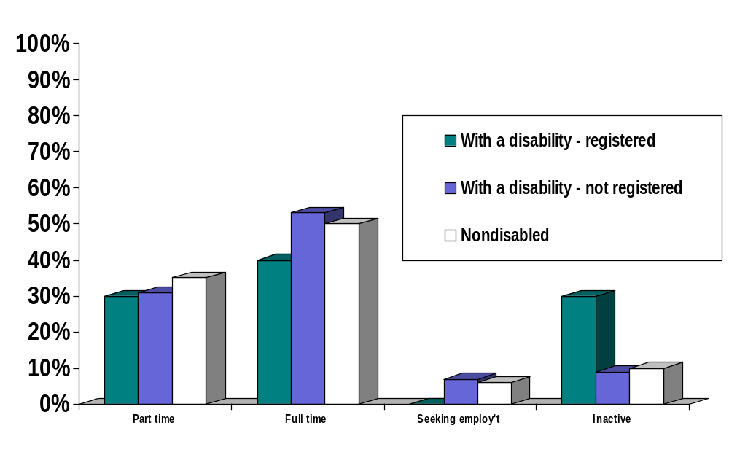
Figure 16

Graduates Studying Full Time

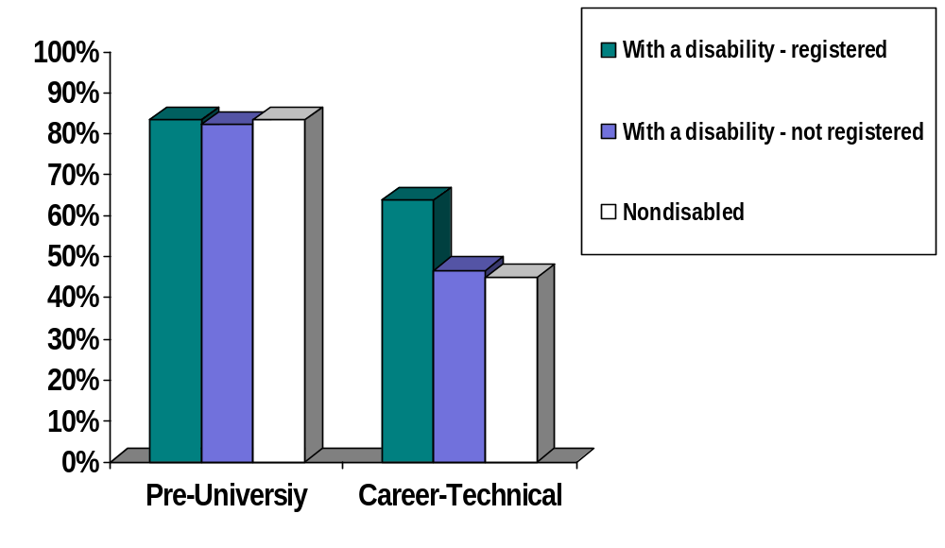

Calculation of the employment rate includes only those graduates who are working or actively seeking work. Those who are studying or claim they are unavailable for work are excluded. The percentage of the sample included in the employment rate calculations is shown in Table 66 for pre-university programs and in Table 67 for career/technical programs. Since the majority of pre-university graduates continue their studies, the number of these graduates actively involved in the labor market is relatively small compared to the total number of pre-university graduates in the sample. The employment rates for graduates of pre-university and career/technical programs are shown in Table 68 and Table 69, respectively.

Table 66

Proportion Of Sample Used In Calculating Employment Rates For Graduates Of Pre-University Programs.

Status | Total Replies To Work Question | Total Included In Employment Rate Calculation |  | Total Who Were Studying Or Not Looking For Work |  | % Included
With A Disability
Registered | 12 | 0 |  | 12 |  | 0%
Unregistered | 78 | 14 |  | 64 |  | 17.9%
Total | 90 | 14 |  | 76 |  | 15.6%
No Disability | 752 | 108 |  | 644 |  | 14.4%
Total Pre-university | 842 | 122 | 720 |  | 14.5%
Note. There were 844 pre-university program graduates. However, 2 did not reply to the work or study question.

A two-way contingency table analysis was conducted to determine whether there was a significant difference in employment rates between students with and without disabilities. The two variables were disability group with 2 levels (With a Disability, No Disability) and employment category with two levels (Employed, Not Employed). The chi-square test shows that there was no significant difference in the employment rates of pre-university graduates with disabilities (92.9%) compared to those without disabilities (88.0%), χ² (1, N = 122) = 0.29, p = .059. There was also no significant difference in the employment rates of career/technical program graduates with disabilities (98.3%) compared to those without disabilities (95.0%), χ² (1, N = 417) = 1.24, p = 0.265.

Table 67

Proportion Of Sample Used In Calculating Employment Rates For Graduates Of Career/Technical Programs

Status | Total Replies To Work Question | Total Included In Employment Rate Calculation | Total Who Were In Study Or Not Looking For Work | Total Included
With A Disability
Registered | 11 | 5 | 6 | 45.5%
Unregistered | 75 | 53 | 22 | 70.7%
Total | 86 | 58 | 28 | 67.4%
No Disability | 540 | 359 | 181 | 66.5%
Total Career/Technical | 626 | 417 | 209 | 66.6%
Note. There were 629 career/technical program graduates; however 3 did not reply to the work question.

Table 68

Employment Rates in Pre-University Programs

Status | Active | Working Full Time | Working Part Time | Looking for Work | Working Full Time | Working Part Time | Unemployment Rate | Employment Rate
With A Disability
Registered | 0 | 0 | 0 | 0 | na | na | na | na
Unregistered | 14 | 9 | 4 | 1 | 64.3% | 28.6% | 7.1% | 92.9%
Total | 14 | 9 | 4 | 1 | 64.3% | 28.6% | 7.1% | 92.9%
No Disability | 108 | 57 | 38 | 13 | 52.8% | 35.2% | 12.0% | 88.0%
Total Pre-University | 122 | 66 | 42 | 14 | 54.1% | 34.4% | 11.5% | 88.5%

Table 69

Employment Rates In Career/Technical Programs

Disability Status | Active | Working Full Time |  | Working Part Time |  |  | Looking for Work |  | Working Full Time |  | Working Part Time |  | Unemployment Rate |  | Employment Rate
With A Disability
Registered | 5 | 4 |  | 1 |  |  | 0 |  | 80.0% |  | 20.0% |  | 0.0% |  | 100.0%
Unregistered | 53 | 40 |  | 12 |  |  | 1 |  | 75.5% |  | 22.6% |  | 1.9% |  | 98.1%
Total | 58 | 44 |  | 13 |  |  | 1 |  | 75.9% |  | 22.4% |  | 1.7% |  | 98.3%
No Disability | 359 | 267 |  | 74 |  |  | 18 |  | 74.4% |  | 20.6% |  | 5.0% |  | 95.0%
Grand Total | 417 | 311 |  | 87 |  |  | 19 |  | 74.6% |  | 20.9% |  | 4.6% |  | 95.4%
Note. There were only 5 registered graduates who were "active."

A chi-square test was carried out to determine whether there was a significant difference between graduates with and without disabilities in the proportions working full time, part-time and seeking work. The two variables were Disability Group with 2 levels (With a Disability, No Disability) and Employment Category with 3 levels (Employed Full Time, Employed Part Time, Seeking Work). The test showed that there was no significant difference for either pre-university, χ2 (2, N = 122) = 0.72, p = .698, or career/technical program graduates, χ2 (2, N = 417) = 1.28, p = .528.

Are graduates working in the fields in which they studied? To calculate the percentage of graduates employed in the field of study of the program from which they graduated only those who were in full time employment and who replied to the field of study question were included. This is in accordance with the methodology use by the MELS in the Relance publications (Ministère de l'Éducation, Loisir et Sport, 2004). This left a sample of 66 pre-university and 310 career/technical program graduates. The percentages of graduates employed in the field of study of the program from which they graduated are shown in Table 70 for pre-university programs and in Table 71 career/technical programs.

Table 70

Pre-University Programs – Employment in Field of Study

Disability Status | Fully Related | Not Related | Partially Related | Grand Total | % Closely Related | % Partially Related | %  Not Related | % Related  (Fully+Partially)
With A Disability
*Registered
Unregistered | 1 | 6 | 2 | 9 | 11.1% | 22.2% | 66.7% | 33.3%
Total | 1 | 6 | 2 | 9 | 11.1% | 22.2% | 66.7% | 33.3%
No Disability | 4 | 40 | 13 | 57 | 7.0% | 22.8% | 70.2% | 29.8%
Pre-University Total | 5 | 46 | 15 | 66 | 7.6% | 22.7% | 69.7% | 30.3%

*There were no registered graduates who met the criteria for inclusion.

Table 71

Career/Technical Programs – Employment in Field of Study

Disability Status | Closely Related | Not Related | Partially Related | Grand Total | % Closely Related | % Partially Related | % Not Related | % Related  (Fully+Partially)
With A Disability
Registered | 2 | 1 | 1 | 4 | 50.0% | 25.0% | 25.0% | 75.0%
Unregistered | 24 | 7 | 8 | 39 | 61.5% | 20.5% | 17.9% | 82.1%
Total | 26 | 8 | 9 | 43 | 60.5% | 20.9% | 18.6% | 81.4%
No Disability | 204 | 25 | 38 | 267 | 76.4% | 14.2% | 9.4% | 90.6%
Career/Technical Total | 230 | 33 | 47 | 310 | 74.2% | 15.2% | 10.6% | 89.4%

The percentage of graduates employed in the field of study of their programs was lower for pre-university programs (30.3%) than for career/technical programs (89.4%). This is not surprising given that pre-university programs are designed to prepare graduates for university rather than for the workforce. There was, however, no significant difference between pre university graduates with and without disabilities employed in a field of study that was related to their program (33.3% vs. 29.8%), χ2 (1, N = 66) = 0.05, p = 0.83. This was also true when the proportion of graduates in a field closely related to the program was compared, χ2 (1, N = 66) = 0.19, p = 0.67.

There was, also no significant difference between graduates with (81.4%) and without disabilities (90.6%) in the proportion of career/technical program graduates employed in a field of study that was related to their program, χ2 (1, N = 310) = 3.33, p = 0.07. However, when the proportions of graduates in a field closely related to their programs were compared, for graduates with (60.5%) and without disabilities (76.4%) the difference was significant, χ2 (1, N = 310) = 4.91, p < .05. This suggests that although the employment rates for graduates with and without disabilities in career/technical programs are similar, graduates with disabilities are less likely to be employed in a field of study closely linked to their program. It was not possible to conduct a meaningful analysis of the registered graduates due to the small size of the sample. Similarly, employment rates by disability type were not calculated due to the small numbers in each category.

Results In Brief

Sample characteristics. Before discussing the findings it is important to note that there were five distinct samples in this investigation. The samples were

        - 57 Cegep based disability service providers
        - 300 current students with various disabilities who were enrolled at the time of testing at one of the public Cegeps and who were registered to receive disability related services
        - 1486 recent Cegep graduates from 2 large French Cegeps and 1 large English Cegep
          - 1304 who were nondisabled
          - 182 who had a disability
            - 24 of whom were registered to receive disability related services from their college
            - 158 of whom were not registered to receive disability related services.

Cegep based disability service providers. The 57 disability service provider participants represent a response rate of 83%. They worked in 42 different Cegeps. Slightly over half were women. Although there was considerable variability, they had been working an average of 7 years providing services to students with disabilities. On average, providing services to students with disabilities constituted 20% of their workload, but again there was substantial variability. More than ¾ of the disability service providers had provided services to students with learning disabilities/ADD, mobility and hearing impairments. Less than half, however, had provided services to students with psychological/psychiatric disabilities, medically related conditions, or speech/communication impairments.

Current students with disabilities who were registered to receive disability related services. The mean age of the 300 students, who were enrolled in 32 different Cegeps, was 21. Almost ⅔ were women. The return rate for current students was 32%. By far the largest number of students, over 90%, were enrolled in a diploma program with approximately ½ enrolled in a pre-university program and ½ in a career/technical program. Less than 7% were enrolled in an attestation program or in another course of studies. Students had various impairments. The most common impairment/disability was a learning disability/attention deficit disorder, followed by mobility impairment, hearing impairment, medically related disability, and psychological disability. It is noteworthy than approximately ⅓ of the students had more than one impairment, with approximately 10% having 3 or more impairments.

Recent Cegep graduates. The 1486 graduates who responded to the survey represent a 28% return rate. The average age of the graduates was 22.5 years and 182 of them (12%) indicated that they had a disability. This percentage was similar in the three participating Cegeps. Of graduates with a disability, 24 (13%) were registered with their Cegep disability service provider and 158 (87%) were not registered. Again, these percentages were similar in the three Cegeps. Slightly over ⅔ of both graduates with and without disabilities were female. Graduates with disabilities were slightly (1/2 year) but significantly older than graduates without disabilities. As was the case for current students with disabilities, approximately half of the graduates with disabilities were enrolled in a pre-university program and half in a career/technical program This was true both of graduates with and without disabilities. There were substantial and significant differences in the nature of impairments of graduates with disabilities who had registered to receive disability related services compared to those who did not register. Registered graduates were more likely to have a learning disability/ADD or a hearing impairment and to have more than one disability. In addition, of the unregistered graduates, the largest percentage had a visual impairment, while none of the registered graduates reported this. Unregistered graduates were also more likely to have a medical or psychological impairment than registered graduates.

Implications of the demographic findings for the interpretation of the results. While the demographic section serves to describe the samples, in the present context it also provides vital information needed when interpreting the results. First, there are numerous implications of the very small sample of graduates with disabilities who were registered to receive disability related services. Our findings (Jorgensen et al., 2005) show that Dawson students with disabilities and nondisabled students graduate at the same rate given sufficient time. Nevertheless, our current findings show that the small proportion of students with disabilities registered to receive services in the Cegep system in 1999 (Fichten et al., 2003, 2005) continues to the present day. Only a small numbers of graduates with disabilities had registered to receive disability related services. Second, it is inappropriate to assume that the disability related obstacles and facilitators for students and graduates with one type of impairment are similar to those of individuals with a different impairment. Learners with different impairments may require either similar accommodations (e.g., extended time for exams) or disability specific accommodations and services (e.g., a sign language interpreter). For example, while most students can benefit from lighter course loads and extended time for exams, it is primarily students with visual impairments and with learning disabilities who are likely to need materials in alternate formats. Students with psychiatric impairments and many medical conditions generally do not need this type of accommodation. Similarly, it is primarily students and graduates with mobility and neuromuscular impairments who are likely to need adapted transport, home care, and architectural modifications to their home. Students with many other impairments do not require this.

To make the Cegep Experience Questionnaire (CEQ) comprehensive, we included items that are likely, in varying degrees, to be important obstacles or facilitators to students with specific disabilities. This both increases certain types of validity (e.g., ecological validity, face validity) and complicates the evaluation of the findings because in certain cases this has meant very small numbers of participants answering certain questions.

Representation of students and graduates with disabilities in the cegeps.

Current students with disabilities registered to receive disability related services. We asked disability service providers how many students with a disability were registered with them to receive disability related services. Disability service providers from 44 of the 48 Cegeps provided data which ranged from 0 to 238 students with disabilities/Cegep, for a total of 1069 students. The average number of students with a disability per Cegep was 24, with a median of 12, which we believe better represents the findings. These figures translate into .84% of the student body (i.e., less than one student per 100 full time students).

We also obtained data from the 3 "centres d'accueil" about the total number of students with disabilities for whom the MELS funds the Cegeps. The findings show that Cegeps received funding only for 391 of the 1069 students (i.e., 37%). These figures translate into disability related funding for .31% of the student body (i.e., funding for approximately 1 in 300 full time students).

Changes from 1999 to 2004: Current students with disabilities registered to receive disability related services. One of our goals was to examine what changes occurred during the past 5 years in the proportion of students who are registered to receive disability related services at their Cegep. We did this because in a recent study of Canadian disability service providers we found that Québec had a smaller proportion of both college (⅔% vs. 6%) and university (1/2% vs. 2½%) students with disabilities than the rest of Canada (Fichten, Asuncion, Barile, Robillard, Fossey, & Lamb, 2003). Our data show that the situation has improved, but not significantly.

Comparison of data from service providers concerning the number of students registered to receive disability related services from the Cegep from the same 31 Cegeps in 1999 and 2004 show that in 1999, of a full time student body of 105,153 students 787 students were registered to receive services from their Cegep (i.e., .75%). In 2004, the corresponding numbers are 940 students with disabilities among a full time student enrolment of 100,369 (i.e., .94%), with a trend toward a larger proportion of students with disabilities. When we carried out a t-test to compare the mean percentages, we found that the change was not significant.

We also compared data from 1999 and 2004 for the same 31 Cegeps. Variables included the number of students with disabilities enrolled, the overall enrollment at the Cegep, and number of students for whom the Cegeps received funding from the MELS. Here, the data show a similar change. In 1999, of a full time student body of 105,153 students the Cegeps were funded to provide disability related services to 252 students (i.e., .24% of the full time student body and 32% of the 787 students with disabilities registered to receive services). In 2004, the corresponding numbers are funding for 343 students with disabilities among a full time student enrolment of 100,369 (i.e., .34% of the full time student body and 36% of the 940 students with disabilities registered to receive services), with a trend toward a larger proportion of students with disabilities. t-tests c the proportion of the student body for whom the MELS provides funding showed that the MELS provides disability related funding for a significantly larger proportion of the full time student body in 2004 than in 1999. However, the test comparing the proportion of registered students for whom the Cegeps receive funding was not significant.

Changes over time in the proportions of students with different impairments: Current students with disabilities registered to receive disability related services. Our findings on current students with disabilities who are registered with their Cegep to receive disability related services shows that the largest number had a learning disability with or without attention deficit/hyperactivity disorder. This was the case for students from both French and English Cegeps. Statistics provided by the managers in charge of services for students with disabilities at the 3 "centre d'accueil" Cegeps provided current and historical data for students who are registered to receive disability related services from a Cegep and for whom funding is provided by the MELS. These show important changes during the past decade in the proportion of students with different impairments. For example, in 1992 67% of students for whom the eastern portion of Québec received funding consisted of students with visual and hearing impairments. By 2004 that number had decreased to 37%, when students with learning disabilities, for whom funding is currently based on a lump sum rather than on a per student formula, are excluded. The number is 30% if students with learning disabilities are included in the calculations (Juhel, 2006). These figures show large increases in the number of students with a learning disability and those who fall into the "other" disability category, such as mobility and neuromuscular impairments, certain chronic medical and neurological conditions, and pervasive developmental disorders. Similarly, at Dawson College in the fall of 2006 only 35% of funded students had a visual or hearing impairment when students with learning disabilities are excluded from the computation (Havel, 2006). In the western portion of Québec in 1996 the proportion of students with visual and hearing impairments was 61% (Fiset, 2004). This percentage dropped to 57% in 2004 when students with learning disabilities are excluded from consideration and to 48% when these students are included (Fiset, 2006). As Daniel Fiset noted (Fiset, personal communication, 2004), "Learning disability is an English disease. But the French are rapidly catching it."

Graduates. 182 of the 1486 graduates who responded to the survey (i.e., 12%) indicated that they had a disability. This percentage was similar in the three participating Cegeps. Of graduates with a disability, 24 (13%) were registered with their Cegep disability service provider and 158 (87%) were not registered. Again, these percentages were similar in the three Cegeps. Many of the unregistered graduates have a medical or a psychological impairment.

Using the Cegep Experience Questionnaire (CEQ) to facilitate student success.

Refining the CEQ - Psychometric Analyses. The Cegep Experience Questionnaire (CEQ) measure we refined in this investigation is based on a modified version of Fougeyrollas et al.'s (1999, 2001) PPH model. It evaluates obstacles and facilitators from three vantagepoints: (1) the student's personal situation, (2) the Cegep environment, and (3) government and community supports and services. Therefore, in a previous investigation we grouped the 32 items of the Cegep Experience Questionnaire into three subscales and a total "Index of Difficulty."

Students make ratings on the 32 items of the Cegep Experience Questionnaire using a 6-point Likert-type scale (1 = much harder, 6 = much easier, and "not applicable"). We grouped the 32 items based on face validity into the following three subscales:

- Students' Personal Situation (9 items including 1 that is only applicable to students/graduates with disabilities)
- Cegep Environment (14 items including 1 that is only applicable to students/graduates with disabilities)
- Government and Community Supports and Services (9 items including 4 that are only applicable to students/graduates with disabilities)
- Index of Difficulty (IDF) (25 items are common to students with and without disabilities, 6 are applicable only to students/graduates with disabilities).

To be consistent with the goals of providing a scale that can be used on an item-by-item basis as well as having subscales, we used single item, subscale, and Index of Difficulty (IDF) scores in the analyses. Two versions of the Index of Difficulty (IDF) and of the subscale scores can be calculated: one set includes only those items which are applicable to both students/graduates with and without disabilities. These are best when comparing scores of students/graduates with and without disabilities. A second set was calculated that includes items that are disability specific. This set of scores is best used in analyses dealing only with students/graduates with disabilities. The items included in each subscale can be seen in Table 34. To compile subscale scores data only from participants who answered a minimum of 50% of items on the subscale in question are summed. IDF scores are summed only for those participants who completed at least 50% of all items.

In a previous investigation (Fichten, Jorgensen, Havel, & Barile, 2005) we provided preliminary psychometric information for the measure. In the present investigation we obtained additional indices of reliability and validity. This includes test-retest data from 159 current students with disabilities. Results indicate that on the item-by-item, subscale, and index of difficulty test-retest correlations all coefficients are of moderate to large size and highly significant. Moreover, the vast majority of test and retest scores did not differ significantly. We also evaluated the internal consistency of subscales both for current students with disabilities as well as for graduates with and without disabilities. Cronbach's alpha scores range from .58 to .89, suggesting that the internal consistency of subscales is acceptable. In addition, the findings show modest significant correlations among subscales and high and significant correlations between subscale and Index of Difficulty scores.

What factors make cegep studies easier? Harder?

Analysis of open-ended obstacle/facilitator responses. Part of the process of determining the facilitators and obstacles that students with disabilities face in the Cegeps involved analysis of the responses of all participants to a series of two open-ended questions that dealt with factors that have made Cegep studies easier and harder for students. Campus based disability service providers responded based on their perception of the circumstances of students with disabilities. Current students with disabilities, graduates with disabilities, and nondisabled graduates responded based on their own experiences and circumstances. It should be noted that depending on the specific student's situation and on the specifics of the environmental conditions, the same topic could be either an obstacle or a facilitator. It should also be noted that all learners, whether they have a disability or not, are influenced by factors common to all students such as good and poor teachers.

Current students with disabilities and disability service providers. To provide a picture of similarities and differences between these two groups, obstacles and facilitators identified by current students with disabilities and campus based disability service providers were compared. In general, both students and campus based disability service providers indicated more Cegep based facilitators than obstacles and more student's personal situation and community and government supports and services obstacles than facilitators.

Facilitators: Current students with disabilities and disability service providers. Current students with disabilities, all of whom were registered to receive disability related services from their Cegep, were most likely to indicate that disability related accommodations were the most important facilitators. These include: services for students with disabilities in general and specific disability related accommodations such as having a note taker or interpreter in class, extended time for exams and assignments, and an accessible building, as well sensitization and information dissemination about disabilities.
Approximately half of the facilitators cited most frequently by students with disabilities were not specifically disability related but issues of concern to all students. These include: good teachers, the Cegep environment, tutors and learning centers (which assist with studying, writing, and exam taking skills and provide tutoring), the availability of computers and of support and help. Other factors that students indicated made their studies easier are the facilitating role of: friends and family, having a good schedule, and their financial situation, motivation, and study skills.

Although many of the important facilitators noted by current students with disabilities were also noted by campus based disability service providers, there were exceptions. For example, although students identified friends, their schedule, their family, finances, and the possibility to take a reduced number of courses and still be considered "full time students," disability service providers did not do so. Campus based disability service providers, on the other hand, indicated that a small college, the service provider being knowledgeable about disabilities, pre-registration for courses before other students register, helpful staff, and the availability of good counselling and academic advising were important facilitators, as well as the student's personal situation - factors not noted by students with disabilities.

Obstacles: Current students with disabilities and disability service providers. In general, obstacles noted by most students with disabilities were not specific to students with disabilities. Important obstacles included: poor teachers, difficult courses, poor schedules, having to hold a job, students' personal situations in general, the Cegep environment, transportation issues, students' finances, lack of availability of computers, too many courses, poor study skills, bad schedules, transition related issues, demanding and boring programs, poor motivation, and insufficient time.

Most obstacles noted by campus based disability service providers were also noted by students with disabilities. A notable exception relates to disability related accommodations, aspects of which close to ½ of disability service providers saw as an obstacle, while only 2% of students with disabilities did so. Other exceptions are as follows. Service providers noted that important obstacles included poor or few accommodations and services for students with disabilities, lack of information and sensitization about disabilities, disability service providers not having adequate knowledge about disabilities and accommodations, and students' poor self-advocacy skills. Students, on the other hand, noted the following important obstacles that were not mentioned by service providers: too many courses, problems with their courses and programs of study in general, insufficient time, bad schedules, transition issues, having to hold a job, and poor motivation, study skills, and health.

Commonalities between obstacles and facilitators: Current students with disabilities and disability service providers. Depending on the student's situation and on the specifics of the environmental conditions, the same factor was seen as either an obstacle or a facilitator. For example, for current students with disabilities teachers, the availability of computers, the Cegep environment, their schedules, and course load were seen either as facilitators or obstacles. The same was true of students' motivation, study skills, and finances.

Cegep based disability service providers also identified several factors as both obstacles and facilitators, depending on the circumstances: the accessibility of Cegep buildings, the overall Cegep environment, how knowledgeable the campus based disability service provider is about disability and accommodations, and sensitization and information about disabilities. Teachers, the availability of computers, and students' personal situations were also seen as both facilitators and as obstacles, depending on the circumstances.

Graduates. Facilitators and obstacles identified by nondisabled graduates and those with disabilities were compared as were the responses of graduates with disabilities who were, and those who were not registered to receive disability related services from their Cegep.

Facilitators: Graduates. Graduates with and without disabilities noted virtually all of the same important facilitators: good teachers, the Cegep environment, their motivation, program, friends, and finances, as well as good transportation, interesting courses, a favorable personal situation, good schedules, easy courses, good support and help, a helpful family, available computers, the library, and good study skills. There were only three exceptions: graduates with disabilities indicated that their classmates and the services for students with disabilities were important facilitators while nondisabled graduates noted that their academic preparation was important.

Obstacles: Graduates. Similarly, most important obstacles were also shared by graduates with and without disabilities. These include: difficult courses, poor teachers, the Cegep environment, poor schedules, a poor personal situation, having to work at a job, poor finances, too many courses, difficulties with one's program of study, transportation issues, poor study skills, and transition concerns. Exceptions are that graduates with disabilities also noted that their study skills, motivation, and family situations posed important obstacles along with the impact of their disability/impairment. Nondisabled graduates, on the other hand, noted that inadequate availability of computers and their academic schedules posed problems.

Graduates with disabilities who were, and who were not registered to receive disability related services. There were many dissimilarities between these two groups. For example, almost half of the graduates registered to receive disability related services noted that this was a facilitator, making this the second most popular option of this group. It is not surprising that students not registered for disability related services did not mention this. In addition, registered graduates noted that a learning center (which provides tutoring and assists with studying, writing, and exam taking skills) was important for them while graduates not registered noted other types of facilitators, such as the Cegep environment, their friends, family, finances, study skills, and personal situation in general as well as good transportation and library facilities.

Similarly, registered graduates were much more likely to indicate that their disability and health were obstacles along with poor access to computers. Graduates with disabilities who did not register, on the other hand, noted that their course load and program of studies posed obstacles along with transition issues, transportation problems their family situations and poor motivation. It is noteworthy that none of the registered graduates indicated that disability related accommodations posed an obstacle.

Analysis of Cegep Experience Questionnaire (CEQ) responses.

Current students with disabilities who are registered to receive disability related services and campus based disability service providers. Although it may seem obvious, it nevertheless needs to be underscored that students with disabilities are, first and foremost, students. To the extent that they attend college they are subject to many of the same obstacles and facilitators as nondisabled students.

Students with disabilities. That having been said, the results indicate that the availability of disability related services and accommodations was seen as the most important facilitator by students with disabilities and the impact of their disability was seen as the most important obstacle. In general, aspects of the Cegep environment were the most facilitating, students' personal situations posed the most difficulty, with government and community supports and services being in between. In particular, the following items were seen as the 10 most important factors that made students' college studies easier.

- Availability of disability related services at the Cegep
- Attitudes of non-teaching staff
- Availability of computers off-campus
- Accessibility of building facilities
- Accessibility of Cegep physical education courses
- Availability of course materials
- Friends
- Availability of computers on campus
- Level of personal motivation
- Attitudes of students

The following were seen as obstacles by students:

- Impact of my disability
- Course load
- Level of difficulty of courses
- Paid employment
- Financial situation
- Availability of adapted transportation for people with disabilities

We expected that the more impairments students had, the more obstacles they would encounter. The results show that for 9 of the 10 instances where there was a significant correlation, the more disabilities students had, the more likely they were to experience obstacles.

Nature of students' impairments and Cegep Experience Questionnaire results. Students with different impairments were expected to have different responses on disability specific items of the scale. For example, while factors such as accessibility of the class and coordination between needed external support services were expected to elicit ratings by students who use a wheelchair, these were expected to be answered "not applicable" by students with visual impairments. Too numerous to detail, these results can best be seen in Tables 43 and 46.

Campus based disability service providers. Disability service providers made importance rather than easy-difficult ratings, so their scores cannot be compared directly to easy-difficult ratings made by students. The results indicate that, in general, service provision items were seen as most important, followed by items dealing with students' personal situations, the Cegep environment, and government and community supports and services. In particular, the 10 most important service provision related items were:

- Collaboration between professors and disability service providers
- Availability of affordable diagnostic services (e.g., LD assessment) external to the Cegep
- Students’ ability to express their needs
- Attitudes of the administration toward services provided to students with disabilities
- Identification of students' individual needs by the disability service provider
- Students’ awareness of the impact of their disability
- Budget allocated for disability services at the Cegep
- Willingness of students to use suitable accommodations
- Students' choice of career
- Professors’ level of knowledge about disability services / accommodations

Of the aspects which students also rated, the 10 most important factors seen as being implicated in the academic performance of Cegep students with disabilities were:

- Students' level of personal motivation
- Attitudes of professors
- Availability of disability related services at the Cegep
- Students' study habits
- Willingness of professors to adapt courses to the student's needs
- Students' health
- Accessibility of building facilities
- Availability of adapted transportation for people with disabilities
- Students' course load
- Attitudes of students
Comparison of disability service providers' importance ratings and current students' facilitators and obstacles ratings. When we correlated campus based disability service providers' importance ratings with students' easy-difficult ratings we found that these were not significantly related. Similarly, we also carried out a direct comparison of service providers' and current students' importance ratings by collapsing the easier-harder scores of students (i.e., If an item was a major facilitator or a major obstacle we rated this as very important. Items with slightly easy-difficult scores were scored as unimportant. Items rated by the students as making their studies moderately easier or more difficult were scored as medium in importance. When we correlated these "importance" scores of students with the importance ratings by campus based disability service providers we found that the correlation was low and nonsignificant.

Nevertheless, on the top 11 items of importance students and service providers agreed upon most. Differences show that campus based disability service providers felt that the attitudes and willingness of professors to adjust their courses to students' needs were important as well as students' study habits, health, and course loads, and the attitudes of other students. Students felt that the availability of computers off-campus and of physical adaptations at home were important along with public transportation, the accessibility of Cegep physical education courses, and their friends and family situation.

We also examined items seen by disability service providers as most important, mid-range in importance, and least important and examined students' facilitator and obstacle scores in relation to these. The results show that the number 1 ranked facilitator, considered a facilitator by 70% of students, was the availability of disability related services at the Cegep, an item among those seen as the most important by service providers. The corresponding greatest obstacle, endorsed by 53% of students, was the impact of their disability; this item, however, was only seen as being of intermediate importance by service providers. In addition, among items rated in the most important range by disability service providers, two items had student scores in the obstacle range: availability of adapted transportation for people with disabilities and course load. In addition, three items that were seen as among the least important by disability service providers were seen as major obstacles by students with disabilities: financial situation, paid employment, and level of difficulty of courses.

Graduates. Three groups of recent graduates completed the CEQ: graduates who were nondisabled, graduates with a disability who were registered to receive disability related services from their college, and graduates with disabilities who were not registered to receive disability related services. While we did expect to find differences between graduates with and without disabilities on certain items as well as between graduates who had registered to receive disability related services and those who did not, (e.g., health), in most cases we expected more similarities than differences.

Graduates with vs. without disabilities. There was considerable overlap between the items that were perceived as the greatest obstacles and facilitators by graduates with and without disabilities. Three of the four items with the highest mean scores were common to both groups. The seven items with the lowest mean scores were also common to both groups. However, results on the 26 items which were applicable to graduates with and without disabilities (of the total of 32 items six are applicable only to graduates with disabilities) show that, overall, graduates with disabilities had significantly lower scores on the overall Index of Difficulty than nondisabled graduates. Examination of the items showed that graduates with disabilities had less facilitating scores mainly on items dealing with their personal situation. For example, graduates with disabilities rated their families as less supportive than did nondisabled graduates. As expected, graduates with disabilities, as a group, had significantly less facilitating scores on the health item as well. Comparison of scores of graduates with different disabilities shows that this is largely due to the nature of graduates' impairments, as health was more of an obstacle for graduates with medical and psychological impairments while it was more of a facilitator for graduates with learning disabilities and visual impairments. It should be noted that although level of personal motivation was rated as a very important facilitator by most students, it was especially facilitating for students with learning disabilities and/or attention deficit disorder. Overall, there were no significant difference between graduates with and without disabilities on the Cegep Environment subscale. There was one notable exception however: graduates with disabilities in career/technical programs (but not pre-university programs) found professors less accommodating of their needs than graduates without disabilities.

It should be noted, however, that differences may often have been obscured by very small sample sizes. Therefore, we also examined similarities and differences in the relative rankings of scores by graduates with and without disabilities. The results show that rankings by graduates with and without a disability were closely related. Nevertheless, there were some important discrepancies. The health of nondisabled graduates was ranked first (i.e., most facilitating) while this item was ranked 19th out of 26 by graduates with disabilities. Similarly, while their families were ranked number 6 by nondisabled graduates, this item was ranked 15th by graduates with disabilities.

It is noteworthy that for both graduates with and without disabilities the following items were among the highest in the rankings (i.e., most facilitating).

- Level of personal motivation
- Friends
- Accessibility of classrooms/labs etc.
- Previous educational experience
- Availability of computers off-campus
- Public transport
- Availability of course materials
- Availability of disability related services (graduates with disabilities only)
- Accessibility of Cegep physical education courses

Similarly, for both graduates with and without disabilities the following items were among the lowest in the rankings (i.e., least facilitating).

- Course schedule
- Financial situation
- Level of difficulty of courses
- Disability related support services off-campus (graduates with disabilities only)
- Availability of financial aid
- Scheduling conflicts between disability related services (graduates with disabilities only)
- Computer technologies training off-campus
- Paid employment
- Course load
- Impact of disability (graduates with disabilities only)

Graduates with disabilities who were vs. were not registered for disability related services from their Cegep. We also compared the scores of graduates with disabilities who registered and those who did not register for disability related services. Here, the results are conclusive: graduates with disabilities who had registered to receive disability related services had scores that were more facilitating than graduates who did not register. This was true on the overall index of difficulty as well as on the Cegep environment subscale. Differences in favor of registered graduates were also found on specific items. These are:
- Level of personal motivation
- Course schedule
- Attitudes of non-teaching staff
- Availability of computers on campus
- Availability of course materials
- Availability of disability related services

Nondisabled graduates vs. registered graduates with disabilities vs. non-registered graduates with disabilities. When we compared the scores of the three groups of graduates directly, the results show that the registered group of graduates with disabilities had higher (i.e., more facilitative) overall index of difficulty scores than did nondisabled graduates, who, in turn had higher scores than graduates with disabilities who had not registered.

We also compared the rankings of the two groups of graduates. The results show that rankings of graduates with and without a disability were closely related. For example, the following items had the highest ranks (i.e., most facilitating) in both samples of graduates.

- Level of personal motivation
- Availability of computers off-campus
- Availability of course materials
- Friends
- Attitudes of professors
- Previous educational experience

Similarly, there were many commonalities among items with the lowest ranks (i.e., least facilitating). Not surprisingly, the item dealing with the impact of their disability ranked lowest for both groups.

- Course schedule
- Health
- Level of difficulty of courses
- Financial situation
- Course load
- Paid employment
- Availability of financial aid
- Impact of my disability

Nevertheless, there were some important discrepancies. For example the availability of disability related services at the Cegep ranked near the top of the list for registered graduates but was in the lower half of the ranking of unregistered graduates, suggesting that those graduates who registered for services found that disability related services was one of the main factors that made their Cegep experience easier. The items dealing with the availability of computers on campus as well as with the accessibility of Cegep physical education courses also showed large differences in rankings, with considerably higher rankings by registered graduates than by unregistered graduates.

What should be changed? Analysis of open-ended recommendations for changes.

Current students with disabilities and campus based disability service providers. Approximately 10% of students with disabilities felt that things were reasonably good and that no changes were needed, whereas this response was not given by any of the service providers. Of high priority to both students with disabilities and disability service providers was the need for sensitizing and informing others about disabilities. Other changes frequently suggested by both groups were improving general support and help in the Cegep, improving services for students with disabilities, including providing better access to computer technologies and better accessibility of building and facilities. Promoting collaboration and communication between staff, teachers and students, increased funding for their services, and better availability of tutoring were frequent suggestions made by disability service providers. Students, but not campus based disability service providers, also wanted easier courses, better teachers, and more human assistance.

Graduates. Changes suggested by graduates with and without disabilities were very similar and were generally aimed at the Cegep in general. Of greatest importance to both groups were better schedules and teachers, improving programs and courses in general, more available computer technologies and support and help from Cegep staff as well as improvements to the physical environment of the college. A slightly larger proportion of graduates with disabilities suggested the need for easier courses, better building accessibility and more government support.

What happens after graduation?

Studying. The activity profiles for graduates with and without disabilities were very similar; this was true for both pre-university and career/technical program graduates. For example, 83% of graduates with disabilities in pre-university programs were studying after graduation compared to 84% of graduates without disabilities, rates that are consistent with the MELS Relance data reported for pre-university programs (Ministère de l’Éducation, Loisir et Sport, 2000). In both groups approximately 31% of career/technical program graduates were continuing their studies.

Employment rates. Calculation of employment rate includes only those graduates who were working or actively seeking work. Those who were studying or indicated they were unavailable for work are excluded. The results here, too, show that employment rates of pre-university graduates with disabilities (93%) and without disabilities (89%) were very similar. Nor was there a significant difference in the employment rates of career/technical program graduates with (98%) and without disabilities (95%); this was true whether they were or were not registered to receive disability related services from their Cegep. Employment rates by disability type were not calculated due to the small numbers in each category.

What about full time and part-time status? The results again show no significant differences between graduates with and without disabilities, whether they had registered to receive disability related services from their Cegeps or not, in the proportions working full time, part-time and seeking work for either pre-university or career/technical program graduates.

Are graduates working in the fields in which they studied? It was not surprising that the percentage of graduates employed in the field of study of their programs was considerably lower for pre-university programs than for career/technical programs. There was, however, no significant difference between graduates with and without disabilities in the proportion of pre-university graduates employed in a field of study that was related to their program. This was also true of the proportion of career/technical program graduates employed in a field of study that was related to their program: the rates were 81% and 91% for graduates with and without disabilities, respectively. However, when the proportions of career/technical program graduates in a field closely related to their programs were compared, for graduates with (61%) and without disabilities (76%) the difference was significant. This suggests that although the employment rates for graduates with and without disabilities in career/technical programs are similar, graduates with disabilities are less likely to be employed in a field of study closely linked to their program. It was not possible to conduct a meaningful comparison of registered and unregistered graduates or of graduates with different impairments due to small sample sizes.

Summary, Discussion, Conclusions, and Recommendations

Sample Characteristics And Representation Of Students And Graduates With Disabilities In The Cegeps

Summary: Campus based disability service providers and learners with disabilities in the Cegeps. Although this varied greatly, campus based disability service providers typically had seven years experience in the job and devoted an average of one day per week to providing services to students with disabilities. Over half of the campus based disability service providers reported that they had experience providing services to students with learning disabilities, and mobility and hearing impairments. However, less than half of them had experience providing services to students with medical and psychological disabilities.

As is the trend in all postsecondary education, Cegep students with disabilities and all three groups of graduates were more likely to be female than male. This is similar to results for Dawson College graduates from a previous investigation (Fichten, Jorgensen, et al., 2005). Consistent with the results of an earlier study (Jorgensen et al., 2005), where we found that Cegep students with disabilities take one semester longer to graduate, in the present investigation we found that Cegep graduates with disabilities are, on average, ½ year older than their nondisabled counterparts. The vast majority (over 90%) of both current students with disabilities and all three groups of graduates were enrolled in a regular diploma program: approximately ½ in a pre-university program and ½ in a career/technical program.

The nature of the impairments of those who register to receive disability related services from their Cegep has changed over the years. Among the most common impairments of current students and graduates alike are: a learning disability/attention deficit disorder, mobility impairment, hearing impairment, medically related disability, and psychological disability. Also, approximately 25% of those who register for disability related services have 2 or more impairments.

The impairments of many students with disabilities no longer fit the original tripartite Québec Ministère de l’Éducation, Loisir et Sport (MELS) division of visual impairment, hearing impairment, and "other." In fact, a learning disability, the most common impairment reported by current students registered to receive disability related services from their Cegep, is not funded according to the MELS’s traditional funding formula. Other common impairments of students include certain health and psychiatric and psychological disabilities, impairments which are not recognized or funded by the MELS, and about which disability service providers know relatively little. This trend is similar to that reported for a large sample of American 2 year colleges (D'Amico, 2006).

The proportion of Cegep students who are registered to receive disability related services has risen slightly over 1999 levels. This change, however, is not dramatic and it may not be keeping up with corresponding increases in other provinces. Most troubling is that the percentage of students receiving disability related services continues to be under 1% of the student body. Similarly, the percentage of students registered to receive disability related services for whom the Cegeps receive funding from the Ministère de l’Éducation, Loisir et Sport has improved over the 1999 level, but only slightly: currently, the Cegeps receive funding only for approximately ⅓ of the students who are actually registered to receive services. This has resulted in serious service provision and funding issues. Cegeps handle this problem in various ways. For example, some Cegeps have "waiting lists" for service (Juhel, 2006, personal communication).

Our study of graduates suggests that the actual proportion of Cegep students who self-identify as having a disability hovers around 10%, but that most students with disabilities do not register to receive disability related services. The majority of unregistered graduates with disabilities had medical, psychological, visual or learning disabilities.

Conceptual issues. These include registered vs. unregistered students, funding issues, and the "emerging clientele" of students with disabilities in the Cegeps.

Registered vs. unregistered students. As is the case in the rest of North American colleges and universites, our results suggest that the majority (approximately 90% in our sample) of students with self-reported disabilities in the Cegeps do not register to receive disability related services or accommodations. Therefore, estimating the rate of disability in the Cegeps using only those students who register significantly under-reports the actual rate. This also raises the question of whether there really are, proportionally, very few students with disabilities with disabilities who require disability related services in the Cegep system or whether the students are enrolled, but, for a variety of reasons, do not register to receive disability related services.

Nevertheless, because most students with disabilities are not registered to receive disability related services, accommodations are often not made for them by faculty or staff. Therefore, there is increased need for universal instructional design, which involves educational strategies that are accessible to all students, including those with disabilities (cf. Loewen, 2006; McGuire, Scott, & Shaw, 2003; Nguyen et al., in press; Scott, Loewen, Funckes, & Kroeger, 2003).

Universal instructional design is an outgrowth of the universal design movement in architecture (cf. Connell, et al. 1995). “Universal design is the design of products and environments to be usable by all people, to the greatest extent possible, without the need for adaptation or specialized design The intent of universal design is to simplify life for everyone by making products, communications, and the built environment more usable by as many people as possible at little or no extra cost. Universal design benefits people of all ages and abilities (Center for Universal Design, 2006).

The principles of universal instructional design, adapted from McGuire, Scott, and Shaw (2003), Nguyen et al. (in press), and Scott, Loewen, Funckes, & Kroeger (2003) are presented in Table 72.

Table 72

The 9 Principles Of Universal Design For Instruction
Principle Definition Examples of recommendations
Equitable use  Flexibility in use  Simple, intuitive use  Perceptible information  Tolerance for error  Low physical effort  Size and space for approach and use  A community of learners  Instructional climate | The design does not disadvantage or stigmatize any group of users  The design accommodates a wide range of individual preferences and abilities  Use of the design is easy to understand, regardless of the user’s experience, knowledge, language skills, or current concentration level  The design communicates necessary information effectively to the user, regardless of ambient conditions or the user’s sensory abilities  The design minimizes hazards and the adverse consequences of accidental or unintended actions  The design can be used efficiently and comfortably, and with a minimum of fatigue  Appropriate size and space is provided for approach, reach, manipulation, and use, regardless of the user’s body size, posture, or mobility  The instructional environment promotes interaction and communication among students and between students and faculty  Instruction is designed to be welcoming and inclusive. High expectations are espoused for all. | An access ramp is available in the establishment; multiple modes of presentation of class material (can help diminish language related obstacles)  Offer choices or alternative ways of completing the course workload (can help decrease course difficulty)  Eliminate all material that is unnecessarily complex, use concise vocabulary and speak clearly  Use PowerPoint presentations and/or a projector to communicate class material (using a large font and a good contrast); make the content available online prior to each class  When providing computer based or online exams ensure that it will not be made invalid by an accidental keystroke  Avoid unduly long exams  Classrooms used for exams should take into consideration the number of students and ensure their comfort  Assign students to groups or give them group projects - this will promote greater communication and inclusion among students  Assert you availability to all students; underline your openness to discuss individual needs
Funding issues. Extrapolation suggests that there are approximately 15,000 students with disabilities currently enrolled in the Cegeps (i.e., approximately 10%), although only approximately 10% of them register to receive disability related services from their Cegep. In turn, Cegeps receive funding for only about ⅓ of students who are registered, suggesting that there are serious financial concerns around providing services for students with disabilities.

The "emerging clientele." Reports from the disability service providers and from the managers in charge of services for students with disabilities at the three “centre d’accueil” Cegeps show important trends in the types of impairments presented by students to whom they provide services. Many of these are impairments for which Cegeps receive little or no funding from the MELS. The trend over time shows that the "emerging clientele" of students with learning disabilities, psychiatric and medical conditions has been increasing dramatically, resulting in even more important funding concerns. The "emerging clientele" has also posed difficulties for disability service providers who feel inexperienced and inadequate in providing services to students with some of these impairments (e.g., psychiatric disabilities, Asperger's). This situation has resulted in additional important funding concerns.

The "emerging clientele" has translated into only very modest funding increases to the Cegeps (e.g., a total of $30,000 for all students with learning disabilities in the entire eastern portion of the province (Juhel, 2006, personal communication). Nevertheless, there are some positive developments concerning the "emerging clientele" of students. For example, the MELS has already instituted changes in the Cegeps to ensure that students with learning disabilities receive increased attention from faculty and administration. For example, the entire February 2006 issue of Correspondance (2006), a MELS funded magazine distributed to all professors of French at the French Cegeps, was devoted entirely to students with learning disabilities. In this issue helpful guidelines for accommodating students with learning disabilities in general are provided and there are specific recommendations about accommodations to help these students succeed on the "épreuve uniforme" (i.e., Ministerial Examination of College French (or English) also known as the Exit Exam), a four-hour examination that all Cegep students must pass to obtain their college diploma (DEC) (Fortier, 2006).

Using The Cegep Experience Questionnaire (CEQ) To Facilitate Student Success

We have developed the content of the 32 item closed-ended Cegep Experience Questionnaire and established that it has acceptable reliability and validity. Regular print, large print and digital (Word) versions are provided in the Appendix in French and English. Disability specific items are designated in Table 34. There are no "norms" per se. However, average scores for students with disabilities in general are provided in Table 38. Mean scores for a smaller number of students with specific impairments are provided in Table 45.

What Factors Make Cegep Studies Easier? Harder? What Should Be Changed?

Conceptual issues. These concern the comparison of open-ended listings with Cegep Experience Questionnaire results, the PPH model, and the commonalities and differences between individuals with disabilities who do vs. those who do not register for disability related services.

Comparison of open-ended listings with Cegep Experience Questionnaire results. A one-to-one comparison of open-ended listings and Cegep Experience Questionnaire scores is not possible. The open-ended listing looks at the frequency of how many students spontaneously indicated a topic as a facilitator or an obstacle. The CEQ, on the other hand, provides a mean score for students on the item. Nevertheless, examination of items with "facilitating" mean scores suggests that many of these items also appear on the open-ended listings. This is also true of obstacles, providing additional evidence for the validity of the CEQ measure. For example, for students with disabilities, disability related accommodations were the most frequently mentioned facilitators on the open-ended measure; this is also one of the top ranked item on the CEQ. Health and the impact of one’s impairment were the most frequently mentioned obstacles on the open ended listings by students and graduates with disabilities: these are also common obstacles noted on the CEQ.

Data from the findings of others also provide confidence that the CEQ measure is measuring what it is supposed to measure. For example, several of the facilitator concepts were also reported by the sample of 71 individuals interviewed at Baylor University (Graham-Smith & Lafayette, 2004). Here, researchers found that of accommodations offered at the university, the largest percentage of responses dealt with the attitudes of the staff, a quiet place for exams, extended time for exams, and study skills training and tutoring. Similarly, in a study by Smith and Nelson (1993) the results show that the following were deemed important in influencing college studies: level of personal motivation, study habits, previous education experiences, attitudes of students, attitudes of professors, and disability related services at the college.
PPH model. We examined the obstacles and facilitators to student success at Cegep that students with disabilities, campus based disability service providers and graduates with and without disabilities reported from the vantagepoint of Fougeyrollas' PPH model (Processus de production du handicap: Fougeyrollas, Lippel, St-Onge, Gervais, Boucher, Bernard, & Lavoie, 1999). The PPH model was developed in Québec (Fougeyrollas, Cloutier, Bergeron, Cote, & St Michel, 1998) and is widely used in the rehabilitation community. According to this model the presence of a handicap reduces the ability to perform daily activities; this results from the interaction of personal and environmental factors (Fougeyrollas et al., 1999). In the case of education, daily activities ("habitude de vie") involve attending college, studying, writing, reading and participating in the extracurricular and social activities offered at the college (cf. Lemieux-Brassard, 1996). This approach recognizes that through the individuals’ abilities, and with appropriate interventions, the obstacles that the individual who has an impairment encounters in the educational setting can be overcome. These interventions in Cegeps are often mediated though the campus based disability service providers who provide various accommodations to students with disabilities who register for disability related services.

Our findings show that a very large percentage of students with disabilities may not receive such support to help them overcome obstacles they may encounter as a result of their disability because they do not register for disability related services. The findings show that these unregistered individuals with disabilities report experiencing more difficulties, especially obstacles related to the Cegep environment, than do individuals who either have no disabilities or who do have a disability and have registered to receive disability related services from their college.

Certain factors can serve as both a facilitator as well as an obstacle, depending on the circumstances, and it is the interaction between personal and environmental factors that create either obstacles or facilitators. It is these "common" frequently endorsed items (i.e., those that can be obstacles as well as facilitators) that need to be paid special attention when trying to ensure that Cegeps provide a supportive environment to students. For example, the availability of computers on campus was a popular facilitator - and a popular obstacle - to students. Clearly, if computers with needed adaptations are available in settings where the student needs to work on these, then it is a facilitator. When it is not available or when the available computer does not have needed accessibility features, then it can pose an obstacle.

Future research needs to examine whether it is the same individual who has identified a particular item as both an obstacle and facilitator or whether it is different students who did this (e.g., designate the Cegep environment as a facilitator or an obstacle). Exploring this issue can help determine good student-Cegep environment fit, which may be especially important for students with disabilities. For example, if students who are blind typically indicate that the Cegep environment is an obstacle, while students with mobility impairments indicate that this is a facilitator, then the nature of environmental solutions to best solve problems are likely to differ. In this instance the environment of the Cegep is a constant, so its evaluation as either an obstacle or a facilitator is the result of an interaction between personal aspects and the Cegep environment.

On the other hand, some obstacles and facilitators may not reflect a person-environment interaction, but, rather be exclusively based on the individual or on the environment. An example of an exclusively environmentally based evaluation would occur if virtually all students were to, for example, rate specific teachers as good and other teachers as poor. An exclusively personal evaluation would mean that a single student evaluates specific teachers as good when most others evaluate the teacher as poor or the converse. That each of these situations can occur is evident from an examination of teacher ratings at RateMyTeachers.Ca (2006) and at RateMyProfessors.Com (2006).

Registered vs. unregistered individuals with disabilities. The findings also show that those individuals with disabilities who did not register with their Cegep based disability service provider perceived the factors that influence success at college as less facilitating than either individuals with disabilities who did register or individuals without disabilities. This was true on the overall Index of Difficulty, on the Cegep environment subscale, and on specific Cegep environment items, including course schedules, the attitudes of non-teaching staff, and the availability of course materials and computers on campus.

Our recent research at Dawson College showed that students with disabilities who registered to receive disability related services from their college can and do achieve good academic results and that they are just as likely to graduate as nondisabled students given sufficient time (Jorgensen, Fichten, Havel et al., 2003; Jorgensen, Fichten, Havel, et al., 2003; Jorgensen, Fichten, Havel, 2005). But what about the very large number of students with disabilities who do not register to receive disability related services? Does a decision not to register and, therefore, to receive no disability related services result in a less facilitating environment that impacts on the academic success of the unregistered students? Does not registering compromise their ability to graduate and to successfully compete for admission to university? Future research needs to investigate this issue by examining the academic outcomes of students with the same types of impairments who do and those who do not register to receive disability related services.

It is important to know whether graduates who chose not to register for disability related services might have fared better if they had registered. If so, students should be encouraged to use available services in their Cegeps. Comparing academic outcomes of the three groups will provide insight into whether disability related services not only help eliminate perceived educational obstacles faced by learners because of their disability but also helps students succeed in their studies. Making the findings available to those involved in planning pedagogical changes, advising students, and providing disability related services will help assure quality education and post-graduation opportunities for all Cegep students and graduates, including those with disabilities. How does this group compare academically to students with disabilities who are registered to receive disability related services? Are their impairments similar or different? What could - or should - be done to assist these students?

Summary. In general, all participants (i.e., students with disabilities, campus based disability service providers, and graduates with and without disabilities) indicated more conditions that made Cegep studies easier than harder. This was especially notable in the case of Cegep based factors, which were generally seen as both important and quite facilitating. Students' personal situations and community and government based services were less so. Consistent with the findings of our previous investigation (Fichten, Jorgensen, et al., 2005), in general, the more impairments a student reported having, the more obstacles he or she encountered.

Disability service providers identified numerous issues related to their function as service providers that they considered important to student success. These include: good collaboration between professors and disability service providers; affordable diagnostic services external to the Cegep, such as evaluations of learning disabilities; students’ ability to express their needs; the attitudes of the administration toward services provided to students with disabilities; identification of students' individual needs by the disability service provider; students’ awareness of the impact of their disability; the budget allocated for disability services at the Cegep; willingness of students to use suitable accommodations; students' choice of career; and professors’ level of knowledge about disability services and accommodations.

Most facilitators and obstacles reported by individuals with and without disabilities were common to both groups. Individuals with disabilities who did not register for disability related services, however, had significantly and substantially less facilitating scores overall as well as on several Cegep environment related items than nondisabled individuals or individuals with disabilities who did register. These results, which are based on data from Cegep graduates, are very similar to our findings on current students with and without disabilities (Fichten, Jorgensen, et al., 2005).

Good teachers, tutors and learning centers (which assist with studying, writing, and exam taking skills and provide tutoring), and the availability of computers both on and off-campus were generally seen as important facilitators by current students and by all three groups of graduates. Friends, good schedules, easy and interesting courses and programs, a good financial situation, good motivation and good study skills were also identified as facilitators by all groups. On the other hand, poor teachers, difficult courses, poor schedules, having to hold a job during the academic term, transportation problems, a poor financial situation, lack of access to computers, having to take too many courses, poor study skills, demanding and boring programs, poor motivation, and insufficient time were generally seen as obstacles.

Consistent with the finding that the availability and accessibility of computers, both at the Cegep and off-campus, were seen as important facilitators, other investigations have also found that computers were rated as important facilitators by students with disabilities (e.g., Burgstahler & Doe, 2006). In addition, a recent investigation shows that computer use on the job is associated with higher salaries for employees both with and without disabilities (Canadian Council on Social Development, 2004). Nevertheless, Abrami et al. (2005), who showed that eLearning initiatives are important in Canadian postsecondary education, also noted that very little is known about eLearning needs and concerns of students with disabilities. Clearly, more research is needed. The role of computers in the education of individuals with disabilities was recently reviewed by Berkowitz (2006), who also highlighted the need for campus based disability service providers to become more knowledgeable about assistive computer technologies.

Although level of personal motivation was rated as a very important facilitator by most students, this was seen as especially facilitating by students with learning disabilities. This finding is consistent with other research, as personal motivation was identified by students with learning disabilities to be among the most important facilitators, along with family and friends (Greenbaum, Graham, & Scales, 1995).

Nondisabled graduates and graduates with disabilities who were and who were not registered to receive disability related services. The results also show that, overall, graduates with disabilities had significantly lower scores on personal situation items as well as on the overall Index of Difficulty than nondisabled graduates. Examination of the items shows that graduates with disabilities had less facilitating scores mainly on items dealing with their personal situation. Issues of concern to students with disabilities in particular include poor health and the impact of their disability/impairment.

Improvements suggested by current students with disabilities as well as by graduates with and without disabilities were very similar and were generally aimed at aspects of the Cegep environment. Of greatest importance to all groups were better schedules, improving the college system, improving programs and courses in general, having better teachers, more available computer technologies, support and help as well as improvements to the physical environment of the college. Changes suggested by disability service providers generally focused on improving the accessibility of classrooms and facilities as well as aspects of their services. Promoting collaboration and communication between staff, teachers and students, increased funding for their services, and better availability of tutoring were also frequent suggestions among disability service providers.

The data also suggest that it may be important for students with disabilities to register with their disability service provider. For example, graduates with disabilities who registered for disability related services experienced certain aspects of their Cegep environment, such as the availability of computers and course materials, as more facilitating than their peers with disabilities who did not register. They also had overall Index of Difficulty (IDF) scores that were more facilitating than graduates with disabilities who did not register. In fact, graduates with disabilities who did not register for services generally had the worst scores, especially on Cegep environment related items. The IDF score for graduates who had registered for disability related services was similar to that for graduates with no disabilities. However, when disability related items were excluded, the registered graduates had IDF scores that were, on average, more facilitating than those of graduates without disabilities. This was not true for unregistered graduates.

Consistent with reports by others (e.g., Skinner, 2004; Stewart & Morris-Wales, 2004), individuals with disabilities who were registered to receive disability related services from their Cegep overwhelmingly indicated that disability related accommodations were among the most important facilitators, along with sensitization and information dissemination about disabilities to teachers. In the present investigation specific accommodations seen as helpful were: having a note taker or interpreter in class, extended time for exams and assignments, accessible facilities, as well as Ministère de l'Éducation, du Loisir et du Sport (MELS) and college policies which permit students with disabilities to take a reduced number of courses and still be considered "full time students."

Not only has extended time been shown to be especially important to students with learning disabilities (Greenbaum, Graham, & Scales, 1995) but it has also been shown to improve their scores. This has been found to be the case for both algebra and reading comprehension tasks where students with learning disabilities, who initially scored significantly lower than nondisabled peers under regular timing conditions, improved their scores and did not differ from nondisabled peers when both groups experienced extended time conditions (Alster, 1997; Runyan, 1997).

Comparing students with disabilities and campus based disability service providers. In most cases students and service providers agreed on what was important and on the nature of obstacles and facilitators. Exceptions show that although students identified a variety of "personal situation" variables such as friends, their schedule, computers off-campus, physical adaptations at home, and their finances as facilitators, disability service providers did not do so. Also, students noted the following important obstacles that were not indicated by most service providers: too many and difficult courses, bad schedules, the impact of their impairment, a problematic financial situation, and having to hold a job during the academic term.

Campus based disability service providers, on the other hand, indicated that a knowledgeable service provider, pre-registration of students with disabilities for courses before other students register, the attitude and willingness of professors to adjust their courses to students' needs, and good counselling and academic advising were important facilitators – factors generally not noted by students with disabilities. On the other hand, although students did not identify these concerns, service providers were dissatisfied with various aspects of the disability related services and accommodations that they provide, with the lack of information and sensitization about disabilities in the Cegep, with not having adequate knowledge about disabilities and accommodations themselves, and with students' poor self-advocacy skills. Indeed, more knowledge about computer based disability accommodations (Fichten et al., 2000, 2003, 2004; Gitlow & Wade, 2006) and students’ self-advocacy skills have long been seen as important for academic success by disability service providers (Stewart, Cornish, & Somers, 1995) and the importance of the evolving role of faculty in the successful outcomes of students with disabilities has been stressed in several recent publications (e.g., Burgstahler & Doe, 2006; Shaw & Scott, 2003; Vogel et al., 2006).

What Happens After Graduation?

Our findings show little difference in the percentage of graduates with and without disabilities who continued their studies after Cegep or in the percentages of those who were working full time or part time. Similarly, there was no significant difference between the employment rates of graduates with and without disabilities.

The employment rates of graduates in career/technical programs was very high - over 95% for both graduates with and without disabilities. Students enrolled in career/technical programs often have a work based component such as an internship or a stage. Research has shown that this is seen as especially valuable by students with disabilities (Burgstahler, 2001; Burgstahler & Bellman, 2005).

Canadian statistics for people with and without disabilities in general also show little difference in the employment rate of adults with and without disabilities (e.g., Statistics Canada 2001d, 2001e: 89% vs. 93%, respectively). There is an important caveat, however, because the overall statistics for Canada show a huge difference between the proportions of people with and without disabilities who are not in the labor force (i.e., 51% vs. 21%, respectively). This was not found for our sample of Cegep graduates as the proportions of graduates with and without disabilities who were studying or not available to the labor force for other reasons were very similar. These results resemble recent data from McGill University, where 60% of a sample of individuals with disabilities who graduated two to three years previously indicated that they were employed. The remaining 40% reported being enrolled in a graduate program, pursuing mainly Master's or Ph.D. degrees (Wolforth, 2006).

Also, there was no significant difference between graduates with and without disabilities concerning whether their employment was related to their field of studies. That the employment of graduates' with disabilities is related to their studies was also found both at McGill University (Wolforth, 2006) as well as in a large U.S. study of university graduates (Horn & Berktold, 1999). Indeed, the only important difference we found between graduates with and without disabilities was that graduates with disabilities in career/technical programs were less likely than nondisabled graduates to obtain employment in a field "closely" related to their field of study. This parallels findings showing that while most employees with and without disabilities are satisfied with their jobs, workers with disabilities were somewhat less likely to be satisfied than nondisabled employees (i.e., 80% vs. 91%, respectively: Canadian Council on Social Development, 2004).

Limitations Of This Investigation

One limitation of this investigation is that the graduate data are based on self reports of disability, and not on documented conditions. It could be argued that self-definition is a key element in evaluating the impact of an impairment. This could, of course, have affected our estimates of the number of individuals with disabilities in the Cegeps. Another, more important concern in this regard involves the large number of unregistered graduates who indicated having a visual impairment. Because we did not add the caveat that a visual impairment excluded individuals who simply needed glasses, it is possible that several graduates who noted that they had a visual impairment may not have been considered to have a disability by most definitions. Examination of the responses of these graduates suggests that in many cases they answered disability specific questions in similar proportions to graduates with other impairments. Yet, in other cases the scores of graduates indicating a visual impairment who responded to these items were more facilitating than expected (e.g., Availability of course materials). In an attempt to eliminate any possible confounding of the results we re-ran the analyses on graduates after excluding all who indicated a visual impairment; we are pleased to note that this did not change either the direction or the nature of the findings. In addition, when it comes to a consideration of the proportion of graduates with and without disabilities, it should be noted that even if we remove all 44 graduates who indicated having a visual impairment from the sample of 182 graduates who indicated having a disability and from the whole sample of 1486 graduates who participated, the 138 graduates who have a disability other than a visual impairment still constitute a substantial percentage of the total number of graduate participants: 10%. Nevertheless, this important limitation needs to be considered when interpreting the findings on graduates.

Another limitation revolves around the fact all that participants were volunteers, and, thus, may not have represented all disability categories equally. In addition, it was possible that graduates without disabilities may not have bothered to answer our questionnaire because the content seemed to be geared to graduates with disabilities. Although this possibility exists, we do not believe that it is likely. First, most questions on the survey are equally applicable to graduates with and without disabilities. Second, at Dawson College our portion of the institutional evaluation mailing constituted a small part of the total questionnaire package. Yet the proportion of graduates with and without disabilities at Dawson College and at the other two Cegeps was very similar, as was the overall response rate, especially keeping in mind that the Dawson questionnaire package was considerably longer than that sent to graduates at the other Cegeps. So we do not believe that the nature of the questionnaire had a large effect on the relative proportions of responses by graduates with and without disabilities. Moreover, the proportion of current Dawson College students who self-reported having a disability on other recent college-wide surveys was very similar to that found for the graduates in the present investigation (Jorgensen, 2006).

Conclusions

Overall, when it comes to individuals with disabilities in the Cegeps, the findings of this investigation show more positives than negatives. The proportion of Cegep students with disabilities has increased during the past five years. Participants reported substantially more facilitators than obstacles to student success, especially facilitators related to the Cegep environment. And, graduates with and without disabilities continued their studies and successfully joined the labor force in equal proportions.

There are, however, three major reasons for concern. First, the growth during the past five years in the number of students with disabilities who registered to receive disability related services from their Cegep has been limited and remains under 1% of the student body, compared to the approximately 6% we found for the rest of Canada five years ago. Second, the findings show that approximately nine out of 10 Cegep graduates who had a disability did not register for disability related services. Furthermore, these unregistered graduates with disabilities experienced more obstacles and, in particular, more Cegep related obstacles, than nondisabled graduates or graduates with disabilities who had registered for services. Third, the findings highlight serious funding problems for Cegep based disability related services that need urgent attention.

Recommendations

Research recommendations.

Evaluate obstacles and facilitators to students with different impairments before and after changes are made to Cegep policies and practices at the college.
- The Cegep Experience Questionnaire (CEQ) can be used to evaluate obstacles and facilitators for current students with and without disabilities as well as in institutional research surveys of students and graduates

Routinely include questions related to students' disability status and the nature of their disabilities in research.
- Include disability related questions on all Cegep based surveys and make sure these are available in alternate formats
- Include disability related questions on SRAM (Service régional d'admission du Montréal métropolitain) and SRAQ (Service régional d'admission au collégial de Québec) surveys

Conduct research on the accessibility of eLearning and computer technologies.
- Given that the availability of computers and information technologies was seen as either an important obstacle or an important facilitator, research on the accessibility of eLearning and computer technologies needs to be carried out at the Cegeps

Evaluate the impact of funding of Cegeps' disability related services.
- The academic outcomes of students for whom the Cegeps receive funding should be compared to those of students who are registered but for whom funding is not available (i.e., those with “recognized” vs. “not recognized” disabilities). High school leaving grade can be used as a covariate or as a basis for equating the two groups of students

Gather more information about students with disabilities who do not register to receive disability related services
- Those with disabilities who did not register for disability related services at their Cegep experienced more obstacles to academic success than either individuals with disabilities who had registered for services or nondisabled individuals.
- To ensure appropriate services to unregistered students with disabilities, more information is needed about them: Why do they not register? What are their needs and concerns? How can their educational needs best be met when they are not registered? Would they be better off academically if they were to register?
- There is a need to compare the academic outcomes of students with disabilities who are registered to receive disability related services and those who are not. Here, too, high school leaving grade can be used as a covariate or as a basis for equating the two groups of students

Evaluate the effectiveness of each type of Cegep based disability accommodation for students with different disabilities.
- Disability related accommodations were among the most important facilitators for individuals with disabilities

Conduct prospective and retrospective studies to investigate what happens to Cegep graduates.
- What happens to Cegep graduates with disabilities?
- Since such a large proportion of Cegep graduates continue their studies, how do graduates with disabilities fare at university compared to their nondisabled peers?
- How do the careers of technical program graduates, including their salaries, progress in the long term?

Practice recommendations. These are intended primarily for MELS and college personnel, including campus based disability service providers, faculty, managers of disability related resources, personnel responsible for student services, financial aid, information and computer technologies, professional development, etc.

There is a need for evidence based practice in providing disability related funding, services and accommodations in the Cegeps.
- Inform campus based disability service providers about relevant research findings to promote evidence based practice
- Use the newly developed Cegep Experience Questionnaire (CEQ) in program evaluation and in evaluations of how students with disabilities are faring at the Cegep
- Disability service providers can regularly administer the (CEQ) to their clientele to provide a snapshot of students' current situations. This can help improve services by incorporating the students' views, tracking changes over time, evaluating the impact of any improvements, and providing evidence to facilitate decision making by Cegep and MELS based administrators

There are fewer students with disabilities who are registered to receive disability related services in Québec's colleges compared to other provinces. Also, relatively few Cegep students with disabilities are registered to receive disability related services from their Cegep. In addition, appropriate accommodations and information dissemination about disabilities to the college community were seen as especially facilitating. This suggests that there is a need for greater visibility of disability related services and accommodations in a variety of contexts.
- Increase the visibility of disability related services at the college to incoming students by sending pamphlets to all students upon admission to the Cegep
- Develop a college guide for students with disabilities which provides information about the types of accommodations, resources and facilities available, and information about successful outcomes of students with disabilities, and make this available to all students, not only those with disabilities
- Develop a promotional video and pamphlet to discuss the services available to students with disabilities in the Cegeps. Include services that could benefit students with learning, psychological/psychiatric, and medical disabilities
- Publicize the success of students with disabilities and the availability of disability related services in various settings (e.g., within the Cegep, in high schools, in rehabilitation centers, to community groups, to the Ordre des conseillers et conseillères d’orientation et des psychoéducateurs et psychoéducatrices du Québec, to Emploi Québec, to adapted employment centres such as the SEMOs)
- Include information on disability related accommodations available at the Cegeps at open house and high school visits
- High school professionals and teachers need to motivate high school students with disabilities to attend Cegep
- Include disability related information in SRAM (Service régional d’admission du Montréal métropolitain) and SRAQ (Service régional d'admission au collégial de Québec) publications such as the "Guide aux études" and the "Guide général d'admission"
- Given the high priority accorded by both students with disabilities and disability service providers to sensitizing and informing others about disabilities, design and distribute promotional materials to sensitize and inform college personnel, especially faculty, about disabilities and appropriate accommodations
- Promotional materials could be designed and distributed to all college personnel, with a special emphasis on faculty
- Promote the benefits of registering for disability related services in Cegep newsletters, web sites, and other publications
- Suggest to faculty that they include a statement such as, "If you have a disability you may want to get in touch with the Cegep's campus based disability service provider so that he or she can provide appropriate accommodations to support your success" on all course outlines
- De-stigmatize registration for disability related services by including these among other services offered in the Cegeps (e.g., exam invigilation service, not intended exclusively for students with disabilities)

Students stated that their financial situations and their need to work at a paid job during the term posed obstacles.
- College personnel and MELS policy makers need to pay more attention to students' financial situations. There is an urgent need for better financial assistance to students with disabilities to reduce the need to work during the academic term
- Lobby for more government support to students with disabilities
- Get involved in committees to make improvements to government financial aid and compensation programs for students (e.g., social assistance, funding related to students' Cegep studies)
- Publicize the availability of scholarships to students with disabilities (cf. AQEIPS (Association québécoise des étudiants ayant des incapacités au postsecondaire), NEADS (National Educational Association of Disabled Students))

Students with disabilities indicated that friends constitute an important facilitator.
- Help develop a system of peer mentoring for students with disabilities

Employment is an important post-Cegep outcome.
- Provide support and training to students and graduates with disabilities to help them find summer and permanent jobs and internships
- Encourage prospective employers and adapted employment agencies (e.g., IAM CARES, SEMOs) to recruit on campus

Computer and information technologies, universal instructional design, and knowledgeable faculty were seen as important facilitators.
- Enhance access to computer technologies with needed adaptations for both Cegep and off-campus use
- Promote universal instructional design and the accessibility of eLearning to Cegep based organizations such as APOP (Association des applications pédagogiques de l'ordinateur au postsecondaire), AQPC (Association québécoise de pédagogie collégiale), profWeb (2006), Clic (Bulletin collégial des technologies de l’information et des communications)
- Provide more information about universal instructional design at professional development activities for faculty, disability service providers, and eLearning practitioners and specialists at the Cegep (e.g., PERFORMA, education degree programs)
- Enhance professors’ knowledge by developing faculty teams which can promote accessibility to their peers
- Include consideration of the accessibility of eLearning in Cegep information and communication technology initiatives and activities
- Sensitize rehabilitation centers and officials from various ministries about the importance of computers for off-campus use
- Lobby for better funding for Cegep based adaptive and accessible computer tehcnologies

Campus based disability service providers believe that they are not sufficiently knowledgeable and that providing services to students with disabilities is not an important Cegep priority.
- Improve the status, recognition and relevance of disability service providers in the colleges
- Ensure more job stability of campus based disability service providers
- Provide additional opportunities for professional development for campus based disability service providers to become more knowledgeable about adaptive computer technologies and about how to better meet the needs of the increasing numbers of "emerging clientele" students with disabilities (e.g., students with medical and psychological impairments), whether these students are registered with the service or not

Improving services and accommodations for students with disabilities was seen as an important issue by both students and service providers.
- Given that personal situation factors posed significant obstacles to students with disabilities, campus based disability service providers need to pay more attention to ameliorating problematic situations in this realm.
- Provide services to students with all types of impairments
- Provide supplementary transportation services to supplement adapted transport
- Ensure better availability of tutoring
- Improve the accessibility of college buildings and facilities
- Because a good schedule was seen as an important facilitator, offer pre-registration to students with disabilities to permit them to obtain schedules that better fit with their impairments
- Because having too many courses was seen as an obstacle by many, inform students with disabilities that they are permitted to register for fewer courses and still be considered full-time students and encourage career/technical program coordinators to allow students to complete their studies in more semesters than specified in the program description
- Provide better links between inexperienced campus based disability service providers and the Eastern and Western Quebec "centre d'accueil" Cegeps

Improved funding for disability related services at Cegeps was seen as an important priority.
- The MELS needs to reconsider its funding formula for services to students with disabilities. Changes need to acknowledge the “unrecognized” disabilities of the "emerging clientele," such as learning disabilities, certain medical conditions and psychiatric disabilities

References

Abrami, P.C., Bernard, R.M., Wade, C.A., Schmid, R., Borokhovski, E., Tamim, R., Surkes, M., Lowerison, G., Zhang, D., Nicolaidou, I., Newman, S., Wozney L., & Peretiatkowicz, A. (2005). A state-of-the-field review of e-learning in Canada: A rough sketch of the evidence, gaps and promising directions. Montreal: Centre for the Study of Learning and Performance, Concordia University.
Alster, R.H. (1997). The effects of extended time on algebra test scores for college students with and without learning disabilities. Journal of Learning Disabilities, 30(2), 222 -227.
AQEHPS. (1999). Les étudiants ayant des incapacités, un regard statistique. Montreal, Québec: Association Québécoise des Étudiants Handicapés au Postsecondaire.
Asuncion, J.V., Fichten, C.S., Barile, M., Fossey, M.E., & Robillard, C. (2004). Access to information and instructional technologies in higher education II: Practical recommendations for disability service providers. Journal of Postsecondary Education and Disability, 17(2), 134-137.
Barile, M. Fichten, C.S. Robillard, C., Fossey, M., Généreux, C., Guimont, J.P. (2000, May). Informatique et technologies adaptées dans les cégeps pour les étudiant(e)s ayant des limitations fonctionnelles (ITAC) : Résultats préliminaires / Computer and adaptive computer technologies for students with disabilities in the Cegeps: Preliminary results. Presentation at the 12th Colloque de l'ARC, Hull, Québec. Abstracted in Propositions De Communication (p.11). Retrieved March 23, 2006, from http://www.coll-outao.qc.ca/sdrp/ARC/ARC_PROP.htm
Berkowitz, D. (2006). Literature review. Unpublished manuscript available from the author at djbrky@bu.edu
Bouchard, F., & Veillette, D. with the collaboration of: Arcand, G., Beaupré, A., Brassard, S., Fichten, C.S., Fiset, D., Havel, A., Juhel, J.C., & Pelletier, A. (2005). Situation des étudiants ayant des incapacités dans les cégeps : Rapport des travaux du comité. Drummondville, Québec: Office des personnes handicapées du Québec.
Burgstahler, S. (2001). A collaborative model to promote career success for students with disabilities. Journal of Vocational Rehabilitation, 16(3/4), 209-215.
Burgstahler, S. & Bellman, S. (2005). Perceived Benefits of Work-Based Learning: Differences between High school and postsecondary students with disabilities. The Asia-Pacific Journal of Inclusive Education, 2, 1-19.
Burgstahler, S., & Doe, T. (2006). Improving Postsecondary outcomes for students with disabilities: designing professional development for faculty. Journal of Postsecondary Education and Disability, 18(2), 135-147.
Butlin, G. (1999). Determinants of postsecondary participation. Education Quarterly Review, 5(3), 9-35. Statistics Canada Cat. No. 81-003.
CADSPPE/ACCSEHP. (1999). Towards developing professional standards of service: A report on support for students with disabilities in postsecondary education in Canada. Retrieved on March 23, 2006, from http://www.cacuss.ca/en/16-publications/details.lasso?pid=327
Canadian Council on Social Development (CCSD). (2002). CCSD's Disability Information Sheet. Number 4. Retrieved on March 23, 2006, from http://www.ccsd.ca/drip/research/dis4/index.htm
Canadian Council on Social Development (CCSD). (2004). Workers with disabilities and the impact of workplace structures. CCSD's Disability Information Sheet Number 16. Retrieved on March 23, 2006, from http://www.ccsd.ca/drip/research/drip16/drip16.pdf
Canadian Council on Social Development (CCSD). (undated). First set of supplemental tables for CCSD's Disability Information Sheet #3: Percent employed all year (1993, 1995, 1998), persons with and without disabilities, by age and highest level of education attained (not enrolled as full time students). Retrieved on March 23, 2006, from http://www.ccsd.ca/drip/research/supp3b.htm
Cartier, M. (2000). Québec 2005 : quel contexte pour l'enseignement à distance? Presentation at the annual Conference of the Canadian Association for Distance Education (CADE), Québec, Québec. Abstracted in the Conference Program. Retrieved on March 23, 2006 from http://www.ulaval.ca/aced2000cade/francais/resumes.htm
Center for Universal Design (2006). About universal design (UD). Retrieved March 23, 2006, from http://www.design.ncsu.edu:8120/cud/newweb/about_ud/aboutud.htm
Charest, D. (1997, September). L'insertion sociale et l’intégration professionnelle des jeunes handicapés. Résultats d'un sondage auprès des jeunes handicapés non diplômés au secondaire. Ministère de l'éducation. Direction de la recherche. Direction de l'adaptation scolaire et des services complémentaires. Retrieved on March 23, 2006 from http://www.meq.gouv.qc.ca/drech/handic97.pdf
Connell, B. R., Jones, M., Mace, R., Mueller, J., Mullick, A., Ostroff, E., Sanford, J., Steinfeld, E., Story, M., & Vanderheiden, G. (1995). The principles of universal design (Version 1.1). Retrieved on March 23, 2006, from http://web.archive.org/web/19991008040849/http://trace.wisc.edu/text/univdesn/ud_princ/ud_princ.html
Conseil supérieur de l’éducation. (2000, May). Conditions for student success at the university level. Panorama, 5(2). Retrieved on March 23, 2006, from http://www.cse.gouv.qc.ca/e/pub/panorama/2000-05/Conditions.htm
Correspondance. (2006, February). Correspondance, 11(3). Retrieved on March 23, 2006, from http://www.ccdmd.qc.ca/correspo/Corr11-3/index.html
D'Amico, A. M. (2006). 2003–04 Percent with a disability, and the main type of condition or impairment (of those with a disability) - NCES, NPSAS: 04 undergraduate students 09/06/2005: Table from the National Postsecondary Student Aid Study (NPSAS: 04) Washington, DC: National Center for Education Statistics (NCES), U.S. Department of Education. Available on February 1, 2006, from Aurora.DAmico@ed.gov
Direction générale de l’enseignement collégial. (1993). Regard sur l’enseignement collégial : indicateurs de l’évolution du système 1993. (ISBN : 2-550-27729-5). Gouvernement du Québec : Ministère de l’enseignement supérieur et de la science.
Fawcett, G. (1996). Living with disability in Canada: An economic portrait. Hull, Québec: Human Resources Development Canada, Office for Disability Issues.
Fédération des cégeps. (2006). Liste des cégeps. Retrieved on March 20, 2006 from http://www.fedeCegeps.qc.ca/index.php?section=14
Fichten, C. S., Bourdon, C. V., Creti, L., & Martos, J. G. (1987). Facilitation of teaching and learning: What professors, students with a physical disability and institutions of higher education can do. Natcon, 14, 45-69.
Fichten, C.S., Barile, M., & Asuncion, J.V. (1999). Learning technologies: Students with disabilities in postsecondary education / Projet Adaptech : l'Utilisation des technologies d'apprentissage par les étudiant(e)s handicapé(e)s au niveau postsecondaire. Final report to the Office of Learning Technologies, 1999, Spring. Ottawa: Human Resources Development Canada. Available full text from ERIC (Education Resources Information Center) (ED 433625 EC 37369). Retrieved July 11, 2003, from http://adaptech.dawsoncollege.qc.ca/pubs/79160final_e.pdf.
Fichten, C.S., Barile, M., Robillard, C., Fossey, M., Asuncion, J., Généreux, C., Judd, D., & Guimont, J.P. (2000). Access to college for all: ITAC Project - Computer and adaptive computer technologies in the Cegeps for students with disabilities / L'accessibilité au cégep pour tous : Projet ITAC - informatique et technologies adaptées dans les cégeps pour les étudiants handicapés. (309 pages). ISBN 155-016-837-1. Final report to PAREA. Québec: Ministère de l'Éducation. Eric Document Reproduction Service (ED445457 and EC308063). Retrieved on March 23, 2006, from http://adaptech.dawsoncollege.qc.ca/pubs/ITACexee.doc
Fichten, C.S., Asuncion, J., Barile, M., Fossey, M.E., Robillard, C., & Wolforth, J. (2001). Computer technologies for postsecondary students with disabilities II: Resources and recommendations for postsecondary service providers. Journal of Postsecondary Education and Disability, 15(1), 59-82.
Fichten, C.S., Asuncion, J., Barile, M., Généreux, C., Fossey, M., Judd, D., Robillard, C., De Simone, C., & Wells, D. (2001). Technology integration for students with disabilities: Empirically based recommendations for faculty. Educational Research and Evaluation, 7, 185-221.
Fichten, C.S., Asuncion, J., Fossey, M., Robillard, C., Barile, M., Judd, D., Généreux, C., Guimont, J.P., Senécal., J., Wolforth, J., Juhel, J.C., Lamb, D. (2001). "Accessibility of Campus Computers: Disability Services Scale" (ACCdss): Adaptech's Canadian self-evaluation tool. Presentation to AHEAD, Portland, Oregon.
Fichten, C.S., Asuncion, J., Robillard, C., Fossey, M., Généreux, C., Guimont, J.P., & Lamb, D. (2001). What decision makers need to know about the NTIC needs of postsecondary students with disabilities: The Adaptech research project. Proceedings / Actes du colloque Pour une technologie branchée sur la diversité, 166-172. Montréal, Canada: Comité d'adaptation de la main-d'œuvre (CAMO) pour personnes handicapées.
Fichten, C.S., Asuncion, J.V., & Barile, M. with the Collaboration of: Robillard, C., Fossey, M.E., Judd, D., Guimont, J.P., Tam, R., & Lamb, D. and Partner Representatives: Généreux, C., Juhel, J.C., Senécal, J., & Wolforth, J. (2001). Computer and Information Technologies: Resources for the Postsecondary Education of Students with Disabilities (143 pages). Final Report to the Office of Learning Technologies. 2001, ISBN 2-9803316-8-6. Hull, Québec: Office of Learning Technologies. Resources in Education and ERIC (Education Resources Information Center) (ED 458 733 and EC 308 679).
Fichten, C.S., Barile, M., Robillard, C., Fossey, M., Asuncion, J., Généreux, C., Judd, D., & Guimont, J.P. (2001). Projet ITAC - L'accessibilité au cégep pour tous. Pédagogie Collégiale, 14(3), 4-8.
Fichten, C.S., Asuncion, J.V., Barile, M., Robillard, C., Fossey, M.E., & Lamb, D. (2003). Canadian postsecondary students with disabilities: Where are they? Canadian Journal of Higher Education, 33(3), 71-114.
Fichten, C.S., Asuncion, J.V., Barile, M., Fossey, M.E., Robillard, C., Judd, D., Wolforth, J., Senécal, J., Généreux, C., Guimont, J.P., Lamb, D., & Juhel, J-C. (2004). Access to information and instructional technologies in higher education I: Disability service providers’ perspective. Journal of Postsecondary Education and Disability, 17(2), 114-133.
Fichten, C.S., Jorgensen, S., Havel, A., Barile, M. with the collaboration of Alapin, I., Fiset, D., Guimont, J.P., James, J., Juhel, J.C., Lamb, D., & Nguyen, M.N. (2005). Étudiant(e)s de niveau collégial ayant des incapacités / College students with disabilities. Final report presented to PAREA. Québec: Ministère de l'Éducation, du Loisir et du Sport.
Fichten, C.S., Landry, M.E., Jorgensen, S., Juhel, J.C., Tétreault, S. Barile, M., Havel, A., Fiset, D., Huard, G., & Amsel, R. (2006). Étudiants ayant des incapacités aux cégeps: réussite et avenir II. Presentation at the FQRSC conference on Action concertée pour persévérance et réussite scolaire - Enseignement collégial, Sainte-Foy, Québec.
Fiset, D. (2004). Global de la clientèle desservie pour la région Est à la session Automne 2004. Montréal: SAIDE, Cégep du Vieux Montréal.
Fiset, D. (2004, February 2). Re : Fax. [email]. Montréal: SAIDE, Cégep du Vieux Montréal.
Fiset, D. (2006). Global de la clientèle desservie pour la région Ouest à la session Automne 2004. Montréal: SAIDE, Cégep du Vieux Montréal.
Fortier, H. (2006). Les mesures spéciales et l'épreuve uniforme - résumé. Correspondance, 11(3), 9-11. Retrieved March 15, 2006, from http://www.ccdmd.qc.ca/correspo/Corr11-3/Mesures.html
Fougeyrollas, P., Cloutier, R., Bergeron, H., Cote, J., & St Michel, G. (1998). The Quebec classification: Disability creation process. Quebec: International Network on the Disability Creation Process.
Fougeyrollas, P., Lippel, St-Onge, Gervais, Boucher, Bernard, & Lavoie, (1999). Vers une indemnisation équitable des déficiences, des incapacités et des situations de handicap; document de réflexion. Présenté dans le cadre du colloque de l’Office des personnes handicapées du Québec "Après 20 ans, assurer l’avenir; vers une compensation équitable des besoins des personnes handicapées." Québec: Laboratoire de recherche sociale, IRDPQ.
Fougeyrollas P. & Beauregard L. (2001). Disability: A person/environment interaction social creation. In Albrecht, G.L., Seelman, K.D., and Bury, M. (Eds.). Handbook of disability studies. Thousand Oaks, CA: Sage.
Fournier, A. L., & Tremblay, D. (2003, October). Étude comparative de la clientèle étudiante ayant des besoins spéciaux dans les universités québécoises depuis 1994. Québec: AQICEBS, Université Laval.
Généreux, C. (2001). Les étudiants ayant des incapacités, un regard statistique (2e édition). Montreal, Québec: Author. Available at christian.genereux@videotron.ca
Gitlow, L., & Wade, J. (2006). What perceived skill and knowledge do Certified Psychiatric Rehabilitation Practitioners (CPRPs) have regarding AT? Presentation at CSUN, Los Angeles. Retrieved March 23, 2006, from http://www.tecmaine.org/docs/CSUN-06.rtf
Government of Canada. (1996, October). Equal citizenship for Canadians with disabilities: The will to act: Federal Task Force on disability issues. Ottawa: Minister of Public Works and Government Services, Canada.
Government of Canada. (2002). Knowledge matters: Skills and learning for Canadians- Executive summary. Retrieved on March 23, 2006 from http://www11.hrsdc.gc.ca/sl-ca/doc/summary.shtml Graham-Smith, S. & Lafayette, S. (2004) Quality disability support for promoting belonging and academic success within the college community. College Student Journal, 38(1), 90-99.
Greenbaum, B., Graham, S., & Scales, W. (1995). Adults with learning disabilities: Educational and social experiences during college. Exceptional Children, 61(5), 460-471.
Harris Interactive Inc. (2000). 2000 N.O.D./Harris Survey of Americans with disabilities. N.Y.: Harris Interactive.
Harris Interactive. (2004, June 25). Landmark disability survey finds pervasive disadvantages. Retrieved on March 23, 2006, from http://www.nod.org/index.cfm?fuseaction=feature.showFeature&FeatureID=1422
Havel, A. (2006). Dawson College funded IEPs, not funded. Montréal: Services for Students with Disabilities, Dawson College.
Henderson, C. (1995). College freshmen with disabilities: A triennial statistical profile. Washington DC: HEATH Resource Center.
Henderson, C. (1999). College freshmen with disabilities: A biennial statistical profile -1998. Washington DC: HEATH.
Henderson, C. (2001). College freshmen with disabilities: A biennial statistical profile (Statistical Year 2000). Washington DC: HEATH Resource Center. Retrieved on March 23, 2006, from http://www.heath.gwu.edu/PDFs/collegefreshmen.pdf
HERMES-Information stratégique. (1999). De l’exclusion à l’intégration - État de la situation des jeunes adultes handicapés en matière de formation et d’emploi. Rapport final présenté au Comité d’adaptation de la main d’œuvre pour personnes handicapées (CAMO). CAMO: Montréal.
Hill, J.L. (1992). Accessibility: Students with disabilities in universities in Canada. The Canadian Journal of Higher Education, 22(1), 48-83.
Hill, J.L. (1996). Speaking out: Perceptions of students with disabilities at Canadian universities regarding institutional policies. Journal of Postsecondary Education and Disability, 11(1), 1-13.
Horn, L. & Berktold, J. (1999). Students with disabilities in postsecondary education: A profile of preparation, participation and outcomes. (NCES 1999-187). Washington, DC: U.S. Department of Education - National Center for Education Statistics.
Hubka, D., & Killean, E. (1996). Employment opportunities for postsecondary students and graduates with disabilities: A national study. Ottawa: National Educational Association of Disabled Students.
Human Resources Development Canada. (2003). Disability in Canada: A 2001 profile. Human Resources Development Canada. Retrieved on March 23, 2006, from http://www.hrsdc.gc.ca/en/hip/odi/documents/PALS/PALS.pdf
Jorgensen, S., Fichten, C., Havel, A., Lamb D., & James, C. (2003). Students with and without disabilities at Dawson College graduate at the same rate. The Journal for Vocational Needs Education, 25 (2&3), 44-46.
Jorgensen, S., Fichten, C., Havel, A., Lamb D., James, C., & Barile, M. (2003). Students with Disabilities at Dawson College: Success and outcomes. Final report presented to PAREA / Étudiants ayant des incapacités au Dawson College : réussite et avenir. Rapport final présenté à PAREA. Available in full text from ERIC (Education Resources Information Centre) (ED481553).
Jorgensen, S., Fichten, C.S., Havel, A., Lamb, D., James, C., & Barile, M. (2005). Academic performance of college students with and without disabilities: An archival study. Canadian Journal of Counselling, 39(2), 101-117.
Jorgensen, S. (2006). Dawson College, Office of Institutional Research. Unpublished data.
Jorgensen, S. (2006). Methodology for determining the employment and study status of Dawson graduates following graduation. Montreal: Office of Institutional Research, Dawson College.
Juhel, J.C. (2000). Un cégep à ma porte : Guide d'accès aux services adaptés. Sainte-Foy, Québec: Cégep de Sainte-Foy.
Juhel, J.C. (2004). Étudiants handicapés dans les cégeps de l'Est - Automne 04. Québec, Québec: Les services adaptés. Québec: Les services adaptés, Cégep de Sainte-Foy.
Juhel, J.C. (2006). Variation selon l'handicap de la clientèle desservie dans les 28 cégeps de l'Est. Handout at the Journée des répondants, 2004-2005. Services adaptés, Cégep de Sainte-Foy.
Killean, E., & Hubka, D. (1999, July). Working towards a coordinated national approach to services, accommodations and policies for postsecondary students with disabilities: Ensuring access to higher education and career training. Report to the National Educational Association of Disabled Students. Ottawa: NEADS.
Kilmurray, L., Faba, N., with the collaboration of Alphonse, L., & Smith, F. (2005). Access to Academic Materials for Post-Secondary Students with Print Disabilities. Ottawa: National Educational Association of Disabled Students (NEADS).Retrieved on March 23, 2006, from http://www.neads.ca/en/about/projects/atam/atam_report_final_en.pdf
King, L., Mimouni, Z., & Courtemanche, C. (2006, March). Ce que les évaluations langagières nous indiquent sur les troubles de lecture au collégial. presentation at the 31st LDAQ (Learning Disabilities Association of Quebec) Conference, Montréal.
LeBlanc, A. (1990, February). L'étudiant handicapé a-t-il sa place au Cégep? Cegepropos, 7-9.
Leblanc, A. (1999). Integration of students with disabilities in the CEGEP network of Québec: A historical overview and case study. M.Ed. thesis, Faculty of Education, Université de Sherbrooke, Sherbrooke, Québec.
Lemieux-Brassard, L. (1996). What characteristics would the revised version of the international classification of impairment, disabilities and handicap have to have in order that it get our support? ICIDH Environmental Factors International Network, 8(3), 19-21.
Lemieux-Brassard, L. (2002, September). Les définitions et les grandes catégories dans les nomenclatures du processus de production du handicap. Document prepared for Réseau international sur le Processus de production du handicap.
Livneh, H. (2001). Denial and perceived visibility as predictors of adaptation to disability among college students. Journal of Vocational Rehabilitation, 16(3/4), 227-234.
Loewen, G. & Tomassetti, V. (2002). Fostering independence through refreshable Braille. Presentation at the Developing Skills for the New Economy: International Conference on career/technical and Vocational Education and Training, Manitoba. Abstracted retrieved on March 23, 2006, from http://www.umanitoba.ca/unevoc/2002conference/text/wp_loewen.shtml
Loewen, G. (2006). Implementing universal design theory in higher education. Communiqué, 6(2), 10.
McGuire, J.M., Scott, S.S., & Shaw, S.F. (2003). Universal design for instruction: The paradigm, its principles, and products for enhancing instructional access. Journal of Postsecondary Education and Disability, 17(1), 11-21.
Miller, E.F. (2001, July). Supporting students with disabilities to achieve success in higher education. Presentation at the Annual AHEAD (Association on Higher Education And Disability) Conference, Portland, Oregon.
Mimouni, Z. (2006). La dyslexie développementale au collégial : un premier profil. Correspondance, 11(3), 17-22. Retrieved on March 15, 2006, from http://www.ccdmd.qc.ca/correspo/Corr11-3/Dyslexie2.html
Ministère de l'éducation du Québec. (1998). Accessibilité au collégial des personnes handicapées, des autochtones, des membres des communautés culturelles et des personnes participant au programme sport-études. Annexe F062 (No de CT: 192640). Québec: MEQ.
Ministère de l'éducation du Québec. (1999) Adapting our schools to the needs of all students – A new direction for success: Policy on special education. Retrieved on February 19, 2006, from http://www.mels.gouv.qc.ca/DGFJ/das/orientations/pdf/polite00.pdf
Ministère de l’Éducation, Loisir et Sport (2000). La relance au collégial en formation préuniversitaire - Le Placement au 31 mars 2000 des personnes diplômées de 1998-1999. Québec: Ministère de l'Éuducation, Secteur de planification, Direction de la recherche et de l'évaluation. Retrieved on March 23, 2006 from http://www.mels.gouv.qc.ca/Relance/Collegial/RelCol00/RelColPreU_2000.pdf
Ministère de l’Éducation, Loisir et Sport (2004). La relance au collégial en formation technique - Le placement au 31 mars 2004 des personnes diplômées de 2002-2003. Québec: Ministère de l’Éducation, Loisir et Sport. Retrieved on March 6, 2006, from http://www.mels.gouv.qc.ca/Relance/Collegial/RelCol04/RelanceCollegial2004.pdf
Ministère de l'Éducation, du Loisir et du Sport. (2005). 2005-2008 Strategic plan of the Ministère de l’Éducation, du Loisir et du Sport: Résumé PDF (version anglaise). Québec: Gouvernement du Québec. Retrieved on Feb 19, 2006, from http://www.mels.gouv.qc.ca/administ/plan_strategique/2005-2008/shema-web_a.pdf
Ministère de l'Éducation, du Loisir et du Sport. (2005). Nombre d'étudiants inscrits au collégial à l'enseignement ordinaire et à temps plein, selon le type de formation et la classe : Observations (1999-2004) et prévisions pour chacun des trimestres d'automne (2005-2014) - Réseau collégial public. Québec: Ministère de l'Éducation, du Loisir et du Sport, Direction de la recherche, des statistiques et des indicateurs. Retrieved on January 16, 2006, from http://www.meq.gouv.qc.ca/stat/Sipeec/donnees_2005/Reseau_public_2004_2005.xls
Ministère de l'Éducation, du Loisir et du Sport. (2005). Observations et prévisions des effectifs étudiants au collégial : Données par nom d'établissement. Québec : Ministère de l'Éducation, du Loisir et du Sport. Retrieved March 18, 2006, from http://www.meq.gouv.qc.ca/stat/Sipeec/Etabl_nom.htm
Ministère de l'Éducation, du Loisir et du Sport. (2005a). Observations et prévisions des effectifs étudiants de l'ensemble du réseau collégial et du réseau public : passé récent, présent et perspectives (Code ministériel : 28-2778-01). Retrieved on March 23, 2006, from http://www.meq.gouv.qc.ca/stat/Sipeec/Etabl_nom.htm
Ministère de la Recherche, de la Science et de la Technologie. (2000). Vue d'ensemble pour une Politique scientifique du Québec - Document de consultation. Québec: Gouvernement du Québec. Retrieved on March 23, 2006, from http://www.ccquebec.ca/s4/detail_memoires.php3?id=12
MSSS. (1992). La politique de la santé et du bien-être. Québec: Gouvernement du Québec. Retrieved on March 23, 2006, from http://hcsp.ensp.fr/hcspi/explore.cgi/ad020608.pdf
Munsey, C. (2006). New program helps students with disabilities access APA books. Monitor on Psychology, 37(1), 18.
Nguyen, M.N., Fichten, C.S., Barile, M., & Lévesque, J.A. (in press). Ce que les professeurs au cégep peuvent faire : Facilitateurs et obstacles à la réussite des étudiants handicapés. Pédagogie Collégiale.
Nichols, F. (1998, June). L'après-cégep: Insertion professionnelle. Taux d'activité et de chômage en fonction des études postsecondaires et des incapacités. Presentation at Rencontre de notre 10e année de rencontre avec les répondants. Cégep Vieux Montréal, Montréal, Québec.
Outcomes Group. (1998). 1998 Outcomes of Former Students with Disabilities: BC College and Institute Student Outcomes Report. Retrieved on March 23, 2006, from http://outcomes.bcstats.gov.bc.ca/Publications/disabilities/Disabled.pdf
ProfWeb. (2006). Pour l’intégration des TIC. Le Carrefour des ressources pédagogiques collégiales. Retrieved on March 23, 2006, from http://site.profweb.qc.ca/
RateMyProfessors.Com. (2006). Retrieved March 11, 2006, from http://www.ratemyprofessors.com/index.jsp
RateMyTeachers.Ca. (2006). Retrieved March 11, 2006, from http://www.ratemyteachers.ca/
Richardson, J.T.E. (2001). The representation and attainment of students with a hearing loss in higher education. Studies in Higher Education, 26(2), 184-204.
Richardson, J.T.E., & Roy, A.W.N. (2002). The representation and attainment of students with a visual impairment in higher education. The British Journal of Visual Impairment, 20(1), 37-48.
RIPPH. (undated). Réseau international sur le processus de production du handicap (RIPPH). Retrieved on March 23, 2006, from http://www.med.univ-rennes1.fr/sisrai/cidih.html
Roessler, R.T. & Kirk, H.M. (1998). Improving technology training services in postsecondary education: Perspectives of recent college graduates with disabilities. Journal of Postsecondary Education and Disability, 13(3), 48-59.
Runyan, M.K. (2001). The effect of extra time on reading comprehension scores for university students with and without learning disabilities Journal of Learning Disabilities, 24, 104 - 108.
Scott, S.S, Loewen, G., Funckes, C., & Kroeger, S. (2003). Implementing universal design in higher education: Moving beyond the built environment. Journal of Postsecondary Education and Disability, 16(2), 78-89
Senécal, J. (1998, March 17). Notre clientèle dévoile ses visages: Cégep stats - CUM. [Information Handout].
Shaw, S.F., & Scott, S.S. (2003). New Directions in Faculty Development. Journal of Postsecondary Education and Disability, 17(1), 3-9.
Skinner, M.E. (2004). College students with learning disabilities speak out: What it takes to be successful in postsecondary education. Journal of Postsecondary Education and Disability, 17(2), 91-104.
Smith, D.J. & Nelson, J.R. (1993, April). Factors that influence the academic success of college students with disabilities. Paper presented at the annual convention of the Council for Exceptional Children, San Antonio, Texas. Eric Document Reproduction Service (ED 363038).
SRAM (2003). Le service régional d'admission du Montréal métropolitain. Retrieved on March 23, 2006, from http://www.sram.qc.ca
Statistics Canada (1992). Full time enrollment by level, province, institution, and sex, 1991-1992 (Universities: Enrollment and Degrees pp. 30 -41, Cat. No. 81-204). Ottawa, Ontario: Statistics Canada.
Statistics Canada. (1992, October 13). 1991 Health and activity limitation survey. The Daily. Catalogue 11-001E. ISSN: 0827-0465.
Statistics Canada. (2001, June). Canadian Centre for Justice Statistics profile series: Canadians with disabilities. Catalogue No. 85F0033MIE. Retrieved on March 23, 2006, from http://www.statcan.ca/english/freepub/85F0033MIE/85F0033MIE2001002.pdf
Statistics Canada. (2001). Community college postsecondary enrollment (1998-1999).
Statistics Canada. (2001). University enrollment, full time and part-time, by sex (1998-1999).
Statistics Canada. (2001). Labour force activity for adults without disabilities, by sex and age groups, Canada, 2001. Retrieved on March 14, 2006, from http://www.statcan.ca/english/freepub/89-587-XIE/tables/html/table4/can4.htm
Statistics Canada. (2002). A profile of disability in Canada, 2001: Participation and Activity Limitation Survey (PALS). Catalogue no. 89-577-XIE. Retrieved on March 23, 2006, from http://www.statcan.ca/english/freepub/89-577-XIE/index.htm
Statistics Canada. (2002, December). A profile of disability in Canada, 2001 – Tables. Catalogue no. 89-579-XIE. Retrieved on March 23, 2006, from http://www.statcan.ca/english/freepub/89-579-XIE/89-579-XIE02001.pdf
Statistics Canada. (2003). Census of population: Labour force activity, occupation, industry, class of worker, place of work, mode of transportation, language of work and unpaid work. The Daily, February 11, 2003. Retrieved on June 17, 2003 from http://www.statcan.ca/Daily/English/030211/d030211a.htm
Statistics Canada. (2003). Participation and Activity Limitation Survey, 2001: Education, employment and income of adults with and without disabilities - Tables. (Catalogue no. 89-587-XIE).
Statistics Canada. (2003). Education, employment and income of adults with and without disabilities - Tables: Table 3.1 - Labour force activity for adults with disabilities, by sex and age groups, Canada and provinces, 2001. Retrieved on June 19, 2005, from http://www.statcan.ca/english/freepub/89-587-XIE/tables/csv/table3/can3.csv
Stewart, D., Cornish, P., & Somers, K. (1995). Empowering Students with Learning Disabilities in the Canadian Postsecondary Educational System. Canadian Journal of Counselling, 29(1), 71-79.
Stewart, D.W., & Morris-Wales, J. (2004). Do accommodations improve the academic performance of students with learning disabilities? A complex answer to a simple question. Communiqué, 4(2), 8-11.
Stodden, R. A., & Dowrick, P.W. (2000). Postsecondary education and employment of adults with disabilities. American Rehabilitation, 22, 19-23.
Taillon, J. and Paju, M. (1999). The Class of 95: Report of the 1997 National Survey of 1995 Graduates, Ottawa: Human Resources Development Canada and Statistics Canada. (Catalogue SP-121-04-99).
Tousignant, J. (1995). La vie étudiante des personnes handicapées dans les établissements d'enseignement universitaire québécois (un bilan des années 1989 à 1995). Québec: Ministère de l'éducation: Direction générale des affaires universitaires et scientifiques.
Tremblay, D, Gagné, Y., & Le May, S. (2004). Statistiques concernant les étudiants ayant des besoins spéciaux dans les universités québécoises : 2003-2004 (sommaire). Québec: AQICEBS, Université Laval. Retrieved on June 19, 2005, from http://www.aqicebs.qc.ca/documents/SOM_0304.pdf
Tremblay, D. & Le May, S. (2005). Statistiques concernant les étudiants ayant des besoins spéciaux dans les universités québécoises : 2004-2005 (sommaire). Québec: AQICEBS, Université Laval. Retrieved on June 21, 2005, from http://www.aqicebs.qc.ca/documents/SOMMAIRE_0405.pdf
Vogel, S.A., Leyser, Y., Burgstahler, S., Sligar, S.R., & Zecker, S.G. (2006). Faculty knowledge and practices regarding students with disabilities in three contrasting institutions of higher education. Journal of Postsecondary Education and Disability, 18(2), 109-123.
Wagner, M., Newman, L., Cameto, R. & Levine, P. (2005). National Longitudinal Transition Study-2 (NLTS-2): Changes Over time in the early postschool outcomes of youth with disabilities. Washington, DC: Office of Special Education Programs, U.S. Department of Education. Retrieved on January 31, 2006 from http://www.nlts2.org/pdfs/str6_completereport.pdf
Wolfe, G., & Stokley, L. (1998). Where are they now? Post-school outcomes for college students with disabilities. Paper presented at the AHEAD Conference, Las Vegas, Nevada.
Wolfe, D.A., & Gertler, M.S. (2001). The new economy: An overview. Report for the Social Sciences and Humanities Research Council of Canada. Toronto: Munk Centre for International Studies.
Wolforth, J. (2006). Follow-up questionnaire results of 2002-2003 McGill University graduates. Montréal: Office for Students with Disabilities, McGill University.

Appendix - Cegep Experience Questionnaire: English and French Versions

English versions: CEGEP EXPERIENCE QUESTIONNAIRE
- Regular print
- Large print
- Word

French versions: QUESTIONNAIRE SUR VOTRE EXPÉRIENCE AU CÉGEP
- Regular print
- Large print
- Word

CEGEP EXPERIENCE QUESTIONNAIRE
Using the following scale, indicate in what way each of the items below has affected your Cegep studies by making them:
1 | 2 | 3 | 4 | 5 | 6 |  | [ N/A ]
Much  Harder | Moderately Harder | Slightly  Harder | Slightly  Easier | Moderately Easier | Much  Easier |  | Not  Applicable
Put a number beside all items. If an item is not applicable to you, respond with N/A (not applicable).

Personal Situation
- ______Financial situation
- ______Paid employment
- ______Family situation
- ______Friends
- ______Level of personal motivation
- ______Study habits
- ______Previous education experiences
- ______Health
- ______Impact of my disability

Cegep Environment
- ______Level of difficulty of courses
- ______Course load
- ______Course schedule
- ______Attitudes of professors
- ______Attitudes of non-teaching staff (e.g., registration staff, financial aid staff)
- ______Attitudes of students
- ______Availability of computers on campus
- ______Training on computer technologies on campus
- ______Availability of course materials
- ______Opportunity to participate in Cegep extracurricular activities (e.g., clubs, sports, social activities)
- ______Willingness of professors to adapt courses to my needs
- ______Accessibility of building facilities (e.g., doorways, classrooms, labs)
- ______Accessibility of Cegep physical education courses
- ______Availability of disability related services at the Cegep

Government and Community Supports and Services
- ______Availability of financial aid
- ______Availability of tutoring outside the Cegep
- ______Public transportation
- ______Availability of computers off-campus
- ______Training on computer technologies off-campus
- ______Disability-related support services off-campus
- ______Availability of adapted transport for student with disabilities
- ______Coordination between disability-related support services (e.g., attendant care, adapted transport) and school
- ______Availability of adaptations / career/technical aids at home (e.g., ramp, TDD)

Cegep Experience Questionnaire
Using the following scale, indicate in what way each of the items below has affected your Cegep studies by making them:
1 = Much Harder
2 = Moderately Harder
3 = Slightly Harder
4 = Slightly Easier
5 = Moderately Easier
6 = Much Easier
N/A = Not Applicable

Put a number beside all items. If an item is not applicable to you, respond with N/A (not applicable).

Personal Situation
- ______ Financial situation
- ______ Paid employment
- ______ Family situation
- ______ Friends
- ______ Level of personal motivation
- ______ Study habits
- ______ Previous education experiences
- ______ Health
- ______ Impact of my disability
Cegep Environment

- ______ Level of difficulty of courses
- ______ Course load
- ______ Course schedule
- ______ Attitudes of professors
- ______ Attitudes of non-teaching staff (e.g., registration staff, financial aid staff)
- ______ Attitudes of students
- ______ Availability of computers on campus
- ______ Training on computer technologies on campus
- ______ Availability of course materials
- ______ Opportunity to participate in Cegep extra-curricular activities (e.g., clubs, sports, social activities)
- ______ Willingness of professors to adapt courses to my needs
- ______ Accessibility of building facilities (e.g., doorways, classrooms, labs)
- ______ Accessibility of Cegep physical education courses

- ______ Availability of disability related services at the Cegep

Government and Community Supports and Services

- ______ Availability of financial aid
- ______ Availability of tutoring outside the Cegep
- ______ Public transportation
- ______ Availability of computers off-campus
- ______ Training on computer technologies off-campus
- ______ Disability related support services off-campus
- ______ Availability of adapted transport for student with disabilities
- ______ Coordination between disability related support services (e.g., attendant care, adapted transport) and school
- ______ Availability of adaptations / technical aids at home (e.g., ramp, TDD)

Thank you for your participation.

Cegep Experience Questionnaire

For items 1-32, using the following scale, indicate in what way each of the items below has affected your Cegep studies by making them

1 = Much Harder
2 = Moderately Harder
3 = Slightly Harder
4 = Slightly Easier
5 = Moderately Easier
6 = Much Easier
N/A = Not Applicable

Questions 1 to 9 concern your Personal Situation. Use the scale above, where 1 equals much harder and 6 equals much easier. Indicate to what extent each item has affected your Cegep studies. If an item is not applicable to you, respond with N/A (not applicable).

- Financial situation:
- Paid employment:
- Family situation:
- Friends:
- Level of personal motivation:
- Study habits:
- Previous education experiences:
- Health:
- Impact of my disability:

Questions 10 to 23 concern your Cegep Environment. Use the scale above, where 1 equals much harder and 6 equals much easier. Indicate to what extent each item has affected your Cegep studies. If an item is not applicable to you, respond with N/A (not applicable).

- Level of difficulty of courses:
- Course load:
- Course schedule:
- Attitudes of professors:
- Attitudes of non-teaching staff (e.g., registration staff, financial aid staff):
- Attitudes of students:
- Availability of computers on campus:
- Training on computer technologies on campus:
- Availability of course materials:
- Opportunity to participate in Cegep extracurricular activities (e.g., clubs, sports, social activities):
- Willingness of professors to adapt courses to my needs:
- Accessibility of building facilities (e.g., doorways, classrooms, labs):
- Accessibility of Cegep physical education courses:
- Availability of disability related services at the Cegep:
Questions 24 to 32 concern Government and Community Supports and Services. Use the scale above, where 1 equals much harder and 6 equals much easier. Indicate to what extent each item has affected your Cegep studies. If an item is not applicable to you, respond with N/A (not applicable).

- Availability of financial aid:
- Availability of tutoring outside the Cegep:
- Public transportation:
- Availability of computers off-campus :
- Training on computer technologies off-campus:
- Disability related support services off-campus:
- Availability of adapted transport for student with disabilities:
- Coordination between disability related support services (e.g., attendant care, adapted transport) and school:
- Availability of adaptations / technical aids at home (e.g., ramp, TDD):

Thank you for your participation.

QUESTIONNAIRE SUR VOTRE EXPÉRIENCE AU CÉGEP

À l’aide de l’échelle suivante, indiquez comment chaque item a influencé vos études au Cégep en les rendant :
1 | 2 | 3 | 4 | 5 | 6 |  | [ N/A ]
Plus difficile | Modérément plus difficile | Légèrement plus difficile | Légèrement plus facile | Modérément plus facile | Plus facile |  | Non  Applicable
Inscrivez le chiffre correspondant pour chaque item. Si un élément ne s’applique pas à votre situation, répondez par N/A (non applicable).

Situation personnelle
- ______Situation financière
- ______Travail rémunéré
- ______Situation familiale
- ______Ami(es)
- ______Degré de motivation personnelle
- ______Gestion du travail scolaire (méthode, organisation)
- ______Expériences scolaires antérieures
- ______État de santé
- ______Impact de mon incapacité

Environnement du Cégep
- ______Degré de difficulté des cours
- ______Charge reliée au nombre de cours
- ______Horaire des cours
- ______Attitude des professeurs
- ______Attitude du personnel non enseignant (ex. : personnel du registrariat /de l’aide financière)
- ______Attitude des étudiants
- ______Disponibilité des ordinateurs dans le Cégep
- ______Formation sur les technologies informatiques au Cégep
- ______Disponibilité du matériel de cours
- ______Opportunité de participer aux activités parascolaires au Cégep (ex. : clubs, sports, activités sociales)
- ______Ouverture des professeurs à adapter les cours en fonction de mes besoins
- ______Accessibilité des installations physiques (ex. : portes, salles de cours, laboratoires)
- ______Accessibilité aux cours d’éducation physique au Cégep
- ______Disponibilité des services au Cégep pour les étudiants ayant des incapacités

Soutien et services de la communauté et du gouvernement
- ______Disponibilité d’une aide financière
- ______Disponibilité de tutorat à l’extérieur du Cégep
- ______Service de transport public
- ______Disponibilité des ordinateurs à l’extérieur du Cégep
- ______Formation sur les technologies informatiques à l’extérieur du Cégep
- ______Services adaptés pour les étudiant(es) ayant des incapacités à l’extérieur du Cégep
- ______Disponibilité d’un moyen de transport adapté pour les étudiant(es) ayant des incapacités
- ______Coordination des horaires des services spécialisés pour les étudiant(es) ayant des incapacités
(ex. : préposé(e) aux soins, transport adapté) et du Cégep
- ______Disponibilité des adaptations / aides techniques à mon domicile (ex. : rampe d’accès, ATS)

Questionnaire sur votre expérience au cégep
À l’aide de l’échelle suivante, indiquez comment chaque item a influencé vos études au cégep en les rendant :
1 = Plus difficile
2 = Modérément plus difficile
3 = Légèrement plus difficile
4 = Légèrement plus facile
5 = Modérément plus facile
6 = Plus facile
N/A = Non Applicable

Inscrivez le chiffre correspondant pour chaque item. Si un élément ne s’applique pas à votre situation, répondez par N/A (non applicable).

Situation personnelle

- ______ Situation financière
- ______ Travail rémunéré
- ______ Situation familiale
- ______ Ami(es)
- ______ Degré de motivation personnelle
- ______ Gestion du travail scolaire (méthode, organisation)
- ______ Expériences scolaires antérieures
- ______ État de santé
- ______ Impact de mon incapacité
Environnement du cégep

- ______ Degré de difficulté des cours
- ______ Charge reliée au nombre de cours
- ______ Horaire des cours
- ______ Attitude des professeurs
- ______ Attitude du personnel non enseignant
(ex. : personnel du registrariat /de l’aide financière)
- ______ Attitude des étudiants
- ______ Disponibilité des ordinateurs dans le cégep
- ______ Formation sur les technologies informatiques au cégep
- ______ Disponibilité du matériel de cours
- ______ Opportunité de participer aux activités parascolaires au cégep (ex. : clubs, sports, activités sociales)
- ______ Ouverture des professeurs à adapter les cours en fonction de mes besoins
- ______ Accessibilité des installations physiques (ex. : portes, salles de cours, laboratoires)
- ______ Accessibilité aux cours d’éducation physique au cégep
- ______ Disponibilité des services pour les étudiants ayant des incapacités au cégep

Soutien et services de la communauté et du gouvernement

- ______ Disponibilité d’une aide financière
- ______ Disponibilité de tutorat à l’extérieur du cégep
- ______ Service de transport public
- ______ Disponibilité des ordinateurs à l’extérieur du cégep
- ______ Formation sur les technologies informatiques à l’extérieur du cégep
- ______ Services adaptés pour les étudiant(es) ayant des incapacités à l’extérieur du cégep
- ______ Disponibilité d’un moyen de transport adapté pour les étudiant(es) ayant des incapacités
- ______ Coordination des horaires des services spécialisés pour les étudiant(es) ayant des incapacités (ex. : préposé(e) aux soins, transport adapté) et du cégep
- ______ Disponibilité des adaptations / aides techniques à mon domicile (ex. : rampe d’accès, ATS)

Merci de votre participation.

Questionnaire sur votre expérience au cégep

Ce questionnaire contient 32 items.

Pour les items de 1 à 32 utilisez l’échelle suivante et indiquez comment chaque item a influencé vos études au cégep en les rendant

1 = Plus difficile
2 = Modérément plus difficile
3 = Légèrement plus difficile
4 = Légèrement plus facile
5 = Modérément plus facile
6 = Plus facile
N/A = Non Applicable

Les items de 1 à 9 portent sur votre situation personnelle. Indiquez comment chacun de ces items a influencé vos études au cégep en utilisant l’échelle ci-dessus, où 1 signifie le plus difficile et 6 signifie le plus facile. Si un élément ne s’applique pas à vote situation répondez par N/A (non applicable)

- Situation financière :
- Travail rémunéré :
- Situation familiale :
- Ami (es) :
- Degré de motivation personnelle :
- Gestion du travail scolaire (méthode, organisation) :
- Expériences scolaires antérieures :
- État de santé :
- Impact de mon incapacité :

Les items 10 à 23 portent sur l’environnement du cégep. Indiquez comment chacun de ces items a influencé vos études au cégep en utilisant l’échelle ci-dessus, où 1 signifie le plus difficile et 6 signifie le plus facile. Si un élément ne s’applique pas à vote situation répondez par N/A (non applicable)

- Degré de difficulté des cours :
- Charge reliée au nombre de cours :
- Horaire des cours :
- Attitude des professeurs :
- Attitude du personnel non enseignant (ex. personnel du registrariat /de l’aide financière) :
- Attitude des étudiants :
- Disponibilité des ordinateurs dans le cégep :
- Formation sur les technologies informatiques au cégep :
- Disponibilité du matériel de cours :
- Opportunité de participer aux activités parascolaires au cégep (ex. clubs, sports, activités sociales) :
- Ouverture des professeurs à adapter les cours en fonction de mes besoins :
- Accessibilité des installations physiques (ex. portes, salles de cours, laboratoires) :
- Accessibilité aux cours d’éducation physique au cégep :
- Disponibilité des services pour les étudiants ayant des incapacités au cégep :
Les items 24 à 32 portent sur le soutien et les services de la communauté et du gouvernement. Indiquez comment chacun de ces items a influencé vos études au cégep en utilisant l’échelle ci-dessus, où 1 signifie le plus difficile et 6 signifie le plus facile. Si un élément ne s’applique pas à vote situation répondez par N/A (non applicable)

- Disponibilité d’une aide financière :
- Disponibilité de tutorat à l’extérieur du cégep :
- Service de transport public :
- Disponibilité des ordinateurs à l’extérieur du cégep :
- Formation sur les technologies informatiques à l’extérieur du cégep :
- Services adaptés pour les étudiant (es) ayant des incapacités à l’extérieur du cégep :
- Disponibilité d’un moyen de transport adapté pour les étudiant (es) ayant des incapacités :
- Coordination des horaires des services spécialisés pour les étudiant (es) ayant des incapacités (ex. préposé(e) aux soins, transport adapté) et du cégep :
- Disponibilité des adaptations / aides techniques à mon domicile (ex. rampe d’accès, ATS) :

Merci de votre participation.

